|  |
| --- |
|  |
| Serial Number: 197 |
| Instrument Name: NESTLEIND |

**ECON F354**

**DERIVATIVES & RISK MANAGEMENT PROJECT**

|  |
| --- |
| Financial Analysis of |
| Nestlé India |

|  |
| --- |
| Author: Supervisor: |
| SHUBH MADHAVAN DR. THOTA NAGARAJU |

**Abstract:**

*The primary motive of this project is to make recommendations in relation to the financial health of the stock of* ***Nestlé India Ltd.*** *(NESTLEIND). In order to do this, the spot and future prices between 1st April ’19 to 30th March ’20 are to be analysed on the Daily, Weekly and Monthly Frequencies, so as to find out which investing methodology will work best in ensuring greater returns for the same amount of risk. Apart from calculating Returns on the aforementioned frequencies, these Returns will also be adjusted with the Treasury-Bill Returns in order to calculate the Excess Returns. This is important as it paints a more realistic picture of the situation and helps an investor in making more informed decisions. Calculation of the Sharpe Ratio for each of these three frequencies will also help us in ascertaining the investment method which will give the best returns for the same amount of risk. Apart from the aforementioned work, Call Options are also interpreted using their Standard Deviations so that they can be compared with the actual quoted option prices.*

*All analysis has been done through extensive usage of* ***Python*** *(using the Numpy, Pandas and Matplotlib Libraries). The key observations from the analysis is that the highest Sharpe Ratio amongst stocks and futures was seen in the Far Month Futures Contracts, when investment was made on a Monthly Basis.*

**6**

Table of Contents

**Section 1**

1 Introduction4

* 1. Nature of Business4
  2. Ownership5

1.3 Business Commencement Circumstances5

1.4.1 Industry of the Business6

1.4.2 Relevance and Economic Importance6

1.5.1 Greatness of the Company 7

1.5.2 Corporate Social Responsibility 8

2 Underlying Stock Returns8

3 Underlying Stock Risk-Adjusted Returns9

4 Economic Interpretation of Risk Adjusted and Risk Unadjusted Returns10 **Section 2**

5 Equity Futures12

5.1 Commencement of Equity Futures12

5.2 Lot Size and Contract Specifications12

5.3 Overall greatness of Equity Futures13

6 Risk Unadjusted Daily, Weekly and Monthly Data for Near, Next and Far Months13

6.1 Near Month Returns 14

6.2 Next Month Returns14

6.3 Far Month Returns15

7 Risk Adjusted Daily, Weekly and Monthly Data for Near, Next and Far Months15

8 Economic Interpretation of Risk Adjusted and Risk Unadjusted Futures Returns17

8.1 Near Month Analysis17

8.2 Next Month Analysis18

8.3 Far Month Analysis 19

9 Comparison of Returns23

**Section 3**

10 Comparing Underlying Returns with Futures (both Adjusted and Unadjusted) & Liquidity Position24

**Section 4**

11 Contango or Backwardation in Financial Instruments & Frequency Significance27

**Section 5**

12 Options 29

**Section 6**

13 Conclusion30

**Section 7** References31

**Section 1**

**1 Introduction:**

* 1. Nature of Business

Nestlé S.A. is a privately-owned company with its Headquarters in Vevey, Switzerland. It aims to fulfil its motto of “Good Food, Good Life” by following a value-oriented model in the Food Processing Industry in order to maximise efficiency, growth and shareholder value. Its original logo was based on the coat of arms of the Henri Nestlé family and was a nod to the family name, which in German means 'nest.'

Henri modified it later to create a visual connection between his name and the baby cereal products of his business by incorporating three young birds being fed by a mother.

(Nestlé, n.d.)



1.2 Ownership

As it can be seen from the pie chart of **Nestlé’s Shareholding Pattern** that was plotted using Python, the majority of Nestlé IND Ltd.’s shares are held by its Foreign Promoters (63%), Foreign Institutions (12%) and Public (13%). It should also be noted that the Central Government holds just 0.07% of its shares. The company has established itself across the country with 8 manufacturing facilities and 4 branch offices.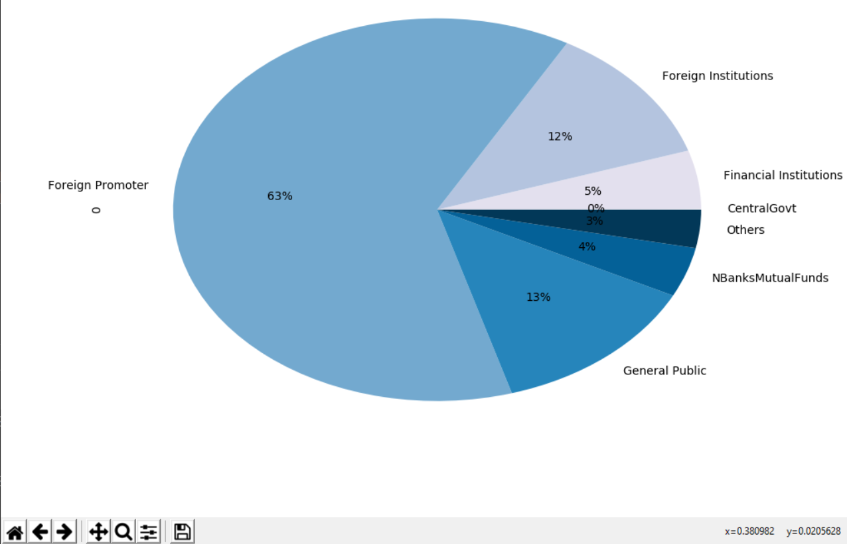

(**Nestlé’s Shareholding Pattern**)

1.3 Business Commencement Circumstances

Its roots date back to 1866, when the Anglo-Swiss Condensed Milk Company’s Milkmaid brand was created; which went on to merge with Henri Nestlé’s company in 1905. As the two Swiss companies had been highly successful in the last decades of the 19th century, Nestlé took off.

(Nestlé, n.d.)

During the First World War, Switzerland experienced a serious economic crisis caused by a decline in energy consumption. Shortages of Milk and nearly every other fresh commodity occurred during this period. Nestlé was able to endure this time of economic distress due to fighting on a wide scale. It won several government contracts allowing them to grow rapidly and had 40 plants all over the world by the time the war came to a close in 1918. Nestlé started trading on the Indian market as The NESTLÉ Anglo-Swiss Condensed Milk Company (Export) Limited in 1912, primarily importing and selling finished goods.

(Luenendonk, 2015)

It began operations in India in 1956 and their first production facility was set up in the year 1961 at Moga (Punjab).

1.4.1 Industry of the Business

It is engaged in theFood Processing Industry and is frequently cited as the largest food company in the world currently. It is the world's largest food and beverage company. Nestle India Ltd, one of the major players in the FMCG market, has a presence in the fields of milk & nutrition, snacks, cooked dishes & cooking aids & candy & confectionery. It sells premium items such as Nescafe, Maggi, Milky Bar, Milo, Kit Kat, Bar-One, Milkmaid and Nestea. The country's four divisions continue to promote the selling and distribution of its goods.

1.4.2 Relevance and Economic Importance**:**

The Nestlé organization employs about a quarter of a million workers from seventy different countries from all over the planet. Activities of the Company in India have enabled direct and indirect jobs and provide livelihood to around one million people including producers, packaging materials manufacturers, utilities and other products.

Nestlé’s total income in India as on December, 2019 was an astounding Rs 12,615.78 Cr and their revenue is higher in comparison to other top Food Processing Companies in India like Parlé Agro and Britannia Industries. Nestlé has a broad variety of items of infant food, cereals for eating, coffee and tea, an array of cakes and much more. In India it has a total of 8 development centres and 4 regional offices (Delhi, Mumbai, Chennai, Kolkata).

1.5.1 Greatness of the Company

Today, Nestlé operates in almost every part of the world. By their own efforts as well as through joint partnerships with companies like Coca-Cola, they have entered an unprecedented global audience, which can be clearly seen through their revenue metrics. They are also a Fortune 500 company, which only adds to their overall greatness.

Nescafe was named by CNBC Awaaz Consumer Awards as the most favoured brand of coffees. Also, Business India has ranked Nestle India among the Super 100 firms as No.1 on Return On Capital Investment. Nestlé is a major player in India and is definitely here to stay.

(Subjecto, n.d.)

1.4.3 Corporate Social Responsibility:

Not only is Nestlé one of the top Food Processing Companies in India but also the forerunners in CSR Initiatives. For example, in the financial year 2017-18, Nestle India invested **more than the required 2%** on CSR initiatives. Here is a basic overview of their CSR Programmes:

1. Nestlé Healthy Kids Programme.
2. Project Jagriti.
3. Clean Drinking Water Projects
4. Project Serve Safe Food etc.

(The CSR Journal, 2018)

**2 Underlying Stock Returns:**

It is evident from the following table that mean returns are higher for monthly Frequency in comparison to the Weekly and Daily data. Moreover, Daily Returns account for 65.7% per annum. Similarly, Weekly and Monthly Returns account for 42.69% and 45.52% respectively. Hence, comparing return/risk ratio for daily, monthly and weekly frequencies of risk unadjusted returns, **Daily frequency has highest reward/risk ratio** of 36.5, followed by Weekly (12.34) Monthly (11.26) frequencies. This implies that investing on a daily frequency will pose lesser risk for the same returns.

|  |  |  |  |
| --- | --- | --- | --- |
|  | Daily | Weekly | Monthly |
| Maximum | 7.81 | 7.89 | 10.272 |
| Minimum | -8.49 | -8.75 | -3.298 |
| Mean | 0.18 | 0.821 | 3.794 |
| Sample Std. Dev | 1.80 | 3.459 | 4.041 |

Table 1: Comparison of Daily, Weekly and Monthly **Risk- Unadjusted** Returns (in %, rounded off)

**3 Underlying Stock Risk-Adjusted Returns:**

It is evident from the following table that mean excess returns are higher for monthly frequency in comparison to daily and weekly frequencies. If we calculate the excess returns per annum for each of these three frequencies, the highest per annum % returns are for Daily (60.59%), followed by Monthly (40.25%) and then Weekly (30.108%). When we divide it by the Standard Deviation (Sharpe Ratio), the Monthly Returns are found to be highest. This means that they offer better return for the same risk (or, equivalently, the same return for lower risk).

|  |  |  |  |
| --- | --- | --- | --- |
|  | Daily | Weekly | Monthly |
| Maximum | 7.801 | 7.748 | 9.82 |
| Minimum | -8.502 | -8.842 | -3.707 |
| Mean | 0.166 | 0.579 | 3.354 |
| Sample Std. Dev. | 1.804 | 3.344 | 4.036 |

Table 2: Comparison of Daily, Weekly and Monthly **Risk- Adjusted** Returns (in %, rounded off)

**4 Economic Interpretation of Risk-Unadjusted and Risk-Adjusted Returns:**

Risk-adjusted return refines the return on an investment by calculating how much risk is involved in generating the gain while risk-unadjusted gain does not take the risk involved in obtaining the return into consideration. Therefore, it is often necessary for an investor to invest after looking at the risk adjusted returns. This ratio is also very critical for portfolio managers working with a variety of clients expecting a varied range of returns for a given amount of risk, or vice versa. The following figures showcase both the risk-adjusted and unadjusted returns for daily, weekly and monthly frequencies:

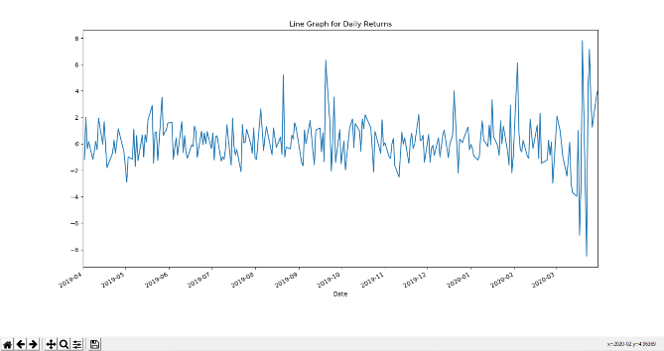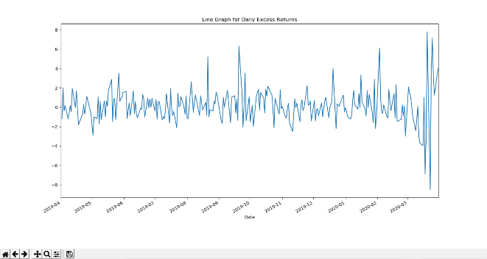

Comparison of **Daily** Risk-Unadjusted and Risk- AdjustedReturns

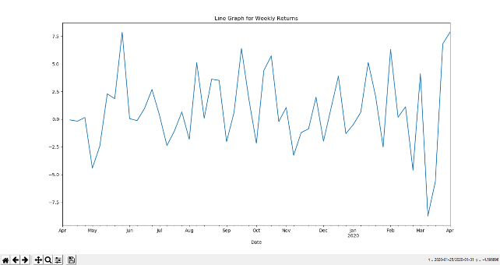 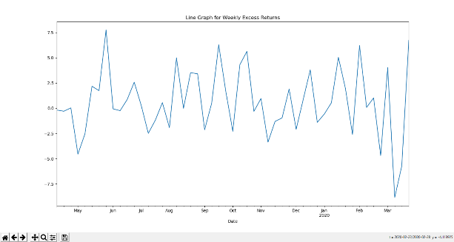

Comparison of **Weekly** Risk-Unadjusted and Risk- AdjustedReturns

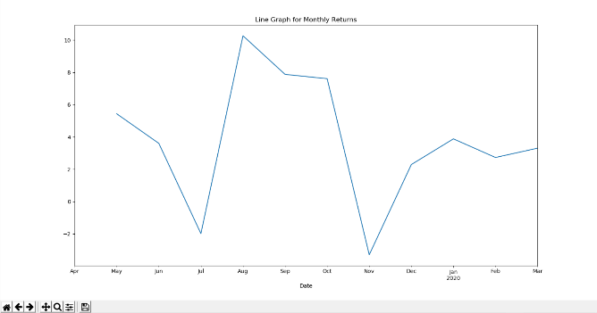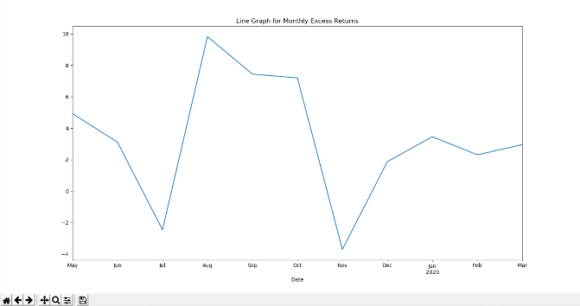

Comparison of **Monthly** Risk-Unadjusted and Risk- AdjustedReturns

Sharpe Ratio calculates the Reward/Risk Ratio by considering the mean and standard deviation. It assesses whether a certain risk is worth taking or not. In the following table, it is clear that the Sharpe Ratio is best for Monthly frequency, followed by Weekly and then Daily. This means that the best returns for the same level of risk will be availed by investing on a monthly basis.

|  |  |  |  |
| --- | --- | --- | --- |
| **Underlying Assets** | **Daily** | **Weekly** | **Monthly** |
| Mean of Excess Return | 0.166 | 0.579 | 3.354 |
| Standard Deviation of Unadjusted Returns | 1.8 | 3.459 | 4.041 |
| Sharpe Ratio | 0.092222 | 0.167389 | 0.8299926 |

The **Reason** behind these observations is the high volatility of Nestlé’s Stock in the year 2019-20. Volatility is not bad per se. A stock which develops over time is volatile. If there is no volatility there are no gains in the market as well. Moreover, companies in the Food Processing Industry generally have such volatility. Although the profitability is evidently high, their lack of stability on a daily basis makes trading on a Monthly frequency the best option.

Another salient point that should be noted is the unusually high volatility in the month of March, which occurred due to the COVID-19 Outbreak, which was the reason behind stock prices crashing down around the world.

**Section 2**

**5 Equity Futures**

5.1 Commencement of Equity Futures

Equity Futures of Nestlé India started trading on the NSE from 28th April, 2017 with 371 contracts for Near Month and none for Next and Far Month. The Open Interest Rate for the Near Month Contract was 24,400 at that time.

5.2 Lot Size & Contract Specifications

Nestlé India is currently trading in the Futures 7 Options Market of the NSE with a Lot Size of 50 and a total of around 2425 futures contracts.

5.3 Overall Greatness of Equity Futures

Owing to their similar movements with the underlying market values, Nestlé India futures have gained a lot of significance. This is primarily because these futures allow an investor to lock the future asset price and help him / her mitigate the risk to a large extent. This is the main reason why their futures contracts are so attractive.

**6 Risk- Unadjusted Daily, Weekly and Monthly Returns on Near, Next and Far Months**

6.1 Near Month Returns

Near month refers to the current month of trading. It is clear from the following table that when compared on a per annum basis, Daily Returns are 73.32%, Weekly returns are 47.1% and Monthly Returns are 48.23%. The highest reward/risk ratio is present in Daily Near Month Returns only (36.73), followed by Weekly (13.20) and Monthly (12.32) frequencies.

|  |  |  |  |
| --- | --- | --- | --- |
|  | Daily | Weekly | Monthly |
| Maximum | 12.867 | 11.056 | 10.094 |
| Minimum | -8.908 | -8.859 | -3.181 |
| Mean | 0.2009 | 0.9059 | 4.0194 |
| Sample Std. Dev. | 1.9961 | 3.5689 | 3.9147 |

Table 3: Comparison of Daily, Weekly and

**Near Month** Returns (in %, rounded off)

6.2 Next Month Returns

The per annum returns are 72.89% for Daily, 47.13% for Weekly and 48% for Monthly. Again, the highest reward/risk ratio is present in Daily Next Month Returns (36.5). So, investing on a daily basis on these next month contract will ensure that the investor is taking lesser risk for the same returns. The ratios for Weekly and Monthly are 13.13 & 11.95 respectively.

|  |  |  |  |
| --- | --- | --- | --- |
|  | Daily | Weekly | Monthly |
| Maximum | 12.741 | 11.053 | 10.379 |
| Minimum | -9.029 | -8.904 | -3.236 |
| Mean | 0.1997 | 0.9063 | 4.0 |
| Sample Std. Dev. | 2.024 | 3.5913 | 4.0166 |

Table 4: Comparison of Daily, Weekly and Monthly **Next Month** Returns (in %, rounded off)

6.3 Far Month Returns

Daily, Weekly and Monthly per annum returns are 72.01%, 46.65% and 47% respectively. **Daily** investment is again recommended as it ensures greater safety/ lesser risk for the same amount of returns. This is because it ensures the highest Reward/Risk ratio of 35.80 compared to 13.03 of Weekly and 12.52 of Monthly.

|  |  |  |  |
| --- | --- | --- | --- |
|  | Daily | Weekly | Monthly |
| Maximum | 12.726 | 11.385 | 10.12 |
| Minimum | -8.536 | -8.834 | -2.799 |
| Mean | 0.1973 | 0.8973 | 3.9266 |
| Sample Std. Dev. | 2.0115 | 3.5876 | 3.7633 |

Table 5: Comparison of Daily, Weekly and Monthly  **Far Month** Returns (in %, rounded off)

**7 Risk- Adjusted Daily, Weekly and Monthly Returns on Near, Next and Far Months**

7.1 Near Month Risk-Adjusted Returns

While the returns on the Daily frequency are 67.89% per annum, the Weekly and Monthly frequency returns account for 29.796% per annum and 40.104 % per annum respectively. When we find the Reward to Risk Ratio, it is clear that Daily Returns are better for Near Month as they pose lesser risk for the same returns. (34.01 Daily> 10.00 Monthly > 8.894 Weekly)

|  |  |  |  |
| --- | --- | --- | --- |
|  | Daily | Weekly | Monthly |
| Maximum | 12.856 | 7.808 | 9.642 |
| Minimum | -8.921 | -8.951 | -3.59 |
| Mean | 0.186 | 0.573 | 3.342 |
| Sample Std. Dev. | 1.996 | 3.35 | 4.01 |

Table 6: Comparison of **Risk-Adjusted** Daily, Weekly and **Near Month** Returns (in %, rounded off)

7.2 Next Month Risk-Adjusted Returns

For Next Month, Daily frequency returns around 67.52% p.a., while weekly and monthly returns account for 29.952% and 39.588% per annum respectively. When comparing the Reward to Risk Ratios, it is evident that trading on a Daily basis is better (Ratio of 33.36 Daily> 9.65 Monthly > 8.89 Weekly).

|  |  |  |  |
| --- | --- | --- | --- |
|  | Daily | Weekly | Monthly |
| Maximum | 12.729 | 7.479 | 9.927 |
| Minimum | -9.042 | -8.997 | -3.645 |
| Mean | 0.185 | 0.576 | 3.299 |
| Sample Std. Dev. | 2.024 | 3.366 | 4.1 |

Table 7: Comparison of **Risk-Adjusted** Daily, Weekly

and  **Next Month** Returns (in %, rounded off)

7.3 Far Month Risk-Adjusted Returns

As far as Far Month is considered, the Daily returns provide the best per annum returns of 66.795% followed by Monthly (39.52% p.a.) and then Weekly (29.69% p.a.). The best Reward/Risk ratio is obtained in the Daily frequency (33.20). Weekly and Monthly Ratios are 8.83 and 10.19 respectively. This makes investment on a Daily basis the safest route for an investor and hence, would be recommended.

|  |  |  |  |
| --- | --- | --- | --- |
|  | Daily | Weekly | Monthly |
| Maximum | 12.714 | 8.309 | 9.668 |
| Minimum | -8.549 | -8.926 | -3.208 |
| Mean | 0.183 | 0.571 | 3.293 |
| Sample Std. Dev. | 2.012 | 3.362 | 3.878 |

Table 8: Comparison of **Risk-Adjusted** Daily, Weekly and **Far Month** Returns (in %, rounded off)

**8 The Economic Interpretation of the Risk-Adjusted and Risk-Unadjusted**

**Returns**

An investor who does not calculate the Sharpe Ratio when investing is extremely likely to slip into the pit of higher returns with much higher risk rates. It is imperative to assess the risk associated with our investments in order to mitigate losses. Returns calibrated for risk are smaller than unadjusted returns. The risk-adjusted return is a more economically realistic measure, as a misleading image can be offered by unadjusted returns. To be competitive, risk-adjusted returns will outweigh risk-free returns; if this is not the case, an investor will create larger gains by engaging in risk-free assets.

8.1 Near Month Analysis

Sharpe Ratio Calculations:

|  |  |  |  |
| --- | --- | --- | --- |
| **Near Month** | **Daily** | **Weekly** | **Monthly** |
| Mean of Excess Return | 0.186 | 0.573 | 3.342 |
| Standard Deviation of Unadjusted Returns | 1.9961 | 3.5689 | 3.9147 |
| Sharpe Ratio | 0.093182 | 0.160554 | 0.8537053 |

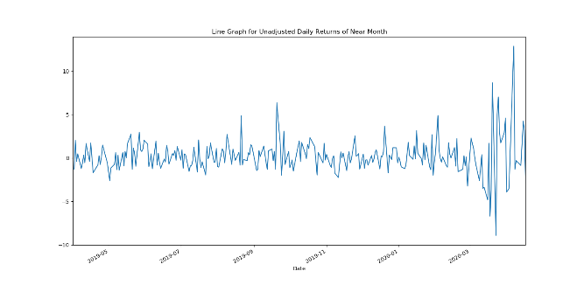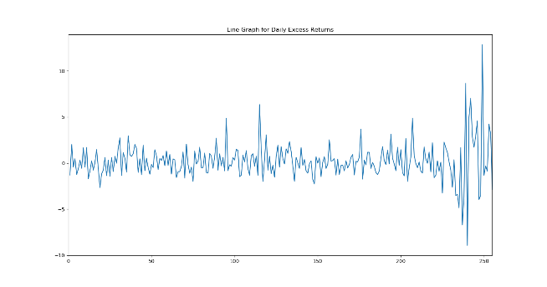

Comparison of **Daily** Risk-Unadjusted and Risk- AdjustedReturns for **Near** Month Frequency

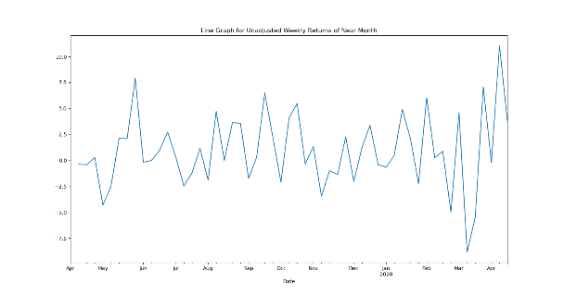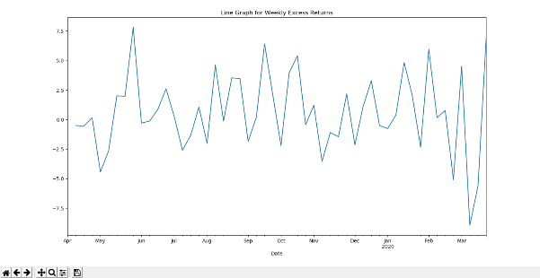

Comparison of **Weekly** Risk-Unadjusted and Risk- AdjustedReturns for **Near** Month Frequency

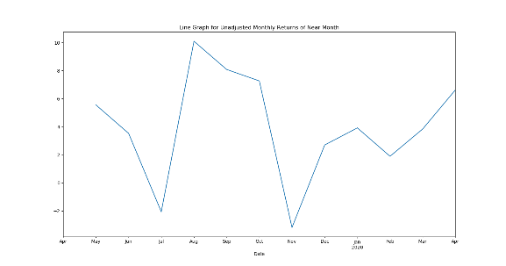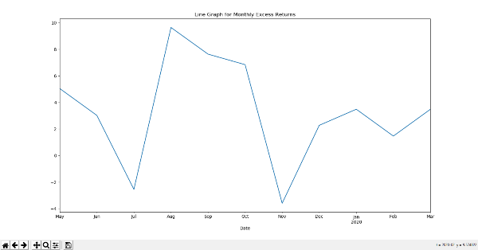

Comparison of **Monthly** Risk-Unadjusted and Risk- AdjustedReturns for **Near** Month Frequency

8.2 Next Month Analysis

Sharpe Ratio Calculations:

|  |  |  |  |
| --- | --- | --- | --- |
| **Next Month** | **Daily** | **Weekly** | **Monthly** |
| Mean of Excess Return | 0.185 | 0.576 | 3.299 |
| Standard Deviation of Unadjusted Returns | 2.024 | 3.5913 | 4.0166 |
| Sharpe Ratio | 0.091403 | 0.160388 | 0.8213414 |

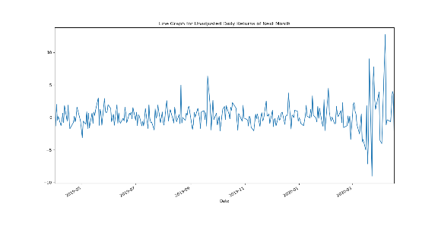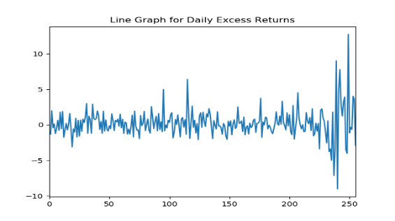

Comparison of **Daily** Risk-Unadjusted and Risk- AdjustedReturns for **Next** Month Frequency

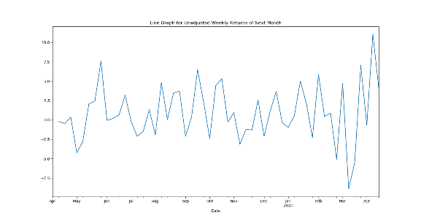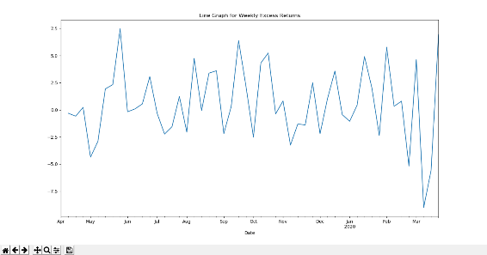

Comparison of **Weekly** Risk-Unadjusted and Risk- AdjustedReturns for **Next** Month Frequency

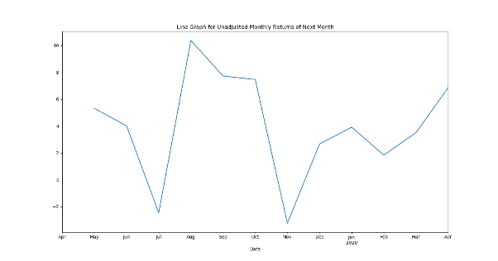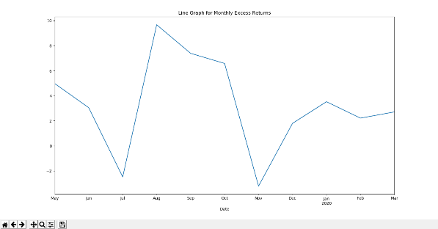Comparison of **Monthly** Risk-Unadjusted and Risk- AdjustedReturns for **Next** Month Frequency

8.3 Far Month Analysis

Sharpe Ratio Calculations:

|  |  |  |  |
| --- | --- | --- | --- |
| **Far Month** | **Daily** | **Weekly** | **Monthly** |
| Mean of Excess Return | 0.183 | 0.571 | 3.293 |
| Standard Deviation of Unadjusted Returns | 2.0115 | 3.5876 | 3.7633 |
| Sharpe Ratio | 0.090977 | 0.159159 | 0.8750299 |

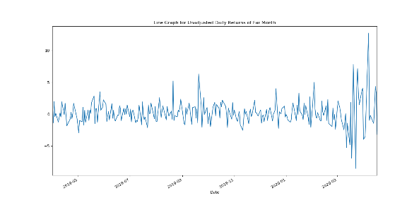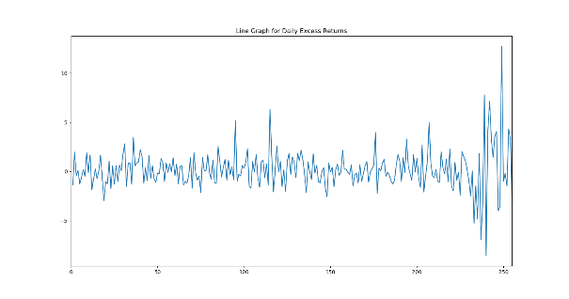

Comparison of **Daily** Risk-Unadjusted and Risk- AdjustedReturns for **Far** Month Frequency

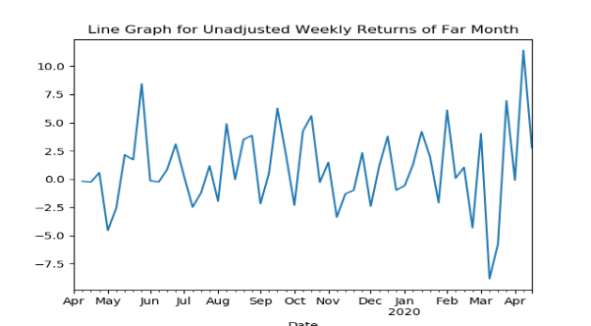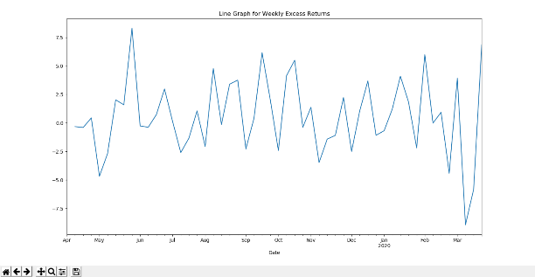

Comparison of **Weekly** Risk-Unadjusted and Risk- AdjustedReturns for **Far** Month Frequency

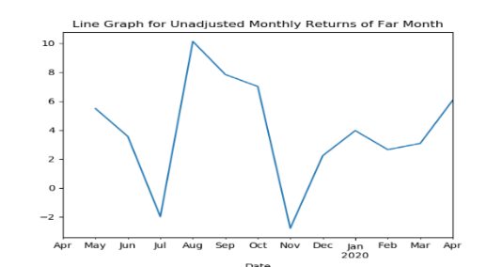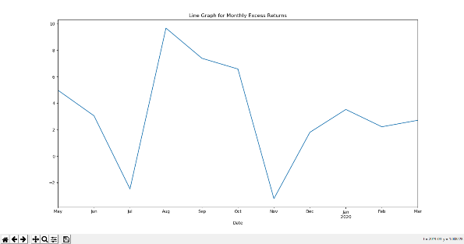

Comparison of **Monthly** Risk-Unadjusted and Risk- AdjustedReturns for **Far** Month Frequency

Observations:

* The returns that have been calculated with consideration of risk associated with them (through the means of ‘Excess Returns’ are lesser than the unadjusted returns.
* These Adjusted Returns help an investor to understand the risk associated as they take the T-Bill Rates into account.
* The standard deviation in both these returns are comparable.
* Highest Volatility is present in daily (followed by Weekly and Monthly) frequency for Futures.
* Highest Volatility is present in daily (followed by Weekly and Monthly) frequency for Risk-Adjusted Ratio.
* Mean yield has been positive for both risk-adjusted stock returns and risk adjusted futures for all three of daily, weekly and monthly frequencies.
* The Sharpe Ratio Calculations help us in understanding the associated risk. As far as Futures are considered, Monthly frequency has proved to be the best for all three of Near, Next and Far Month.

Action:

* As far as Futures are considered, the Near Month contracts on the Monthly frequency have proved to give the best results for excess returns. Since they also, have a good Sharpe Ratio, investing in these is recommended.
* Since the Sharpe Ratios have proved that Monthly frequency pose less risk for the same returns, investors are advised to hold stock for longer periods.
* Since the adjusted returns haven’t been negative for both the Equity and Futures, they are a better choice than T-Bills.

**9 Comparisons of Returns**

The following tables show the Risk-Adjusted data for Daily, Weekly and Monthly Contracts for Near, Next and Far Months for Futures as well as for Underlying Asset Returns:

|  |  |  |  |  |
| --- | --- | --- | --- | --- |
| **Daily** | **Near Month** | **Next Month** | **Far Month** | **Underlying Assets** |
| Maximum | 12.856 | 12.729 | 12.714 | 7.801 |
| Minimum | -8.921 | -9.042 | -8.549 | -8.502 |
| Mean of Excess Returns | 0.186 | 0.185 | 0.183 | 0.166 |
| Std. Deviation | 1.996 | 2.024 | 2.012 | 1.804 |
| Sharpe Ratio | 0.093182 | 0.091403 | 0.090977 | 0.092222 |

|  |  |  |  |  |
| --- | --- | --- | --- | --- |
| **Weekly** | **Near Month** | **Next Month** | **Far Month** | **Underlying Assets** |
| Maximum | 7.808 | 7.479 | 8.309 | 7.748 |
| Minimum | -8.951 | -8.997 | -8.926 | -8.842 |
| Mean of Excess Returns | 0.573 | 0.576 | 0.571 | 0.579 |
| Std. Deviation | 3.35 | 3.366 | 3.362 | 3.344 |
| Sharpe Ratio | 0.160554 | 0.160388 | 0.159159 | 0.167389 |

|  |  |  |  |  |
| --- | --- | --- | --- | --- |
| **Monthly** | **Near Month** | **Next Month** | **Far Month** | **Underlying Assets** |
| Maximum | 9.642 | 9.927 | 9.668 | 9.82 |
| Minimum | -3.59 | -3.645 | -3.208 | -3.707 |
| Mean of Excess Returns | 3.342 | 3.299 | 3.293 | 3.354 |
| Std. Deviation | 4.01 | 4.1 | 3.878 | 4.036 |
| Sharpe Ratio | 0.8537053 | 0.8213414 | 0.8750299 | 0.8299926 |

Analysing at the above table give us various insights. For example, we now know that since the Sharpe Ratio is best in Near Month for Daily, Underlying Asset for Weekly and Far month for Monthly (Overall Best), an investor can choose the way that is compatible with his habits.

The highest Sharpe Ratio of the Far Month Monthly Contracts tell us that they are going to give the best returns for a given amount of risk. This can prove to be game-changing for investors who wish to minimize risk.

Since the Mean Risk-Adjusted Returns have been positive for each entry in the tables above, we can say that an investor who likes to invest in T-Bills can find these pastures greener. Another point to note is that the highest Standard Deviation and maximum mean excess returns can be easily found out using these tables.

**Section 3**

**10.1 Comparing the Risk-Unadjusted and Adjusted Returns with Futures Risk-Unadjusted and Adjusted Returns**

Apart from the Graphs plotted above, several other observations were made in both the risk-unadjusted and adjusted data. These are as follows:

* The Mean Unadjusted Daily Returns are highest for Near Month Contracts.
* The Mean Unadjusted Weekly Returns are highest for Next Month Contracts.
* The Mean Unadjusted Monthly Returns are highest for Near Month Contracts.
* The Mean Adjusted Daily Returns are best for Near- Month Contracts.
* The Mean Adjusted Weekly Returns are best for Equity.
* The Mean Adjusted Monthly Returns are best for Equity as well.
* The highest Sharpe Ratio of Adjusted Daily Returns is seen in Near Month Contracts.
* The highest Sharpe Ratio of Adjusted Weekly Returns is seen in Equity.
* The highest Sharpe Ratio of Adjusted Monthly Returns is seen in Far Month Contracts.
* All the adjusted values are obviously smaller than the unadjusted values. However, their graphs are very similar.
* The highest S.D. in Adjusted Data is seen in Next Month Contracts for Daily, Weekly and Monthly Frequencies.
* It would be wiser to look at the Risk Adjusted Data for any kind of investment and they should be used as a reference before setting any expectation.
* Although the shape of the graphs for both Risk-Adjusted and Risk-Unadjusted Returns are going to be very similar, the former is obviously going to stay beneath the latter and the difference at any point would be equal to the T-Bill Return on that particular day.
* A wise investor would always consider the Sharpe Ratio before investing. It is important to avoid getting swayed by prospects of heavy returns with huge risk associated with them.

**10.2 Liquidity position**

|  |  |  |  |
| --- | --- | --- | --- |
|  | Near | Next | Far |
| Average No of Contracts | 1958.164 | 593.0820 | 1.1171875 |
| Average Open Interest | 366466.41 | 48609.96 | 134.375 |

* For equity shares, the average no of Daily Volume from July ‘19 to December ’19 was around 85937.
* Although returns are better for Far Month, people prefer Near (as seen from the average no of contracts)
* This is because of the comparatively superior liquidity position of the Near Month Frequency.

**Section 4**

**11.1 Contango or Backwardation of Future Instruments**

Here, we will be looking for any Contango or Backwardation in the Futures. While the former is a state of the market where a stock's forward price or futures price is greater than the spot price, the latter is the market situation when, at equilibrium, the price of a forward or future commodity is traded below the current spot price of the product. It is important to account for both of them as not doing so can incur serious losses.

(Harpe, 2019)

It is important to note that the future price must converge with the spot price over time, else it would lead to an arbitrage opportunity. The following Graphs for Near, Next and Far Month Futures make it clear that **Contango** behaviour is present.

Since the future prices remain a tad bit higher than the spot price, the graphs indicate Contango behaviour.

**11.2 Frequency Significance**

As per the “Random Walk Theory” & “Efficient Market Hypothesis”, stock prices are totally unpredictable and the frequency shouldn't be a cause for concern. This is so because the return will be the same on average provided each trade's transaction costs are not included.

Nonetheless, the frequency is essential for the investor since the measurement of the Sharpe ratio relies on the standard deviation, which in turn is dependent on the period frequency.

It is observed that the highest mean returns on a per annum basis were obtained when money was invested on Near Month Futures on a Daily Basis. However, a more prudent investor who wishes to minimise his risk will look at the Sharpe Ratios as well and not just the Mean Returns when making an investment. Therefore, for an investor who wishes to minimise risk, investing on a Monthly Basis in Far Month Futures is advisable as it showcases the best Sharpe Ratio.

**Section 5**

**Options**

Call Options have been selected for this section. The strike price and expiry corresponding to the highest Open Interest has been taken and data has been interpreted from dates around 90 days prior to it. The following table provides details of the dataset:

|  |  |
| --- | --- |
| Duration | Apr. ’19- June ‘19 |
| Strike Price | 12000 |
| Std. Dev of Stock Returns | 0.01238 |
| Annualised Volatility | 0.19653 |
| Prob. Of Going Up | 1.10325 |
| Prob. Of Going Down | 0.90641 |

Taking the values from the Date 22nd April, 2019, we can construct a simple binary tree representing the values and then implement the Binomial Option Pricing Model:

The Theoretical Option Value obtained from this is 166.15 INR, which is quite close to the actual value of 167.95. However, this is not always the case as the actual option prices are determined in the Open Market, which is subject to change and the values can differ by quite a margin.

**Observations:**

* Although the values calculated don’t come out to be equal to the actual option values, they go a long way in helping us analyse the characteristics of the options.
* For example, the trends (as seen from the excel column) are very similar to the actual trends.
* The above calculated value never fully converge into the actual trading option values as the latter are set with various current market scenarios kept in mind which are not available to us.

**Section 6**

**Conclusion**

Nestlé India Ltd. has a come a long way since it began operations in India in 1956. It is one of the topmost players in the country’s Food Processing Industry and provides value to a myriad of consumers.

Nestlé’s Equity Shares have shown continuous growth and have been giving positive returns after adjusting risk for all three of Daily, Weekly and Monthly frequencies. Quality returns from Nestlé make it a very attractive choice for investors in both Equity and Futures.

From the above analysis, it is clear that investing on a monthly basis in Far Month Future Contracts provides the best return for the same amount of risk. Nestlé’s performance in the spot market has also been appreciable, In the last 1 year, their stock prices have gone from around 10,900 INR to 17,400 INR, having also reached the figure 17,925 INR, a new high. The company is still expanding in India and is undoubtedly profitable. Even after the immediate impact of the COVID-19 Outbreak, their stock bounced back very well. They have already started to prepare for the upcoming post-pandemic “new normal” for India. Overall, it can be safely said that Nestlé is a very lucrative investment option for investors of all kinds.

**Section 7**

# References

CME Group. (n.d.). *What is Contango and Backwardation*. Retrieved from CME Group: https://www.cmegroup.com/education/courses/introduction-to-ferrous-metals/what-is-contango-and-backwardation.html

Harpe, D. R. (2019, May 14). *Contango & Backwardation: What's the difference?* Retrieved from Investopedia: https://www.investopedia.com/articles/07/contango_backwardation.asp

Luenendonk, M. (2015, September 3). *The History of Neslé*. Retrieved from Cleverism: https://www.cleverism.com/the-history-of-nestle/

Nestlé. (n.d.). *Logo Evolution*. Retrieved from Nestlé: https://www.nestle.com/aboutus/history/logo-evolution

Nestlé. (n.d.). *Nestlé Company History*. Retrieved from Nestle: https://www.nestle.com/aboutus/history/nestle-company-history

Subjecto. (n.d.). *Introduction and Company Profile of Nestlé*. Retrieved from Subjecto: https://subjecto.com/introduction-and-company-profile-of-nestle

The CSR Journal. (2018, December 11). *CSR Report: Nestlé India spent above 2% of average net profits*. Retrieved from The CSR Journal: https://thecsrjournal.in/csr-report-nestle-india-spent-above-2-of-average-net-profits/