EventHub - Phase 1, Step 9: Sketches
First draft by Claude, for Madhavan Suresh to change | 28 September 2026

How to use this document
These are wireframes: simple drawings that show what goes where on each page. Colours and pictures come later. This is a first draft for you to change.
- Print it, or open it in Word.
- Look at each sketch and ask: What is missing? What would I move? What would a student want here?
- Write your ideas in the "My changes" lines under each sketch (or draw on the printout).
- Send a photo or tell Claude your changes. The sketches will be updated to your final version.
Signature features shown in the sketches: (1) seat hold, never oversell; (2) smart waitlist; (3) QR tickets; (4) certificates for attendees only.

Page 1 - Home (list of events)
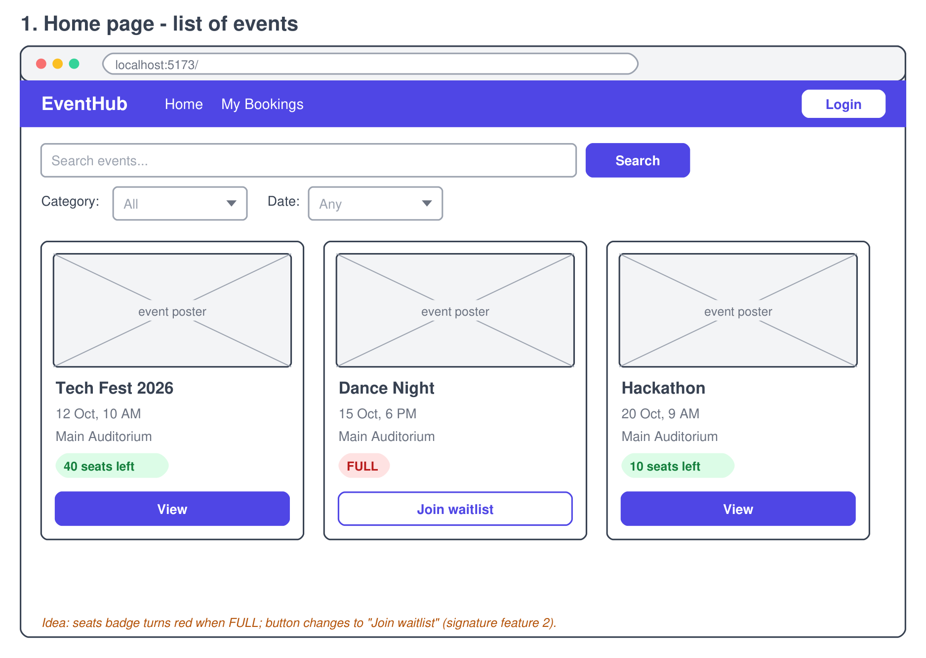
What it shows:
- Search bar + Category and Date filters
- Event cards: poster, name, date, venue, seats badge
- FULL events show a red badge and a "Join waitlist" button
My changes:

Page 2 - Event details
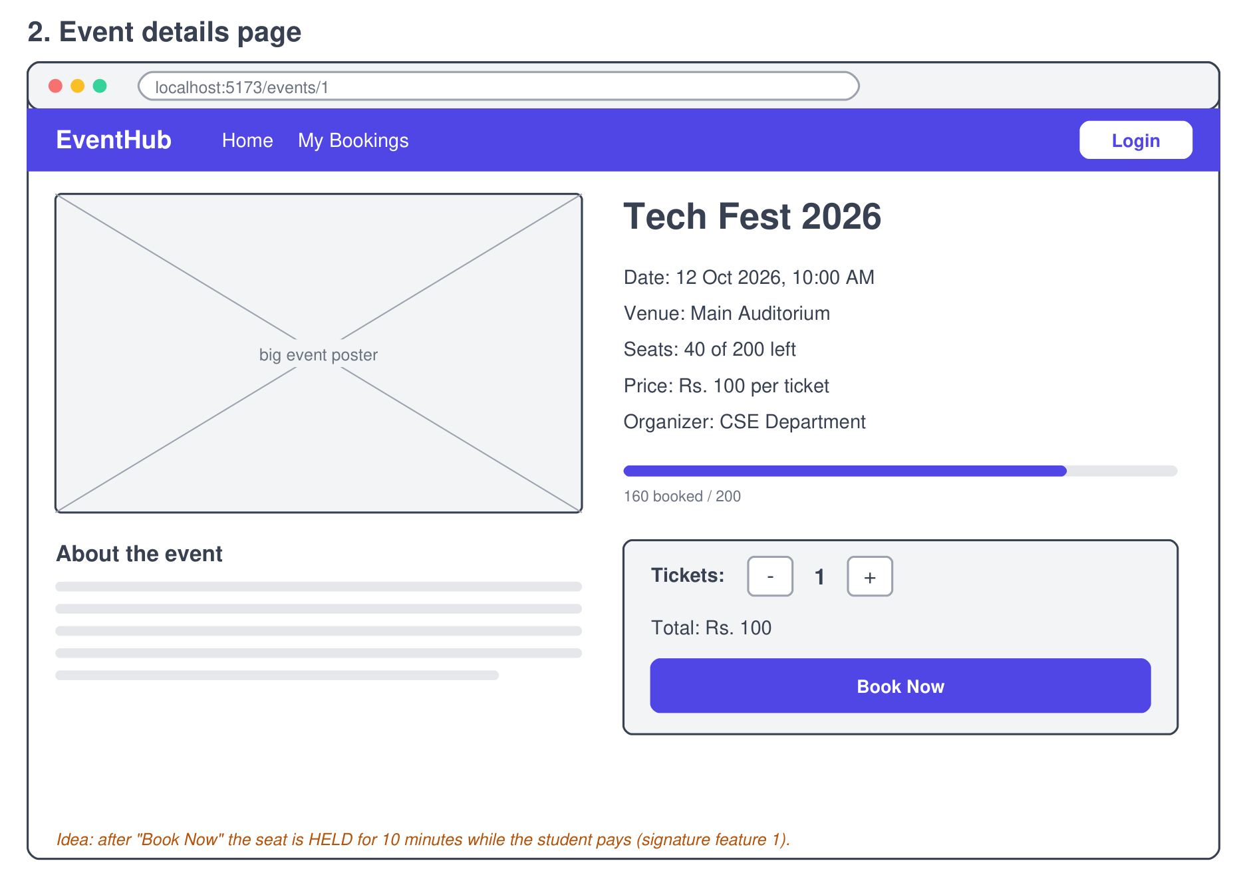
What it shows:
- Big poster + all details (date, venue, seats, price, organizer)
- Progress bar: how many seats are booked
- Ticket counter (- 1 +), total price and the Book Now button
My changes:

Page 3 - Login
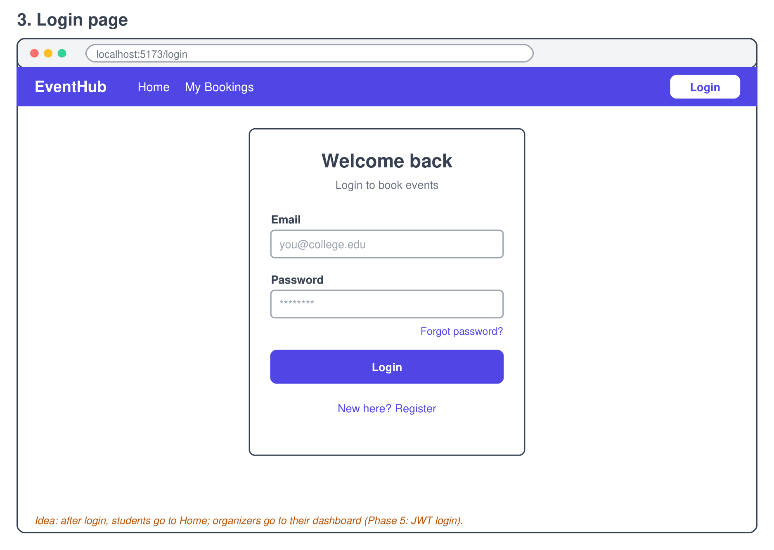
What it shows:
- Email + password
- Forgot password link and Register link
- Students go to Home, organizers go to their dashboard
My changes:

Page 4 - My Bookings
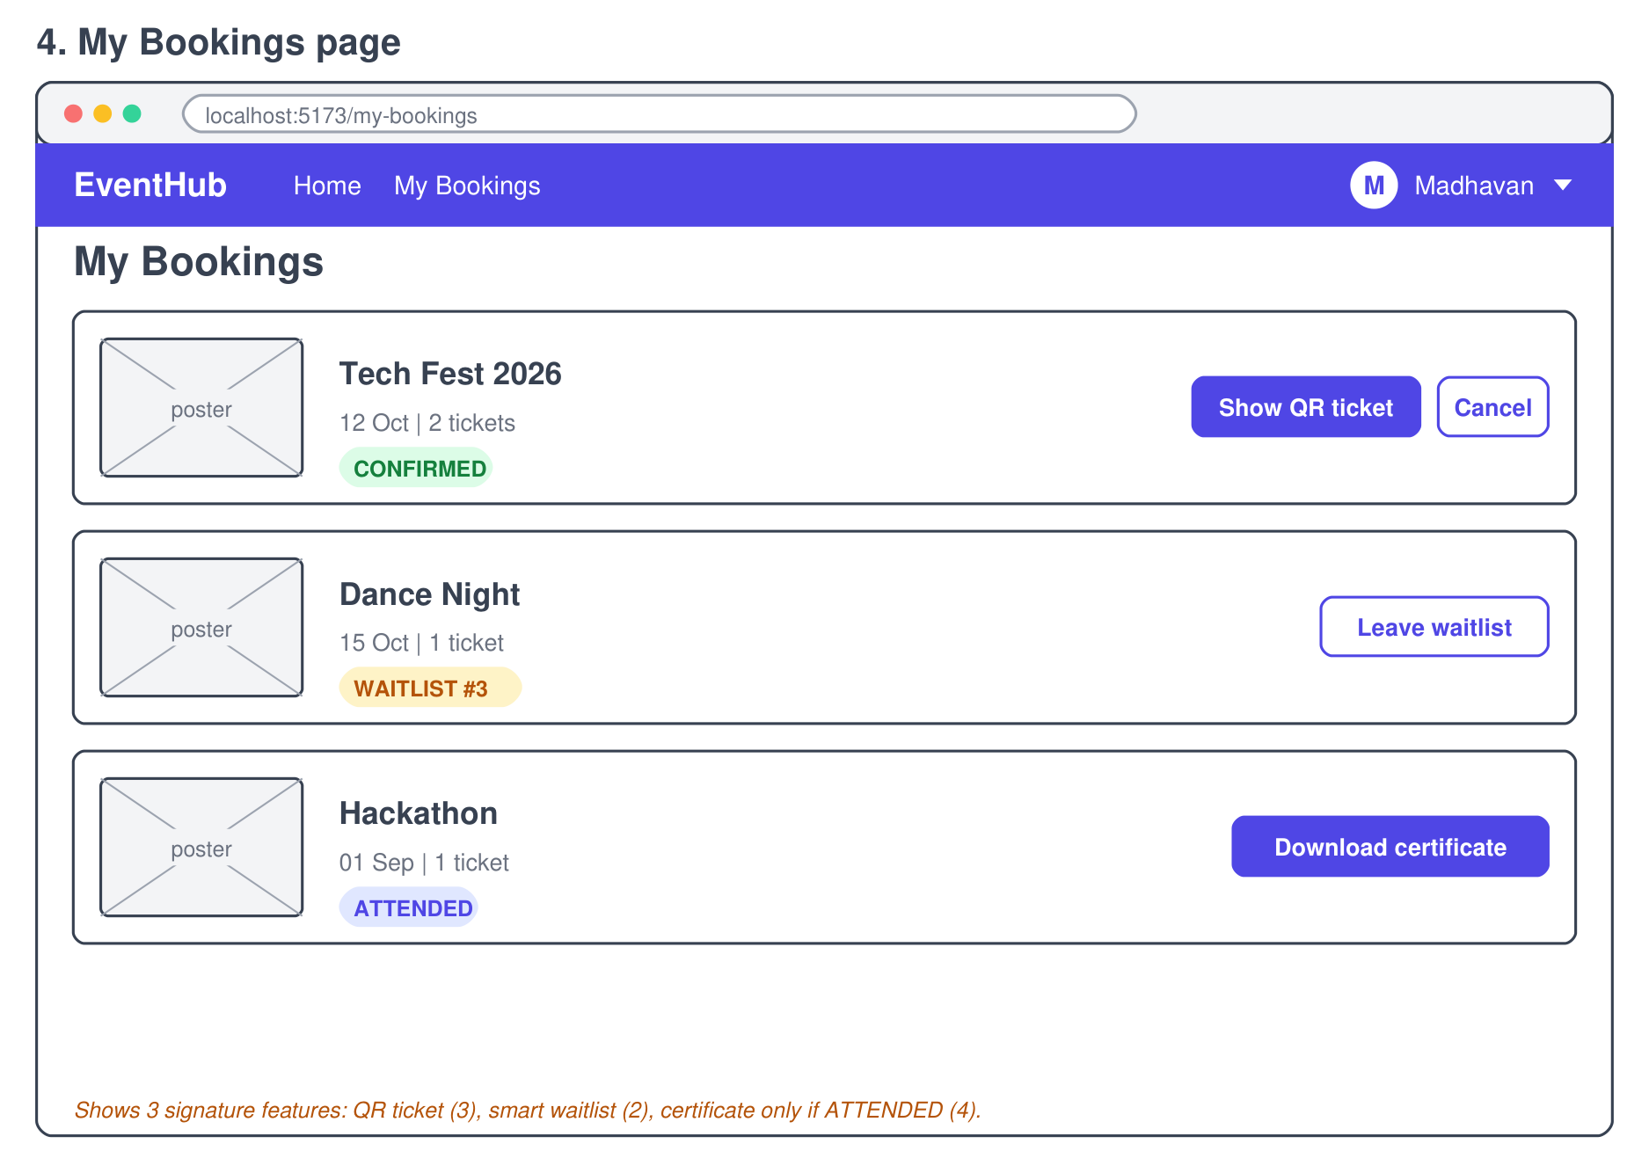
What it shows:
- Each booking shows a status badge: CONFIRMED / WAITLIST / ATTENDED
- CONFIRMED: Show QR ticket, Cancel
- ATTENDED: Download certificate
My changes:

Database diagram (ER diagram)
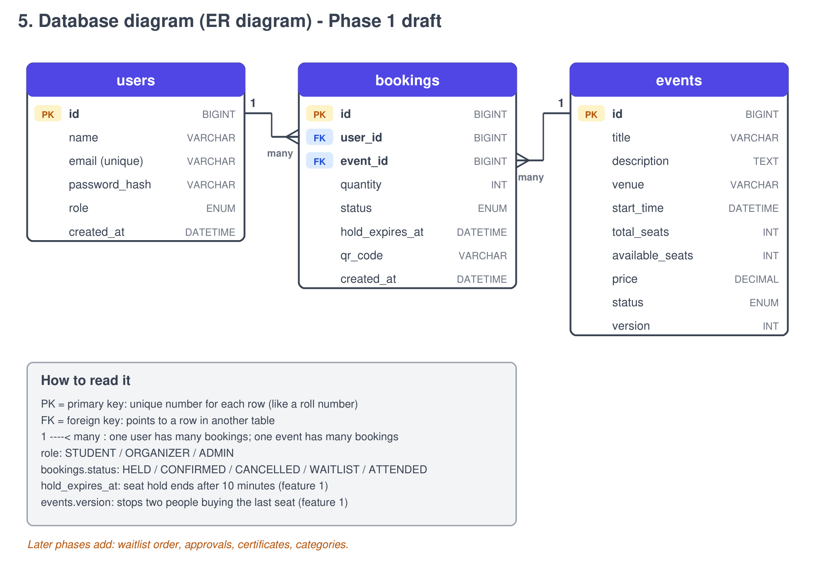
What it shows:
- 3 tables: users, events, bookings
- bookings links a user to an event (1 user - many bookings, 1 event - many bookings)
- hold_expires_at and version protect the seat booking (feature 1)
My changes:

