EventHub
College Event Management Platform
Complete Project Guide
Setup, architecture, code, database, API, testing, troubleshooting, user guide and viva questions - explained step by step with examples
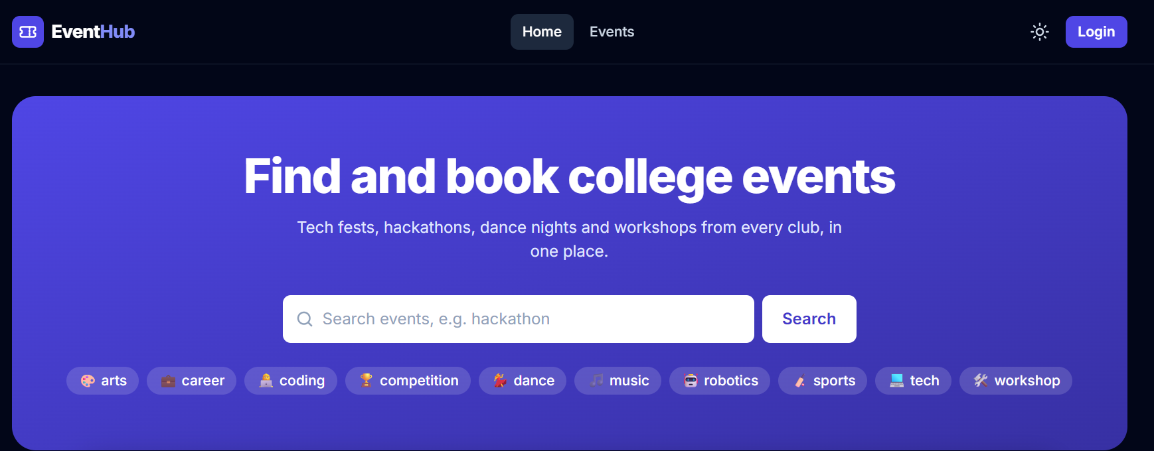
Madhavan Suresh
Java Full Stack practice project · React + Spring Boot + MySQL
Version 1.0 · 29 September 2026 · github.com/madhavansuresh000-sys/eventhub

Contents
1. Introduction 5
1.1 What is EventHub? 5
1.2 Why this project? (the problem) 5
1.3 Objectives 6
1.4 Scope 6
1.5 Who should read this document 7
1.6 How this document is written 7
1.7 The demo accounts 7
2. Requirements 8
2.1 Functional requirements by role 8
2.2 Business rules (the most important ones) 9
2.3 Non-functional requirements 10
2.4 User stories with examples 10
3. Technologies used 12
3.1 The big picture 12
3.2 Frontend technologies 12
3.3 Backend technologies 14
3.4 Database and infrastructure 15
3.5 Quality tools 16
4. System architecture 17
4.1 The three tiers 17
4.2 Layers inside the backend 17
4.3 The journey of one request 18
4.4 Package structure (backend) 18
4.5 Folder structure of the repository 19
4.6 Important design decisions 19
5. Setup and installation 21
5.1 What you need to install 21
5.2 Step 1 - get the code 21
5.3 Step 2 - create your .env file 21
5.4 Step 3 - start MySQL and Mailpit 22
5.5 Step 4 - start the backend 23
5.6 Step 5 - start the frontend 24
5.7 Step 6 - run the tests 24
5.8 Step 7 - try the API with Postman 25
5.9 Useful addresses (development) 25
5.10 Stopping everything 25
5.11 The demo tour 25
6. Database design 27
6.1 Overview 27
6.2 Rules that protect the data 27
6.3 Optimistic locking columns 28
6.4 Every table, column by column 28
6.5 Useful SQL queries (with examples) 33
6.6 How Java classes map to tables (JPA) 34
6.7 Example: what the tables look like after one booking 35
7. Backend code explained 37
7.1 The application entry point 37
7.2 Errors that make sense: GlobalExceptionHandler 37
7.3 Events: search, rules and the approval workflow 38
7.4 Security: login, JWT cookie, CSRF and permissions 41
7.5 Bookings: holding seats without ever overselling 44
7.6 Payments: one interface, two gateways 47
7.7 The smart waitlist 49
7.8 Notifications: bell, email and reminders 50
7.9 The gate: QR codes and check-in 51
7.10 Certificates 52
7.11 Feedback 53
7.12 Analytics with caching 54
7.13 The audit log 55
8. REST API reference 56
8.1 What a REST API is 56
8.2 All endpoints 56
8.3 Examples with request and response 58
8.4 Swagger UI 59
8.5 The Postman collection 59
9. Frontend explained 60
9.1 How the React app starts 60
9.2 Folder by folder 60
9.3 Talking to the backend 60
9.4 Redux slices 61
9.5 Protecting pages: RequireAuth 62
9.6 Forms and validation 63
9.7 Timers, QR codes, charts and code splitting 64
9.8 Design system, dark mode and accessibility 65
10. User guide (with screenshots) 66
10.1 Visitor: finding events 66
10.2 Student: booking and paying 66
10.3 Student: my tickets, waitlist, notifications 68
10.4 Student: certificates and feedback 69
10.5 Volunteer: the gate scanner 70
10.6 Anyone: verifying a certificate 71
10.7 Organizer: creating and managing events 71
10.8 Admin: approvals, overview, analytics 73
10.9 What happens when someone is not allowed 75
11. Testing 76
11.1 Why test automatically? 76
11.2 The testing pyramid 76
11.3 The numbers 76
11.4 Unit tests with Mockito 77
11.5 Integration tests with Testcontainers 78
11.6 Concurrency tests 79
11.7 React component tests 80
11.8 Continuous integration (GitHub Actions) 81
11.9 Bugs the tests found 82
11.10 How to run the tests 82
12. Security in depth 83
12.1 The main threats and the answers 83
12.2 Authentication vs authorization 83
12.3 Why the JWT is in a cookie 84
12.4 The login lock in action 84
12.5 Security checklist (Phase 8) 84
13. Troubleshooting 85
13.1 Setup and start-up 85
13.2 Login and security 86
13.3 Booking, payment and gate 86
13.4 Tests 86
13.5 How to investigate any problem 87
14. Lessons learned 88
14.1 Technical lessons 88
14.2 Working lessons 88
15. Deployment plan and future scope 89
15.1 Deployment plan (Phase 9) 89
15.2 Future scope 89
16. Glossary 90
17. Viva and presentation questions with answers 92
17.1 About the project 92
17.2 Architecture 92
17.3 Backend and Spring 92
17.4 Concurrency and correctness 93
17.5 Security 94
17.6 Payments, waitlist, notifications, certificates 94
17.7 Frontend 95
17.8 Testing and quality 95
17.9 Database 96
17.10 Future and reflection 96
18. How to present EventHub (demo script) 97
18.1 Before you start (checklist) 97
18.2 The flow (about 11 minutes) 97
18.3 Tips for presenting 98
19. How EventHub was built: the phase-by-phase story 99
20. How to change EventHub (developer how-to) 100
20.1 Add a new column (example: a "meeting link" for online events) 100
20.2 Add a new endpoint (example: "my upcoming events count") 100
20.3 Add a new page 100
20.4 Add a new business rule (example: max 2 active bookings per student per day) 101
Appendix A. Commit history 102

1. Introduction

1.1 What is EventHub?
EventHub is a website where a college runs all of its events in one place. A student can find an event, book a seat, pay, receive a QR ticket, enter through the gate by showing that QR code, download a certificate after the event and rate the event. Clubs create the events, the Student Affairs Office (the admin) approves them, and volunteers check tickets at the gate.
It is a full stack application: the part you see in the browser (the frontend) is written in React, the part that stores data and applies the rules (the backend) is written in Java with Spring Boot, and the data lives in a MySQL database.
Real-life example: Think of a cinema. The cinema website shows the films (frontend). Behind it, a ticket system makes sure two people never get the same seat and records every payment (backend). The list of seats and bookings is kept in a big register (database). At the door, a staff member scans your ticket once (gate check-in). EventHub is the same idea for college events.
The EventHub home page - students search events or pick a tag

1.2 Why this project? (the problem)
In many colleges, events are organised with WhatsApp groups, Google Forms and printed lists. This causes real problems:
- Overbooking. Two students fill the form for the last seat at the same time. Both believe they are in.
- Fake or shared tickets. A screenshot of a confirmation message is forwarded. At the door nobody can tell whether it was already used.
- Slow, fake-able certificates. Certificates are made by hand, weeks later, and a nicely edited PDF can be put on a resume even by someone who never attended.
- No numbers for organizers. Clubs do not know how many tickets they sold per day, how many people actually came, or what people thought of the event.
- No control. Anybody can announce an event; there is no approval step and no record of who changed what.

EventHub solves each of these problems with a clear rule in the software, and the rest of this document shows exactly how.

1.3 Objectives
# | Objective | How EventHub meets it
1 | Easy discovery | Search by text, filter by tag, club and date; results are filtered and paged by the server
2 | Fair booking | Seats are held for 10 minutes while paying; optimistic locking guarantees no overselling
3 | Smart waitlist | When a seat frees up, it is kept 30 minutes for the next student on the waitlist
4 | Fast, safe entry | Each ticket has a random code shown as a QR code; the gate accepts it only once
5 | Proof of attendance | PDF certificates only for students who were scanned at the gate, verifiable by anyone
6 | Control | Events need admin approval; every change is written to an audit log
7 | Insight | Feedback stars, check-in rate and sales charts for organizers and the admin
8 | Quality | 146 automated tests, 91% service coverage, every push tested by GitHub Actions

1.4 Scope
Inside the scope of this project:
- Public catalogue of events, clubs and tags
- Registration and login with roles (student, organizer, volunteer, admin)
- Event creation, editing and the approval workflow
- Booking with seat holds, payment (Stripe test mode or a built-in test page), cancellation and refunds
- Waitlist with automatic offers, notifications (bell + email) and day-before reminders
- QR tickets and a gate scanner with a live counter
- PDF certificates and a public verification page
- Feedback and analytics dashboards
- Automated tests, continuous integration and full documentation

Outside the scope (see the Future Scope chapter): password reset by email, a mobile app, several colleges on one installation, and a real "volunteers" management page (volunteers exist and can scan; only the management screen uses sample names).

1.5 Who should read this document
Reader | Start with
A teacher or examiner | Chapters 1, 2, 4, 11 and 17 (viva questions)
A developer who wants to run it | Chapter 5 (setup), then chapter 13 (troubleshooting)
A developer who wants to change the code | Chapters 4, 6, 7, 8 and 9
A user of the website | Chapter 10 (user guide with screenshots)
An interviewer | Chapters 12 (security), 14 (lessons) and 17

1.6 How this document is written
- Simple English. Every technical word is explained the first time it appears, and the Glossary (chapter 16) repeats the definitions.
- Real examples. The examples use the real demo data: the student Ravi Kumar, the organizer Madhavan (Coding Club), the volunteer Priya Raman, the organizer Kavya (Cultural Club) and the admin of the Student Affairs Office.
- Real code. Every code excerpt is copied automatically from the project files when this document is built, so the code you read here is exactly the code on GitHub.
- Real screenshots. All screenshots were taken by a script (tools/edge-tour.mjs) that drives the real application in Microsoft Edge.

Note: Boxes like this one contain notes: extra detail, a warning or a tip.
Real-life example: Boxes like this one compare a technical idea with something from everyday life.

1.7 The demo accounts
In development the backend creates five demo accounts automatically (class DevDataSeeder). They all use the password stored in DEMO_PASSWORD in the .env file.
Email | Who | What they can do
admin@eventhub.test | Admin (Student Affairs Office) | Approve / send back events, see all analytics and the activity log
madhavan@eventhub.test | Organizer of the Coding Club | Create and submit Coding Club events, see its analytics and feedback, scan tickets
kavya@eventhub.test | Organizer of the Cultural Club | The same, but only for the Cultural Club
priya@eventhub.test | Volunteer of the Coding Club | Scan tickets at the gate for Coding Club events
ravi@eventhub.test | Student | Book, pay, tickets, waitlist, certificates, feedback

2. Requirements
Requirements describe what the system must do (functional) and how well it must do it (non-functional). They were written before the code, phase by phase, in the checklists of the Phase_* folders.

2.1 Functional requirements by role

Visitor (not logged in)
ID | Requirement
V1 | See upcoming published events on the home page, with search and tag chips
V2 | Search, filter (tag, club, from/to date) and sort (date, price, title) all events, with paging
V3 | Open an event: description, venue, time, price and a live "seats left" bar
V4 | Open a club page with its events
V5 | Register a student account; log in
V6 | Verify a certificate number without logging in

Student
ID | Requirement
S1 | Book 1-10 tickets for a published future event; seats are held for 10 minutes
S2 | Pay (Stripe Checkout, or the built-in test page when no Stripe key is set); free events are confirmed at once
S3 | See "My tickets" (upcoming, past, cancelled) and open a QR ticket; print it
S4 | Cancel a confirmed ticket before the event (seats go back, payment refunded)
S5 | Join the waitlist of a sold-out event and see the position ("You are #2"); accept an offer within 30 minutes
S6 | Receive notifications (bell) and emails: booking confirmed, seat offered, reminder the day before
S7 | Download a PDF certificate for events attended (scanned at the gate) that are over
S8 | Rate an attended event 1-5 stars with an optional comment; change the rating later

Organizer (per club)
ID | Requirement
O1 | Create and edit events of their own club (title, description, venue, times, seats, price, tags)
O2 | Submit a draft for approval; see the admin's note when an event is sent back
O3 | Dashboard: published events, tickets sold, money collected, waiting approvals
O4 | Analytics for the last 7 / 30 / 90 days: tickets and money per day, check-in rate, ratings
O5 | Read the feedback of their events (anonymous)
O6 | Use the gate scanner for their club's events

Volunteer (per club)
ID | Requirement
G1 | Choose an event of their club and scan QR tickets (camera or typed code)
G2 | See VALID (let in), ALREADY USED (when, by whom) or INVALID, in big colours
G3 | See a live counter "checked in / booked" shared by all gates

Admin
ID | Requirement
A1 | Approval queue (soonest first): approve, or send back with a reason
A2 | Overview per club: published, waiting, tickets sold, money
A3 | Activity (audit) log: who created, edited, submitted, approved or rejected each event
A4 | Analytics for all clubs or one club
A5 | Open the API documentation (Swagger) and technical pages (Actuator)

2.2 Business rules (the most important ones)
Business rules are the "laws" of the system. The server checks every one of them, even if the page already did.
Rule | Where it is checked
End time must be after start time | EventService.checkTimes
Seats cannot be reduced below the number already booked | EventService.update
An event waiting for approval cannot be edited | EventService.update
Only future events can be submitted | EventService.submit
Status moves only DRAFT → PENDING_APPROVAL → PUBLISHED (or back to DRAFT) | EventStatus.canMoveTo
Never sell more seats than exist | @Version on Event + Retry.onConflict
One active booking per student per event | BookingService.holdOnce
A ticket can be used at the gate only once | conditional UPDATE in BookingRepository.markCheckedIn
A used ticket cannot be cancelled | BookingService.cancel
Certificate only if checked in AND the event has ended | BookingRepository.findIdsEarningCertificate
Rating only by attendees, after the event, 1-5 stars | FeedbackService.give + database CHECK
5 wrong passwords (same email + address) → locked 15 minutes | LoginAttemptService

2.3 Non-functional requirements
Quality | Requirement | How it is met
Correctness under load | 100 students clicking "book" at the same second never oversell | optimistic locking + retry; concurrency test with 100 threads
Security | Passwords never stored in plain text; tokens not readable by scripts; roles checked on the server | BCrypt, httpOnly JWT cookie, CSRF, @PreAuthorize
Performance | Search and lists are paged; dashboards do not hammer the database | server-side paging, @EntityGraph, @BatchSize, 60-second cache
Usability | Works on a phone (375 px wide), light and dark mode, readable contrast | Tailwind responsive layout; automated contrast and tap-size checks
Accessibility | Labels on every input, screen-reader announcements for results, table view for charts | aria-* attributes, role="alert", "Show the numbers as a table"
Maintainability | Clear modules, one migration per database change, readable code with comments | package per feature, Flyway, code comments in simple English
Testability | Automatic tests for every rule; CI on every push | 146 tests, Testcontainers, GitHub Actions
Portability | Runs on any laptop with Docker, Java and Node | docker-compose.yml, Maven wrapper, package.json

2.4 User stories with examples
A user story says who wants what and why. Each one below has an example with the demo data.
1. As a student, I want to see how many seats are left, so that I know if I must hurry. Example: Ravi opens "24-Hour Hackathon" and sees "110 booked / 120 · 92% full".
2. As a student, I want my seats kept while I pay, so that nobody takes them in the meantime. Example: Ravi presses "Book now"; the checkout shows a 10:00 timer; the two seats are his for ten minutes.
3. As a student on a waitlist, I want to be told when a seat frees up. Example: Asha cancels; Ravi (#1 on the waitlist) gets an email "A seat is waiting for you" and a bell notification, with 30 minutes to accept.
4. As a volunteer, I want a clear answer at the gate, so that the queue moves fast. Example: Priya scans Ravi's QR: a big green "LET IN - Ravi Kumar". Someone tries the same QR again: red "ALREADY USED at 8:41 pm by Priya Raman".
5. As a company recruiter, I want to check a certificate, so that I know it is real. Example: the recruiter types EH-2026-BEQR4Y79 on /verify and sees "Genuine EventHub certificate - Ravi Kumar - Linux Basics (demo)".
6. As an organizer, I want to know if people liked my event. Example: Madhavan opens the feedback page of Linux Basics: average 4.0 stars and the comment "Clear explanations of the terminal", without the student's name.
7. As the admin, I want to review events before they are public. Example: the admin opens the approval queue, reads "Drone Building Workshop", and sends it back with "Please add the venue capacity".

3. Technologies used
This chapter explains every important tool in simple words: what it is, why EventHub uses it, and a small example from the project.

3.1 The big picture
Layer | Technology | Version
Frontend language | JavaScript (JSX) | ES2024
Frontend library | React | 19
Build tool / dev server | Vite | 8
Styling | Tailwind CSS | 4
Shared state | Redux Toolkit + React Redux | 2 / 9
Routing | React Router | 7
HTTP client | Axios | 1
Charts / QR camera | Recharts / html5-qrcode | 3 / 2
Backend language | Java | 25
Backend framework | Spring Boot (Web MVC, Data JPA, Security, Validation, Mail, Cache, Actuator) | 4.1
Database | MySQL | 8.4
Database migrations | Flyway | via Spring Boot
Tokens | Nimbus JOSE (JWT, HS256) via spring-security-oauth2-jose | via Spring Boot
QR images / PDFs | ZXing / OpenPDF | 3.5 / 2.2
Payments | Stripe Java SDK | 29
Cache | Caffeine | via Spring Boot
API documentation | springdoc-openapi (Swagger UI) | 3.1
Tests (backend) | JUnit 5, Mockito, AssertJ, MockMvc, Testcontainers, JaCoCo
Tests (frontend) | Vitest, React Testing Library, jsdom | 5 / 16
Containers | Docker Desktop, Docker Compose
CI | GitHub Actions

3.2 Frontend technologies

React
React builds a page out of small, reusable components. A component is a JavaScript function that returns what should appear on the screen (written in JSX, which looks like HTML). When data changes, React redraws only the parts that changed.
Real-life example: A component is like a LEGO brick. EventCard is one brick; the events page puts twelve of them in a grid; the home page reuses the same brick in the "Upcoming events" row.
Example from EventHub: the gate scanner shows its answer with the small component ResultPanel:
ResultPanel.jsx (frontend/src/components/scanner/ResultPanel.jsx)
/** The answer of one scan: VALID / ALREADY_USED / INVALID (from POST /api/gate/events/{id}/check-in). */
export default function ResultPanel({ result }) {
if (!result) {
return (
<div className="grid min-h-40 place-items-center rounded-2xl border-2 border-dashed border-slate-300 p-6 text-center text-slate-500 dark:text-slate-400 dark:border-slate-700">
Scan a ticket or type its code.
</div>
)
}
const l = look[result.result]
return (
<div role="alert" className={`rounded-2xl p-6 text-center text-white ${l.color}`}>
<div className="text-6xl leading-none font-black" aria-hidden="true">{l.mark}</div>
<p className="mt-3 text-3xl font-extrabold tracking-wide uppercase">{l.word}</p>
{result.holder && <p className="mt-1 text-lg font-semibold">{result.holder}</p>}
<p className="mt-1 text-white/90">{result.message}</p>
<p className="mt-3 font-mono text-sm text-white/80">{result.code}</p>
</div>
)
}

Vite
Vite is the development server and build tool. npm run dev starts a server on port 5173 that reloads the page the moment a file is saved. npm run build produces small, optimised files for production. Vite also forwards every call that starts with /api to Spring Boot on port 8080, so the browser only ever talks to one address:
vite.config.js (frontend/vite.config.js, lines 5-20)
// https://vite.dev/config/
export default defineConfig({
plugins: [react(), tailwindcss()],
server: {
// send /api/... requests to Spring Boot during development
proxy: {
'/api': 'http://localhost:8080',
},
},
// Phase 8: `npm test` runs the component tests (Vitest + React Testing Library) in a fake browser (jsdom)
test: {
environment: 'jsdom',
setupFiles: './src/test/setup.js',
},
})

Tailwind CSS
Tailwind is a way of styling with small ready-made class names written directly on the elements, such as rounded-2xl p-6 text-white bg-green-700. The EventHub colours (the indigo "brand" colours) are defined once as design tokens in index.css. Dark mode works by adding a dark class on the <html> element; classes such as dark:bg-slate-900 then apply.

Redux Toolkit
Some data is needed by many pages at once: who is logged in, the seats being held in the cart, the organizer's events. Redux keeps this data in one store. Each area has a slice (auth, cart, notifications, student, organizer, admin) with its own actions. Pages read with useSelector and change things with useDispatch.
Real-life example: The Redux store is like the notice board in a college office: everybody reads the same board, and only the office staff (the reducers) may change what is pinned on it.

React Router
React Router shows the right page for the address in the browser, without reloading the whole page. EventHub has 29 routes, for example /events/:id, /checkout/:bookingId, /organizer/analytics and /verify/:number. Protected routes are wrapped in RequireAuth, which sends visitors to the login page and remembers where they wanted to go (?next=).

Axios
Axios sends HTTP requests to the backend. EventHub creates one configured instance (api/client.js) with the base address /api. It automatically sends cookies and copies the CSRF token into the X-XSRF-TOKEN header.

Recharts and html5-qrcode
Recharts draws the bar charts of the analytics dashboard. html5-qrcode reads QR codes from the laptop or phone camera on the scanner page. Both are loaded only when those pages are opened (code splitting, see chapter 9).

3.3 Backend technologies

Java 25 and Spring Boot 4
Java is the programming language of the backend. Spring Boot is a framework: it gives ready-made building blocks (a web server, database access, security, email, scheduling) and connects them automatically, so the project only writes the business logic.
Important ideas of Spring used everywhere in EventHub:
- Bean: an object created and managed by Spring (for example BookingService).
- Dependency injection: a class says which beans it needs in its constructor, and Spring passes them in. With Lombok's @RequiredArgsConstructor this is one line.
- Annotations: labels such as @RestController, @Service, @Transactional, @Scheduled that tell Spring what to do with a class or method.

Real-life example: Dependency injection is like a hotel room: you do not bring your own bed and lamp; you ask for "a room" and everything you need is already there.

Spring Web MVC
Turns Java methods into web addresses. A method with @GetMapping("/api/events/{id}") answers GET /api/events/5. Java objects are converted to JSON automatically (Jackson 3).

Spring Data JPA and Hibernate
JPA maps Java classes (entities) to database tables. Hibernate is the library that writes the SQL. Spring Data creates repositories: an interface such as BookingRepository extends JpaRepository<Booking, Long> already has save, findById, findAll; methods named like findByUserIdOrderByCreatedAtDesc are turned into queries automatically; complex ones are written in JPQL with @Query.

Flyway
Flyway runs the SQL files in db/migration in order (V1, V2, … V9) and remembers which ones already ran (table flyway_schema_history). So every laptop, test database and server always has exactly the same tables. Hibernate is set to ddl-auto: validate: it only checks that the entities match the tables and refuses to start if they do not.

Spring Security
Every request passes through a chain of filters before it reaches a controller. EventHub adds its own JwtCookieFilter (reads the login cookie) and configures CSRF protection, CORS and URL rules in SecurityConfig. Method-level rules use @PreAuthorize, for example @PreAuthorize("@clubAccess.isOrganizer(#clubId)").

Other backend libraries
Library | Used for | Example in EventHub
Bean Validation | Checking request fields | @NotBlank, @Size(max = 200), @Min(1) in EventRequest
Spring Mail | Sending emails | EmailSender sends "Seat offered" through Mailpit
Spring Scheduling | Jobs on a timer | HoldExpiryJob every 60 s; reminders at 18:00
Spring Cache + Caffeine | Remembering answers | analytics kept 60 s with @Cacheable
ZXing | Drawing QR codes | GET /api/bookings/{id}/qr.png
OpenPDF | Drawing PDFs | certificate PDF with name, event and QR
Stripe Java | Payments | Checkout session, webhook signature, refunds
Lombok | Less boilerplate | @Getter @Setter on entities
springdoc-openapi | API documentation | Swagger UI at /swagger-ui.html (admin only)

3.4 Database and infrastructure

MySQL 8.4
A relational database: data is stored in tables with rows and columns, and tables are linked with foreign keys. EventHub uses InnoDB transactions (all-or-nothing changes) with the default isolation level REPEATABLE READ.

Docker and Docker Compose
Docker runs programs in containers: small, isolated boxes that contain everything the program needs. docker-compose.yml starts two containers with one command: MySQL (port 3306) and Mailpit (a fake email server with a web inbox at port 8025).
Real-life example: A container is like a lunch box: the food (MySQL) comes with its own plate and spoon, so it works the same on every table (laptop).

Mailpit
In development, emails must not go to real people. Mailpit accepts every email on port 1025 and shows it in a web inbox at http://localhost:8025.

3.5 Quality tools
Tool | What it does
JUnit 5 | Runs Java tests (@Test)
Mockito | Creates fake objects ("mocks") so one class can be tested alone
AssertJ | Readable checks: assertThat(x).isEqualTo(5)
MockMvc | Calls controllers like a browser would, without a real server
Testcontainers | Starts a real, fresh MySQL 8.4 in Docker for the tests
JaCoCo | Measures which lines the tests ran (coverage report)
Vitest + React Testing Library | Runs React component tests in a fake browser (jsdom)
oxlint | Finds mistakes in JavaScript, e.g. a variable that does not exist
GitHub Actions | Runs all of the above on every push
Postman | Manual and scripted API calls (collection with 43 checks)

4. System architecture

4.1 The three tiers
EventHub follows the classic three-tier architecture:
1. Presentation tier - the React app in the browser. It only shows data and sends the user's actions to the server. It never decides important things (such as "is there a seat left?") on its own.
2. Application tier - the Spring Boot API. It owns every business rule, checks security, and talks to the database, the mail server and Stripe.
3. Data tier - MySQL. It stores everything and protects the data with keys and constraints.

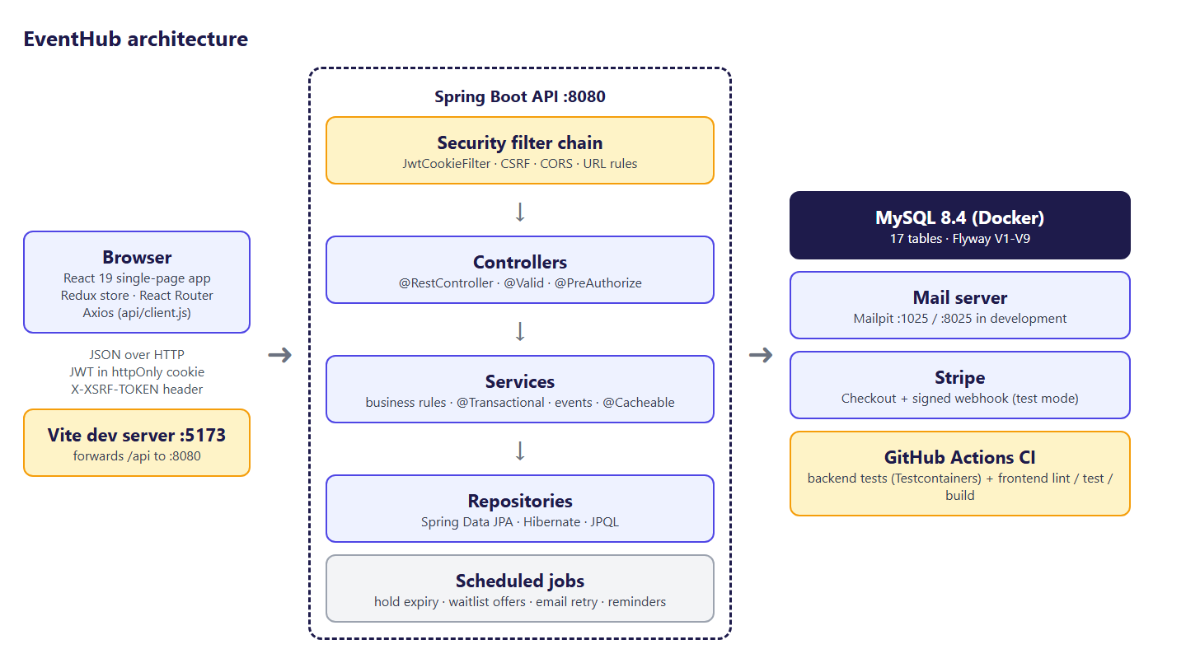
EventHub architecture: browser, Spring Boot layers, MySQL and outside services
Real-life example: A restaurant: the waiter (React) takes your order and brings the food, but never cooks. The kitchen (Spring Boot) cooks by the recipes (business rules) and checks your table number (security). The store room (MySQL) keeps the ingredients safe and counted.

4.2 Layers inside the backend
The backend itself has four layers. Each layer only talks to the layer directly below it.
Layer | Job | Example class
Security filters | Who is calling? Are they allowed to call this URL? | JwtCookieFilter, SecurityConfig
Controller | Receive the HTTP request, validate the input, return JSON | BookingController
Service | Apply the business rules inside a transaction | BookingService
Repository | Read and write the database | BookingRepository

Why layers? Each piece can be understood and tested on its own. A rule such as "seats cannot go below zero" lives in exactly one place (the service), no matter whether the request came from the website, Postman or a test.

4.3 The journey of one request
The diagram below follows one real request from the moment Ravi presses "Book now" until the checkout page appears.
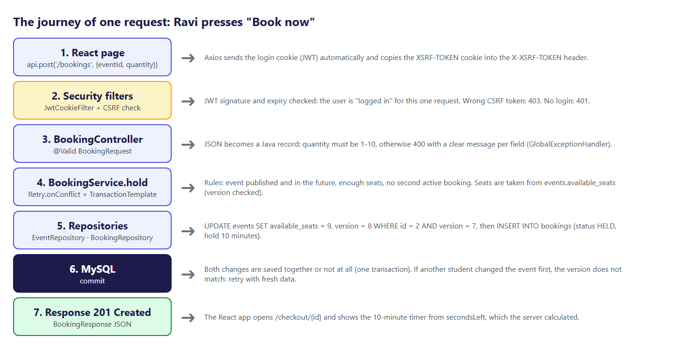
One request from the React page to MySQL and back
This is the controller method that receives it. Notice how small it is: the controller only translates HTTP into a service call.
BookingController.java (backend/src/main/java/com/eventhub/booking/BookingController.java)
/** Hold seats: 201 with the booking (HELD with a timer, or CONFIRMED for a free event). */
@PostMapping
public ResponseEntity<BookingResponse> hold(@AuthenticationPrincipal CurrentUser user,
@Valid @RequestBody BookingRequest request) {
BookingResponse booking = service.hold(user.id(), request.eventId(), request.quantity());
return ResponseEntity.created(URI.create("/api/bookings/" + booking.id())).body(booking);
}

4.4 Package structure (backend)
The backend code is organised by feature, not by technical type. Everything about bookings is in com.eventhub.booking: the entity, the repository, the service, the controller and the DTOs (data transfer objects, the shapes of the JSON).
Package | What it contains
analytics | Dashboard numbers (JPQL GROUP BY queries) and the 60-second cache
audit | The audit log: who did what to which event
auth | Registration, login, JWT, cookies, CSRF, club permissions, login lock, demo accounts
booking | Bookings, seat holds, confirmation, cancellation, expiry job, retry helper
certificate | Certificate numbers, PDF drawing, public verification
club | Clubs and club members (with their club role)
common | Shared exceptions and the global error handler; page responses
config | Security, CORS, cache and OpenAPI configuration
event | Events, search specifications, the status state machine, organizer and admin screens
feedback | Ratings and anonymous comments
gate | QR images, check-in and the live counter
health | /api/health
notification | In-app notifications, emails (after commit, with retry) and reminders
payment | The payment gateway interface, Stripe and the fake gateway, webhooks
tag | Event tags
user | Users, roles, profiles
waitlist | Waitlist entries and seat offers

4.5 Folder structure of the repository
eventhub/
├── backend/ Spring Boot application (Maven)
│ ├── pom.xml dependencies and build plugins (JaCoCo, surefire)
│ ├── mvnw, mvnw.cmd Maven wrapper: no Maven installation needed
│ └── src/
│ ├── main/java/com/eventhub/<feature>/ code, one package per feature
│ ├── main/resources/application.yml settings (dev and prod profiles)
│ ├── main/resources/db/migration/ Flyway SQL files V1..V9
│ └── test/java/com/eventhub/ 133 tests
├── frontend/ React application (Vite)
│ ├── package.json dependencies and scripts (dev, build, lint, test)
│ ├── vite.config.js dev server, /api proxy, test settings
│ └── src/
│ ├── api/ one file per backend area (axios calls)
│ ├── components/ reusable pieces: ui, layout, events, scanner ...
│ ├── pages/ one file per screen (+ organizer/, admin/)
│ ├── store/ Redux slices
│ ├── hooks/ useAsync, useForm, useCountdown, useTheme
│ └── utils/ formatting and validation helpers
├── docker-compose.yml MySQL 8.4 + Mailpit
├── .env.example template for your secrets (.env is never committed)
├── postman/ Postman collection (25 requests, 43 checks)
├── tools/ Edge demo tour scripts
├── docs/sketches/ the original page sketches
├── Showcase/ presentation, this guide, screenshots
└── .github/workflows/ci.yml GitHub Actions: tests on every push

4.6 Important design decisions
Decision | Why | Alternative considered
JWT in an httpOnly cookie (not localStorage) | JavaScript cannot read it, so an injected script cannot steal the login | Bearer token in localStorage (easier, but stealable)
Optimistic locking (@Version) for seats | No waiting locks, safe under heavy load, simple retry | Pessimistic SELECT ... FOR UPDATE (locks rows, slower)
One seat counter: events.available_seats | A single number is easy to keep correct; holds already take seats | Counting bookings on every request (slow, race-prone)
Server decides time (hold timers, secondsLeft) | A phone clock can be wrong or changed | Timer only in the browser
Payment behind an interface (PaymentGateway) | The same booking code works with Stripe and with the test page | Stripe calls inside BookingService
Emails sent after commit | Never email about a change that was rolled back | Sending inside the transaction
Club roles read from the database on every request | Removing an organizer works immediately | Club roles inside the JWT (valid until it expires)
Flyway migrations + ddl-auto: validate | Every database is identical; mistakes are caught at start-up | Hibernate creating tables itself
Package by feature | Everything for one feature is together | Package by layer (controllers/, services/ ...)

5. Setup and installation
This chapter takes you from an empty laptop to a running EventHub. The commands are for Windows (Command Prompt or Git Bash); on macOS or Linux use ./mvnw instead of mvnw and cp instead of copy.

5.1 What you need to install
Tool | Version | Why | Check with
Git | any recent | download the code | git --version
Java JDK | 25 (Temurin recommended) | run the backend | java -version
Node.js | 24 LTS | run the frontend | node -v
Docker Desktop | recent | MySQL and Mailpit in containers; also needed by the tests | docker --version
IntelliJ IDEA (optional) | Community or Ultimate | edit and run the backend | -
VS Code (optional) | any | edit the frontend | -
Postman (optional) | any | try the API by hand | -

Note: Maven does not need to be installed: the project contains the Maven wrapper (mvnw), which downloads the right Maven version the first time.

5.2 Step 1 - get the code
git clone https://github.com/madhavansuresh000-sys/eventhub.git
cd eventhub

5.3 Step 2 - create your .env file
Secrets (database passwords, the JWT key, the demo password, Stripe keys) are never stored in the code. They live in a file called .env in the project folder, which is listed in .gitignore so it can never be pushed to GitHub. A template is provided:
.env.example (.env.example, lines 1-18)
# Copy this file to .env and choose your own passwords.
# .env is in .gitignore, so your real passwords never go to GitHub.
MYSQL_USER=eventhub
MYSQL_PASSWORD=change-me
MYSQL_ROOT_PASSWORD=change-me-root

# Phase 5 (security)
# Key that signs login tokens. Make one with: python -c "import secrets; print(secrets.token_hex(32))"
JWT_SECRET=change-me-use-64-random-hex-characters
# Password for the demo accounts created in dev (leave empty to create none)
DEMO_PASSWORD=change-me

# Phase 6 (payments). Leave empty to use the built-in test payment page.
# Stripe dashboard (Test mode) -> Developers -> API keys -> Secret key (starts with sk_test_)
STRIPE_SECRET_KEY=
# From "stripe listen" (Stripe CLI) or Developers -> Webhooks; starts with whsec_
STRIPE_WEBHOOK_SECRET=

copy .env.example .env
Now open .env and replace every change-me with your own values:
1. MYSQL_PASSWORD and MYSQL_ROOT_PASSWORD - any passwords you like.
2. JWT_SECRET - at least 32 random characters. Generate one with python -c "import secrets; print(secrets.token_hex(32))".
3. DEMO_PASSWORD - the password of the five demo accounts (leave empty to create no demo accounts).
4. STRIPE_SECRET_KEY and STRIPE_WEBHOOK_SECRET - leave empty. EventHub then uses its built-in test payment page.

Real-life example: The .env file is like the key of your house: you make copies for your own family (your laptop), but you never pin it on the notice board (GitHub). The .env.example file is the empty key shape that shows everyone what kind of key is needed.

5.4 Step 3 - start MySQL and Mailpit
Start Docker Desktop and wait until it says "Engine running". Then:
docker compose up -d
docker compose ps
You should see two containers, eventhub-mysql (healthy) and eventhub-mailpit. The file that describes them:
docker-compose.yml (docker-compose.yml, lines 1-34)
# EventHub local services — start with: docker compose up -d
# Passwords come from the .env file (never pushed to GitHub). See .env.example.
services:
mysql:
image: mysql:8.4
container_name: eventhub-mysql
restart: unless-stopped
environment:
MYSQL_DATABASE: eventhub
MYSQL_USER: ${MYSQL_USER}
MYSQL_PASSWORD: ${MYSQL_PASSWORD}
MYSQL_ROOT_PASSWORD: ${MYSQL_ROOT_PASSWORD}
TZ: Asia/Kolkata
ports:
- "3306:3306"
volumes:
- mysql-data:/var/lib/mysql # keeps your data when the container stops
healthcheck:
test: ["CMD", "mysqladmin", "ping", "-h", "localhost", "-u", "root", "-p${MYSQL_ROOT_PASSWORD}"]
interval: 10s
timeout: 5s
retries: 10

mailpit:
image: axllent/mailpit:latest
container_name: eventhub-mailpit
restart: unless-stopped
ports:
- "1025:1025" # SMTP: Spring Boot sends emails here
- "8025:8025" # Web inbox: open http://localhost:8025

volumes:
mysql-data:

- MySQL listens on localhost:3306. Its data is kept in the Docker volume mysql-data, so it survives restarts.
- Mailpit shows every email EventHub sends at http://localhost:8025.

5.5 Step 4 - start the backend
Option A, IntelliJ: open the backend folder, wait until Maven has downloaded the dependencies, then run the class EventhubApplication (green triangle).
Option B, command line:
cd backend
mvnw spring-boot:run
What happens on start-up:
1. Spring Boot reads application.yml. The default profile is dev, which also imports ../.env.
2. Flyway creates or updates the tables (V1 to V9). The first run also inserts sample data (V2: 5 clubs, 10 tags, 20 events).
3. Hibernate checks that the Java entities match the tables (ddl-auto: validate).
4. DevDataSeeder creates the five demo accounts if they do not exist yet.
5. The server listens on port 8080.

Check it: open http://localhost:8080/api/health - it answers {"app":"eventhub","status":"UP"}.
The settings file, with a comment on every line:
application.yml (backend/src/main/resources/application.yml, lines 1-70)
# ---------- Common settings (all profiles) ----------
spring:
application:
name: eventhub
profiles:
default: dev # when no profile is chosen, use "dev"
jpa:
hibernate:
ddl-auto: validate # Flyway creates tables; Hibernate only checks them
open-in-view: false
flyway:
enabled: true
cache:
# Phase 7 step 7: dashboard numbers are kept in memory for 60 s (see analytics/AnalyticsService)
cache-names: analytics
caffeine:
spec: maximumSize=500,expireAfterWrite=60s

management:
endpoints:
web:
exposure:
include: health,info
endpoint:
health:
# everyone sees only "UP"/"DOWN"; the admin also sees database, mail and disk details
show-details: when-authorized
roles: ADMIN

springdoc:
swagger-ui:
path: /swagger-ui.html

# Websites allowed to call the API from a browser (CorsConfig). Comma-separated.
app:
cors:
allowed-origins: ${CORS_ALLOWED_ORIGINS:http://localhost:5173,http://localhost:4173}
jwt:
expiry: 8h # how long a login lasts
cookie:
secure: false # true in prod (cookie only over HTTPS)
login:
max-failures: 5 # wrong passwords before the account+address is locked for a while
lock-time: 15m
booking:
hold-time: 10m # how long seats are kept for a student who has not paid yet
expiry-check: 60s # how often the job frees expired holds
waitlist:
offer-time: 30m # how long freed seats are kept for the next student on the waitlist
expiry-check: 60s # how often the job passes unanswered offers to the next student
mail:
from: ${MAIL_FROM:EventHub <no-reply@eventhub.test>}
retry-every: 60s # emails that failed (mail server down) are tried again, up to 5 times
reminders:
cron: "0 0 18 * * *" # every day at 18:00: reminders for tomorrow's events
zone: Asia/Kolkata
scheduling:
enabled: true # the every-minute job (tests switch it off)
# where the React app runs: Stripe sends the student back here after paying
frontend-url: ${FRONTEND_URL:http://localhost:5173}
stripe:
# from .env; both empty = the built-in test payment page is used (dev only)
secret-key: ${STRIPE_SECRET_KEY:}
webhook-secret: ${STRIPE_WEBHOOK_SECRET:}

---
# ---------- dev: your laptop (MySQL + Mailpit in Docker) ----------
spring:
config:
activate:

5.6 Step 5 - start the frontend
cd frontend
npm install
npm run dev
Open http://localhost:5173. The footer shows "Backend: UP" when the React app can reach Spring Boot. Log in with one of the demo accounts from section 1.7.

5.7 Step 6 - run the tests
Docker Desktop must be running, because the backend tests start their own MySQL container.
cd backend
mvnw test
After about two minutes Maven prints Tests run: 133, Failures: 0, Errors: 0. The coverage report is written to backend/target/site/jacoco/index.html.
cd frontend
npm run lint
npm test
npm test prints Tests 13 passed.
Note: Stop the running backend before mvnw test on Windows: both use the backend/target folder, and Windows may lock files that are in use.

5.8 Step 7 - try the API with Postman
1. Open Postman → Import → choose postman/EventHub.postman_collection.json.
2. Start the backend.
3. Click the collection → Run. The 25 requests run in order and 43 checks turn green.

Or from the command line, without installing Postman:
npx -y newman@6 run postman/EventHub.postman_collection.json

5.9 Useful addresses (development)
Address | What
http://localhost:5173 | The React app
http://localhost:8080/api/health | Backend health check (public)
http://localhost:8080/swagger-ui.html | API documentation (admin only: log in as the admin in the React app first)
http://localhost:8080/actuator/health | Health with details for the admin
http://localhost:8025 | Mailpit inbox: every email EventHub sent
localhost:3306 | MySQL (database eventhub)

5.10 Stopping everything
Ctrl + C in the backend and frontend windows
docker compose down (stops the containers, keeps the data)
docker compose down -v (also deletes the database data - be careful)

5.11 The demo tour
tools/edge-tour.mjs opens a separate Microsoft Edge window and walks through the whole application in 28 steps, with a yellow explanation box at each step: visitor, booking and payment, QR ticket, certificates, gate scanning, public verification, organizer, admin approval, analytics and security. It also saves a screenshot of each step. Run it with the backend and frontend running:
node tools/edge-tour.mjs tour-shots
Every run creates one new event ("Kotlin for Beginners HH:MM") and one new booking for Ravi in the development database.

6. Database design

6.1 Overview
EventHub stores its data in 17 MySQL tables. They are never created or changed by hand: every change is a numbered SQL file (a migration) in backend/src/main/resources/db/migration, run automatically by Flyway when the backend starts.
Migration | Phase | What it adds
V1__create_core_tables.sql | 2 | roles, users, user_roles, profiles, clubs, club_members, events, tags, event_tags
V2__seed_sample_data.sql | 2 | 5 clubs, 10 tags, 20 sample events
V3__create_audit_log.sql | 5 | audit_log
V4__create_bookings_and_payments.sql | 6 | bookings, payments, processed_payment_events
V5__create_waitlist.sql | 7 | waitlist_entries
V6__create_notifications.sql | 7 | notifications, bookings.reminder_sent_at
V7__add_check_in.sql | 7 | bookings.checked_in_at / checked_in_by
V8__create_certificates.sql | 7 | certificates
V9__create_feedback.sql | 7 | feedback

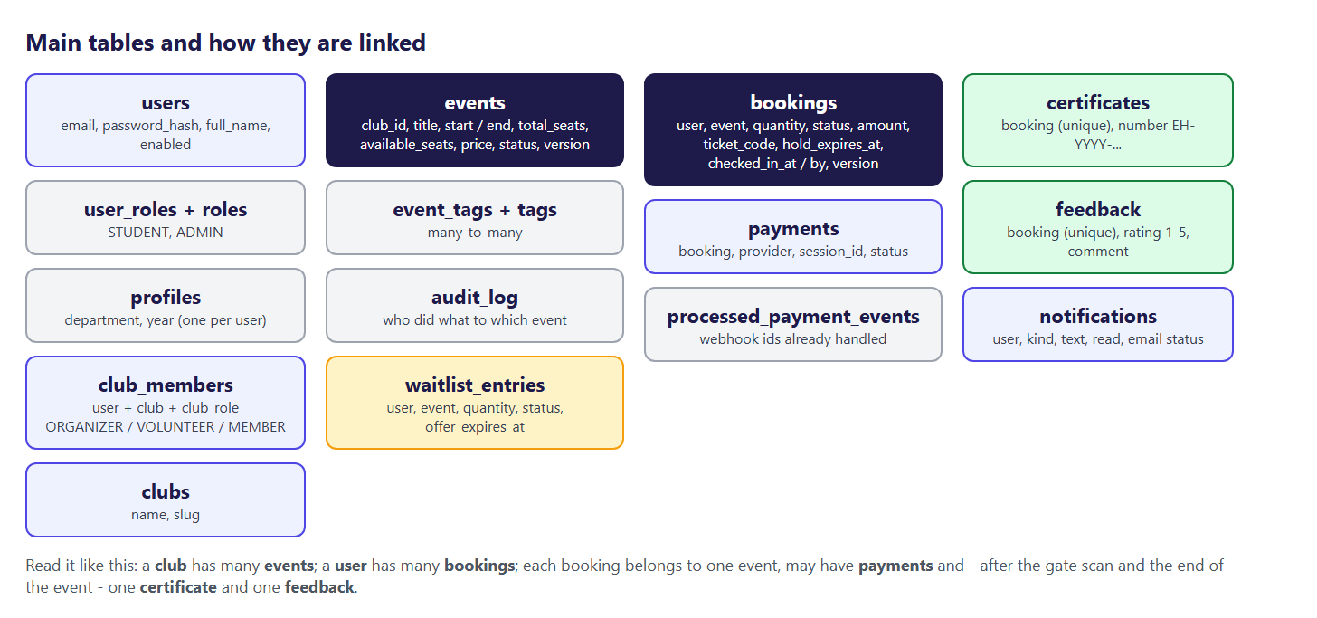
The main tables and how they are linked
Real-life example: A migration is like a numbered page in a building's renovation log: "1 - build the walls, 2 - add furniture, 3 - add a security camera". Any new building (a laptop, the test database, the server) follows the same pages in the same order and ends up identical.

6.2 Rules that protect the data
The database itself refuses wrong data, even if a bug in Java tried to save it:
- Primary keys (id BIGINT AUTO_INCREMENT) identify every row.
- Foreign keys link rows: a booking must point to an existing user and event.
- UNIQUE keys stop duplicates: one email per user, one ticket code per booking, one certificate and one rating per booking, one processed webhook message per id.
- CHECK constraints limit values: booking status must be HELD, CONFIRMED, CANCELLED or EXPIRED; quantity 1-10; rating 1-5.
- NOT NULL columns must always have a value.
- Indexes make the frequent searches fast, for example idx_bookings_hold (status, hold_expires_at) for the job that frees old holds.

Note: Status columns are VARCHAR + CHECK instead of MySQL ENUM. Adding a new status then only needs a new CHECK, and the values read naturally in Java (@Enumerated(EnumType.STRING)).

6.3 Optimistic locking columns
events.version and bookings.version are version numbers. Hibernate adds WHERE version = ? to every UPDATE and increases the number. If two transactions read the same row and both try to save, the second UPDATE finds no row with the old version and fails - so the second one must read again and retry. Chapter 7 shows the code.

6.4 Every table, column by column
The tables below are generated automatically from the migration files, so they always match the real database. The "Meaning / rule" column shows the comment written next to each column in the SQL file, plus the rules (required, unique, default).

Table roles (V1)
Column | Type | Meaning / rule
id | BIGINT | primary key
name | VARCHAR(30) | STUDENT, ADMIN - required, unique

Table users (V1)
Column | Type | Meaning / rule
id | BIGINT | primary key
full_name | VARCHAR(100) | required
email | VARCHAR(150) | required, unique
password_hash | VARCHAR(100) | required
enabled | BOOLEAN | required, default TRUE
created_at | DATETIME(6) | required, default CURRENT_TIMESTAMP(6)

Table user_roles (V1)
Column | Type | Meaning / rule
user_id | BIGINT | required
role_id | BIGINT | required
Links to other tables: user_id → users, role_id → roles.

Table profiles (V1)
Column | Type | Meaning / rule
id | BIGINT | primary key
user_id | BIGINT | required, unique
department | VARCHAR(100)
year_of_study | TINYINT
phone | VARCHAR(20)
bio | VARCHAR(500)
Links to other tables: user_id → users.

Table clubs (V1)
Column | Type | Meaning / rule
id | BIGINT | primary key
name | VARCHAR(100) | required, unique
slug | VARCHAR(100) | used in URLs: /clubs/coding-club - required, unique
description | VARCHAR(1000)
created_at | DATETIME(6) | required, default CURRENT_TIMESTAMP(6)

Table club_members (V1)
Column | Type | Meaning / rule
id | BIGINT | primary key
club_id | BIGINT | required
user_id | BIGINT | required
club_role | VARCHAR(20) | required
joined_at | DATETIME(6) | required, default CURRENT_TIMESTAMP(6)
Links to other tables: club_id → clubs, user_id → users.

Table events (V1)
Column | Type | Meaning / rule
id | BIGINT | primary key
club_id | BIGINT | required
created_by | BIGINT | organizer (NULL for seed data)
title | VARCHAR(150) | required
description | TEXT
venue | VARCHAR(150) | required
start_time | DATETIME(6) | required
end_time | DATETIME(6) | required
total_seats | INT | required
available_seats | INT | required
price | DECIMAL(10,2) | required, default 0.00
status | VARCHAR(20) | required, default 'DRAFT'
review_note | VARCHAR(500) | admin's reason when sending back to DRAFT
version | INT | optimistic locking (no overselling) - required, default 0
created_at | DATETIME(6) | required, default CURRENT_TIMESTAMP(6)
updated_at | DATETIME(6) | required, default CURRENT_TIMESTAMP(6)
Links to other tables: club_id → clubs, created_by → users.

Table tags (V1)
Column | Type | Meaning / rule
id | BIGINT | primary key
name | VARCHAR(50) | lower-case: tech, music, sports ... - required, unique

Table event_tags (V1)
Column | Type | Meaning / rule
event_id | BIGINT | required
tag_id | BIGINT | required
Links to other tables: event_id → events, tag_id → tags.

Table audit_log (V3)
Column | Type | Meaning / rule
id | BIGINT | primary key
user_id | BIGINT
user_name | VARCHAR(100)
user_email | VARCHAR(150)
action | VARCHAR(20) | required
event_id | BIGINT
event_title | VARCHAR(150) | required
details | VARCHAR(500)
created_at | DATETIME(6) | required, default CURRENT_TIMESTAMP(6)
Links to other tables: user_id → users, event_id → events.

Table bookings (V4)
Column | Type | Meaning / rule
id | BIGINT | primary key
user_id | BIGINT | required
event_id | BIGINT | required
quantity | INT | required
status | VARCHAR(20) | required
amount | DECIMAL(10,2) | price x quantity when booked (the price may change later) - required
ticket_code | VARCHAR(40) | goes into the QR code (Phase 7 gate scan) - required, unique
hold_expires_at | DATETIME(6) | only for HELD bookings
created_at | DATETIME(6) | required, default CURRENT_TIMESTAMP(6)
confirmed_at | DATETIME(6)
cancelled_at | DATETIME(6)
version | INT | optimistic locking (webhook vs expiry job) - required, default 0
reminder_sent_at | DATETIME(6) | (added in V6)
checked_in_at | DATETIME(6) | (added in V7)
checked_in_by | BIGINT | (added in V7)
Links to other tables: user_id → users, event_id → events.

Table payments (V4)
Column | Type | Meaning / rule
id | BIGINT | primary key
booking_id | BIGINT | required
provider | VARCHAR(20) | STRIPE, or FAKE (dev test page) - required
session_id | VARCHAR(255) | the payment provider's checkout session id - required, unique
status | VARCHAR(20) | required
amount | DECIMAL(10,2) | required
currency | VARCHAR(3) | required
created_at | DATETIME(6) | required, default CURRENT_TIMESTAMP(6)
paid_at | DATETIME(6)
refunded_at | DATETIME(6)
Links to other tables: booking_id → bookings.

Table processed_payment_events (V4)
Column | Type | Meaning / rule
event_id | VARCHAR(255) | primary key
received_at | DATETIME(6) | required, default CURRENT_TIMESTAMP(6)

Table waitlist_entries (V5)
Column | Type | Meaning / rule
id | BIGINT | primary key
user_id | BIGINT | required
event_id | BIGINT | required
quantity | INT | required
status | VARCHAR(20) | required
offer_expires_at | DATETIME(6) | only while OFFERED
booking_id | BIGINT | the booking made when the offer was accepted
created_at | DATETIME(6) | required, default CURRENT_TIMESTAMP(6)
offered_at | DATETIME(6)
closed_at | DATETIME(6) | when it became BOOKED / EXPIRED / LEFT
version | INT | optimistic locking (accept vs expiry job) - required, default 0
open_flag | TINYINT
Links to other tables: user_id → users, event_id → events, booking_id → bookings.

Table notifications (V6)
Column | Type | Meaning / rule
id | BIGINT | primary key
user_id | BIGINT | required
kind | VARCHAR(30) | required
title | VARCHAR(200) | required
body | VARCHAR(1000) | required
link | VARCHAR(300) | page in the React app, e.g. /waitlist
created_at | DATETIME(6) | required, default CURRENT_TIMESTAMP(6)
read_at | DATETIME(6) | NULL = unread (counts on the bell)
email_status | VARCHAR(10) | NONE (bell only), PENDING, SENT, FAILED - required
email_attempts | INT | required, default 0
emailed_at | DATETIME(6)
Links to other tables: user_id → users.

Table certificates (V8)
Column | Type | Meaning / rule
id | BIGINT | primary key
number | VARCHAR(30) | required, unique
booking_id | BIGINT | required, unique
user_id | BIGINT | required
event_id | BIGINT | required
holder_name | VARCHAR(100) | required
issued_at | DATETIME(6) | required, default CURRENT_TIMESTAMP(6)
Links to other tables: booking_id → bookings, user_id → users, event_id → events.

Table feedback (V9)
Column | Type | Meaning / rule
id | BIGINT | primary key
booking_id | BIGINT | required, unique
event_id | BIGINT | required
user_id | BIGINT | required
rating | TINYINT | required
comment | VARCHAR(1000)
created_at | DATETIME(6) | required, default CURRENT_TIMESTAMP(6)
updated_at | DATETIME(6)
Links to other tables: booking_id → bookings, event_id → events, user_id → users.

6.5 Useful SQL queries (with examples)
You can run these in MySQL Workbench, IntelliJ's database tool, or docker exec -it eventhub-mysql mysql -u eventhub -p eventhub.
Which events are almost full?
SELECT id, title, total_seats, available_seats,
ROUND(100 * (total_seats - available_seats) / total_seats) AS percent_full
FROM events
WHERE status = 'PUBLISHED' AND start_time > NOW()
ORDER BY percent_full DESC
LIMIT 5;
Ravi's tickets with the event name
SELECT b.id, e.title, b.quantity, b.status, b.ticket_code, b.checked_in_at
FROM bookings b
JOIN events e ON e.id = b.event_id
JOIN users u ON u.id = b.user_id
WHERE u.email = 'ravi@eventhub.test'
ORDER BY b.created_at DESC;
Check-in rate per event (the same idea as the analytics dashboard)
SELECT e.title,
SUM(b.quantity) AS sold,
SUM(CASE WHEN b.checked_in_at IS NOT NULL THEN b.quantity ELSE 0 END) AS came
FROM events e
JOIN bookings b ON b.event_id = e.id AND b.status = 'CONFIRMED'
GROUP BY e.id, e.title;
Who is on the waitlist of an event, in order
SELECT w.id, u.full_name, w.quantity, w.status, w.offer_expires_at
FROM waitlist_entries w
JOIN users u ON u.id = w.user_id
WHERE w.event_id = 16
ORDER BY w.id;
The audit trail of one event
SELECT created_at, action, user_email, event_title, details
FROM audit_log
WHERE event_id = 35
ORDER BY created_at;
Which Flyway migrations ran
SELECT version, description, installed_on, success FROM flyway_schema_history;

6.6 How Java classes map to tables (JPA)
An entity is a Java class that stands for one table; each field stands for one column. Here is the Event entity (shortened by the generator to its fields):
Event.java (backend/src/main/java/com/eventhub/event/Event.java)
/** A college event, e.g. "Tech Fest 2026". */
@Entity
@Table(name = "events")
@Getter
@Setter
@NoArgsConstructor
public class Event {

@Id
@GeneratedValue(strategy = GenerationType.IDENTITY)
private Long id;

/** Many events belong to one club. */
@ManyToOne(fetch = FetchType.LAZY, optional = false)
@JoinColumn(name = "club_id", nullable = false)
private Club club;

/** The organizer who created it (empty for sample data). */
@ManyToOne(fetch = FetchType.LAZY)
@JoinColumn(name = "created_by")
private User createdBy;

@Column(nullable = false, length = 150)
private String title;

@Column(columnDefinition = "TEXT")
private String description;

@Column(nullable = false, length = 150)
private String venue;

@Column(name = "start_time", nullable = false)
private LocalDateTime startTime;

@Column(name = "end_time", nullable = false)
private LocalDateTime endTime;

@Column(name = "total_seats", nullable = false)
private int totalSeats;

@Column(name = "available_seats", nullable = false)
private int availableSeats;

@Column(nullable = false, precision = 10, scale = 2)
private BigDecimal price = BigDecimal.ZERO;

@Enumerated(EnumType.STRING)
@Column(nullable = false, length = 20)
private EventStatus status = EventStatus.DRAFT;

/** The admin's reason when an event is sent back to DRAFT. */
@Column(name = "review_note", length = 500)
private String reviewNote;

/** Optimistic locking: stops two people saving over each other (and overselling). */
@Version
@Column(nullable = false)
private int version;

/** Many-to-Many: tags via the event_tags table (loaded 50 events at a time). */
@ManyToMany
@BatchSize(size = 50)
@JoinTable(name = "event_tags",
joinColumns = @JoinColumn(name = "event_id"),
inverseJoinColumns = @JoinColumn(name = "tag_id"))
private Set<Tag> tags = new HashSet<>();

@CreationTimestamp
@Column(name = "created_at", nullable = false, updatable = false)
private LocalDateTime createdAt;

@UpdateTimestamp
@Column(name = "updated_at", nullable = false)
private LocalDateTime updatedAt;

}
Points to notice:
- @ManyToOne(fetch = FetchType.LAZY) - an event belongs to one club, but the club is only loaded from the database when the code actually uses it. This avoids loading data nobody needs.
- @ManyToMany + @JoinTable(name = "event_tags") - the link table between events and tags.
- @Version - the optimistic-locking column described in 6.3.
- @Enumerated(EnumType.STRING) - the status is stored as text ('PUBLISHED'), not as a number.
- @BatchSize(size = 50) - when a page shows 12 events, their tags are loaded in one extra query instead of 12 (this avoids the "N+1 queries" problem).

6.7 Example: what the tables look like after one booking
Ravi books 1 ticket for the 24-Hour Hackathon (event 2, ₹150) and pays.
Table | Row after the booking
events | id 2 · available_seats 10 → 9 · version +1
bookings | new row · status HELD → CONFIRMED · amount 150.00 · ticket_code EVH-97Z38-F9Y5Q · hold_expires_at now+10 min · confirmed_at set
payments | new row · provider FAKE (or STRIPE) · session_id fake_cs_... · status PENDING → PAID
processed_payment_events | new row with the payment notice id (so the same notice is never processed twice)
notifications | new row "Booking confirmed" for Ravi · email PENDING → SENT

After Priya scans the ticket at the gate: bookings.checked_in_at and checked_in_by are filled. After the event, when Ravi opens his certificates page, a row is added to certificates with a random number like EH-2026-BEQR4Y79.

7. Backend code explained
This chapter walks through the backend module by module. For each one you get: what it does, the most important real code, an explanation line by line, a worked example, and what could go wrong without it.

7.1 The application entry point
Every Spring Boot application starts from one class with a main method:
EventhubApplication.java (backend/src/main/java/com/eventhub/EventhubApplication.java)
@SpringBootApplication
public class EventhubApplication {

public static void main(String[] args) {
SpringApplication.run(EventhubApplication.class, args);
}

}
@SpringBootApplication tells Spring to scan the package com.eventhub and everything below it, create a bean for every class marked @Service, @RestController, @Component, @Configuration or @Repository, and start the embedded web server.

7.2 Errors that make sense: GlobalExceptionHandler
When something goes wrong, the API always answers in the same shape: the standard Problem Details format (RFC 9457) with an extra errors map for field problems. The React app reads detail for the message and errors for the field messages.
Situation | Exception | HTTP status
A field is invalid (@Valid) | MethodArgumentNotValidException | 400 Bad Request + errors map
Wrong input such as end before start | BadRequestException | 400
Not logged in | (security) | 401 Unauthorized
Logged in but not allowed | AccessDeniedException | 403 Forbidden
The thing does not exist | ResourceNotFoundException | 404 Not Found
A business rule says no (sold out, not your turn) | BusinessRuleException | 409 Conflict
Two people changed the same row | ObjectOptimisticLockingFailureException | 409
Too many wrong passwords | TooManyLoginAttemptsException | 429 + Retry-After
Anything unexpected | Exception | 500 (details only in the server log)

GlobalExceptionHandler.java (backend/src/main/java/com/eventhub/common/GlobalExceptionHandler.java)
@ExceptionHandler(BusinessRuleException.class)
ProblemDetail handleBusinessRule(BusinessRuleException ex) {
return ProblemDetail.forStatusAndDetail(HttpStatus.CONFLICT, ex.getMessage());
}
Example answer when Ravi tries to book a sold-out event:
HTTP/1.1 409 Conflict
Content-Type: application/problem+json

{
"type": "about:blank",
"title": "Conflict",
"status": 409,
"detail": "Dance Night is sold out. You can join the waitlist.",
"instance": "/api/bookings"
}
Note: A 500 error never shows the internal message to the user (it could reveal table names or code). The real exception is written to the server log instead.

7.3 Events: search, rules and the approval workflow

The status state machine
The allowed moves are written once, in the enum itself. Every service method asks canMoveTo before changing the status, so an illegal move (for example DRAFT straight to PUBLISHED) is impossible.
EventStatus.java (backend/src/main/java/com/eventhub/event/EventStatus.java)
/**
* Approval workflow (a small "state machine"):
*
* <pre>
* DRAFT --submit--> PENDING_APPROVAL --approve--> PUBLISHED
* ^ |
* +------reject----------+ (with a reason)
* </pre>
*/
public enum EventStatus {

DRAFT, PENDING_APPROVAL, PUBLISHED;

/** The only moves allowed from this status. */
public Set<EventStatus> nextAllowed() {
return switch (this) {
case DRAFT -> Set.of(PENDING_APPROVAL);
case PENDING_APPROVAL -> Set.of(PUBLISHED, DRAFT);
case PUBLISHED -> Set.of();
};
}

public boolean canMoveTo(EventStatus target) {
return nextAllowed().contains(target);
}

}
Real-life example: Like a job application: "draft" → "submitted" → "accepted". You cannot jump from "draft" to "accepted", and once it is submitted you cannot secretly edit it; you can only get it back (rejected) and submit again.
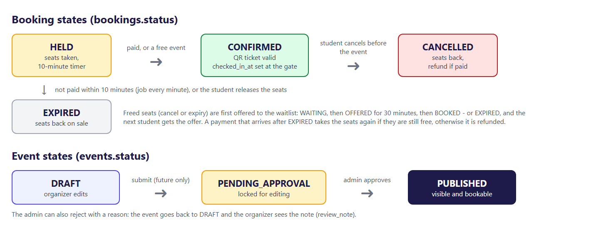
Event and booking states

Searching with Specifications
The search page can combine up to five filters (text, tag, club, from, to). Instead of writing 32 different queries, EventHub builds the WHERE clause from small pieces called Specifications and joins only the ones that were filled in:
EventSpecifications.java (backend/src/main/java/com/eventhub/event/EventSpecifications.java)
/** Builds the full search from the filter; blank options are skipped. */
public static Specification<Event> publishedMatching(EventFilter f) {
Specification<Event> spec = hasStatus(EventStatus.PUBLISHED);
if (hasText(f.q())) {
spec = spec.and(textContains(f.q().trim()));
}
if (hasText(f.tag())) {
spec = spec.and(hasTag(f.tag().trim().toLowerCase()));
}
if (hasText(f.club())) {
spec = spec.and(inClub(f.club().trim().toLowerCase()));
}
if (f.from() != null) {
spec = spec.and(startsOnOrAfter(f.from()));
}
if (f.to() != null) {
spec = spec.and(startsOnOrBefore(f.to()));
}
return spec;
}
Example: GET /api/events?q=robot&tag=robotics&page=0&size=9&sort=date becomes, roughly:
SELECT ... FROM events e
WHERE e.status = 'PUBLISHED'
AND (lower(e.title) LIKE '%robot%' OR lower(e.description) LIKE '%robot%')
AND EXISTS (SELECT 1 FROM event_tags et JOIN tags t ... WHERE t.name = 'robotics')
ORDER BY e.start_time ASC
LIMIT 9 OFFSET 0
Visitors only ever see PUBLISHED events: the status filter is always added by the server, whatever the browser sends.

Creating and updating an event
EventService.java (backend/src/main/java/com/eventhub/event/EventService.java)
/**
* Rules: an event under review cannot be edited, and seats cannot be
* reduced below the number already booked.
*/
@Transactional
public EventDetailResponse update(Long id, EventRequest request) {
Event event = findEvent(id);
checkTimes(request);

if (event.getStatus() == EventStatus.PENDING_APPROVAL) {
throw new BusinessRuleException("Event " + id + " is waiting for approval and cannot be edited");
}

int booked = event.getTotalSeats() - event.getAvailableSeats();
if (request.totalSeats() < booked) {
throw new BusinessRuleException(
"totalSeats cannot be less than the " + booked + " seats already booked");
}
event.setAvailableSeats(request.totalSeats() - booked);
applyRequest(event, request);
// more seats on a published event? the waitlist gets them first
waitlistOffers.offerFreeSeats(event, LocalDateTime.now());

audit.record(AuditAction.UPDATE, event, null);
return EventMapper.toDetail(event);
}
Line by line:
1. findEvent(id) loads the event or throws 404.
2. checkTimes refuses an end time before the start time (400).
3. An event waiting for approval cannot be changed (409) - the admin must see exactly what was submitted.
4. Seats cannot be reduced below the seats already sold. booked = totalSeats - availableSeats.
5. applyRequest copies the new values; availableSeats moves by the same amount as totalSeats.
6. If seats were added, waitlist.offerFreeSeats immediately offers them to the waitlist.
7. audit.record writes who changed it into the audit log, in the same transaction.

Submit, approve, reject
EventService.java (backend/src/main/java/com/eventhub/event/EventService.java)
/** Admin: PENDING_APPROVAL -> PUBLISHED. Students can now see it. */
@Transactional
public EventDetailResponse approve(Long id) {
Event event = findEvent(id);
moveTo(event, EventStatus.PUBLISHED, "approve");
event.setReviewNote(null);
audit.record(AuditAction.APPROVE, event, null);
publisher.publishEvent(new EventReviewed(event.getId(), true, null)); // tells the organizers
return EventMapper.toDetail(event);
}
EventService.java (backend/src/main/java/com/eventhub/event/EventService.java)
private void moveTo(Event event, EventStatus target, String action) {
EventStatus current = event.getStatus();
if (!current.canMoveTo(target)) {
throw new BusinessRuleException("Cannot " + action + " event " + event.getId()
+ ": it is " + current + " (allowed next: " + current.nextAllowed() + ")");
}
event.setStatus(target);
}
eventsPublisher.publishEvent(new EventReviewed(...)) announces the decision inside the application. The notification module listens and creates "Your event was approved" (or "sent back") for the organizer - the event module does not need to know how notifications work.

7.4 Security: login, JWT cookie, CSRF and permissions

Passwords
Passwords are hashed with BCrypt before they are saved. A hash cannot be turned back into the password; at login, BCrypt hashes the typed password again and compares. Each hash contains a random "salt", so two users with the same password still get different hashes.
AuthService.java (backend/src/main/java/com/eventhub/auth/AuthService.java)
/**
* New STUDENT account. The password is stored only as a BCrypt hash: a one-way "fingerprint"
* with a random salt, so even we cannot see the real password, and two users with the same
* password get different hashes.
*/
@Transactional
public User register(RegisterRequest request) {
String email = normalizeEmail(request.email());
if (users.existsByEmail(email)) {
throw new BusinessRuleException("An account with this email already exists. Try logging in.");
}
User user = new User();
user.setFullName(request.fullName().trim());
user.setEmail(email);
user.setPasswordHash(passwordEncoder.encode(request.password()));
user.getRoles().add(role(STUDENT));
users.save(user);

Profile profile = new Profile();
profile.setUser(user);
profile.setDepartment(blankToNull(request.department()));
profile.setYearOfStudy(request.yearOfStudy());
profiles.save(profile);
user.setProfile(profile);
return user;
}

The login token (JWT)
After a successful login the server creates a JSON Web Token: a small signed text with the user id, email, name and global roles, valid for 8 hours. It is signed with HMAC-SHA256 using JWT_SECRET, so nobody without the secret can create or change one.
JwtService.java (backend/src/main/java/com/eventhub/auth/JwtService.java)
/** A new token for this user, valid for app.jwt.expiry (8 hours). */
public String issue(User user) {
Instant now = Instant.now();
JwtClaimsSet claims = JwtClaimsSet.builder()
.issuer(ISSUER)
.issuedAt(now)
.expiresAt(now.plus(expiry))
.subject(String.valueOf(user.getId()))
.claim("email", user.getEmail())
.claim("name", user.getFullName())
.claim("roles", user.getRoles().stream().map(Role::getName).sorted().toList())
.build();
JwsHeader header = JwsHeader.with(MacAlgorithm.HS256).build();
return encoder.encode(JwtEncoderParameters.from(header, claims)).getTokenValue();
}
The token travels in a cookie named EVENTHUB_TOKEN with three important flags: HttpOnly (JavaScript cannot read it), SameSite=Lax (other websites cannot make the browser send it with a form POST) and Secure in production (only over HTTPS).
On every request the JwtCookieFilter reads the cookie and, if the signature and expiry are fine, tells Spring Security who the user is:
JwtCookieFilter.java (backend/src/main/java/com/eventhub/auth/JwtCookieFilter.java)
@Override
protected void doFilterInternal(HttpServletRequest request, HttpServletResponse response, FilterChain chain)
throws ServletException, IOException {
Cookie cookie = WebUtils.getCookie(request, AuthCookies.NAME);
if (cookie != null && !cookie.getValue().isBlank()) {
jwtService.read(cookie.getValue()).ifPresent(jwt -> {
CurrentUser user = new CurrentUser(Long.valueOf(jwt.getSubject()),
jwt.getClaimAsString("email"), jwt.getClaimAsString("name"));
List<SimpleGrantedAuthority> authorities = JwtService.roles(jwt).stream()
.map(role -> new SimpleGrantedAuthority("ROLE_" + role))
.toList();
SecurityContext context = SecurityContextHolder.createEmptyContext();
context.setAuthentication(UsernamePasswordAuthenticationToken.authenticated(user, null, authorities));
SecurityContextHolder.setContext(context);
});
}
chain.doFilter(request, response);
}
Real-life example: The JWT is like a college ID card with a hologram. The gatekeeper does not phone the office for every student; he checks the hologram (signature) and the expiry date. A card with a changed name has a broken hologram and is refused.

The security rules
SecurityConfig.java (backend/src/main/java/com/eventhub/config/SecurityConfig.java)
@Bean
SecurityFilterChain securityFilterChain(HttpSecurity http, JwtService jwtService) throws Exception {
http
// no server-side session: every request carries its own JWT cookie
.sessionManagement(s -> s.sessionCreationPolicy(SessionCreationPolicy.STATELESS))
// CSRF for a single-page app: the server sets an XSRF-TOKEN cookie that JavaScript CAN read;
// Axios copies it into the X-XSRF-TOKEN header. Another website cannot read our cookie,
// so it cannot send a valid header, and its forged POST gets 403.
// sessionAuthenticationStrategy: Spring normally makes a NEW CSRF token whenever someone "logs in".
// Without server sessions it thinks every request with our JWT cookie is a new login, so the token
// changed on every request and a second request sent at the same moment could fail. Keep one token.
.csrf(csrf -> csrf.spa().sessionAuthenticationStrategy((authentication, request, response) -> { })
// Stripe's server has no CSRF cookie; the Stripe-Signature header proves the message instead
.ignoringRequestMatchers("/api/payments/stripe/webhook"))
.addFilterAfter(new CsrfCookieFilter(), CsrfFilter.class)
// use the rules from CorsConfig (browser calls from other addresses)
.cors(Customizer.withDefaults())
.addFilterBefore(new JwtCookieFilter(jwtService), UsernamePasswordAuthenticationFilter.class)
.authorizeHttpRequests(auth -> auth
// health checks for the hosting platform (Phase 9): only "UP" / "DOWN", no details
.requestMatchers("/api/health", "/actuator/health").permitAll()
// Phase 8 step 4: the API map (Swagger) and the other Actuator pages tell an attacker a lot
// (every URL, versions, settings), so only the admin may open them. The admin's login cookie
// also works on :8080 (cookies are per host name, not per port): log in on the React app first.
.requestMatchers("/swagger-ui.html", "/swagger-ui/**", "/v3/api-docs/**", "/actuator/**").hasRole("ADMIN")
.requestMatchers("/api/auth/register", "/api/auth/login", "/api/auth/logout", "/api/auth/me").permitAll()
.requestMatchers(HttpMethod.POST, "/api/payments/stripe/webhook").permitAll() // checked by its signature
// public catalogue: anyone can browse events, clubs and tags
.requestMatchers(HttpMethod.GET, "/api/events/**", "/api/clubs/**", "/api/tags").permitAll()
// anyone (a company checking a resume) can verify a certificate number
.requestMatchers(HttpMethod.GET, "/api/certificates/verify/*").permitAll()
// admin work
.requestMatchers("/api/admin/**").hasRole("ADMIN")
.requestMatchers(HttpMethod.POST, "/api/events/*/approve", "/api/events/*/reject").hasRole("ADMIN")
// everything else (create / edit / submit events, organizer screens ...) needs login;
// the controllers then check "organizer of THIS club" with @PreAuthorize
.anyRequest().authenticated())
.exceptionHandling(ex -> ex
.authenticationEntryPoint(SecurityProblems.notLoggedIn())
.accessDeniedHandler(SecurityProblems.forbidden()));
return http.build();
}
- STATELESS: the server keeps no session; every request carries its own proof (the cookie).
- CSRF: the server sets a cookie XSRF-TOKEN that JavaScript can read. Axios copies it into the header X-XSRF-TOKEN. Another website cannot read our cookie, so its forged POST has no valid header and gets 403.
- URL rules: public catalogue and login pages; /api/admin/**, Swagger and Actuator for ADMIN only; everything else needs login.

Club-level permissions
Global roles (STUDENT, ADMIN) are in the token. Club roles (ORGANIZER, VOLUNTEER of a club) are read from the database on every check, so removing an organizer takes effect immediately.
ClubAccess.java (backend/src/main/java/com/eventhub/auth/ClubAccess.java)
/** May the logged-in user edit / submit this event? Only organizers of the event's own club. */
@Transactional(readOnly = true)
public boolean canManageEvent(Long eventId) {
return events.findClubIdById(eventId).map(this::isOrganizer).orElse(false);
}
Used on controller methods like this: @PreAuthorize("@clubAccess.canManageEvent(#id)"). Example: Kavya (Cultural Club organizer) may edit Dance Night (event 6, Cultural Club). If she calls PUT /api/events/5 (Spring Boot Bootcamp, a Coding Club event), the answer is 403 Forbidden.

Stopping password guessing
LoginAttemptService.java (backend/src/main/java/com/eventhub/auth/LoginAttemptService.java)
/** Wrong password: count it; the 5th one locks. */
public void failed(String email, String address) {
if (attempts.size() > CLEANUP_ABOVE) {
removeOld();
}
attempts.compute(key(email, address), (k, a) -> {
int failures = (a == null ? 0 : a.failures()) + 1;
return failures >= maxFailures
? new Attempts(0, clock.instant().plus(lockTime))
: new Attempts(failures, null);
});
}
After the 5th wrong password for the same email from the same address, login is locked for 15 minutes (HTTP 429 with a Retry-After header), even with the right password. Locking by email alone would let anybody lock your account on purpose; locking by address alone would block a whole college Wi-Fi.

7.5 Bookings: holding seats without ever overselling

The problem
Imagine one seat left and two students pressing "Book" at the same moment. Both requests read "1 seat left". Both subtract one and save "0 seats left". Two bookings, one seat. This is called a race condition or lost update.

The solution: optimistic locking + retry
The Event entity has a @Version field. When Hibernate saves the event it runs:
UPDATE events SET available_seats = 0, version = 8 WHERE id = 2 AND version = 7
The first request changes one row. The second finds no row with version 7 (it is now 8), changes nothing, and Hibernate throws an optimistic-locking exception. The Retry helper catches it and runs the whole booking again in a new transaction, which reads the fresh value "0 seats left" and answers "sold out".
Retry.java (backend/src/main/java/com/eventhub/booking/Retry.java)
public static <T> T onConflict(Supplier<T> work) {
for (int attempt = 1; ; attempt++) {
try {
return work.get();
}
catch (OptimisticLockingFailureException | PessimisticLockingFailureException
| jakarta.persistence.OptimisticLockException ex) {
// Pessimistic... = MySQL found a deadlock and cancelled one of the two: also safe to retry
if (attempt == MAX_ATTEMPTS) {
throw new BusinessRuleException("Too many people are booking right now. Please try again.");
}
sleep(ThreadLocalRandom.current().nextLong(5, 10 + attempt * 10L));
}
}
}
BookingService.java (backend/src/main/java/com/eventhub/booking/BookingService.java)
private Long holdOnce(Long userId, Long eventId, int quantity) {
if (quantity < 1 || quantity > MAX_PER_BOOKING) {
throw new BusinessRuleException("You can book 1 to " + MAX_PER_BOOKING + " seats at a time.");
}
LocalDateTime now = LocalDateTime.now();
Event event = events.findById(eventId)
.filter(e -> e.getStatus() == EventStatus.PUBLISHED) // drafts are invisible to students
.orElseThrow(() -> new ResourceNotFoundException("Event", eventId));
if (!event.getStartTime().isAfter(now)) {
throw new BusinessRuleException(event.getTitle() + " has already started.");
}
if (bookings.existsByUserIdAndEventIdAndStatusIn(userId, eventId, ACTIVE)) {
throw new BusinessRuleException("You already have seats for " + event.getTitle() + ". See My tickets.");
}
WaitlistEntry myPlace = waitlist
.findFirstByUserIdAndEventIdAndStatusIn(userId, eventId, List.of(WaitlistStatus.WAITING, WaitlistStatus.OFFERED))
.orElse(null);
if (myPlace != null && myPlace.getStatus() == WaitlistStatus.OFFERED) {
throw new BusinessRuleException("Seats of " + event.getTitle() + " are kept for you. Accept the offer on the Waitlist page.");
}
if (event.getAvailableSeats() < quantity) {
throw new BusinessRuleException(event.getAvailableSeats() == 0
? event.getTitle() + " is sold out. You can join the waitlist."
: "Only " + event.getAvailableSeats() + " seats are left for " + event.getTitle() + ".");
}

// 1) take the seats FIRST: "UPDATE events ... WHERE id = ? AND version = ?".
// If someone else changed the event since we read it, 0 rows match -> exception -> Retry.
// (Doing this before inserting the booking also avoids a MySQL deadlock.)
event.setAvailableSeats(event.getAvailableSeats() - quantity);
events.saveAndFlush(event);

// 2) then write the booking
Booking booking = saveNew(userId, event, quantity, now);
if (myPlace != null) {
// booked directly while waiting: the waitlist place is no longer needed
myPlace.setBooking(booking);
myPlace.close(WaitlistStatus.BOOKED, now);
}
return booking.getId();
}
Details worth noticing:
- transactions.execute(...) (TransactionTemplate) gives each attempt its own transaction.
- events.saveAndFlush(event) writes the seat change before inserting the booking. Always touching the event row first gives every booking the same lock order, which prevents a MySQL deadlock that appeared during testing.
- Free events are confirmed immediately; paid ones stay HELD for 10 minutes (app.booking.hold-time).

Real-life example: Optimistic locking is like editing a shared Google Sheet cell that shows "last edited version 7". If someone else saved first, your save is refused with "this changed - please reload", instead of silently overwriting their work.

Proof: the concurrency test
BookingConcurrencyTest starts 100 threads that all try to book one seat of an event with 10 seats, at the same moment, three times in a row. The test checks that exactly 10 bookings succeed and the event shows 0 seats left. When @Version was removed as an experiment, the same test sold 96 to 99 tickets.

Freeing unpaid holds
BookingService.java (backend/src/main/java/com/eventhub/booking/BookingService.java)
/**
* Step 4: called every minute by HoldExpiryJob. Each booking is expired in its own small
* transaction, so one problem does not stop the others. Returns how many were expired.
*/
public int expireOldHolds() {
int expired = 0;
for (Long id : bookings.findExpiredHoldIds(LocalDateTime.now())) {
List<String> toClose = new ArrayList<>();
Boolean done = Retry.onConflict(() -> tx.execute(status -> {
toClose.clear();
Booking booking = bookings.findById(id).orElse(null);
LocalDateTime now = LocalDateTime.now();
// re-check: the student may have paid a moment ago
if (booking == null || booking.getStatus() != BookingStatus.HELD || booking.getHoldExpiresAt().isAfter(now)) {
return false;
}
release(booking, BookingStatus.EXPIRED, now, toClose, new ArrayList<>());
return true;
}));
toClose.forEach(gateway::expireSession);
if (Boolean.TRUE.equals(done)) {
expired++;
}
}
if (expired > 0) {
log.info("Expired {} unpaid seat holds; their seats are free again", expired);
}
return expired;
}
HoldExpiryJob calls this method every 60 seconds (@Scheduled). Each expired hold is handled in its own transaction, so one failure does not stop the others; the freed seats are offered to the waitlist.

Cancelling
BookingService.java (backend/src/main/java/com/eventhub/booking/BookingService.java)
/** Step 9: the student cancels. Seats go back; a paid booking gets its money back. */
public BookingResponse cancel(Long userId, Long bookingId) {
List<String> toClose = new ArrayList<>();
List<String> toRefund = new ArrayList<>();
Retry.onConflict(() -> tx.execute(status -> {
toClose.clear();
toRefund.clear();
Booking booking = own(userId, bookingId);
LocalDateTime now = LocalDateTime.now();
if (!booking.getStatus().holdsSeats()) {
throw new BusinessRuleException("This booking is already " + booking.getStatus().name().toLowerCase() + ".");
}
if (booking.getCheckedInAt() != null) {
throw new BusinessRuleException("This ticket was already used at the gate, so it cannot be cancelled.");
}
if (booking.getStatus() == BookingStatus.CONFIRMED && !booking.getEvent().getStartTime().isAfter(now)) {
throw new BusinessRuleException("The event has already started, so this booking cannot be cancelled.");
}
release(booking, BookingStatus.CANCELLED, now, toClose, toRefund);
booking.setCancelledAt(now);
return null;
}));
toClose.forEach(gateway::expireSession);
toRefund.forEach(gateway::refund);
return get(userId, bookingId);
}
A ticket that was already scanned at the gate cannot be cancelled (otherwise someone could enter and then ask for a refund).

7.6 Payments: one interface, two gateways
The booking code never talks to Stripe directly. It talks to an interface:
PaymentGateway.java (backend/src/main/java/com/eventhub/payment/PaymentGateway.java)
/**
* The outside payment company, behind one small interface (like a plug socket):
* StripePaymentGateway - real Stripe Checkout in test mode (when STRIPE_SECRET_KEY is in .env)
* FakePaymentGateway - a built-in test page for development (no keys needed)
* The booking code only talks to this interface, so it works the same with both.
*/
public interface PaymentGateway {

PaymentProvider provider();

/** Starts a checkout for a HELD booking. The student is sent to redirectUrl to pay. */
CheckoutSession createCheckout(Booking booking);

/** Has the student paid for this session? (asked when they come back, in case the webhook is late) */
boolean isPaid(String sessionId);

/** The hold ran out or was cancelled: close the payment page so nobody can pay any more. Best effort. */
void expireSession(String sessionId);

/** Gives the money back (cancelled booking, or a payment that arrived after the seat was gone). */
void refund(String sessionId);

record CheckoutSession(String sessionId, String redirectUrl) {
}

}
PaymentConfig chooses the implementation when the application starts: StripePaymentGateway if STRIPE_SECRET_KEY is set, otherwise FakePaymentGateway, which sends the student to EventHub's own test page. In production the fake gateway is refused.
Real-life example: A phone charger with a standard plug: the phone (booking code) works with any charger (Stripe, test page) that fits the socket (interface).

The Stripe webhook (and why it must be idempotent)
After a student pays on Stripe's page, Stripe's server calls EventHub (POST /api/payments/stripe/webhook). This endpoint has no login, so the message is proven by its signature:
PaymentController.java (backend/src/main/java/com/eventhub/payment/PaymentController.java)
/**
* Step 7: Stripe tells us a checkout was paid. Anyone on the internet can call this URL, so we
* FIRST check the Stripe-Signature header: an HMAC made with the webhook secret that only
* Stripe and we know. Wrong signature -> 400, and nothing is changed.
* We answer 200 quickly for every genuine message (also duplicates), otherwise Stripe sends it again.
*/
@PostMapping("/stripe/webhook")
public ResponseEntity<String> stripeWebhook(@RequestBody String payload,
@RequestHeader(name = "Stripe-Signature", required = false) String signature) {
if (webhookSecret.isBlank()) {
return ResponseEntity.status(HttpStatus.SERVICE_UNAVAILABLE).body("Stripe webhook secret is not configured");
}
com.stripe.model.Event event;
try {
event = Webhook.constructEvent(payload, signature, webhookSecret);
}
catch (SignatureVerificationException | RuntimeException ex) {
log.warn("Rejected a webhook with a bad signature");
return ResponseEntity.badRequest().body("Invalid signature");
}

String type = event.getType();
if ("checkout.session.completed".equals(type) || "checkout.session.async_payment_succeeded".equals(type)) {
Session session = (Session) dataObject(event);
if ("paid".equals(session.getPaymentStatus())) {
BookingService.PaidResult result = bookings.markPaid(event.getId(), session.getId());
log.info("Stripe {} for session {}: {}", type, session.getId(), result);
}
}
return ResponseEntity.ok("received");
}
Stripe may send the same message more than once. markPaid first inserts the message id into processed_payment_events (primary key). A second insert of the same id fails with a duplicate key, and the message is ignored: the same notice never confirms twice (this is called idempotency).
BookingService.java (backend/src/main/java/com/eventhub/booking/BookingService.java)
private PaidResult markPaidOnce(String noticeId, String sessionId, List<String> toRefund) {
processedEvents.insert(noticeId); // throws DataIntegrityViolationException for a duplicate

Payment payment = payments.findBySessionId(sessionId).orElse(null);
if (payment == null) {
log.warn("Payment notice {} for unknown session {}", noticeId, sessionId);
return PaidResult.UNKNOWN_SESSION;
}
if (payment.getStatus() == PaymentStatus.PAID || payment.getStatus() == PaymentStatus.REFUNDED) {
return PaidResult.ALREADY_DONE;
}
LocalDateTime now = LocalDateTime.now();
payment.setStatus(PaymentStatus.PAID);
payment.setPaidAt(now);

Booking booking = payment.getBooking();
switch (booking.getStatus()) {
case HELD -> {
confirm(booking, now);
return PaidResult.CONFIRMED;
}
case EXPIRED -> {
// paid just after the 10 minutes ran out: give the seats again if they are still free
Event event = booking.getEvent();
if (event.getAvailableSeats() >= booking.getQuantity() && event.getStartTime().isAfter(now)) {
event.setAvailableSeats(event.getAvailableSeats() - booking.getQuantity());
events.saveAndFlush(event);
confirm(booking, now);
return PaidResult.CONFIRMED;
}
return refundLater(payment, now, toRefund);
}
default -> {
// CANCELLED, or CONFIRMED already by another payment: never keep money twice
return refundLater(payment, now, toRefund);
}
}
}
Late payments: if the money arrives after the 10-minute hold expired, the code tries to take the seats again; if they are gone, the payment is refunded automatically.

Verify on return
If the webhook is slow (or the Stripe CLI is not running on a laptop), the success page calls POST /api/payments/{session}/verify, which asks Stripe directly "is this session paid?" and runs the same markPaid code.

7.7 The smart waitlist
When an event is sold out, students can join its waitlist. When seats become free (a cancellation, an expired hold, or the organizer adds seats), they are offered to the first students in the queue and kept for them for 30 minutes.
WaitlistOffers.java (backend/src/main/java/com/eventhub/waitlist/WaitlistOffers.java)
/** Offers the event's free seats to waiting students. Returns how many offers were made. */
public int offerFreeSeats(Event event, LocalDateTime now) {
if (event.getStatus() != EventStatus.PUBLISHED || !event.getStartTime().isAfter(now)
|| event.getAvailableSeats() == 0) {
return 0;
}
int offers = 0;
for (WaitlistEntry entry : entries.findByEventIdAndStatusOrderByIdAsc(event.getId(), WaitlistStatus.WAITING)) {
if (event.getAvailableSeats() == 0) {
break;
}
if (entry.getQuantity() > event.getAvailableSeats()) {
continue; // does not fit yet; keeps its place
}
event.setAvailableSeats(event.getAvailableSeats() - entry.getQuantity()); // kept for this student
entry.setStatus(WaitlistStatus.OFFERED);
entry.setOfferedAt(now);
entry.setOfferExpiresAt(now.plus(offerTime));
// sent to listeners (email, bell) only AFTER the transaction commits - see notification package
publisher.publishEvent(new SeatOffered(entry.getId()));
offers++;
}
if (offers > 0) {
events.saveAndFlush(event); // optimistic lock: a clash with another booking -> the caller retries
log.info("Offered free seats of event {} to {} waiting student(s)", event.getId(), offers);
}
return offers;
}
Rules visible in the code:
- The queue is served in order of joining (id ascending).
- A group that does not fit (Ravi wants 3, only 2 are free) keeps its place; smaller requests behind it may be served meanwhile.
- offerFreeSeats runs inside the same transaction that freed the seats, so seats are never free and un-offered at the same time.
- It publishes SeatOffered, which triggers the email and the bell notification.

WaitlistOfferJob runs every 60 seconds: offers older than 30 minutes expire and the seats move to the next student.

7.8 Notifications: bell, email and reminders
The notification module listens to events from other modules (SeatOffered, BookingConfirmed, EventReviewed):
NotificationTriggers.java (backend/src/main/java/com/eventhub/notification/NotificationTriggers.java)
/** Done-when check of Phase 7: a cancel frees a seat -> the first waitlisted student is emailed. */
@EventListener
public void seatOffered(SeatOffered offered) {
WaitlistEntry entry = waitlist.findById(offered.entryId()).orElseThrow();
Event event = entry.getEvent();
String seats = entry.getQuantity() == 1 ? "1 seat" : entry.getQuantity() + " seats";
String them = entry.getQuantity() == 1 ? "it" : "them";
notifications.create(entry.getUser().getId(), NotificationKind.SEAT_OFFERED,
"Seats free for " + event.getTitle() + " - kept for you",
"Good news! " + seats + " for " + event.getTitle() + " (" + WHEN.format(event.getStartTime())
+ ") came free and we are keeping " + them + " for you until " + TIME.format(entry.getOfferExpiresAt())
+ ". Accept " + them + " on your Waitlist page before then, or " + (entry.getQuantity() == 1 ? "it goes" : "they go")
+ " to the next student.",
"/waitlist", true);
}
The email is sent after the transaction commits:
EmailSender.java (backend/src/main/java/com/eventhub/notification/EmailSender.java)
@TransactionalEventListener(phase = TransactionPhase.AFTER_COMMIT)
public void afterCommit(EmailQueued queued) {
send(queued.notificationId());
}
Why after commit? If the email were sent inside the transaction and the transaction then rolled back (for example because of a conflict), the student would get "A seat is waiting for you" for a seat that does not exist. This pattern - save the message with the change, deliver it after the commit - is a simple form of the outbox pattern.
If the mail server is down, the notification stays PENDING and NotificationJobs.emailRetry tries again every minute, at most 5 times (then FAILED). The bell in the app shows the notification anyway.
Reminders: every day at 18:00 (India time) ReminderService.remindForDayAfter sends "See you tomorrow" to everyone with a confirmed ticket for tomorrow's events, once per booking (reminder_sent_at).

7.9 The gate: QR codes and check-in

Drawing the QR code
QrCodeService.java (backend/src/main/java/com/eventhub/gate/QrCodeService.java)
public byte[] png(String text, int size) {
try {
// M = about 15% of the squares may be dirty or scratched and it still reads; margin 2 = white border
BitMatrix matrix = new QRCodeWriter().encode(text, BarcodeFormat.QR_CODE, size, size,
Map.of(EncodeHintType.ERROR_CORRECTION, ErrorCorrectionLevel.M, EncodeHintType.MARGIN, 2));
ByteArrayOutputStream out = new ByteArrayOutputStream();
MatrixToImageWriter.writeToStream(matrix, "PNG", out);
return out.toByteArray();
}
catch (WriterException ex) {
throw new IllegalArgumentException("Cannot make a QR code of: " + text, ex);
}
catch (IOException ex) {
throw new UncheckedIOException(ex);
}
}
The QR code contains only the random ticket code (for example EVH-97Z38-F9Y5Q), not the name or the event - nothing private is printed on the ticket.

One scan, one entry
The heart of the gate is one SQL statement that checks and marks in a single step:
BookingRepository.java (backend/src/main/java/com/eventhub/booking/BookingRepository.java, lines 40-48)
/**
* Marks the ticket as used - ONLY if it is not used yet. Returns 1 (you let them in) or 0 (someone
* else scanned it a moment earlier). The database does the "check and set" in one step, so two
* volunteers can never both get VALID. The version goes up too, like any other change of the booking.
*/
@Modifying(flushAutomatically = true, clearAutomatically = true)
@Query("update Booking b set b.checkedInAt = :now, b.checkedInBy = :scanner, b.version = b.version + 1"
+ " where b.id = :id and b.checkedInAt is null and b.status = com.eventhub.booking.BookingStatus.CONFIRMED")
int markCheckedIn(@Param("id") Long id, @Param("now") LocalDateTime now, @Param("scanner") User scanner);
CheckInService.java (backend/src/main/java/com/eventhub/gate/CheckInService.java)
@Transactional
public CheckInResponse checkIn(Long eventId, String rawCode, Long scannerId) {
Event event = events.findById(eventId).orElseThrow(() -> new ResourceNotFoundException("Event", eventId));
String code = rawCode.trim().toUpperCase(Locale.ROOT);
LocalDateTime now = LocalDateTime.now();

Booking booking = bookings.findByTicketCode(code).orElse(null);
if (booking == null) {
return invalid(event, code, "This code is not an EventHub ticket. Ask for the QR code in the app.");
}
if (!booking.getEvent().getId().equals(eventId)) {
return invalid(event, code, "This ticket is for " + booking.getEvent().getTitle() + ", not " + event.getTitle() + ".");
}
String holder = booking.getUser().getFullName();
if (booking.getStatus() != BookingStatus.CONFIRMED) {
String why = switch (booking.getStatus()) {
case CANCELLED -> "This booking was cancelled.";
case HELD -> "This booking is not paid yet.";
default -> "This booking was never paid (" + booking.getStatus().name().toLowerCase() + ").";
};
return invalid(event, code, why);
}
if (!event.getEndTime().isAfter(now)) {
return invalid(event, code, event.getTitle() + " is already over.");
}
if (booking.getCheckedInAt() != null) {
return alreadyUsed(event, code, holder, booking);
}

// the one important line: "mark used, but only if not used yet" - done by the database in one step
int updated = bookings.markCheckedIn(booking.getId(), now, users.getReferenceById(scannerId));
if (updated == 0) {
// Another gate scanned it a split second ago. We cannot simply read the booking again to see when:
// MySQL (REPEATABLE READ) keeps showing this transaction the snapshot from its first read,
// where the ticket was still unused.
return new CheckInResponse(CheckInResult.ALREADY_USED, "Already used just now at another gate.", code, holder,
booking.getQuantity(), null, stats(eventId));
}
int people = booking.getQuantity();
return new CheckInResponse(CheckInResult.VALID, "Let in " + people + (people == 1 ? " person" : " people") + ".",
code, holder, people, now, stats(eventId));
}
How to read the result:
- markCheckedIn returns 1 (one row changed): this scan won → VALID, "Let in".
- It returns 0: the ticket was already used → ALREADY USED, with the time and the volunteer name.
- The code does not exist, is for another event, or was cancelled → INVALID.

Real-life example: Like a library book with one stamp box: the librarian stamps it only if the box is empty. Two librarians cannot both stamp it - the second sees the box is already filled.
A subtle bug found during testing: MySQL's default isolation (REPEATABLE READ) keeps showing a transaction the data as it was when it started. The gate that lost the race re-read the ticket and still saw "not used". The fix: decide from the UPDATE's result instead of reading again. GateConcurrencyTest has 20 gates scan the same ticket at once and expects exactly one VALID.

7.10 Certificates
Certificates are created lazily: when a student opens "My certificates", the server looks for their bookings that were checked in and whose event has ended, and creates any missing certificates.
CertificateService.java (backend/src/main/java/com/eventhub/certificate/CertificateService.java)
/** My certificates: first issue any that were earned since last time, then list them all. */
public List<CertificateResponse> mine(Long userId) {
for (Long bookingId : bookings.findIdsEarningCertificate(userId, LocalDateTime.now())) {
if (!certificates.existsByBookingId(bookingId)) {
issue(bookingId);
}
}
return tx.execute(s -> certificates.findByUserIdOrderByIssuedAtDesc(userId).stream()
.map(CertificateResponse::from).toList());
}
CertificateService.java (backend/src/main/java/com/eventhub/certificate/CertificateService.java)
/** EH-2026-7QK2MP4X : 8 random characters = about 1 million million possibilities. */
private static String newNumber(int year) {
StringBuilder code = new StringBuilder("EH-").append(year).append('-');
for (int i = 0; i < 8; i++) {
code.append(CODE_CHARS[RANDOM.nextInt(CODE_CHARS.length)]);
}
return code.toString();
}
- The number is random (EH-2026 + 8 characters without look-alike letters), so nobody can walk through numbers 1, 2, 3 and collect names.
- certificates.booking_id is UNIQUE: even two clicks at the same moment create only one certificate.
- The PDF is drawn by CertificatePdf with OpenPDF: name, event, club, date, venue, number and a QR code that opens the public verify page.
- GET /api/certificates/verify/{number} is public: it answers only with the name, event, club and date - no email or other private data.

7.11 Feedback
FeedbackService.java (backend/src/main/java/com/eventhub/feedback/FeedbackService.java)
/** Give or change my rating for one attended ticket. */
@Transactional
public MyFeedbackResponse give(Long userId, Long bookingId, FeedbackRequest request) {
Booking b = bookings.findWithEventById(bookingId)
.filter(x -> x.getUser().getId().equals(userId)) // someone else's booking = 404
.orElseThrow(() -> new ResourceNotFoundException("Booking", bookingId));
Event event = b.getEvent();
if (b.getCheckedInAt() == null) {
throw new BusinessRuleException("Only students who attended " + event.getTitle() + " (ticket scanned at the gate) can rate it.");
}
if (event.getEndTime().isAfter(LocalDateTime.now())) {
throw new BusinessRuleException("You can rate " + event.getTitle() + " after it ends.");
}
String comment = request.comment() == null || request.comment().isBlank() ? null : request.comment().trim();

Feedback f = feedback.findByBookingId(bookingId).orElse(null);
if (f == null) {
f = new Feedback();
f.setBooking(b);
f.setEvent(event);
f.setUser(b.getUser());
}
else {
f.setUpdatedAt(LocalDateTime.now());
}
f.setRating(request.rating());
f.setComment(comment);
feedback.save(f);
return new MyFeedbackResponse(b.getId(), event.getId(), event.getTitle(), event.getStartTime(), f.getRating(), comment);
}
- Only the ticket's owner, only if scanned at the gate, only after the event ended.
- PUT means "set it to this": sending the same rating twice gives the same result, and a student can change their mind.
- Organizers see average, star counts and comments without names, so students can be honest.

A small real problem: the database column is TINYINT, the Java field int. With ddl-auto: validate, Hibernate refused to start ("wrong column type"). The fix was one annotation: @JdbcTypeCode(SqlTypes.TINYINT).

7.12 Analytics with caching
The database does the counting with JPQL aggregates (SUM, COUNT, AVG, GROUP BY), so Java receives a few small rows instead of every booking:
AnalyticsQueries.java (backend/src/main/java/com/eventhub/analytics/AnalyticsQueries.java, lines 36-55)

/**
* One row per published event starting on or after `from`. LEFT JOIN keeps events with no bookings (0 sold).
* The booking condition sits in the ON part, not in WHERE - in WHERE it would drop those events again.
*/
@Query("""
select new com.eventhub.analytics.AnalyticsQueries$EventSales(
e.id, e.title, e.startTime, e.totalSeats,
coalesce(sum(b.quantity), 0L),
coalesce(sum(case when b.checkedInAt is not null then b.quantity else 0 end), 0L),
coalesce(sum(b.amount), 0))
from Event e
left join Booking b on b.event = e and b.status = com.eventhub.booking.BookingStatus.CONFIRMED
where e.status = com.eventhub.event.EventStatus.PUBLISHED
and e.startTime >= :from
and (:clubId is null or e.club.id = :clubId)
group by e.id, e.title, e.startTime, e.totalSeats
order by e.startTime
""")
List<EventSales> salesPerEvent(@Param("clubId") Long clubId, @Param("from") LocalDateTime from);
AnalyticsService.java (backend/src/main/java/com/eventhub/analytics/AnalyticsService.java)
/**
* @param clubId one club, or null = all clubs
* @param days the last N days, today included
*/
@Cacheable(cacheNames = CACHE, key = "(#clubId ?: 'all') + ':' + #days")
@Transactional(readOnly = true)
public AnalyticsResponse dashboard(Long clubId, int days) {
LocalDateTime now = LocalDateTime.now();
LocalDate to = now.toLocalDate();
LocalDate from = to.minusDays(days - 1L);

List<DayPoint> perDay = everyDay(from, to, queries.salesPerDay(clubId, from.atStartOfDay()));
List<EventRow> events = withRatings(queries.salesPerEvent(clubId, from.atStartOfDay()), now);

return new AnalyticsResponse(from, to, days, now, totals(perDay, events), perDay, events);
}
- @Cacheable(cacheNames = "analytics", key = "(#clubId ?: 'all') + ':' + #days") stores the answer per club and period in a Caffeine cache for 60 seconds (spring.cache.caffeine.spec: expireAfterWrite=60s).
- everyDay fills days without sales with 0, so the chart has no gaps.
- The check-in rate uses only events that have already started (for a future event nobody could come yet).
- The average rating is weighted: an event rated by 10 people counts more than one rated by 1.

Real-life example: Caching is like a shop's daily sales board: the manager writes the totals once every few minutes instead of counting every receipt each time someone asks.

7.13 The audit log
AuditService.java (backend/src/main/java/com/eventhub/audit/AuditService.java)
/** Who did it comes from the logged-in user of this request (empty for system jobs and service tests). */
public void record(AuditAction action, Event event, String details) {
AuditEntry entry = new AuditEntry();
entry.setAction(action);
entry.setEventId(event.getId());
entry.setEventTitle(event.getTitle());
entry.setDetails(details);
CurrentUser.get().ifPresent(user -> {
entry.setUserId(user.id());
entry.setUserName(user.fullName());
entry.setUserEmail(user.email());
});
entries.save(entry);
}
It is called inside the same transaction as the change, so a change and its audit row are saved together or not at all. The user's name and email are copied into the row, so the history stays readable even if the account is later deleted.

8. REST API reference

8.1 What a REST API is
The backend offers its features as URLs that the frontend (or Postman, or a test) calls with an HTTP method:
Method | Meaning | Example
GET | read, changes nothing | GET /api/events/2 - one event
POST | create or trigger an action | POST /api/bookings - hold seats
PUT | replace / set to this value | PUT /api/events/2 - save the edited event
DELETE | remove | (not needed in EventHub; things are cancelled, not deleted)

Answers use HTTP status codes: 200 OK, 201 Created (with a Location header), 204 No Content, 400 Bad Request, 401 Unauthorized (not logged in), 403 Forbidden (not allowed), 404 Not Found, 409 Conflict (a business rule said no), 429 Too Many Requests, 500 Server Error.
Real-life example: A REST API is like the menu of a restaurant: every dish (URL) has a name and a way to order it (method). You do not walk into the kitchen; you order from the menu and the waiter brings the answer.

8.2 All endpoints
This table is generated from the controller classes when the document is built.
Method | URL | Who may call it | Controller
GET | /api/organizer/clubs/{clubId}/analytics | club rule: isOrganizer(#clubId) | AnalyticsController
GET | /api/admin/analytics | ADMIN | AnalyticsController
POST | /api/auth/register | anyone | AuthController
POST | /api/auth/login | anyone | AuthController
POST | /api/auth/logout | anyone | AuthController
GET | /api/auth/me | anyone | AuthController
POST | /api/bookings | logged in | BookingController
GET | /api/bookings/mine | logged in | BookingController
GET | /api/bookings/{id} | logged in | BookingController
GET | /api/bookings/{id}/qr.png | logged in | BookingController
POST | /api/bookings/{id}/pay | logged in | BookingController
POST | /api/bookings/{id}/cancel | logged in | BookingController
GET | /api/certificates/mine | logged in | CertificateController
GET | /api/certificates/{number}/pdf | logged in | CertificateController
GET | /api/certificates/verify/{number} | anyone | CertificateController
GET | /api/clubs | anyone | ClubController
GET | /api/clubs/{slug} | anyone | ClubController
GET | /api/admin/events/pending | ADMIN | AdminEventController
GET | /api/admin/stats/clubs | ADMIN | AdminEventController
GET | /api/admin/audit | ADMIN | AdminEventController
GET | /api/events | anyone | EventController
GET | /api/events/{id} | anyone | EventController
POST | /api/events | club rule: isOrganizer(#request.clubId()) | EventController
PUT | /api/events/{id} | club rule: canManageEvent(#id) and @clubAccess.isOrganizer(#request.clubId()) | EventController
POST | /api/events/{id}/submit | club rule: canManageEvent(#id) | EventController
POST | /api/events/{id}/approve | ADMIN | EventController
POST | /api/events/{id}/reject | ADMIN | EventController
GET | /api/organizer/clubs/{clubId}/events | club rule: isOrganizer(#clubId) | OrganizerEventController
GET | /api/organizer/events/{id} | club rule: canManageEvent(#id) | OrganizerEventController
GET | /api/feedback/mine | logged in | FeedbackController
PUT | /api/bookings/{bookingId}/feedback | logged in | FeedbackController
GET | /api/organizer/events/{eventId}/feedback | club rule: canManageEvent(#eventId) | FeedbackController
GET | /api/gate/events | logged in | GateController
POST | /api/gate/events/{eventId}/check-in | club rule: canScanEvent(#eventId) | GateController
GET | /api/gate/events/{eventId}/stats | club rule: canScanEvent(#eventId) | GateController
GET | /api/health | anyone | HealthController
GET | /api/notifications | logged in | NotificationController
POST | /api/notifications/{id}/read | logged in | NotificationController
POST | /api/notifications/read-all | logged in | NotificationController
POST | /api/admin/reminders/run | ADMIN | NotificationController
POST | /api/payments/stripe/webhook | anyone | PaymentController
POST | /api/payments/{sessionId}/verify | logged in | PaymentController
GET | /api/payments/fake/{sessionId} | logged in | PaymentController
POST | /api/payments/fake/{sessionId}/complete | logged in | PaymentController
GET | /api/tags | anyone | TagController
POST | /api/waitlist | logged in | WaitlistController
GET | /api/waitlist/mine | logged in | WaitlistController
GET | /api/waitlist/{id} | logged in | WaitlistController
POST | /api/waitlist/{id}/leave | logged in | WaitlistController
POST | /api/waitlist/{id}/accept | logged in | WaitlistController
50 endpoints in total. "logged in" = any logged-in user; club rules are checked by the ClubAccess bean on every call.

8.3 Examples with request and response

Search events (public)
GET /api/events?tag=robotics&page=0&size=9&sort=date&dir=asc

200 OK
{
"content": [
{ "id": 16, "title": "Arduino Basics Workshop", "clubName": "Robotics Club",
"clubSlug": "robotics-club", "venue": "ECE Lab 3", "startTime": "2026-10-14T10:00:00",
"availableSeats": 12, "totalSeats": 40, "soldOut": false, "price": 50.00,
"status": "PUBLISHED", "tags": ["robotics", "workshop"] },
{ "id": 15, "title": "Robo Race", ... }
],
"page": 0, "size": 9, "totalElements": 2, "totalPages": 1
}

Log in
POST /api/auth/login
X-XSRF-TOKEN: 3f1c... (copied from the XSRF-TOKEN cookie)
{ "email": "ravi@eventhub.test", "password": "••••••••" }

200 OK
Set-Cookie: EVENTHUB_TOKEN=eyJhbGciOiJIUzI1NiJ9...; Path=/; HttpOnly; SameSite=Lax; Max-Age=28800
{ "id": 5, "fullName": "Ravi Kumar", "email": "ravi@eventhub.test", "roles": ["STUDENT"], "clubs": [] }
Wrong password: 401 {"detail": "Wrong email or password."}. Sixth try within 15 minutes: 429 with Retry-After: 900.

Hold seats, then pay
POST /api/bookings
{ "eventId": 2, "quantity": 1 }

201 Created
Location: /api/bookings/41
{ "id": 41, "status": "HELD", "quantity": 1, "amount": 150.00, "ticketCode": "EVH-97Z38-F9Y5Q",
"secondsLeft": 600, "event": { "id": 2, "title": "24-Hour Hackathon", ... }, "canCancel": true }

POST /api/bookings/41/pay
200 OK
{ "provider": "FAKE", "sessionId": "fake_cs_8f2...", "redirectUrl": "http://localhost:5173/test-payment/fake_cs_8f2..." }

Scan a ticket at the gate
POST /api/gate/events/2/check-in
{ "code": "EVH-97Z38-F9Y5Q" }

200 OK
{ "result": "VALID", "message": "Let in 1 person.", "holder": "Ravi Kumar", "quantity": 1,
"code": "EVH-97Z38-F9Y5Q", "stats": { "bookedPeople": 111, "checkedInPeople": 1 } }

(the same request again)
200 OK
{ "result": "ALREADY_USED", "message": "Already used at 8:41 pm by Priya Raman.", ... }

Validation error
POST /api/events
{ "clubId": 1, "title": "", "totalSeats": 0, ... }

400 Bad Request
{ "title": "Bad Request", "status": 400, "detail": "Validation failed",
"errors": { "title": "title is required", "totalSeats": "totalSeats must be at least 1" } }

8.4 Swagger UI
The full, always-current API description is generated by springdoc-openapi from the controllers. Log in as the admin in the React app, then open http://localhost:8080/swagger-ui.html. Each endpoint can be tried directly from the page ("Try it out"). It is admin-only because a complete map of the API is valuable information for an attacker.

8.5 The Postman collection
postman/EventHub.postman_collection.json contains 25 requests in folders (catalogue, create and edit, approval workflow, error cases) with 43 automatic checks such as "status is 201" and "the Location header points to the new event". It is a quick way to see that the API works after a change.

9. Frontend explained

9.1 How the React app starts
main.jsx puts three things around the whole app: the Redux store (shared data), the router (which page to show) and React's StrictMode (extra checks in development).
main.jsx (frontend/src/main.jsx, lines 1-19)
import { StrictMode } from 'react'
import { createRoot } from 'react-dom/client'
import { Provider } from 'react-redux'
import { BrowserRouter } from 'react-router-dom'
import './index.css'
import App from './App.jsx'
import { store } from './store'

createRoot(document.getElementById('root')).render(
<StrictMode>
<Provider store={store}>
<BrowserRouter>
<App />
</BrowserRouter>
</Provider>
</StrictMode>,
)

App.jsx lists every route. Pages that only some users need are loaded lazily (code splitting) - see 9.7.

9.2 Folder by folder
Folder | What is inside | Example
api/ | one file per backend area; each function is one HTTP call | bookings.js: holdSeats, payBooking, fetchMyBookings
components/ui/ | the design system: Button, Card, Badge, Modal, StatCard, FormField, Loader, EmptyState | <Button variant="secondary">
components/layout/ | Navbar, Footer, NotificationBell, Toaster, Layout | the bell polls every 30 s
components/… | feature pieces: events, scanner, tickets, organizer, admin, analytics, auth | EventCard, QrCamera, ResultPanel
pages/ | one file per screen | CheckoutPage.jsx, ScannerPage.jsx
store/ | Redux slices | authSlice.js, cartSlice.js
hooks/ | reusable logic | useForm, useAsync, useCountdown, useTheme
utils/ | helpers | format.js (dates, ₹ prices), validation.js (form rules)

9.3 Talking to the backend
client.js (frontend/src/api/client.js, lines 1-12)
import axios from 'axios'

// All backend calls go through this one "messenger".
// "/api" is forwarded to Spring Boot (localhost:8080) by vite.config.js.
// Errors: every page turns a failed call into a friendly message with describeError() (hooks/useAsync.js),
// which reads the backend's problem-details JSON ({ detail, errors }).
const api = axios.create({
baseURL: '/api',
timeout: 10_000, // give up after 10 seconds instead of spinning forever
})

export default api
All calls go through this one Axios instance. The base address /api goes to the Vite dev server, which forwards it to Spring Boot. Axios automatically sends cookies (the login) and copies the XSRF-TOKEN cookie into the X-XSRF-TOKEN header, which is exactly what the backend's CSRF protection expects.
When a call fails, describeError turns the backend's Problem Details into { status, message, fieldErrors } that every page can show:
useAsync.js (frontend/src/hooks/useAsync.js)
/**
* Turns an Axios error into { status, message, fieldErrors } using the backend's problem-details JSON.
* fieldErrors is the "errors" map from GlobalExceptionHandler, e.g. { title: 'title is required' }.
*/
export function describeError(error) {
const status = error?.response?.status
const data = error?.response?.data
if (!status) return { status: 0, message: 'Cannot reach the server. Is the backend running?', fieldErrors: {} }
return { status, message: data?.detail || 'Something went wrong.', fieldErrors: data?.errors ?? {} }
}
The store also installs an interceptor: if any call answers 401 while the app thinks someone is logged in, the login has expired (after 8 hours) - the app forgets the user and says "Your login has expired".
index.js (frontend/src/store/index.js, lines 32-41)
// If any call answers 401 while we think someone is logged in, their login ran out (8 hours):
// forget the user and say so. Protected pages then send them to the login page.
api.interceptors.response.use(undefined, (error) => {
const isAuthCall = error.config?.url?.startsWith('/auth/')
if (error.response?.status === 401 && !isAuthCall && store.getState().auth.user) {
store.dispatch(sessionExpired())
store.dispatch(notify('Your login has expired. Please log in again.', 'error'))
}
return Promise.reject(error)
})

9.4 Redux slices
Slice | Holds | Main actions
auth | the logged-in user, loading status | loadSession, login, register, logout, sessionExpired
cart | the seats being held and when the hold ends | seatsHeld, cartCleared
notifications | toast messages (bottom corner) | notify(text, tone), dismissed
student | the student's waitlist entries | loadWaitlist
organizer | the chosen club and its events | loadClubEvents, saveEvent, submitEvent
admin | approval queue, club stats, audit log | approveEvent, rejectEvent, loadClubStats

An async thunk is an action that calls the API and has three outcomes: pending, fulfilled or rejected. Example:
organizerSlice.js (frontend/src/store/organizerSlice.js)
/**
* The club + all its events (drafts too). Which club: the one picked in the sidebar,
* else the first club the logged-in user organizes (from GET /api/auth/me).
*/
export const loadClubEvents = createAsyncThunk('organizer/loadClubEvents', async (_, { getState, rejectWithValue }) => {
const mine = clubsWithRole(getState().auth.user, 'ORGANIZER')
const picked = getState().organizer.clubId
const clubId = mine.some((c) => c.clubId === picked) ? picked : mine[0]?.clubId
if (!clubId) return rejectWithValue({ message: 'You are not an organizer of any club.' })
try {
const [clubs, events] = await Promise.all([fetchClubs(), fetchClubEvents(clubId)])
return { clubId, club: clubs.find((c) => c.id === clubId) ?? null, events }
} catch (e) {
return rejectWithValue(describeError(e))
}
})
Real-life example: A thunk is like sending a friend to the shop: you note "gone to the shop" (pending), then either "came back with milk" (fulfilled) or "shop was closed" (rejected). The page shows a spinner, the data, or an error for each case.

9.5 Protecting pages: RequireAuth
RequireAuth.jsx (frontend/src/components/auth/RequireAuth.jsx)
/**
* Guards a group of routes:
* <Route element={<RequireAuth allow={isAdmin} />}> ...admin pages... </Route>
* - still asking the server who you are -> spinner
* - not logged in -> login page, then back here (?next=)
* - logged in but not allowed -> a friendly "no permission" page
* This only hides pages. The real protection is the backend, which checks every request again.
*/
export default function RequireAuth({ allow = () => true, what = 'this page' }) {
const user = useSelector(selectUser)
const status = useSelector(selectAuthStatus)
const location = useLocation()

if (status === 'checking') {
return <div className="flex justify-center py-24"><Spinner label="Checking your login" /></div>
}
if (!user) {
const next = encodeURIComponent(location.pathname + location.search)
return <Navigate to={`/login?next=${next}`} replace />
}
if (!allow(user)) {
return (
<EmptyState
title="You cannot open this page"
message={`Your account does not have permission for ${what}. Ask the admin if you think this is a mistake.`}
action={<Button to="/" variant="secondary">Go to Home</Button>}
/>
)
}
return <Outlet />
}
Used in App.jsx around groups of routes, e.g. <Route element={<RequireAuth allow={isAdmin} what="the admin area" />}>. As the comment in the code says: this only hides pages. The backend checks every request again.

9.6 Forms and validation
useForm keeps the values of a form, validates them with small rules from utils/validation.js, shows an error only after the user leaves a field (or presses submit), puts the cursor on the first wrong field, and can show errors that came back from the server.
useForm.js (frontend/src/hooks/useForm.js)
/**
* Form state + validation.
* - errors appear after you leave a field (blur), or for every field when you press submit
* - once shown, an error updates live while you type the fix
* - onValidSubmit(values, { setServerErrors }): setServerErrors({ title: '...' }) shows the backend's
* answer under a field until that field is edited
*/
export default function useForm(initialValues, rules, onValidSubmit) {
const [values, setValues] = useState(initialValues)
const [touched, setTouched] = useState({})
const [submitting, setSubmitting] = useState(false)
const [serverErrors, setServerErrors] = useState({})

const allErrors = validate(values, rules)
const errors = { ...serverErrors, ...Object.fromEntries(Object.entries(allErrors).filter(([f]) => touched[f])) }

const field = (name) => ({
name,
id: name,
value: values[name],
error: errors[name],
onChange: (e) => {
const { type, checked, value } = e.target
setValues((v) => ({ ...v, [name]: type === 'checkbox' ? checked : value }))
setServerErrors(({ [name]: _fixed, ...rest }) => rest)
},
onBlur: () => setTouched((t) => ({ ...t, [name]: true })),
})

const handleSubmit = async (e) => {
e.preventDefault()
setTouched(Object.fromEntries(Object.keys(rules).map((f) => [f, true])))
if (Object.keys(allErrors).length > 0) {
// move the cursor to the first field that needs fixing
document.getElementById(Object.keys(allErrors)[0])?.focus()
return
}
setSubmitting(true)
try {
await onValidSubmit(values, { setServerErrors })
} finally {
setSubmitting(false)
}
}

/** For inputs that are not a plain <input>, e.g. a list of tag chips. */
const setValue = (name, value) => {
setValues((v) => ({ ...v, [name]: value }))
setTouched((t) => ({ ...t, [name]: true }))
}

return { values, errors, field, setValue, handleSubmit, submitting }
}
Example rules for the register form: email must look like an email, password at least 8 characters with letters and numbers (and at most 72 - BCrypt only reads 72 bytes), "confirm password" must match, and the rules checkbox must be ticked. The backend checks the same rules again with Bean Validation, because anybody can call the API without the React app.

9.7 Timers, QR codes, charts and code splitting
- Seat-hold timer - useCountdown(endsAt) recalculates from the real clock every second, so it stays right even if the phone put the tab to sleep. The end time comes from the server (secondsLeft).

useCountdown.js (frontend/src/hooks/useCountdown.js)
/**
* Counts down to a fixed moment. Returns the seconds left (never below 0).
* Uses the real clock, so it stays correct even if the browser tab was in the background.
*/
export default function useCountdown(endsAt) {
const [now, setNow] = useState(() => Date.now())

useEffect(() => {
const timer = setInterval(() => setNow(Date.now()), 1000)
return () => clearInterval(timer)
}, [])

return Math.max(0, Math.ceil((endsAt - now) / 1000))
}
- QR camera - QrCamera uses html5-qrcode to read the code from the camera; on devices without a camera the volunteer types the code.
- Charts - AnalyticsDashboard draws two bar charts with Recharts (tickets per day, money per day - never on one axis, because they have different scales), plus a table view for screen readers.
- Code splitting - organizer, admin, scanner and analytics pages are loaded with React.lazy. The first download fell from 1,213 kB to 329 kB; the chart and camera libraries load only when those pages open.

App.jsx (frontend/src/App.jsx, lines 28-40)
// Loaded only when someone opens them (React.lazy = code splitting): a student browsing events never
// downloads the charts (Recharts), the camera scanner or the organizer/admin screens.
// <Suspense> in Layout / OrganizerLayout / AdminLayout shows a spinner while a page's file loads.
const AdminAnalyticsPage = lazy(() => import('./pages/admin/AdminAnalyticsPage'))
const AdminOverviewPage = lazy(() => import('./pages/admin/AdminOverviewPage'))
const ApprovalQueuePage = lazy(() => import('./pages/admin/ApprovalQueuePage'))
const EventFeedbackPage = lazy(() => import('./pages/organizer/EventFeedbackPage'))
const EventFormPage = lazy(() => import('./pages/organizer/EventFormPage'))
const OrganizerAnalyticsPage = lazy(() => import('./pages/organizer/OrganizerAnalyticsPage'))
const OrganizerDashboardPage = lazy(() => import('./pages/organizer/OrganizerDashboardPage'))
const VolunteersPage = lazy(() => import('./pages/organizer/VolunteersPage'))
const ScannerPage = lazy(() => import('./pages/ScannerPage'))
const StyleGuidePage = lazy(() => import('./pages/StyleGuidePage'))

9.8 Design system, dark mode and accessibility
- Colours are design tokens in index.css (--color-brand-50 … --color-brand-900, indigo), used as Tailwind classes such as bg-brand-600.
- Dark mode: a dark class on <html>; useTheme remembers the choice in localStorage; the first visit follows the device setting.
- Every input has a <label>; errors are linked with aria-describedby; scan results use role="alert" so screen readers announce them.
- Phase 8 measured every public page at 375 px (phone) in light and dark mode: no sideways scrolling, tap targets at least 24 px, and text contrast at least 4.5:1. Sixty-two grey hint texts, the dark-mode buttons and the green "Let in" panel were darkened or lightened to pass.

10. User guide (with screenshots)
This chapter shows how each kind of user works with EventHub. The screenshots come from the real application (demo data, dark mode).

10.1 Visitor: finding events
1. Open the home page. Type in the search box or click a tag chip such as robotics.
2. The events page shows matching events. Use the filters on the left: tag, club, dates, sort order. The address bar keeps the filters, so the link can be shared.

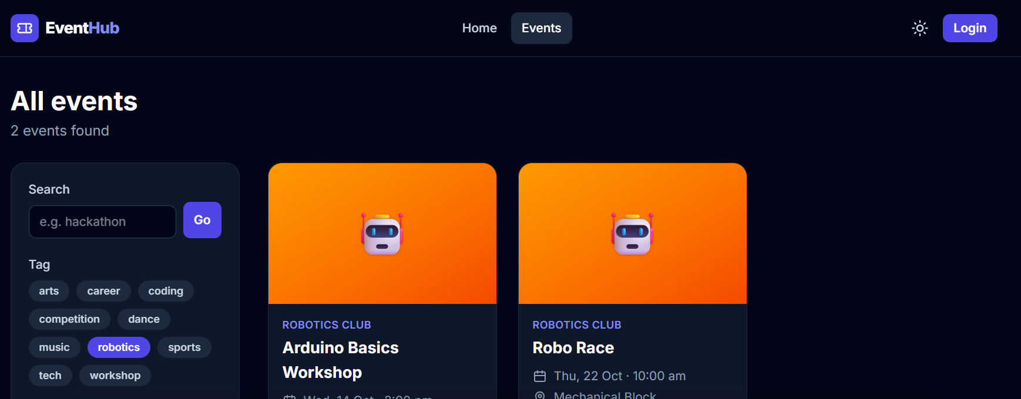
All events filtered by the tag "robotics"
3. Click an event to see its details and the live seat bar. Pressing Book now without being logged in opens the login page, which brings you back to the event afterwards.

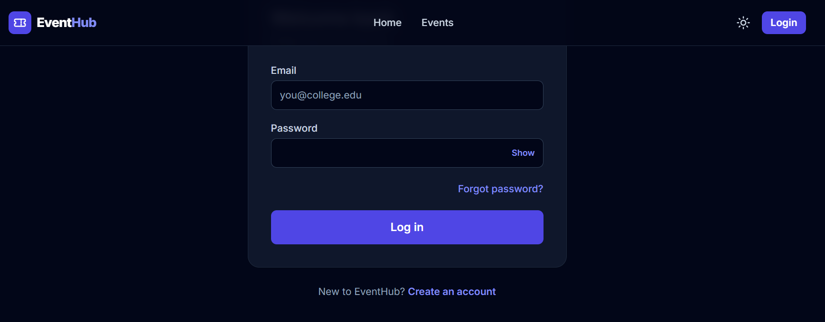
Login page - after login EventHub returns to the event you were looking at

10.2 Student: booking and paying
1. On the event page, choose the number of tickets (1-10) and press Book now.

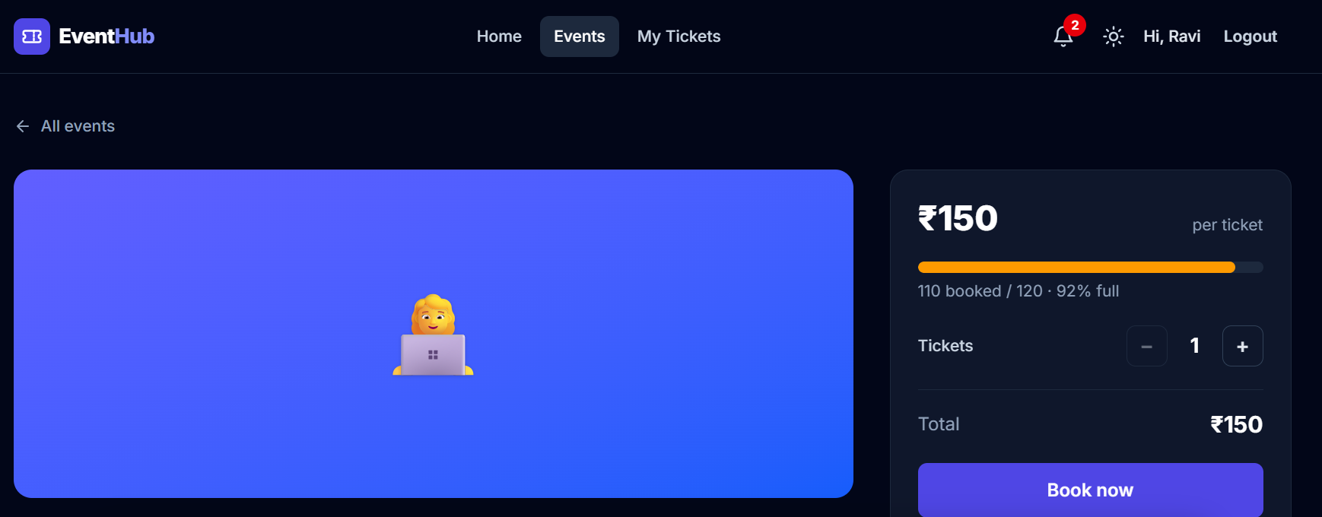
Event details: price, live "booked / total" bar, ticket stepper
2. The checkout page shows your details and a 10-minute timer. The seats are yours while it runs. Press Pay. (Press "Release my seats" if you changed your mind.)

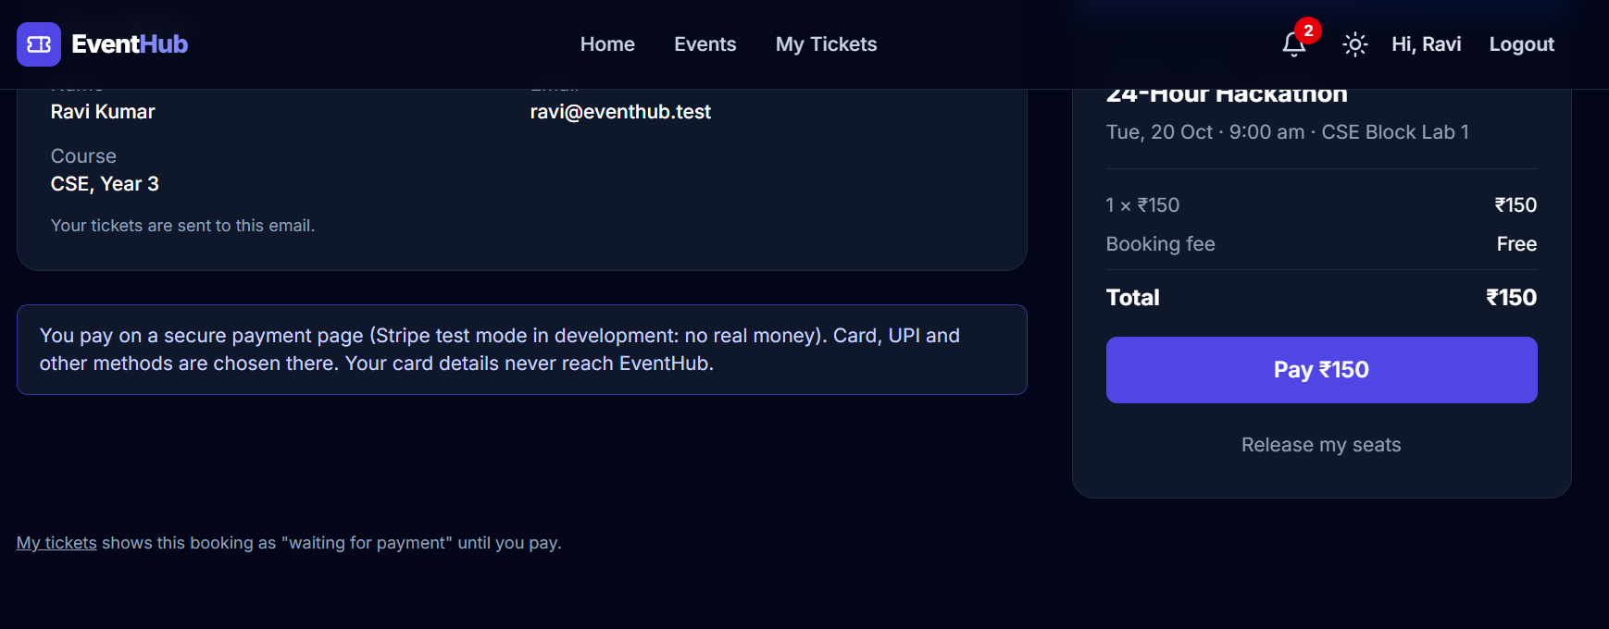
Checkout: seats held, total, Pay button
3. In development you see EventHub's test payment page (no real money). With a Stripe test key you would see Stripe's own page instead. Press Pay.

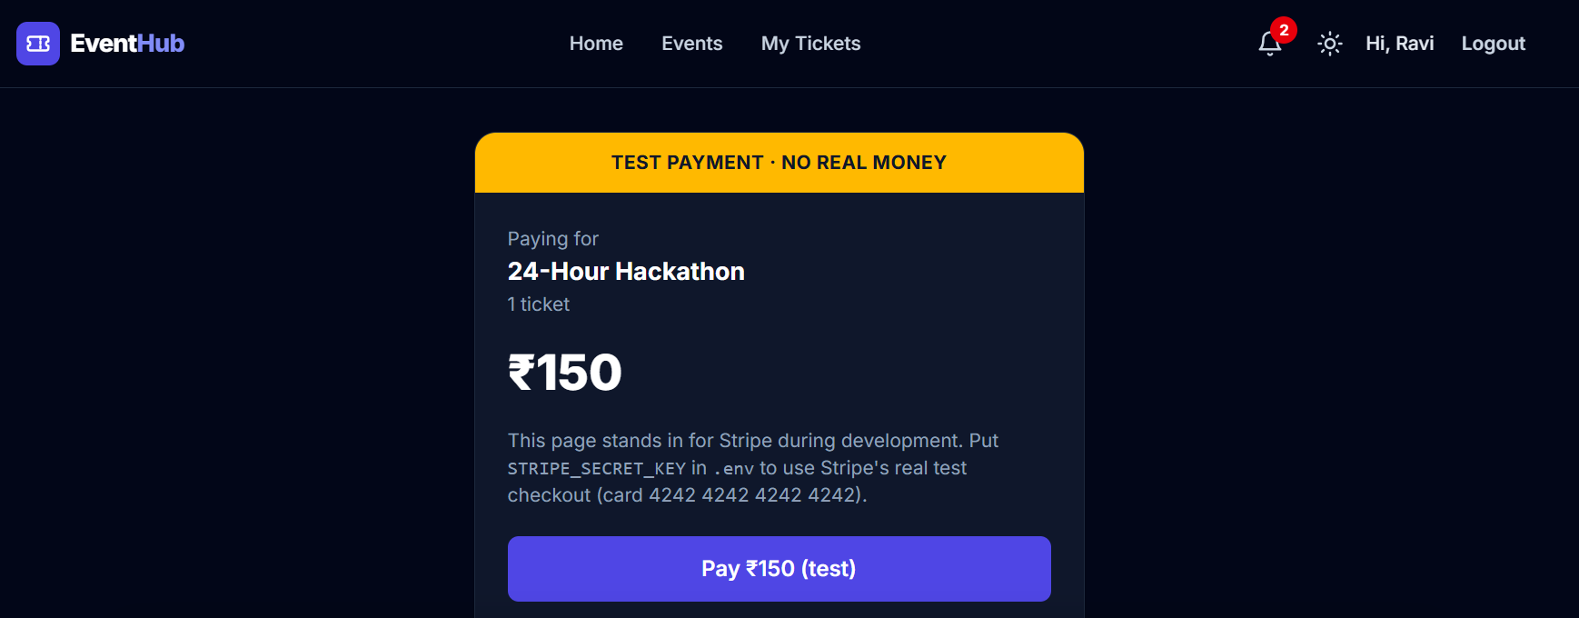
The built-in test payment page
4. "Payment received. You are going!" Press Show my ticket.

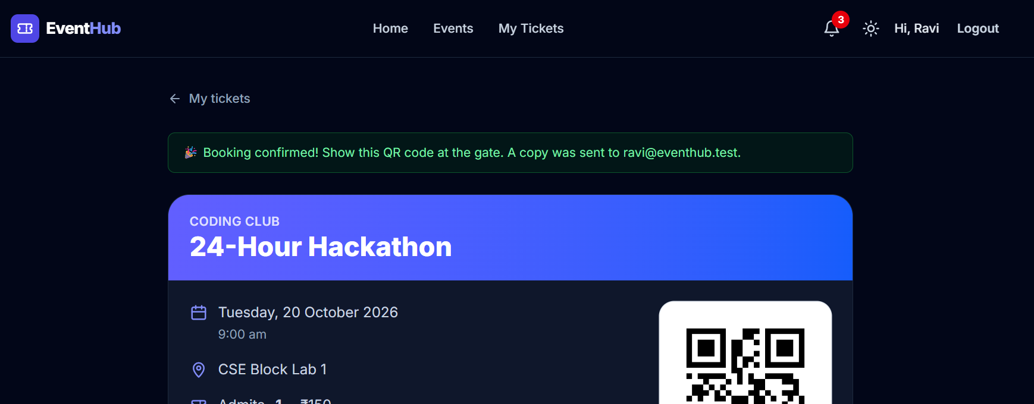
Booking confirmed with the QR code
5. The ticket page shows the QR code and the ticket code. Print it or save it as PDF - or just show it on the phone at the gate.

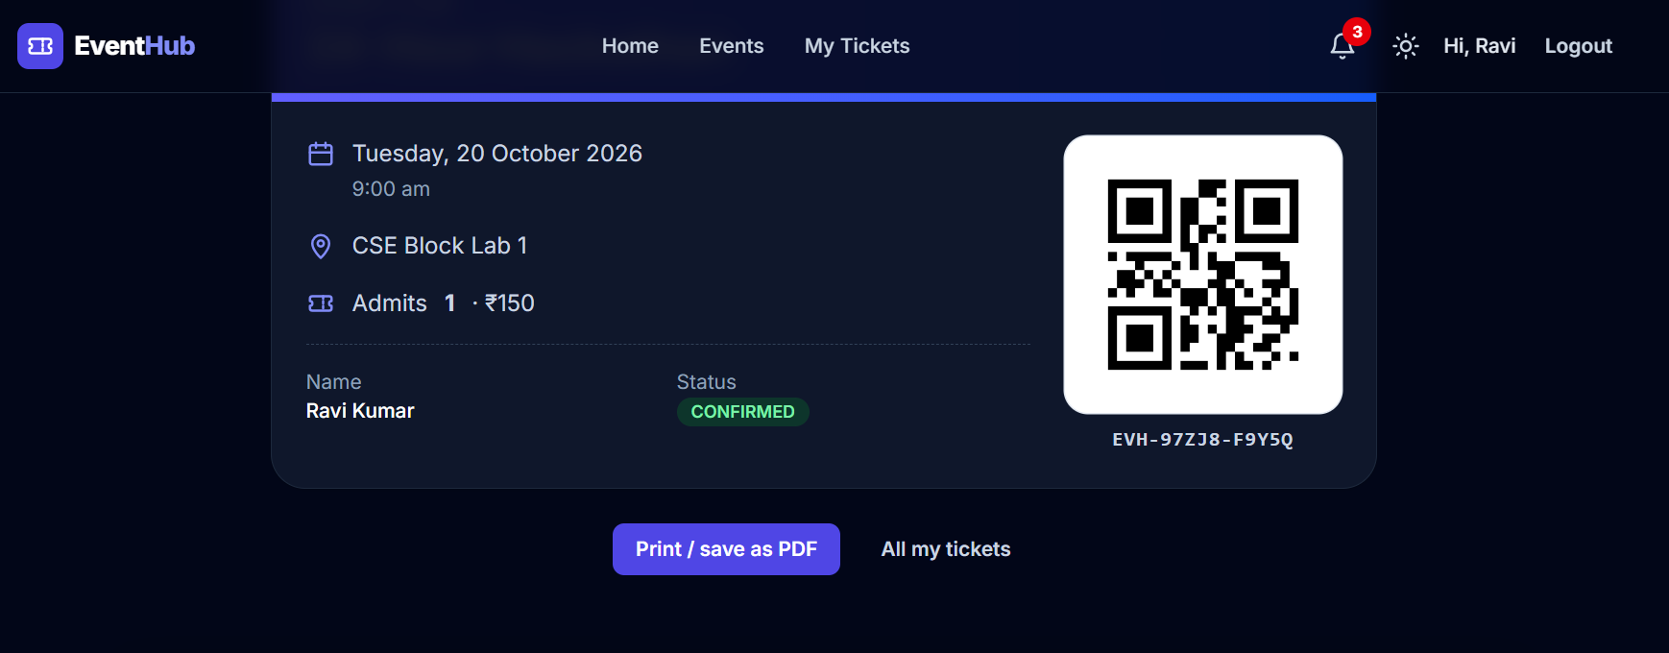
The QR ticket

10.3 Student: my tickets, waitlist, notifications
- My tickets lists upcoming, past and cancelled bookings. A paid ticket can be cancelled before the event (the money is refunded); a ticket still waiting for payment shows "Pay now".

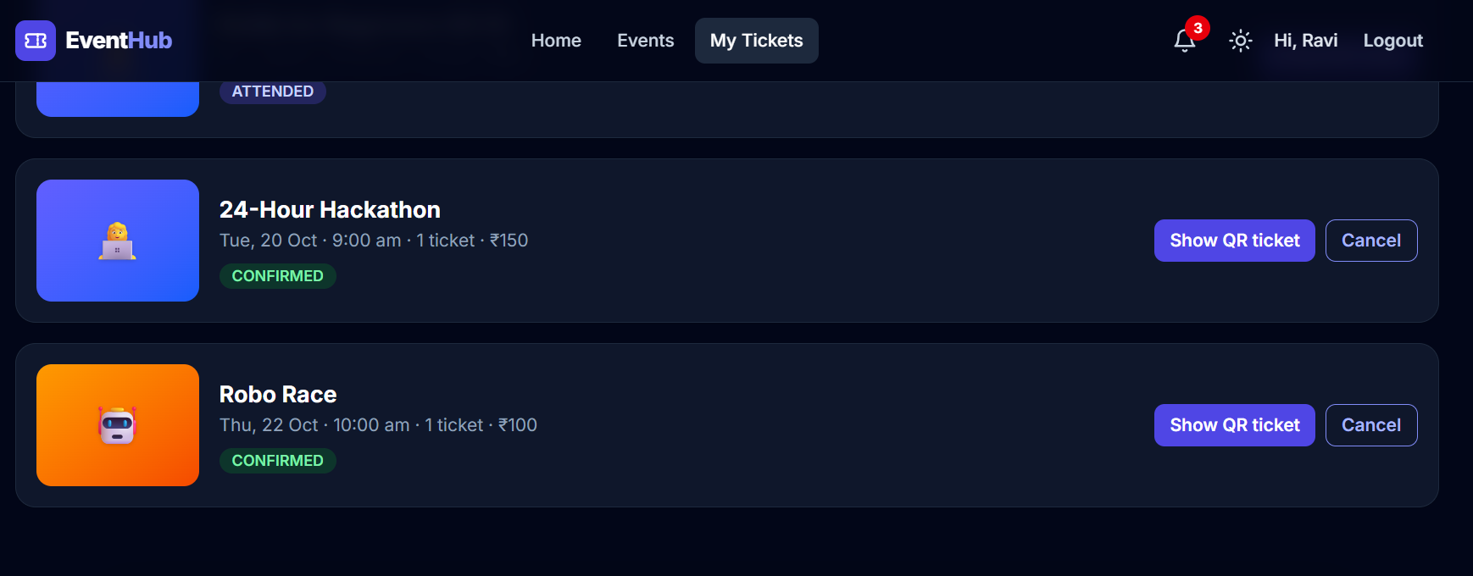
My tickets
- Waitlist: on a sold-out event press "Join the waitlist" and choose how many seats you need. The waitlist page shows your place ("You are #2"). When seats are offered, a card with a 30-minute countdown appears: press Accept to go to checkout.
- Bell: the bell in the top bar shows unread notifications (booking confirmed, seat offered, event approved, reminders). The same messages arrive by email (in development: the Mailpit inbox at http://localhost:8025).

10.4 Student: certificates and feedback
After an event you attended (your ticket was scanned at the gate) is over, it appears under Certificates.
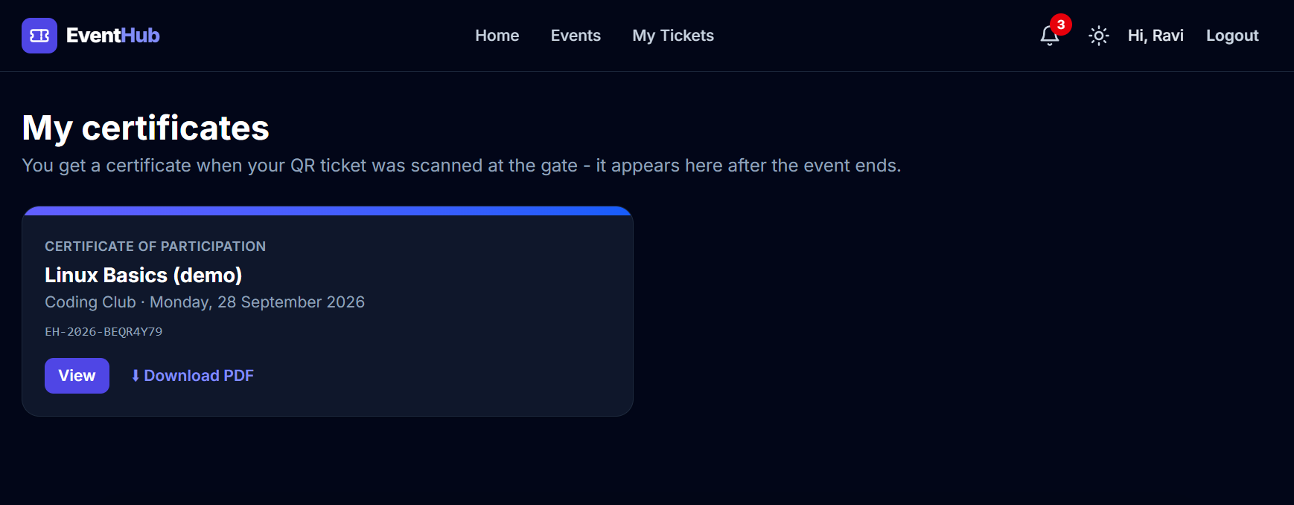
My certificates
Open it to see the certificate and download the PDF. The QR code in the corner opens the public verify page.
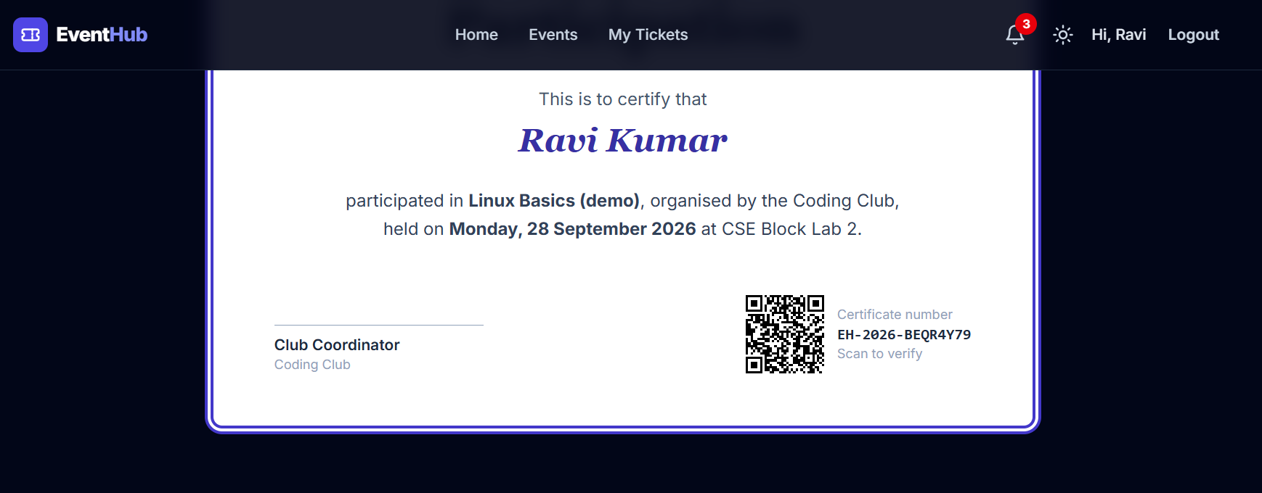
The certificate
On My tickets → Past, press Rate to give 1-5 stars and an optional comment. You can change your rating later.

10.5 Volunteer: the gate scanner
1. Log in as a volunteer (for example Priya). Open Scanner in the top bar.
2. Choose the event you are on duty for. The live counter shows "checked in / booked" for all gates together.
3. Press Scan with camera and point it at the QR code - or type the code and press Check.

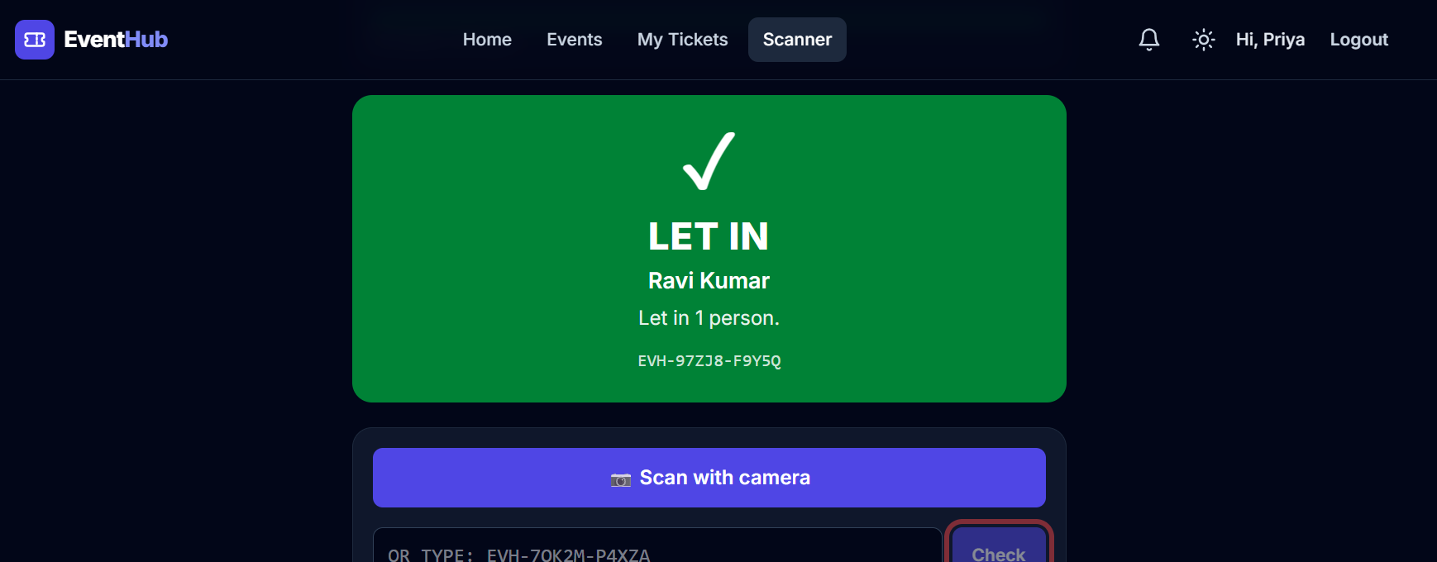
First scan: LET IN, with the name and number of people
4. The answer is big and coloured: green LET IN, or red ALREADY USED / STOP. Phones vibrate on red.

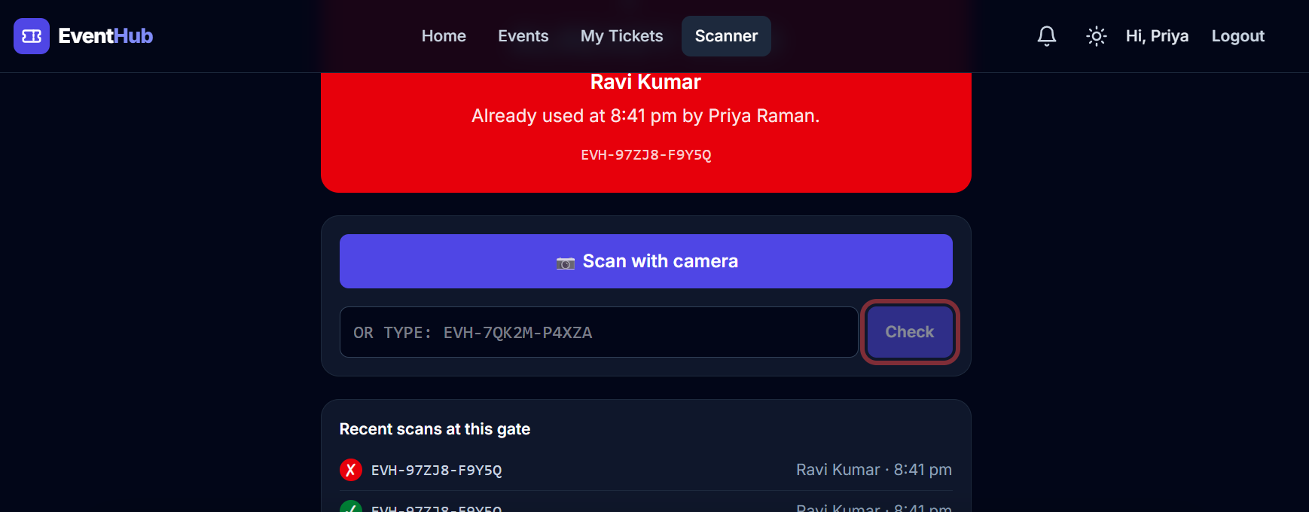
The same ticket again: ALREADY USED, with the time and the volunteer's name

10.6 Anyone: verifying a certificate
Open /verify (link "Verify a certificate" in the footer) and type the number, or scan the QR code on the certificate. No login is needed.
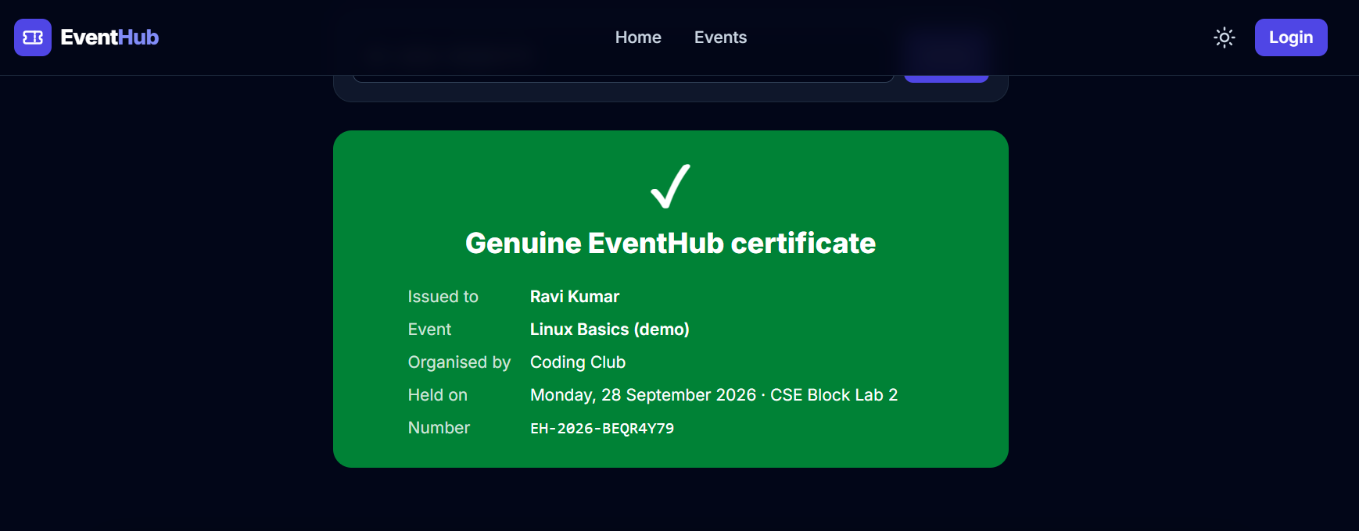
A genuine certificate on the public verify page

10.7 Organizer: creating and managing events
1. Log in as an organizer (Madhavan). The Organizer area shows the club's dashboard: published events, tickets sold, money, waiting approvals, and every event with its status.

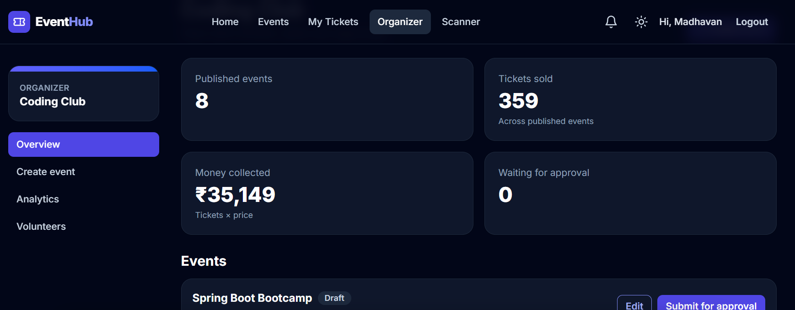
Organizer dashboard of the Coding Club
2. Create event: fill in title, description, venue, start and end, seats, price and up to 5 tags. The form checks each field as you go.

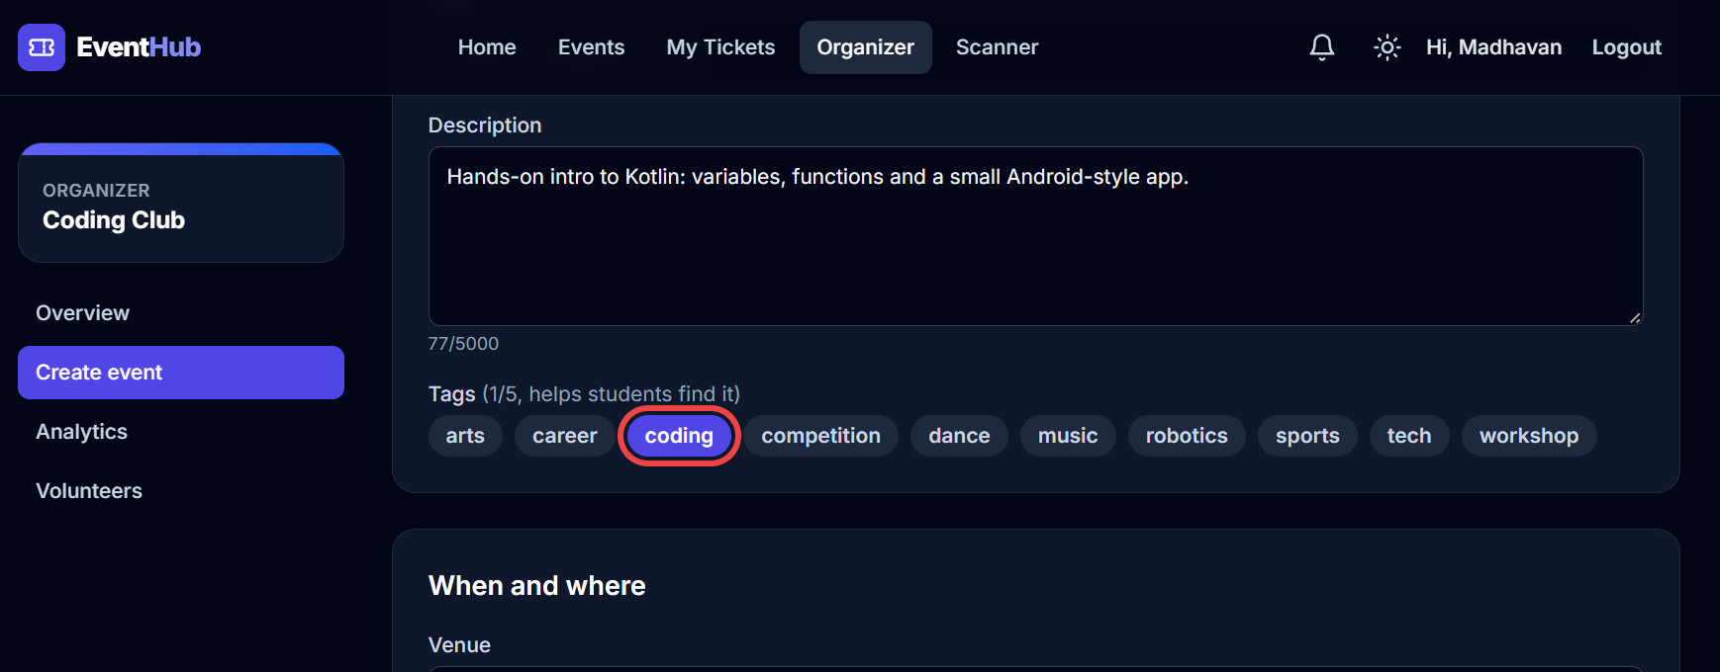
Create event form
3. Press Save and submit (or save as a draft first). The event waits for the admin. If the admin sends it back, the reason appears in red under the event.

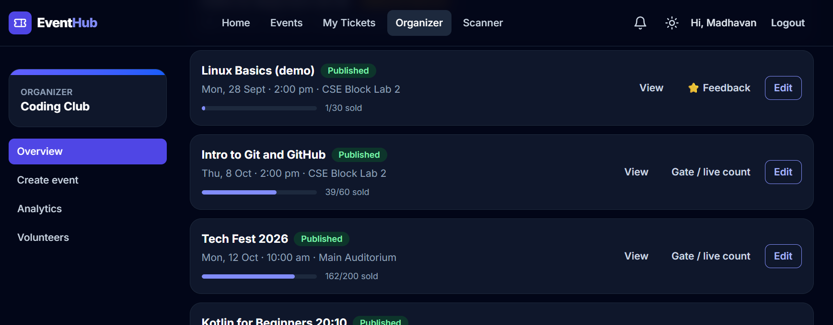
The organizer's event list with statuses
4. Analytics: tickets and money per day for the last 7/30/90 days, check-in rate and average rating.

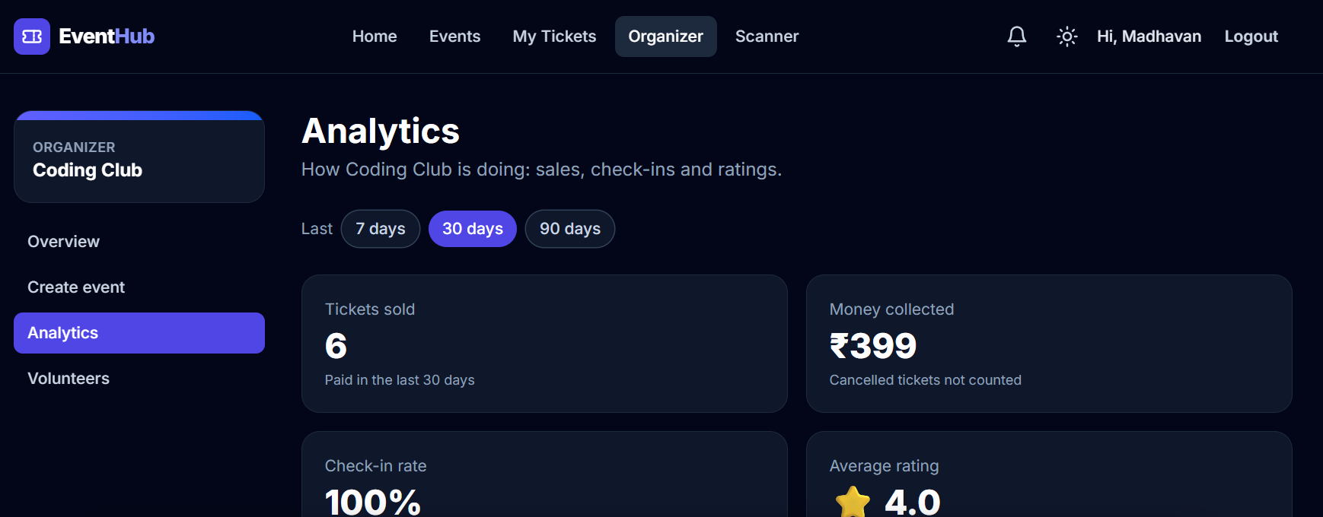
Organizer analytics
5. Feedback (on past events): average stars, how many gave each star, and the comments without names.

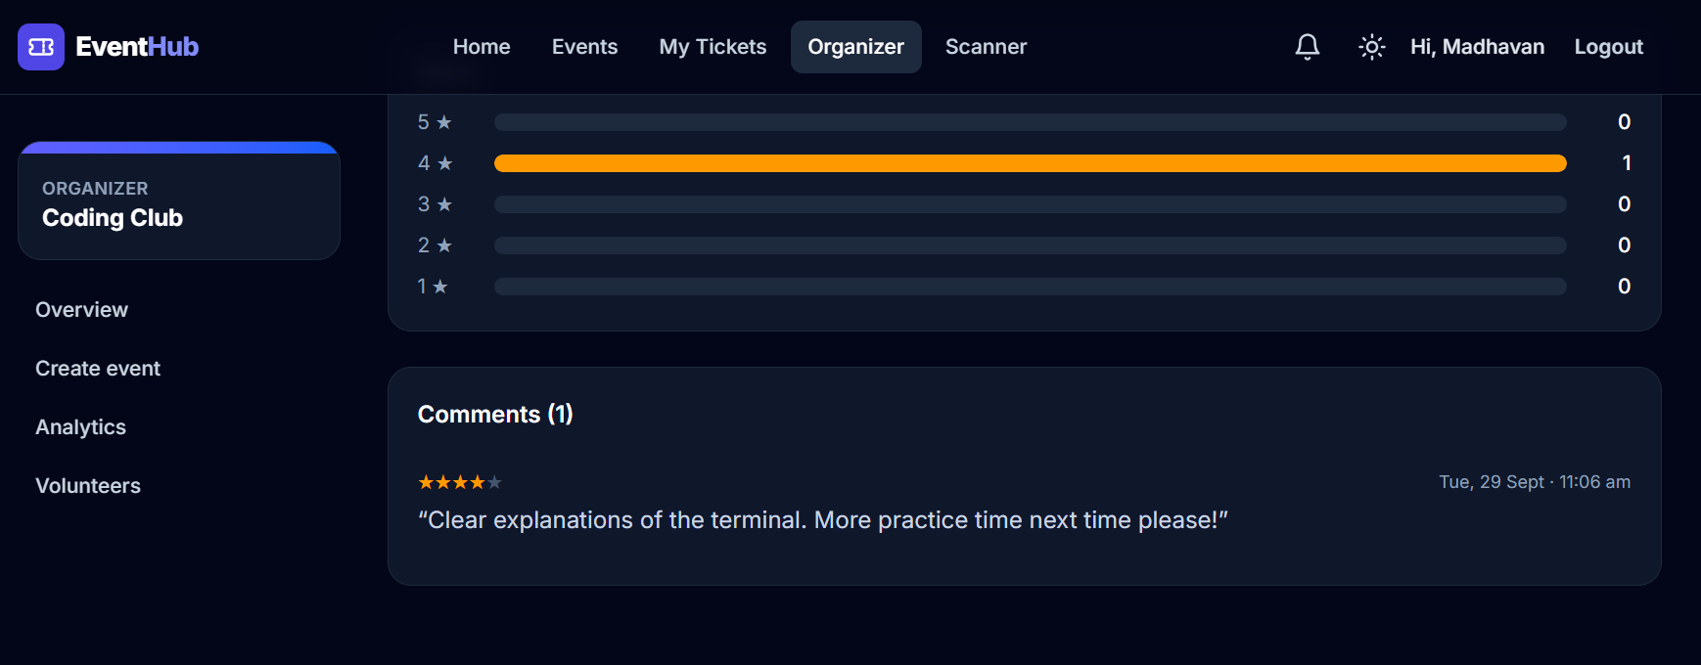
Feedback of Linux Basics (demo)

10.8 Admin: approvals, overview, analytics
1. Log in as the admin. Approval queue lists waiting events, soonest first. Press Approve (and confirm), or Send back with a reason.

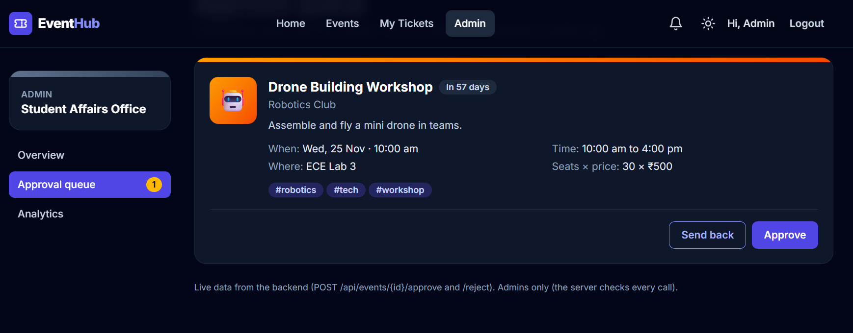
Approval queue
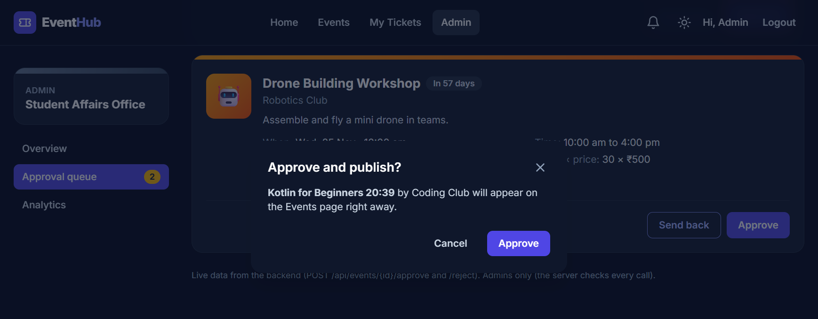
Confirming an approval
2. Overview shows totals per club and the activity log (who created, submitted, approved or sent back each event).

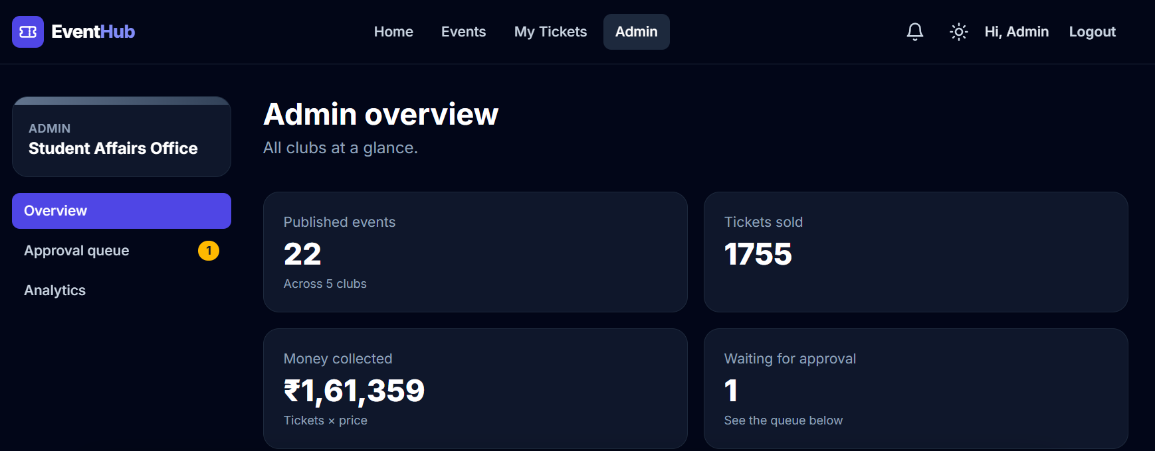
Admin overview
3. Analytics shows the same dashboard as organizers, for all clubs or one club.

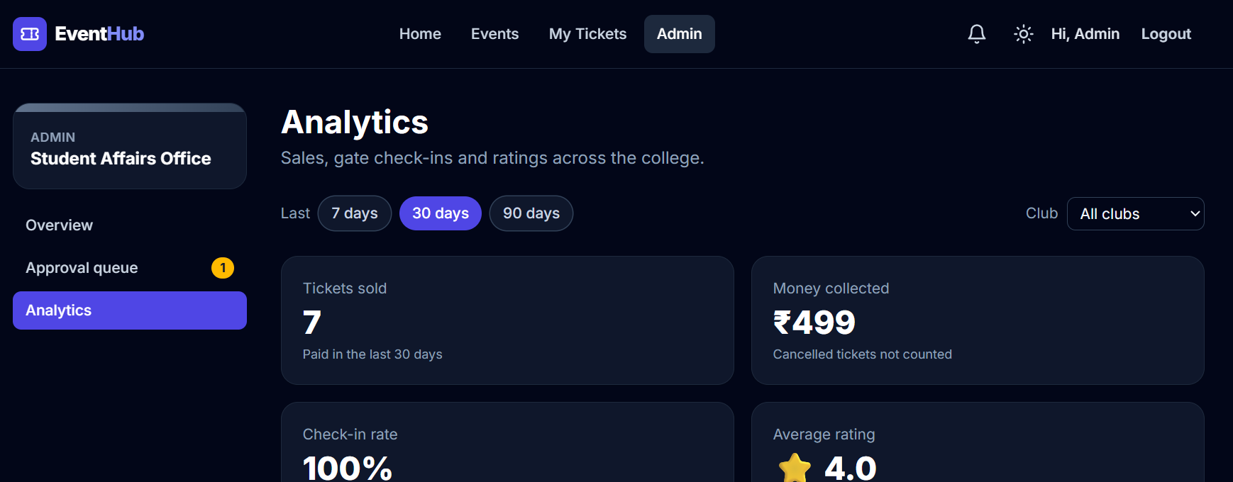
Admin analytics for all clubs

10.9 What happens when someone is not allowed
Kavya organizes the Cultural Club. If she opens the admin area, the page says she has no permission - and even if she called the admin API directly, the server would answer 403 Forbidden.
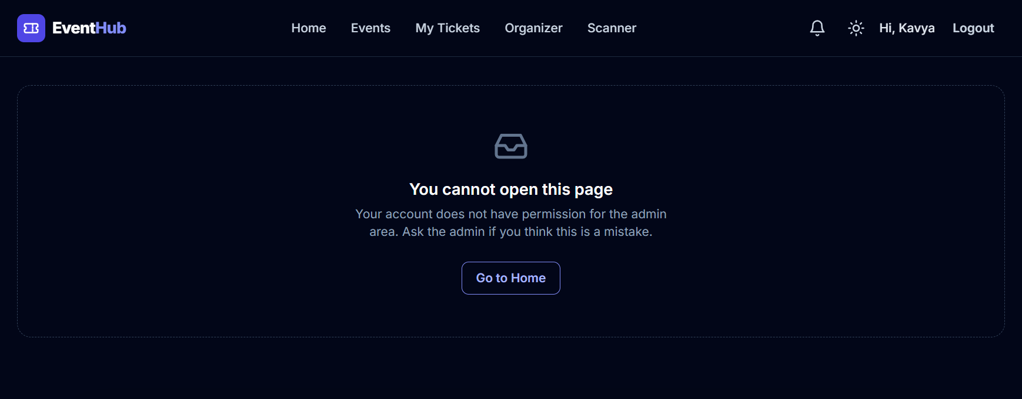
A non-admin opening the admin area

11. Testing

11.1 Why test automatically?
Every time the code changes, something that used to work can break. Clicking through 29 pages by hand after every change is slow and people forget steps. Automated tests are small programs that use the application and check the answers - in about two minutes, every time, on every push.
Real-life example: Automated tests are like the quality-control machine at a biscuit factory: every biscuit is weighed automatically; a person only looks when the machine rings the bell.

11.2 The testing pyramid
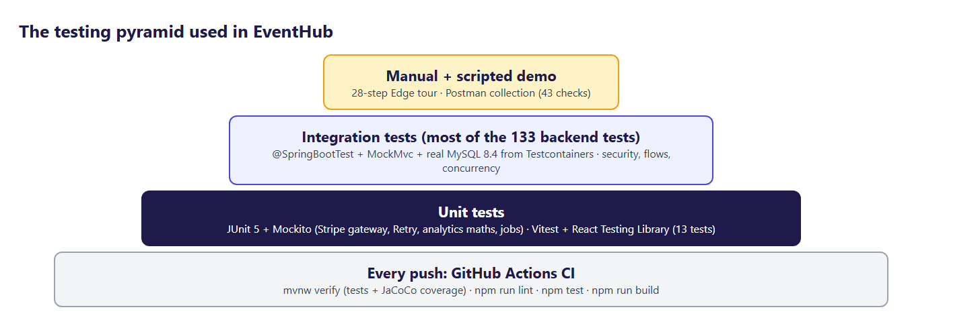
The testing pyramid used in EventHub
Level | What it checks | Speed | EventHub examples
Unit test | One class alone; everything around it is replaced by mocks | milliseconds | StripePaymentGatewayTest, RetryTest, AnalyticsServiceTest, EventStatusTest
Integration test | Several layers together, with a real database | seconds | BookingFlowTest, GateFlowTest, SecurityRulesTest, WaitlistFlowTest
Concurrency test | Many threads at the same moment | seconds | BookingConcurrencyTest (100 threads), GateConcurrencyTest (20 gates)
Component test (React) | One page or component in a fake browser | milliseconds | LoginPage.test.jsx, ScannerPage.test.jsx, useCountdown.test.jsx
End-to-end demo | The whole running system in a real browser | minutes | tools/edge-tour.mjs (28 steps)

11.3 The numbers
Measure | Value
Backend tests | 133 (26 test classes)
Frontend tests | 13 (4 test files)
Line coverage of the service classes | 91%
Line coverage of the whole backend | 92%
Time for all backend tests | about 2 minutes (including starting MySQL)
CI | GitHub Actions, on every push, green

11.4 Unit tests with Mockito
A mock is a fake object that answers what the test tells it to. It lets us test the maths of AnalyticsService without a database: the test decides what the "database" returns and checks what the service calculates.
AnalyticsServiceTest.java (backend/src/test/java/com/eventhub/analytics/AnalyticsServiceTest.java)
@Test
void checkInRateCountsOnlyStartedEventsAndStarsAreWeightedByHowManyRated() {
LocalDateTime yesterday = LocalDateTime.now().minusDays(1);
LocalDateTime nextWeek = LocalDateTime.now().plusDays(7);
when(queries.salesPerDay(any(), any())).thenReturn(List.of());
when(queries.salesPerEvent(any(), any())).thenReturn(List.of(
new EventSales(10L, "Git workshop", yesterday, 60, 40, 30, BigDecimal.ZERO),
new EventSales(11L, "Robo Race", yesterday, 100, 10, 10, new BigDecimal("1000")),
new EventSales(12L, "Tech Fest", nextWeek, 200, 150, 0, new BigDecimal("15000"))));
when(queries.ratings(List.of(10L, 11L, 12L))).thenReturn(List.of(
new EventRating(10L, 4.0, 3), // 3 people gave 4 stars
new EventRating(11L, 2.0, 1))); // 1 person gave 2 stars

AnalyticsResponse r = service.dashboard(null, 30);

// started events only: (30 + 10) came of (40 + 10) sold = 80 %; Tech Fest (not started) is left out
assertThat(r.totals().checkedIn()).isEqualTo(40);
assertThat(r.totals().expectedAtGate()).isEqualTo(50);
assertThat(r.totals().checkInRate()).isEqualTo(0.8);
// (4+4+4+2) / 4 ratings = 3.5, NOT (4.0 + 2.0) / 2 events = 3.0
assertThat(r.totals().averageRating()).isEqualTo(3.5);
assertThat(r.totals().ratings()).isEqualTo(4);

assertThat(r.events()).extracting(AnalyticsResponse.EventRow::started).containsExactly(true, true, false);
assertThat(r.events().get(2).averageRating()).isNull(); // Tech Fest: no ratings yet
}
Line by line:
1. @Mock AnalyticsQueries queries - a fake repository.
2. when(queries.salesPerEvent(any(), any())).thenReturn(...) - "if the service asks for sales per event, give it these three rows".
3. service.dashboard(null, 30) - run the real code.
4. assertThat(...).isEqualTo(0.8) - (30 + 10) people came out of (40 + 10) tickets for the started events = 80%. The future event is correctly left out.
5. The weighted average: (4 + 4 + 4 + 2) / 4 ratings = 3.5, not (4.0 + 2.0) / 2 events = 3.0.

The Stripe gateway was never run against real Stripe in this project, so its unit test is especially valuable. Mockito's mockStatic replaces Stripe's static methods for one test and captures exactly what EventHub would send:
StripePaymentGatewayTest.java (backend/src/test/java/com/eventhub/payment/StripePaymentGatewayTest.java)
@Test
void checkoutAsksStripeForTheRightAmountInPaiseAndTheRightReturnPages() {
ArgumentCaptor<SessionCreateParams> sent = ArgumentCaptor.forClass(SessionCreateParams.class);
ArgumentCaptor<RequestOptions> options = ArgumentCaptor.forClass(RequestOptions.class);
// make the fake session FIRST: creating a mock in the middle of another when(...) confuses Mockito
Session created = session("cs_test_1", "https://checkout.stripe.com/c/pay/cs_test_1", "unpaid");
sessions.when(() -> Session.create(sent.capture(), options.capture())).thenReturn(created);

CheckoutSession checkout = gateway.createCheckout(booking());

assertThat(checkout.sessionId()).isEqualTo("cs_test_1");
assertThat(checkout.redirectUrl()).isEqualTo("https://checkout.stripe.com/c/pay/cs_test_1");

SessionCreateParams p = sent.getValue();
LineItem item = p.getLineItems().getFirst();
assertThat(item.getQuantity()).isEqualTo(3L);
assertThat(item.getPriceData().getUnitAmount()).isEqualTo(10050L); // ₹100.50 = 10050 paise
assertThat(item.getPriceData().getCurrency()).isEqualTo("inr");
assertThat(item.getPriceData().getProductData().getName()).isEqualTo("Robo Race");
assertThat(p.getMode()).isEqualTo(SessionCreateParams.Mode.PAYMENT);
assertThat(p.getMetadata()).containsEntry("booking_id", "42"); // the webhook finds the booking with it
assertThat(p.getClientReferenceId()).isEqualTo("42");
assertThat(p.getCustomerEmail()).isEqualTo("ravi@eventhub.test");
assertThat(p.getSuccessUrl())
.isEqualTo("http://localhost:5173/payment/success?booking=42&session={CHECKOUT_SESSION_ID}");
assertThat(p.getCancelUrl()).isEqualTo("http://localhost:5173/payment/cancelled?booking=42");
// Stripe refuses pages that close sooner than 30 minutes
assertThat(Instant.ofEpochSecond(p.getExpiresAt()))
.isBetween(Instant.now().plus(30, ChronoUnit.MINUTES), Instant.now().plus(32, ChronoUnit.MINUTES));
assertThat(options.getValue().getApiKey()).isEqualTo(KEY);
}

11.5 Integration tests with Testcontainers
Integration tests start the whole Spring application and call it through MockMvc, exactly like the browser would, including the login cookie and the CSRF header. They need a real MySQL - an in-memory database behaves differently (locks, isolation, SQL details).
Testcontainers starts a brand-new MySQL 8.4 container in Docker once per test run and removes it at the end:
MySqlTestDatabase.java (backend/src/test/java/com/eventhub/MySqlTestDatabase.java)
/**
* Phase 8 step 2 - Testcontainers: the tests start their OWN MySQL 8.4 in Docker (same version as
* docker-compose and production), fresh and empty; Flyway then builds the tables from V1..V9.
*
* before: tests used the database "eventhub_test" inside our dev container - it had to be created
* by hand, leftovers from old runs stayed, and CI needed its own MySQL service.
* now: `mvnw test` only needs Docker running. The container starts ONCE for the whole test run
* (about 10 s) and Testcontainers removes it when the run ends.
*
* Registered in src/test/resources/META-INF/spring.factories, so every Spring test context
* (@SpringBootTest, @DataJpaTest ...) gets it without any change in the test classes.
*/
public class MySqlTestDatabase implements ApplicationContextInitializer<ConfigurableApplicationContext> {

/** static = one container per test run, shared by every test context (like a singleton). */
private static final MySQLContainer MYSQL = new MySQLContainer("mysql:8.4")
.withDatabaseName("eventhub_test")
.withUsername("eventhub")
.withPassword("test-only-password");

@Override
public void initialize(ConfigurableApplicationContext context) {
synchronized (MYSQL) {
if (!MYSQL.isRunning()) {
MYSQL.start();
}
}
// addFirst = these win over application.yml (which points at the dev database)
context.getEnvironment().getPropertySources().addFirst(new MapPropertySource("testcontainers-mysql", Map.of(
"spring.datasource.url", MYSQL.getJdbcUrl(),
"spring.datasource.username", MYSQL.getUsername(),
"spring.datasource.password", MYSQL.getPassword())));
}

}
It is registered in src/test/resources/META-INF/spring.factories, so every test class uses it automatically. Most integration tests are @Transactional: each test's changes are rolled back at the end, so tests never disturb each other.
Example of an integration test - the security rule "Swagger and Actuator are for the admin only":
SecurityRulesTest.java (backend/src/test/java/com/eventhub/auth/SecurityRulesTest.java)
@Test
void swaggerAndActuatorAreForTheAdminOnly() throws Exception {
for (String url : new String[] { "/v3/api-docs", "/swagger-ui.html", "/actuator/info" }) {
mvc.perform(get(url)).andExpect(status().isUnauthorized()); // visitor
mvc.perform(get(url).with(accounts.as(accounts.student()))).andExpect(status().isForbidden());
mvc.perform(get(url).with(accounts.as(accounts.organizerOf(1L)))).andExpect(status().isForbidden());
}
mvc.perform(get("/v3/api-docs").with(accounts.as(accounts.admin())))
.andExpect(status().isOk())
.andExpect(jsonPath("$.info.title").value("EventHub API"));
mvc.perform(get("/actuator/info").with(accounts.as(accounts.admin()))).andExpect(status().isOk());
}

11.6 Concurrency tests
BookingConcurrencyTest.java (backend/src/test/java/com/eventhub/booking/BookingConcurrencyTest.java)
@RepeatedTest(3)
void hundredStudentsTenSeatsExactlyTenBookings() throws Exception {
AtomicInteger booked = new AtomicInteger();
AtomicInteger soldOut = new AtomicInteger();
ConcurrentLinkedQueue<Throwable> unexpected = new ConcurrentLinkedQueue<>();
CountDownLatch startGun = new CountDownLatch(1);

ExecutorService pool = Executors.newFixedThreadPool(STUDENTS);
List<Future<?>> runs = new ArrayList<>();
for (Long userId : userIds) {
runs.add(pool.submit(() -> {
try {
startGun.await(); // everybody waits here ...
service.hold(userId, eventId, 1);
booked.incrementAndGet();
}
catch (BusinessRuleException ex) {
if (ex.getMessage().contains("sold out") || ex.getMessage().contains("Only")) {
soldOut.incrementAndGet();
}
else {
unexpected.add(ex);
}
}
catch (Throwable ex) {
unexpected.add(ex);
}
return null;
}));
}
startGun.countDown(); // ... and all 100 press "Book" together
for (Future<?> run : runs) {
run.get(60, TimeUnit.SECONDS);
}
pool.shutdown();

assertThat(unexpected).as("unexpected errors").isEmpty();
assertThat(booked.get()).as("successful bookings").isEqualTo(SEATS);
assertThat(soldOut.get()).as("told 'sold out'").isEqualTo(STUDENTS - SEATS);
assertThat(events.findById(eventId).orElseThrow().getAvailableSeats()).as("seats left").isZero();
assertThat(jdbc.queryForObject("select count(*) from bookings where event_id = ?", Integer.class, eventId))
.as("rows in bookings").isEqualTo(SEATS);
}
- 100 threads wait at a CountDownLatch and are released at the same moment.
- The test is not @Transactional (each thread needs its own real transaction) and cleans up after itself.
- @RepeatedTest(3) runs it three times, because concurrency bugs do not always show up on the first try.
- Mutation check: when @Version was removed from Event on purpose, this test failed with 96-99 bookings. A test that can fail is a test that proves something.

11.7 React component tests
Vitest runs the tests in jsdom, a fake browser. React Testing Library finds elements the way a user would (by label, role or text) and user-event types and clicks like a person.
LoginPage.test.jsx (frontend/src/pages/LoginPage.test.jsx)
it('after login goes back to the page in ?next= (and trims the email)', async () => {
vi.mocked(loginRequest).mockResolvedValue(ravi)
const user = renderLogin('/login?next=/events/15')
await fillAndSubmit(user, ' ravi@eventhub.test ', 'secret123')

expect(await screen.findByText('Event page')).toBeInTheDocument()
expect(loginRequest).toHaveBeenCalledWith({ email: 'ravi@eventhub.test', password: 'secret123' })
})
The API module is replaced by a mock (vi.mock('../api/auth', ...)), so the test controls the server's answer.
useCountdown.test.jsx uses fake timers: the test moves the clock by 65 seconds instantly and checks that "10:00" became "08:55".

11.8 Continuous integration (GitHub Actions)
ci.yml (.github/workflows/ci.yml, lines 1-48)
# CI = GitHub builds and tests EventHub automatically on every push.
name: CI

on:
push:
branches: [main]
pull_request:

jobs:
backend:
name: Backend (Spring Boot)
runs-on: ubuntu-latest
# no MySQL service needed: the tests start their own MySQL with Testcontainers (Docker is on the runner)
defaults:
run:
working-directory: backend
steps:
- uses: actions/checkout@v5
- uses: actions/setup-java@v5
with:
distribution: temurin
java-version: '25'
cache: maven
- run: ./mvnw -B verify
# Phase 8: the JaCoCo coverage report, downloadable from the run's page (Artifacts)
- uses: actions/upload-artifact@v4
if: always()
with:
name: coverage-report
path: backend/target/site/jacoco/

frontend:
name: Frontend (React)
runs-on: ubuntu-latest
defaults:
run:
working-directory: frontend
steps:
- uses: actions/checkout@v5
- uses: actions/setup-node@v5
with:
node-version: '24'
cache: npm
cache-dependency-path: frontend/package-lock.json
- run: npm ci
- run: npm run lint
- run: npm test # Phase 8: Vitest + React Testing Library
- run: npm run build
Every push to GitHub starts two jobs on fresh Ubuntu machines: the backend (Java 25, mvnw verify - all tests with Testcontainers - and the JaCoCo report as a downloadable artifact) and the frontend (Node 24: npm ci, lint, test, build). The green or red result appears next to each commit.

11.9 Bugs the tests found
Bug | Found by | Fix
Two bookings for the last seat | BookingConcurrencyTest | @Version + retry
MySQL deadlock between two bookings | BookingConcurrencyTest | update the event row before inserting the booking
A second gate re-read the ticket and still saw it unused | GateConcurrencyTest | decide from the UPDATE result
CSRF token changed on every request (second parallel request failed) | browser test | keep one token (sessionAuthenticationStrategy)
Jackson 3 refused a missing number | ErrorHandlingTest | Integer + @NotNull instead of int
Hibernate refused TINYINT | start-up validation | @JdbcTypeCode(SqlTypes.TINYINT)
JWT test failed 1 run in 16 | CI | change the first signature letter, not the last (base64 padding bits)
Scanner page went blank after the first scan | Edge demo tour | import the moved colour table; new ScannerPage test; lint rule no-undef

11.10 How to run the tests
cd backend
mvnw test all backend tests
mvnw test -Dtest=BookingConcurrencyTest one test class
start target\site\jacoco\index.html open the coverage report

cd frontend
npm test all React tests once
npm run test:watch re-run on every save

12. Security in depth

12.1 The main threats and the answers
Threat | What an attacker tries | EventHub's defence
Stolen password database | read passwords from a leaked copy | BCrypt hashes with salt; passwords never stored or logged
Password guessing | try thousands of passwords | 5 failures per email + address → 15-minute lock (429)
Stolen login token (XSS) | a script on the page reads the token | JWT in an httpOnly cookie - scripts cannot read it
Forged request (CSRF) | another website makes your browser post to EventHub | SameSite=Lax cookie + CSRF token header that other sites cannot read
Doing other people's work | an organizer edits another club's event; a student opens admin URLs | role and club checks on every request (SecurityConfig, @PreAuthorize, ClubAccess) → 403
Guessing ids | walk through /tickets/1, /2, /3 … | ownership checks (404 for other people's bookings); random ticket and certificate codes
Fake payment notification | call the webhook pretending to be Stripe | Stripe-Signature (HMAC with the webhook secret) checked first
Replayed payment notification | send the same "paid" message again | idempotency table processed_payment_events
Fake ticket at the gate | a screenshot or a made-up code | server-side check; each code works once; codes are random
Fake certificate | edit a PDF | public verify page shows the truth for each number
Leaking secrets | passwords in GitHub | .env in .gitignore; history scanned; only placeholders in .env.example
Learning the system | reading the API map and server details | Swagger and Actuator admin-only; 500 errors hide internal messages
Open redirect | /login?next=https://evil.com | safeNext only allows paths on this site

12.2 Authentication vs authorization
- Authentication = who are you? - proven by the password once, then by the signed JWT cookie on every request.
- Authorization = what may you do? - global roles (STUDENT, ADMIN) from the token; club roles (ORGANIZER, VOLUNTEER) from the database.

Real-life example: Authentication is showing your ID card at the college gate. Authorization is whether that ID card opens the chemistry lab.

12.3 Why the JWT is in a cookie
 | localStorage + Authorization header | httpOnly cookie (EventHub)
Can a malicious script read it? | Yes | No
Sent automatically? | No (code must add it) | Yes (so CSRF protection is needed)
Needs CSRF protection? | No | Yes - done with the XSRF token

EventHub chose the cookie because stealing a token is worse than a forged request that CSRF protection already blocks.

12.4 The login lock in action
1. Ravi's password is typed wrongly 4 times from one laptop - each answer: 401 "Wrong email or password."
2. The 5th wrong try locks the pair (ravi@eventhub.test, that laptop's address) for 15 minutes.
3. Even the right password now gets 429 "Too many wrong passwords. Please wait 15 minutes and try again." with a Retry-After header (seconds to wait).
4. Ravi can still log in from his phone on another network, and other students on the same Wi-Fi are not affected.
5. A successful login resets the counter.

12.5 Security checklist (Phase 8)
- Swagger UI, /v3/api-docs and Actuator (except /actuator/health) require ADMIN - tested by SecurityRulesTest.
- /actuator/health shows only UP/DOWN to visitors; database and disk details only to the admin.
- A scan of the code and the whole git history found no secrets; .env was never committed.
- The JWT secret must be at least 32 characters, and in production there is no default: the application refuses to start without it.
- Production refuses the fake payment gateway.
- Cookies are Secure in production (HTTPS only).

13. Troubleshooting
Each entry: what you see, why it happens, and how to fix it. Most of them really happened while building EventHub.

13.1 Setup and start-up
What you see | Why | Fix
docker compose up → "error during connect" / "cannot find the file specified" | Docker Desktop is not running | Start Docker Desktop, wait for "Engine running", try again
Backend: "Communications link failure" | MySQL container not started or still starting | docker compose up -d, then docker compose ps until mysql is "healthy"
Backend: "Access denied for user 'eventhub'" | .env passwords differ from the ones the MySQL volume was created with | Use the original passwords, or reset: docker compose down -v (deletes the data!) and start again
Backend: "Could not resolve placeholder 'MYSQL_USER'" | No .env file, or the backend was started from a different folder | Create .env from .env.example; start the backend from the backend folder (it imports ../.env)
Backend: "app.jwt.secret must be at least 32 characters" | JWT_SECRET too short | Generate one: python -c "import secrets; print(secrets.token_hex(32))"
Backend: "Port 8080 was already in use" | Another backend is still running (IntelliJ + command line) | Stop the other one; on Windows find it with netstat -ano (look for :8080) and stop it with taskkill /PID <pid> /F
Backend: "Schema-validation: wrong column type" | An entity field does not match the table | Fix the entity (e.g. @JdbcTypeCode(SqlTypes.TINYINT)) or add a new migration - never edit an old one
Backend: "Migration checksum mismatch" | An already-applied migration file was edited | Undo the edit and put the change in a new V10 file
Frontend: blank page, "Backend: DOWN" in the footer | Spring Boot not running or crashed | Check the backend console; open http://localhost:8080/api/health
npm run dev → "Port 5173 is in use" | A second Vite is running | Close it, or accept the other port Vite suggests
Vite does not pick up a change | The file watcher missed a very fast second save | Save the file again or restart npm run dev
mvnw "Permission denied" (Linux CI) | The wrapper lost its executable bit | git update-index --chmod=+x backend/mvnw and commit
IntelliJ will not start (".port" lock error) | A crashed IntelliJ left a lock file | Close all IntelliJ processes, delete the .port file in the IntelliJ config folder, start again

13.2 Login and security
What you see | Why | Fix
"Wrong email or password." with the right password | A typo, an extra space from copy-paste, or the demo accounts were created with an older DEMO_PASSWORD | Copy exactly; the seeder only creates missing accounts, it never changes an existing password
429 "Too many wrong passwords" | 5 wrong tries from this address | Wait 15 minutes (or restart the backend in development - the lock is kept in memory)
403 on every POST from Postman | No CSRF header | First call GET /api/auth/me, copy the XSRF-TOKEN cookie value into an X-XSRF-TOKEN header
403 "You do not have permission to do this." | Logged in, but not the right role or club | Log in as the right user (e.g. the organizer of that club)
Logged out after some hours | The JWT expires after 8 hours | Log in again (by design)
Swagger page gives 401 | Swagger is admin-only | Log in as the admin in the React app, then open Swagger in the same browser

13.3 Booking, payment and gate
What you see | Why | Fix
"You already have seats for …" | One active booking per student per event | Open My tickets; cancel the old one first if needed
The hold timer ran out | Not paid within 10 minutes | Book again; the seats were returned to other students
Payment done, page keeps waiting | The webhook has not arrived (Stripe CLI not running) | The page calls "verify" automatically; with Stripe, run stripe listen --forward-to localhost:8080/api/payments/stripe/webhook
Scanner: "INVALID - not a ticket for this event" | Wrong event chosen, or the ticket is for another event | Pick the right event in "Gate duty for"
Scanner camera does not start | No camera, or the browser blocked it | Allow camera access, or type the code
No certificate after the event | The ticket was never scanned at the gate, or the event is not over yet | Only attendees get certificates (by design)
No email arrived | Development sends to Mailpit, not real mail | Open http://localhost:8025

13.4 Tests
What you see | Why | Fix
"Could not find a valid Docker environment" | Testcontainers needs Docker | Start Docker Desktop
Tests fail on Windows with file-locked errors | The backend is running from the same target folder | Stop the backend while running mvnw test
A test passes alone but fails with the others | Data left behind by a non-transactional test | Non-transactional tests must clean up (see BookingConcurrencyTest.cleanUp)
Vitest: "unhandled rejection" although the page catches it | Vitest 5 quirk with mockReset() + mockRejectedValue | Use vi.clearAllMocks() in beforeEach
Lint passes but the page crashes with "X is not defined" | The undefined-variable rule was off | Now fixed: .oxlintrc.json has "no-undef": "error"

13.5 How to investigate any problem
1. Read the message. The backend's Problem Details detail usually says exactly what is wrong.
2. Browser DevTools (F12): Console for JavaScript errors, Network for the failing request and its answer.
3. Backend console: the full exception and, in development, every SQL statement (show-sql: true).
4. Reproduce with a test. Write a failing test first, then fix the code until it passes - the bug can never come back unnoticed.

14. Lessons learned
These are the most valuable lessons of the project - good material for interviews.

14.1 Technical lessons
1. The server must own every rule. The page can hide a button, but anyone can call the API with Postman. Every rule lives in a service and is tested there.
2. Concurrency is real. "Read, then write" breaks when two people do it at once. Optimistic locking (@Version) with a retry fixes it without slow locks - and a test with 100 threads proves it.
3. Lock order prevents deadlocks. Two transactions touching the same rows in a different order can wait for each other forever. Always update the event row first.
4. One step is safer than two. "Check if unused, then mark as used" is two steps with a gap; UPDATE … WHERE checked_in_at IS NULL is one step with no gap.
5. Know your isolation level. Under REPEATABLE READ a transaction keeps seeing its first snapshot; decide from the result of your own UPDATE instead of reading again.
6. Do side effects after commit. Emails and other outside actions must wait until the database change is final (outbox idea).
7. Idempotency. Anything that can arrive twice (webhooks, double clicks) must give the same result the second time: use unique keys.
8. Let the database protect itself. UNIQUE, CHECK and foreign keys stop wrong data even when Java has a bug.
9. Random, not sequential, public codes. Ticket and certificate numbers must not be guessable.
10. Measure before optimising. Paging, @EntityGraph, @BatchSize, a 60-second cache and code splitting were each added for a measured reason.

14.2 Working lessons
1. Small steps, each tested and committed. 60+ commits, CI green nearly all the time.
2. Checklists with "done when". Each phase ended only when its checks passed.
3. A test for every bug. The flaky JWT test and the scanner crash each got a test that would have caught them.
4. Automate the demo. The Edge tour found a real bug that unit tests missed, and it produced every screenshot in this guide.
5. Write for the reader. Comments in simple English explain why, not only what.

15. Deployment plan and future scope

15.1 Deployment plan (Phase 9)
Part | Planned host | Settings (environment variables, never in code)
Backend (Docker image or JAR) | Render or Railway | SPRING_PROFILES_ACTIVE=prod, DB_URL, DB_USERNAME, DB_PASSWORD, JWT_SECRET, CORS_ALLOWED_ORIGINS, FRONTEND_URL, MAIL_*, STRIPE_*
Database | Managed MySQL (e.g. Aiven or Railway) | automatic backups
Frontend (static files from npm run build) | Vercel or Netlify | a rewrite that forwards /api/* to the backend, so the cookie stays on one site
Email | a free SMTP service (optional) | MAIL_HOST, MAIL_USERNAME, MAIL_PASSWORD

The prod profile already switches on secure cookies, requires all secrets (no defaults), and refuses the fake payment gateway. The "done when" check of Phase 9: a friend can open the link on their phone, register, book, get a QR ticket and download a certificate.

15.2 Future scope
Idea | Why it matters | How
Password reset by email | Students forget passwords | one-time token table, email link, expiry
Real volunteer management page | Organizers add and remove gate volunteers | endpoints on club_members with role VOLUNTEER
Installable app / offline scanner | Weak Wi-Fi at the gate | Progressive Web App, queue scans and sync later
UPI payments | Most Indian students pay with UPI | Razorpay behind the same PaymentGateway interface
Several servers | More users | Redis for the login lock and the cache; sticky-free design already (stateless JWT)
Several colleges | One platform for a whole university | a college_id on clubs and users, filtered everywhere
Recommendations | Students discover more events | suggest events by tags the student booked before

16. Glossary
Term | Meaning in simple words
API | A set of URLs a program can call to use another program's features
Audit log | A diary of who changed what and when
BCrypt | A slow, salted way of hashing passwords so they cannot be turned back
Bean | An object created and managed by Spring
Cache | A short-term memory of an answer, to avoid computing it again
CI (continuous integration) | Automatic build and tests on every push
Component (React) | A reusable piece of the screen, written as a function
Container (Docker) | A small isolated box that runs one program with everything it needs
CORS | Browser rule about which websites may call an API
CSRF | An attack where another website makes your browser send a request; blocked with a secret header
Deadlock | Two transactions waiting for each other forever
Dependency injection | Spring hands a class the objects it needs, instead of the class creating them
DTO | A small class or record describing the shape of JSON sent or received
Entity | A Java class that represents one database table
Flyway migration | A numbered SQL file that changes the database in a controlled order
Foreign key | A column that must point to an existing row in another table
Hash | A one-way fingerprint of data
HttpOnly cookie | A cookie JavaScript cannot read
Idempotent | Doing it twice gives the same result as doing it once
Integration test | A test of several parts working together (here with a real database)
JPA / Hibernate | The standard and the library that map Java objects to tables
JPQL | A query language like SQL, but written with entity and field names
JWT | A signed token that says who you are, valid until it expires
Mock | A fake object used in a test
Optimistic locking | Save only if nobody else changed the row since you read it (version check)
Outbox pattern | Save the message with the change; deliver it only after the change is committed
Race condition | A bug that happens only when two things run at the same moment
Redux slice | One area of the shared frontend state, with its actions
Repository | An interface that reads and writes one kind of entity
REST | A style of API built on URLs and HTTP methods
Specification | A reusable piece of a WHERE clause that can be combined with others
Testcontainers | A library that starts real databases in Docker for tests
Thunk | A Redux action that does async work (like an API call)
Transaction | A group of database changes that succeed or fail together
Webhook | A call from another company's server to ours when something happens (e.g. "paid")

17. Viva and presentation questions with answers
Short, honest answers you can say in your own words. Grouped by topic; the most common questions come first in each group.

17.1 About the project
1. What is EventHub in one sentence? A college event platform where students find, book and pay for events, enter with a one-time QR ticket, and get a verifiable certificate, while clubs create events, the admin approves them and volunteers check tickets.
2. Why did you build it? Colleges run events on WhatsApp and Google Forms, which causes overbooking, shared ticket screenshots, late and fake-able certificates and no numbers for organizers. EventHub solves each of these with a rule in the software.
3. What is special compared with a simple CRUD project? It stays correct when many people act at once (no overselling, no double entry), it handles money (holds, payments, refunds, idempotent webhooks), and it has real-world features: waitlist offers, emails after commit, QR check-in, PDF certificates and cached analytics - all covered by automated tests.
4. Who are the users? Visitor, student, organizer (per club), volunteer (per club) and admin.
5. How long did it take and how did you organise it? Ten phases, from Java basics to launch, each with a checklist and "done when" checks; small commits, every push tested by GitHub Actions.

17.2 Architecture
6. Explain the architecture. Three tiers: a React single-page app in the browser, a Spring Boot REST API, and MySQL. Inside the backend: security filters, controllers, services, repositories.
7. Why separate controller, service and repository? Each has one job: the controller handles HTTP, the service holds the business rules and transactions, the repository talks to the database. Rules live in one place and each layer can be tested alone.
8. Why package by feature? Everything about one feature (for example booking) is in one folder, so it is easy to find, change and test.
9. How do the frontend and backend communicate? JSON over HTTP. The browser calls /api/...; the Vite dev server forwards it to port 8080. The login travels in an httpOnly cookie and the CSRF token in a header.
10. What is a REST API? A set of URLs with HTTP methods (GET to read, POST to create or act, PUT to replace) that return data, usually JSON, with status codes such as 200, 201, 400, 404 and 409.

17.3 Backend and Spring
11. What is Spring Boot? A Java framework that sets up a web server, database access, security and more automatically, so we only write the business logic.
12. What is dependency injection? Spring creates the objects (beans) and passes each class the beans it needs through its constructor, instead of the class creating them itself. It makes code loosely coupled and easy to test with mocks.
13. What does @Transactional do? It runs a method in a database transaction: all its changes are saved together, or none of them if an exception happens.
14. What is JPA / Hibernate? JPA is the standard for mapping Java classes to tables; Hibernate is the library that implements it and writes the SQL.
15. What is the N+1 problem and how did you avoid it? Loading a list (1 query) and then the details of each item separately (N queries). I used @EntityGraph to load the club with the events and @BatchSize to load all tags in one extra query.
16. How does search with filters work? With JPA Specifications: small WHERE-clause pieces (text, tag, club, dates) combined only when the filter is filled, plus server-side paging and sorting.
17. How do you handle errors? A global @RestControllerAdvice turns exceptions into Problem Details JSON with the right status: 400 validation, 404 not found, 409 business rule, 401/403 security, 429 login lock, 500 unexpected (details only in the log).
18. What is Flyway and why use it? It runs numbered SQL migration files in order and remembers which ran, so every database is identical. Hibernate only validates the schema.
19. What are scheduled jobs in your project? Every minute: expire unpaid holds, expire unanswered waitlist offers, retry failed emails. Every day at 18:00: reminders for tomorrow's events. They use @Scheduled and are switched off in tests.

17.4 Concurrency and correctness
20. How do you prevent overbooking? Optimistic locking: the event has a @Version column. An UPDATE only succeeds if the version is unchanged; the loser gets an exception and retries in a new transaction with fresh data, then sees fewer seats.
21. Why optimistic and not pessimistic locking? Optimistic locking does not hold database locks while the user thinks, scales better and conflicts are rare. Pessimistic SELECT … FOR UPDATE would make everyone wait.
22. How did you prove it works? A test starts 100 threads for 10 seats at the same moment, three times: exactly 10 bookings each time. Without @Version the same test sold 96-99.
23. What deadlock did you meet? Two booking transactions locked the event and booking rows in different orders and waited for each other. The fix was to always update the event row first (saveAndFlush) before inserting the booking.
24. How does the gate stop a ticket being used twice? One conditional UPDATE: set checked_in_at only WHERE checked_in_at IS NULL. If it changed 1 row, let them in; if 0 rows, it was already used. A test with 20 gates proves exactly one VALID.
25. What is REPEATABLE READ and how did it affect you? MySQL's default isolation: a transaction keeps seeing the snapshot from its first read. The losing gate re-read the ticket and still saw "unused", so I decide from the UPDATE's row count instead of re-reading.
26. What is idempotency and where do you use it? Doing something twice gives the same result as once. Stripe may send the same webhook twice; each message id is inserted into a table with a primary key, so the second one is ignored. PUT for feedback is also idempotent.

17.5 Security
27. How is the password stored? As a BCrypt hash with a random salt; never in plain text.
28. What is a JWT and what is inside yours? A signed token with the user id, email, name, roles and expiry (8 hours), signed with HMAC-SHA256 using a secret key.
29. Why store the JWT in an httpOnly cookie? JavaScript cannot read it, so a malicious script cannot steal the login. localStorage would be readable.
30. Then how do you stop CSRF? SameSite=Lax cookies plus a CSRF token: the server sets a readable XSRF-TOKEN cookie, Axios copies it into a header, and other websites cannot read our cookie to forge the header.
31. Authentication vs authorization? Authentication proves who you are (password, then JWT). Authorization decides what you may do (roles and club rules, checked on every request).
32. Why are club roles not in the JWT? So that removing an organizer works immediately; a token would keep the old role until it expires.
33. How do you stop password guessing? Five wrong passwords for the same email from the same address lock that pair for 15 minutes (429 with Retry-After).
34. Can a student open admin pages by typing the URL? The page shows "no permission", and more importantly every admin API call returns 403, because the server checks the role.
35. How do you keep secrets out of GitHub? They live in .env, which is git-ignored; .env.example has placeholders; I scanned the code and the whole git history.

17.6 Payments, waitlist, notifications, certificates
36. How does payment work? Seats are held for 10 minutes, the server creates a Stripe Checkout session (or the built-in test page in development), the student pays on Stripe's page, and Stripe's signed webhook confirms the booking. A verify-on-return call is the backup.
37. Why the PaymentGateway interface? The booking code does not depend on Stripe. The same code works with Stripe or the fake test gateway, and a new provider (Razorpay) only needs a new class.
38. What if the payment arrives after the hold expired? The code tries to take the seats again; if they are gone, the payment is refunded automatically.
39. Explain the waitlist. When an event is sold out, students join a queue. Freed seats are offered to the first students that fit and kept for them 30 minutes; if not accepted, they go to the next.
40. Why send emails after commit? If the transaction rolled back after sending, the student would get an email about something that did not happen. So the notification is saved in the transaction and the email is sent after the commit, with retries.
41. How are certificates protected against faking? Only checked-in students of ended events get one; the number is random; anyone can check a number on the public verify page.
42. How are QR codes made? The server draws a PNG with ZXing. The QR contains only the random ticket code, nothing private.

17.7 Frontend
43. Why React? Component-based UI, a huge ecosystem, and fast updates of only the changed parts.
44. What is Redux used for? Data many pages need at once: the logged-in user, held seats, notifications, the organizer's events, the admin's queue. Async thunks call the API with pending/fulfilled/rejected states.
45. How do you protect frontend routes? A RequireAuth wrapper: spinner while checking, login page (remembering ?next=) when not logged in, a friendly message when not allowed. The backend still checks every call.
46. How does form validation work? useForm validates with small rule functions, shows errors after leaving a field or on submit, focuses the first error and can show errors returned by the server.
47. What is code splitting? Loading some pages only when they are opened (React.lazy). It cut the first download from 1,213 kB to 329 kB.
48. How did you make it accessible and mobile-friendly? Labels on all inputs, role="alert" for scan results, a table view for charts, a 375 px phone check of every page, and a contrast check (4.5:1) in light and dark mode.

17.8 Testing and quality
49. What kinds of tests do you have? Unit tests with Mockito, integration tests with MockMvc and a real MySQL from Testcontainers, concurrency tests, React component tests with Vitest and Testing Library, and a scripted end-to-end tour.
50. What is a mock? A fake object that returns what the test says, so one class can be tested alone.
51. Why Testcontainers instead of H2? H2 behaves differently from MySQL (locking, SQL details, isolation). Testcontainers runs the same MySQL 8.4 as development.
52. What is your coverage? 91% of the service code, 92% of the whole backend, measured with JaCoCo.
53. What is CI? GitHub Actions runs all backend and frontend checks on every push, so a broken change is noticed at once.
54. Tell me about a bug you found. The gate scanner went blank after the first scan. My automated Edge tour found it: while refactoring for tests I had moved a colour table to another file but one list still used it. I fixed the import, added a page test that fails without the fix, and switched on the lint rule for undefined variables.
55. Tell me about a flaky test. A JWT tamper test failed about 1 in 16 runs. It changed the last base64 letter of the signature, but that letter has two unused padding bits, so sometimes the bytes did not change and the token was still valid. Changing the first letter fixed it.

17.9 Database
56. How many tables and which are the most important?
17. The core are users, clubs, events, bookings and payments; then waitlist_entries, notifications, certificates, feedback and audit_log.

57. Why VARCHAR + CHECK instead of ENUM? Easier to add a value later, readable, and maps naturally to Java enums stored as strings.
58. What constraints protect the data? Primary and foreign keys, UNIQUE (email, ticket code, one certificate and one rating per booking, one processed webhook id), CHECK (statuses, quantity 1-10, rating 1-5) and NOT NULL.
59. Why keep available_seats instead of counting bookings? One number is fast to read and, with the version column, easy to keep correct; counting bookings on every request would be slow and race-prone.

17.10 Future and reflection
60. What would you improve? Deploy it, add password reset, a real volunteer management page, UPI payments, an offline-capable scanner app, and Redis for running several servers.
61. What did you learn most? That correctness under concurrency and security must be designed and tested on the server, and that small, tested steps make a big project manageable.
62. What was the hardest part? The booking engine: holds, payments that arrive late, refunds, deadlocks and proving with 100 parallel threads that it never oversells.

18. How to present EventHub (demo script)
This chapter is a ready-made script for a 10-12 minute presentation with a live demo. The same flow is used in the narrated demo video (Tamil audio, English subtitles).

18.1 Before you start (checklist)
1. Start Docker Desktop, then docker compose up -d.
2. Start the backend (IntelliJ or mvnw spring-boot:run) and check http://localhost:8080/api/health.
3. Start the frontend (npm run dev) and open http://localhost:5173.
4. Open Mailpit (http://localhost:8025) in a second tab.
5. Keep the demo password ready (from .env), and the PowerPoint open on slide 1.
6. Zoom the browser to 110-125% so the audience can read it.
7. Plan B: if Wi-Fi or a laptop fails, use the screenshots in the slides or play the demo video.

18.2 The flow (about 11 minutes)
Time | Show | Say (short version)
0:00 | Slides 1-3 | "EventHub runs college events end to end. Today colleges use WhatsApp and Forms, which causes overbooking, fake tickets and late certificates."
1:30 | Slides 4-7 | "Five kinds of users. React frontend, Spring Boot backend, MySQL. Every request passes security, controller, service, repository."
3:00 | Live: home → search "robotics" → event page | "Search and filters run on the server; visitors see only published events."
4:00 | Live: log in as Ravi → Book now → checkout timer → Pay → QR ticket | "Seats are held 10 minutes. Optimistic locking guarantees nobody gets the same last seat - proven with 100 threads."
5:30 | Live: log in as Priya → Scanner → type the code twice | "One conditional UPDATE: the first scan lets in, the second says ALREADY USED with time and name."
6:30 | Live: Ravi's certificate → public verify page | "Only attendees of finished events get one; anyone can verify the number."
7:30 | Live: Madhavan → create event → submit; admin → approve | "Draft, pending approval, published - a small state machine; every step in the audit log."
8:30 | Live: organizer analytics | "The database counts with GROUP BY; the answer is cached 60 seconds."
9:00 | Live: Kavya opens /admin | "The page hides it, and the server answers 403 anyway."
9:30 | Slides 16-19 | "BCrypt, httpOnly JWT, CSRF, login lock. 146 tests, 91% coverage, CI on every push. Hard problems: deadlock, snapshot, flaky test."
10:30 | Slides 20-21 | "Next: deployment, password reset, UPI. Thank you - questions?"

18.3 Tips for presenting
- Tell a story, not a feature list: follow Ravi from "I want to go to the hackathon" to "I have a certificate".
- Show one hard thing well instead of ten things quickly - the gate double-scan is the best "wow" moment.
- Say numbers: 100 threads, 10 seats, exactly 10 bookings; 146 tests; 91% coverage.
- Admit limits honestly ("Stripe was tested with mocks; the live card test is planned for my main project").
- If something fails live, stay calm, explain what should happen, and show the screenshot in the slides.

19. How EventHub was built: the phase-by-phase story
Each phase had its own checklist document (in the Phase_* folders) with steps and "done when" checks. A phase was finished only when every check passed.
Phase | Name | What was built | "Done when" (examples)
0 | Foundations | Java console version (classes Event, Student, Booking; a Queue waitlist; a custom SoldOutException), a small JavaScript page, SQL practice | Booking, sold out, cancel and waitlist work in the console
1 | Creating the project | Git repository, Spring Boot 4.1 backend, React + Vite frontend, Docker Compose (MySQL + Mailpit), health check, CI, first page sketches | React shows "Backend: UP"; docker compose up works; CI green
2 | Backend | 9 tables (Flyway V1-V2), entities, repositories, DTOs, EventService rules, search with filters and paging, approval state machine, error handling, Postman collection | 44 tests; Postman 43 checks green
3 | Frontend | Design tokens and dark mode, UI components, all 25 pages with sample data where needed, Redux store, mobile check at 375 px | Every page works on a phone, light and dark
4 | Connecting | CORS; organizer and admin pages on the real API; server field errors shown in forms | Create → submit → approve works through the UI
5 | Security | Register/login, BCrypt, JWT in httpOnly cookie, CSRF, club roles with @PreAuthorize, login lock, audit log, demo accounts | Student gets 403 on admin APIs; an organizer cannot edit another club's events
6 | Booking and payments | Seat holds, optimistic locking + retry, expiry job, payment gateway (Stripe / test page), idempotent webhook, late-payment refunds, My tickets | 100 threads / 10 seats → exactly 10 bookings
7 | Signature features | Smart waitlist, notifications + emails + reminders, QR tickets, gate scanner, PDF certificates + verify, feedback, analytics + cache | Cancel → offer email to #1 waitlisted; same ticket twice → ALREADY USED; only checked-in students get a certificate
8 | Testing and polish | JaCoCo, Mockito unit tests, Testcontainers, React tests, admin-only Swagger/Actuator, secret scan, contrast and mobile fixes, code splitting, cleanup | CI green; service coverage ≥ 70% (reached 91%)
9 | Launch | Deployment, README, demo video, v1.0 tag | A friend can register, book, get a QR ticket and a certificate on their phone

Real-life example: Building in phases is like building a house: foundation, walls, wiring, plumbing, painting, then the house-warming. Each stage is inspected before the next one starts, so a problem is found while it is still small.

20. How to change EventHub (developer how-to)
Four common tasks, step by step, so a new developer can extend the project safely.

20.1 Add a new column (example: a "meeting link" for online events)
1. Migration - create V10__add_meeting_link.sql (never edit V1-V9):

ALTER TABLE events ADD COLUMN meeting_link VARCHAR(300);
2. Entity - add the field to Event:

@Column(name = "meeting_link", length = 300)
private String meetingLink;
3. DTOs - add meetingLink to EventRequest (with @Size(max = 300) and maybe @URL) and to EventDetailResponse; map it in EventMapper and EventService.applyRequest.
4. Frontend - add a TextField to EventFormPage and show the link on EventDetailsPage for ticket holders.
5. Test - extend EventServiceTest: create an event with a link, read it back.
6. Run mvnw test, npm test, commit, push; CI must be green.

20.2 Add a new endpoint (example: "my upcoming events count")
1. Service method with the rule: public long upcomingCount(Long userId) in BookingService, @Transactional(readOnly = true).
2. Repository query: a @Query("select count(b) from Booking b where ...") method.
3. Controller: @GetMapping("/api/bookings/mine/upcoming-count") returning Map.of("count", n).
4. Security: it is under /api/** and not public, so it already needs login - check SecurityConfig if you want different rules.
5. Test with MockMvc: log in with TestAccounts, call the URL, check the number; also check that a visitor gets 401.
6. Frontend: add fetchUpcomingCount in api/bookings.js and use it with useAsync on a page.

20.3 Add a new page
1. Create src/pages/MyPage.jsx (a function component that returns JSX).
2. Add a route in App.jsx; wrap it in RequireAuth if it needs login; use lazy(() => import(...)) if it is large or used by few people.
3. Add a link in Navbar.jsx or a sidebar.
4. Use the UI components (Card, Button, EmptyState, Skeleton) so it matches the design and dark mode.
5. Write a component test with React Testing Library if it has logic.
6. Check it at 375 px width and in dark mode.

20.4 Add a new business rule (example: max 2 active bookings per student per day)
1. Write a failing test first in BookingFlowTest: book three times on the same day, expect the third to answer 409 with a clear message.
2. Add the check in BookingService.holdOnce, throwing BusinessRuleException with a friendly sentence.
3. Run the test until it passes; run all tests.
4. Show the message in the UI - it already appears automatically, because pages display the detail of any 409.

Note: Golden rule for every change: the server enforces the rule, a test proves it, and CI is green before the change counts as done.

Appendix A. Commit history
Every change of the project, in order, as recorded by Git.
# | Commit | When | What changed
1 | dc97e9e | 27 Sep 22:15 | Initial commit: EventHub project structure and planning docs
2 | e94ee0e | 27 Sep 22:20 | Phase 1 step 3: generate Spring Boot 4.1.1 backend (Java 25)
3 | 153b962 | 28 Sep 11:17 | Phase 1 step 3: ignore IntelliJ out/ folder
4 | 6f582ed | 28 Sep 11:24 | Phase 1 step 4: React frontend with Vite, Tailwind, Router, Redux Toolkit, Axios
5 | 572c2a1 | 28 Sep 11:40 | Phase 1 step 5: docker-compose with MySQL 8.4 and Mailpit
6 | f880f76 | 28 Sep 11:40 | Phase 1 step 6: connect Spring Boot to MySQL with dev and prod profiles
7 | 88cfbe0 | 28 Sep 11:40 | Phase 1 step 7: /api/health, Swagger UI, security rules; React shows backend status
8 | 79dbb12 | 28 Sep 11:40 | Phase 1 step 8: GitHub Actions CI for backend and frontend
9 | 737c6b1 | 28 Sep 11:40 | Phase 1 step 8: make mvnw executable for CI
10 | 6711b5f | 28 Sep 11:48 | Phase 1 docs: Phase1_Explained (Word + PDF)
11 | 404f20e | 28 Sep 12:03 | Phase 1 step 9: first-draft sketches (4 pages + ER diagram) for review
12 | f4c4496 | 28 Sep 12:21 | Phase 1 complete: sketches approved
13 | 34118f7 | 28 Sep 12:24 | Phase 2 step 1: Flyway V1 core tables (users, roles, profiles, clubs, club_members, events, tags, event_tags)
14 | e5e9c68 | 28 Sep 12:24 | Phase 2 step 2: Flyway V2 sample data (5 clubs, 10 tags, 20 events)
15 | b1e0f01 | 28 Sep 12:34 | Phase 2 step 3: JPA entities with One-to-One, One-to-Many and Many-to-Many relationships
16 | 2978105 | 28 Sep 12:34 | Phase 2 step 4: Spring Data JPA repositories + tests on sample data
17 | 163860a | 28 Sep 12:37 | Phase 2 step 5: DTOs (event summary/detail/request, review, club, page) + mapper
18 | 1a7ed0d | 28 Sep 12:40 | Phase 2 step 6: EventService with business rules + exceptions + tests
19 | 93488b0 | 28 Sep 12:44 | Phase 2 step 7: event APIs with search, tag/club/date filters, sort and pagination; clubs and tags lists
20 | 5262daa | 28 Sep 12:48 | Phase 2 step 8: approval workflow (submit, approve, reject with reason) as a state machine
21 | ac58479 | 28 Sep 12:51 | Phase 2 step 9: @Valid input checks and global exception handler (400/404/409 problem-details JSON)
22 | 532c113 | 28 Sep 12:55 | Phase 2 step 10: separate eventhub_test database for automated tests
23 | 7ceac4f | 28 Sep 12:55 | Phase 2 step 10: Postman collection (25 requests, 43 checks) and Swagger API info; Phase 2 complete
24 | 2705979 | 28 Sep 13:13 | Phase 3 steps 1-3: design tokens + dark mode, shared components, all routes with 404 page
25 | 739a47c | 28 Sep 13:20 | Phase 3 step 4: Home, Events (filters, sort, pagination), Event details and Club pages on the real API
26 | 68bafd3 | 28 Sep 13:26 | Phase 3 step 5: Login and Register pages with live form validation and password strength meter
27 | dd0f8b1 | 28 Sep 13:47 | Phase 0: console app (OOP, collections, SoldOutException, Queue waitlist), JS event list page, SQL practice
28 | 4a7628f | 28 Sep 13:48 | Phase 0 complete: reviewed and approved
29 | 72b2f09 | 28 Sep 13:54 | Phase 3 step 6: student pages - checkout with 10-minute seat-hold countdown, QR ticket, My tickets, waitlist, certificates (sample data)
30 | d0cd020 | 28 Sep 13:59 | Phase 3 step 7: organizer area - dashboard layout, club overview with stats, create/edit event form, submit for approval, volunteers (sample data)
31 | be0fb18 | 28 Sep 14:10 | Phase 3 step 8: volunteer gate scanner - camera QR (BarcodeDetector) or typed code, big green/red result, no double check-in, recent scans (sample data)
32 | 0f2ed4c | 28 Sep 17:12 | Docs: Project Guide v1.1 - main project named TriVoKo, Java 25 / Spring Boot 4
33 | a441491 | 28 Sep 17:18 | Phase 3 step 9: admin area - approval queue (approve / send back with reason, quick reasons, 500-char limit) and overview (totals, per-club table, recent decisions); orga
34 | 85d1511 | 28 Sep 17:28 | Phase 3 step 10: Redux Toolkit store - auth, cart (seat hold survives page changes, navbar timer), notifications (toasts), student / organizer / admin slices replace the
35 | bac91b5 | 28 Sep 17:34 | Phase 3 step 11: mobile check of all 25 pages at 375px (light + dark) - fix sideways scroll on Volunteers (sr-only label escaped the table scroller), 24px+ tap height for
36 | 3624223 | 28 Sep 17:39 | Phase 4 step 2 + backend for steps 6-7: CORS (app.cors.allowed-origins), GET /api/organizer/clubs/{id}/events and /events/{id} (any status), GET /api/admin/events/pending
37 | 5325c59 | 28 Sep 17:45 | Phase 4 steps 1, 5-7: organizer + admin pages on the real API (createAsyncThunk: loadClubEvents, saveEvent, submitEvent, loadApprovalQueue, loadClubStats, approveEvent, r
38 | bdf61a1 | 28 Sep 18:10 | Phase 5 steps 1-6 (backend): register (BCrypt), login/logout with JWT in httpOnly cookie, JwtCookieFilter, CSRF (spa + cookie filter), roles STUDENT/ADMIN + club roles vi
39 | 0635a07 | 28 Sep 18:12 | Phase 5 step 8: audit log (V3 audit_log table) - CREATE/UPDATE/SUBMIT/APPROVE/REJECT recorded with the user in the same transaction; GET /api/admin/audit; 70 tests
40 | 26eb862 | 28 Sep 18:13 | Phase 5 step 9: login rate limit - 5 wrong passwords per email+address locks login for 15 min (429 + Retry-After); 73 tests
41 | 653e437 | 28 Sep 18:26 | Phase 5 step 7 (frontend): real login/register/logout (auth slice + /api/auth/me on start), RequireAuth routes by role, menu by role, organizer club from the account (swi
42 | 6d33f34 | 28 Sep 18:46 | Phase 6 steps 1-10 (backend): V4 bookings/payments/processed_payment_events, hold API (HELD 10 min / free CONFIRMED), optimistic locking + retry, hold-expiry job, Payment
43 | 1b1c1e6 | 28 Sep 19:14 | Phase 6 step 11 (frontend): Book button holds seats on the server, checkout with server timer + Pay, test payment page (dev), payment success/cancelled pages, My tickets
44 | b8cb5ac | 28 Sep 19:14 | Tools: edge-demo.mjs - scripted EventHub booking demo in a separate Edge window (DevTools protocol)
45 | a1a81c8 | 28 Sep 20:14 | Tools: edge-tour.mjs - 20-step guided tour in Edge with explanations (student, organizer, admin, security)
46 | 548a66b | 29 Sep 09:45 | Phase 7 step 1: smart waitlist - join (position "You are #N"), freed seats kept for the next student for 30 minutes, accept -> normal booking, leave / offer expiry -> nex
47 | 5802ef6 | 29 Sep 10:01 | Phase 7 step 2: notifications - bell with unread count + emails (Mailpit) for seat offers, confirmed bookings, organizer approval decisions, and a day-before reminder job
48 | 497cc32 | 29 Sep 10:10 | Phase 7 steps 3-4: QR tickets drawn by the server (ZXing) and the gate scanner on the real API - VALID / ALREADY USED / INVALID, live check-in counter
49 | dca270c | 29 Sep 10:53 | Phase 7 step 5: PDF certificates (OpenPDF) only for tickets scanned at the gate, after the event; public /verify page
50 | ba3f082 | 29 Sep 11:06 | Phase 7 step 6: feedback - 1-5 stars + optional comment, only from students scanned at the gate, after the event; organizers see average, stars and anonymous comments
51 | df4cbfd | 29 Sep 19:38 | Phase 7 step 7: analytics dashboard - tickets and money per day, check-in rate, ratings (JPQL GROUP BY); @Cacheable with Caffeine (60 s); Recharts pages for organizers an
52 | 8c8619c | 29 Sep 19:38 | tools: the Edge tour picks a paid event Ravi has not booked yet (was always Robo Race)
53 | 29ee449 | 29 Sep 19:44 | Phase 8 step 1: JaCoCo coverage + Mockito unit tests (Stripe gateway with mockStatic, Retry, analytics maths, timer jobs); fix a flaky JWT test (last base64 letter has pa
54 | 5c7e8ff | 29 Sep 19:47 | Phase 8 step 2: integration tests on Testcontainers (MySQL 8.4 started once per test run); CI no longer needs a MySQL service; remove the old eventhub_test init script
55 | fc145b8 | 29 Sep 19:53 | Phase 8 step 3: Vitest + React Testing Library - countdown timer (fake timers), gate scanner result panel, login form (validation, server error, safe ?next=); npm test in
56 | b770b68 | 29 Sep 19:56 | Phase 8 step 4: Swagger and Actuator for ADMIN only (health stays public, details for admin); secret scan of code + history clean
57 | 13842f5 | 29 Sep 20:00 | Phase 8 step 5 (public pages): contrast fixes - dark-mode grey text one step lighter (62 places), primary button brand-600 in dark, green panels green-700; footer links 2
58 | badf298 | 29 Sep 20:14 | Phase 8 step 7: cleanup - React.lazy code splitting (first download 1213 kB -> 329 kB; charts and scanner load on demand), remove 3 unused repository methods, update stal
59 | ef97bbe | 29 Sep 20:18 | README: Phases 3-8 complete, known limitations of the practice project
60 | 9cbb031 | 29 Sep 20:39 | Fix: gate scanner crashed after the first scan (colour table moved to ResultPanel in step 3); scanLook.js shared, ScannerPage test, oxlint no-undef on; Edge tour: waits f

