TriVoKo
Multi-seller E-commerce Marketplace
Master Plan
Goals, outcomes, architecture, core flows, the four standout features, database, API, pages, testing, the 13-phase plan, risks and launch - explained with diagrams
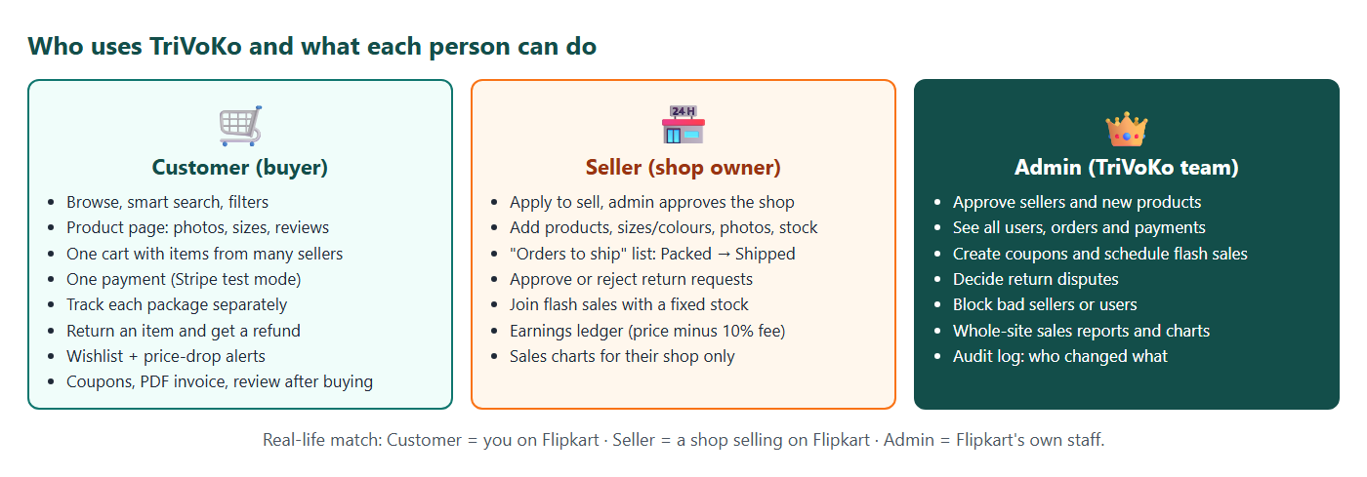
Madhavan Suresh
Java Full Stack main portfolio project · React + Spring Boot + MySQL + Stripe
Version 1.0 · 1 October 2026 · planning document (before Phase 0)

Contents
1. What TriVoKo is and why we are building it 3
1.1 The goal: a job portfolio project 3
1.2 Decisions taken (planning session, 1 October 2026) 3
1.3 What "success" means 3
1.4 What we reuse from EventHub 4
2. Outcomes: what each person can do 5
2.1 A day on TriVoKo (the demo story) 5
2.2 Outcomes per role 5
3. Architecture and technology 7
3.1 Why a modular monolith? 7
3.2 Technology list 8
3.3 Backend modules 8
3.4 Folder layout 9
4. Core flow: cart, checkout and the split order 10
4.1 Cart 10
4.2 Checkout - step by step 10
4.3 Money rules 11
4.4 Package and return states 11
5. The four standout features 13
5.1 Flash sale (standout #1) 13
5.2 Returns and refunds (standout #2) 14
5.3 Price-drop alerts (standout #3) 15
5.4 Smart search (standout #4) 15
6. Database, API and pages 16
6.1 Main tables 16
6.2 API overview 16
6.3 Frontend pages 17
7. Security, testing and quality 18
7.1 Security checklist 18
7.2 Testing plan 18
8. The phase plan 20
8.1 Phases at a glance 20
8.2 Who types what 22
8.3 Must-have core and stretch 22
9. Scope, risks and launch 23
9.1 Not included (on purpose) 23
9.2 Risks and what we do about them 23
9.3 Launch and the portfolio outcome 24
9.4 Next steps after this plan 24

1. What TriVoKo is and why we are building it
TriVoKo is an online marketplace, like a small Flipkart. Many sellers open shops on TriVoKo and list their products. Customers search, put items from different sellers into one cart, pay once, and track every package. The admin team keeps the marketplace safe and running.
Real-life example: Think of Flipkart or Amazon. When you buy a phone from one shop and shoes from another shop in one order, you pay once, but two different shops pack and ship two different boxes. TriVoKo does exactly this.

1.1 The goal: a job portfolio project
TriVoKo is Madhavan's main portfolio project. It will be shown to recruiters and interviewers. That decides three things:
- It must be live online, so an interviewer can click a link and use it.
- It must look polished on laptop and phone.
- It needs standout features that are easy to demo and easy to explain in an interview.

1.2 Decisions taken (planning session, 1 October 2026)
Question | Decision
Why are we building it? | Job portfolio - live, polished, explainable
What kind of shop? | Marketplace - many sellers, one cart, orders split per seller
What is sold? | Everything - electronics, fashion, home, books (general, like Flipkart)
Standout features | Flash sale, Returns & refunds, Price-drop alerts, Smart search
Hosting | Decide at launch - the app is built portable (Docker + environment variables) so free or paid hosting both work
How we build | Claude builds each step and explains it; for the 3 core pieces (flash-sale stock, order split, return state machine) Madhavan types the key logic with guidance
Backend structure | Modular monolith - one Spring Boot app with walled modules; Redis only if the load test proves it is needed

1.3 What "success" means
TriVoKo is finished when all of these are true:
1. An interviewer opens the live link, logs in with a demo account and buys from two sellers in one cart with a Stripe test card.
2. They watch a flash sale start with a countdown, and the stock never goes below zero - proven by a load test with 5,000 virtual users.
3. They return an item and see the refund appear.
4. GitHub shows CI green, about 80% test coverage, and a README with diagrams, GIFs and the load-test graph.
5. Madhavan can explain every standout feature in his own words: how it works, why it was built that way, and what would break without it.

1.4 What we reuse from EventHub
EventHub was the practice. Most building blocks of TriVoKo already exist there, so we copy the pattern and make it bigger.
EventHub feature | Becomes in TriVoKo
Seat hold for 10 minutes + @Version | Stock hold at checkout + flash-sale stock
100-thread "no overbooking" test | 1,000-thread flash-sale test + k6 load test
Event approval state machine (DRAFT → PENDING → PUBLISHED) | Seller approval, product approval, package states, return states
Clubs with organizers | Sellers with their own shop dashboard
Stripe gateway switch + webhook + idempotency | Same, plus partial refunds for returns
Waitlist offer + notification bell + Mailpit emails | Price-drop alerts + order emails
JWT cookie + CSRF + roles | Same, with roles CUSTOMER / SELLER / ADMIN
Analytics with Recharts + @Cacheable | Seller sales charts + admin reports
Testcontainers, JaCoCo, Vitest, CI | Same, plus Playwright end-to-end tests
Docker image + Render/Vercel files | Same launch path, decided at Phase 12

Note: New things to learn in TriVoKo: product variants (size/colour), image upload to Cloudinary, splitting one order into packages, a money ledger, Stripe partial refunds, Hibernate Search (Lucene), k6 load testing and Playwright.

2. Outcomes: what each person can do
Who uses TriVoKo and what each person can do

2.1 A day on TriVoKo (the demo story)
This story is also the script for the demo video and the interview walk-through.
1. Ravi (customer) searches "iphnoe 15". The typo is fixed and iPhone 15 cases show up with filters for brand and price.
2. He adds a phone case from Seller A (Chennai Mobiles) and running shoes from Seller B (Kovai Sports) to one cart.
3. At checkout he picks his saved address, applies coupon WELCOME10 and pays once with the Stripe test card 4242 4242 4242 4242.
4. Order TV-1001 is split into two packages. Chennai Mobiles sees only the phone case; Kovai Sports sees only the shoes.
5. Each seller marks their package Packed → Shipped. Ravi sees two tracking timelines and gets an email at each step.
6. The shoes do not fit. Ravi asks for a return with a reason and a photo. Kovai Sports approves, marks it picked up, and Ravi receives a partial refund of only the shoes (minus their share of the coupon).
7. Kavya (customer) had the same shoes in her wishlist. When Kovai Sports lowers the price, she gets a price-drop alert.
8. At 12:00 PM the admin starts a flash sale: 100 headphones at ₹999. Thousands click at the same moment; exactly 100 win, the rest see "Sold out" instantly.
9. The admin opens reports: sales per day, top sellers, return rate.

2.2 Outcomes per role

Customer
Can do | Shown on page
Browse categories, see deals and flash sales on the home page | Home
Search with typo tolerance and autocomplete; filter by category, brand, price, rating, in stock; sort | Search / listing
See photos, choose size/colour, read verified reviews, see "lowest price in 30 days" | Product page
Add to cart as a guest; the cart is kept after login | Cart
Save addresses, apply a coupon, pay once with Stripe | Checkout
Track every package of an order; download a PDF invoice | My orders / order detail
Cancel before shipping; return within 7 days after delivery | Order detail
Wishlist products and get price-drop alerts | Wishlist, bell, email
Review a product only after buying it | Order detail / product page

Seller
Can do | Shown on page
Apply to become a seller (shop name, city, GST number optional); wait for admin approval | Become a seller
Add and edit products with variants, photos (Cloudinary), price, MRP and stock | Seller → Products
See low-stock warnings | Seller dashboard
See only their own packages and move them Placed → Packed → Shipped (tracking number) | Seller → Orders
Approve or reject return requests (with a reason) | Seller → Returns
Join an admin flash sale with a sale price and a fixed quantity | Seller → Flash sales
See earnings: every sale adds 90% to the ledger, every refund takes it back | Seller → Earnings
See sales charts for their shop (7/30/90 days) | Seller → Analytics

Admin
Can do | Shown on page
Approve or reject seller applications and new products | Admin → Approvals
Search users, sellers and orders; block a seller or user | Admin → Users / Orders
Create coupons (flat or %, minimum order, expiry, one use per customer) | Admin → Coupons
Schedule flash sales and pick which seller offers join | Admin → Flash sales
Decide escalated return disputes | Admin → Returns
Site-wide reports: sales per day, top products, top sellers, return rate | Admin → Reports
Audit log: who changed what and when | Admin → Activity

3. Architecture and technology
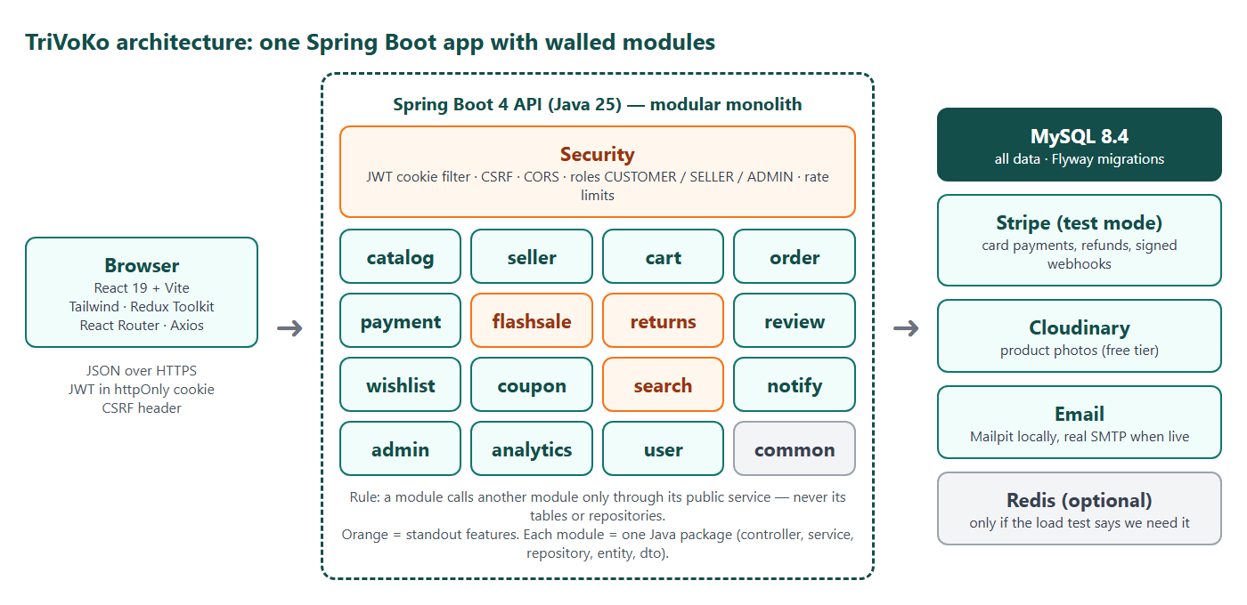
TriVoKo architecture

3.1 Why a modular monolith?
Three ways to structure the backend were compared:
Option | Good | Bad | Decision
1. Modular monolith (one Spring Boot app, one package per module) | One app to host (free or cheap); easy to debug; clear module walls; can be split later | Cannot scale one module alone | Chosen
2. Microservices (product, order, payment services + gateway + Kafka) | Big buzzword | 5+ apps to host - impossible on free hosting; weeks lost on plumbing instead of features | Rejected
3. Monolith + Redis from day one | Strong "high traffic" story | One more thing to host and learn before we know we need it | Only if the k6 load test shows MySQL is too slow

Real-life example: A modular monolith is like one big mall building: every shop (module) has its own walls and its own counter (service), and customers go through the counter - nobody walks into another shop's storeroom (tables). Later, a shop can move into its own building (microservice) without changing how customers talk to it.
Interview answer: "I chose a modular monolith because it is the right size for the traffic and the team. Each module only talks to others through its service interface, so splitting a module into a microservice later is a packaging change, not a rewrite. I measured the flash sale with k6 before deciding whether Redis was needed."

3.2 Technology list
Layer | Technology | Why
Frontend | React 19 + Vite, React Router, Redux Toolkit, Tailwind CSS v4, Axios | Same as EventHub - already known
Frontend extras | Recharts (charts), the useForm hook and UI kit copied from EventHub | Charts for seller and admin; less new code
Backend | Java 25, Spring Boot 4, Spring Web, Spring Data JPA, Spring Security, Validation | Same as EventHub
Database | MySQL 8.4 (Docker locally), Flyway migrations | Same as EventHub
Search | Hibernate Search 8 with the Lucene backend (index stored inside the app) | Typo tolerance + autocomplete without an extra server
Payments | Stripe Checkout (test mode), webhooks, partial refunds | Real payment flow - the carried-over EventHub to-do is done here
Images | Cloudinary free tier (signed upload from the browser) | Photos are not stored in MySQL or in the app
Email | Spring Mail; Mailpit locally; Brevo/SMTP free tier when live | Order and alert emails
PDF | OpenPDF | Invoices (like EventHub certificates)
Testing | JUnit 5, Mockito, Testcontainers, Vitest + React Testing Library, Playwright (end-to-end), k6 (load) | Proof for the README
Quality | JaCoCo coverage, oxlint/ESLint, GitHub Actions CI | Green badge on GitHub
Delivery | Docker image, environment variables, render.yaml / vercel.json or a VPS | Hosting decided at Phase 12
Optional | Redis | Only if the load test needs it

3.3 Backend modules
Every module is one Java package under com.trivoko, with its own controller, service, repository, entity and dto classes.
Module | Owns (tables) | Main job
user | users, user_roles, addresses | Register, login, profile, addresses
seller | sellers, seller_ledger | Seller applications, shop profile, earnings
catalog | categories, products, product_variants, product_images, price_history | Products and stock
cart | carts, cart_items | Cart for guests and users, merge on login
order | orders, packages, order_items | Checkout, order split, package states
payment | payments, refunds, processed_payment_events | Stripe Checkout, webhooks, refunds
flashsale | flash_sales, flash_sale_items, flash_sale_claims | Scheduled sales with atomic stock
returns | return_requests | Return state machine
review | reviews | Verified-buyer reviews and rating average
wishlist | wishlist_items | Wishlist and price-drop alerts
coupon | coupons, coupon_redemptions | Coupon rules
search | (Lucene index) | Search, autocomplete, also-bought
notify | notifications | Bell + emails (after commit, with retry)
admin, analytics | audit_log | Approvals, reports, audit
common | - | Errors (ProblemDetail), money helpers, paging

Note: The module rule: a module may call another module's service, never its repository or entity tables. Modules announce changes with Spring events (for example PackageDelivered, PriceChanged) so that notify, search and analytics can react without being called directly. A small ArchUnit test checks this rule in CI.

3.4 Folder layout
03_TriVoKo_Main_Project/
00_Project_Documents/ master plan, phase plan, guides
Phase_0_Setup/ ... Phase_12_Launch/ one checklist document per phase
backend/ Spring Boot app (package com.trivoko.*)
frontend/ React app
docker-compose.yml MySQL + Mailpit for development
load-tests/ k6 scripts and results
e2e/ Playwright tests
tools/ document generators, demo scripts

4. Core flow: cart, checkout and the split order
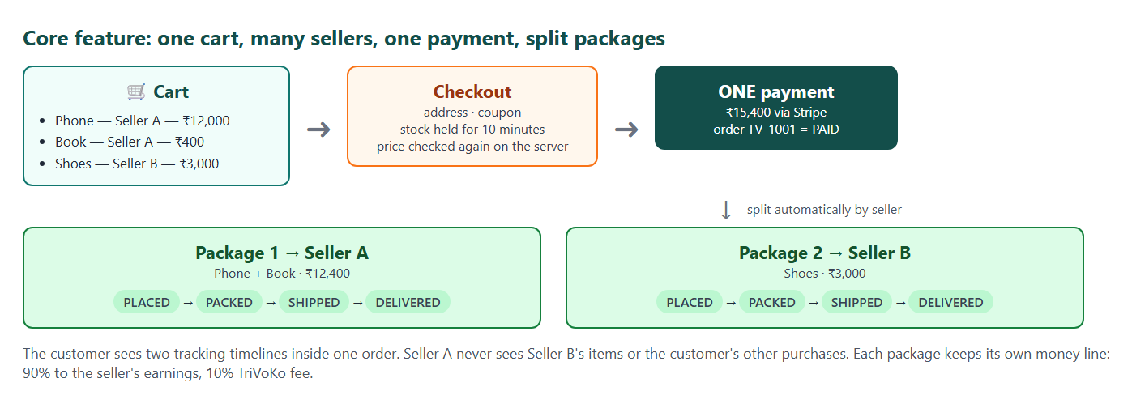
One cart, many sellers, one payment, split packages

4.1 Cart
- A guest can add to cart. The cart lives in the browser (localStorage) with a guest token.
- After login, the guest cart is merged into the user's saved cart (same variant = quantities added, capped by stock).
- The cart shows items grouped by seller, so the customer already sees "this will come in 2 packages".
- Prices in the cart are only for display. The server always recalculates prices at checkout - a changed price is shown to the customer before paying.

4.2 Checkout - step by step
1. Customer chooses an address (or adds one) and optionally a coupon.
2. Server checks: every product still ACTIVE, every seller still APPROVED, coupon valid, quantities ≤ 10 per item.
3. Server holds the stock for every item in one transaction:

UPDATE product_variants SET stock = stock - :qty WHERE id = :id AND stock >= :qty If any line returns 0 rows, the whole checkout is rolled back and the customer is told which item ran out.
4. Server creates the order (status PENDING_PAYMENT, hold 10 minutes) and one package per seller. Order items copy the title, variant and price, so later product changes never change an old order.
5. Server creates a Stripe Checkout session for the full amount and the customer pays.
6. The Stripe webhook (or the "verify on return" fallback from EventHub) marks the order PAID; every package becomes PLACED; each seller gets an email; the coupon is marked used.
7. If nobody pays within 10 minutes, a job (every minute) marks the order EXPIRED and puts the stock back. A payment that arrives late re-takes the stock if still free, otherwise it is refunded automatically (same rule as EventHub).

Real-life example: IRCTC Tatkal works like this: when you click "Book", the seat is kept for you while you pay. If the payment page times out, the seat goes back to the pool.

4.3 Money rules
- All money is stored as DECIMAL(12,2) in rupees; Stripe receives paise (₹15,400.00 → 1540000).
- Coupon discount is split across packages and items in proportion to their price, and stored on each order item. This makes partial refunds exact later.
- When a package is DELIVERED, the seller ledger gets +90% of that package's paid amount; TriVoKo keeps 10%. A refund adds a matching minus line. The seller's balance = sum of the ledger. (No real bank payouts - out of scope.)
- Shipping fee: free above ₹499 per package, otherwise ₹40 per package (simple fixed rule).

4.4 Package and return states
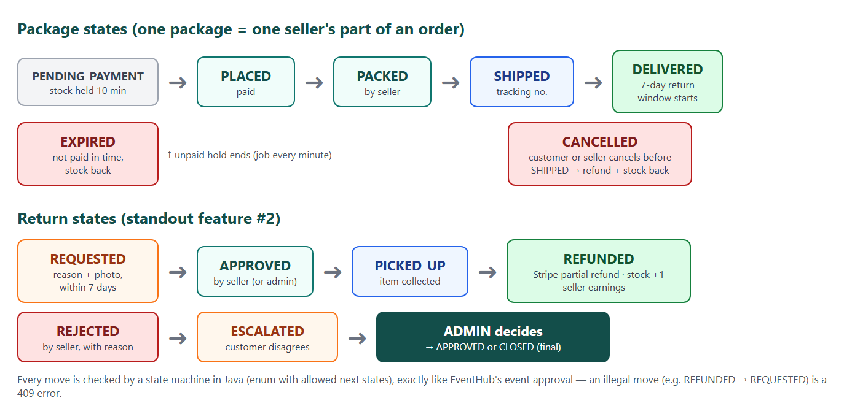
Package and return state machines
Move | Who | Rule
PENDING_PAYMENT → PLACED | system | Payment confirmed (webhook or verify)
PENDING_PAYMENT → EXPIRED | system job | 10 minutes passed, not paid - stock back
PLACED → PACKED | seller | Own package only
PACKED → SHIPPED | seller | Tracking number required
SHIPPED → DELIVERED | seller (simulated courier) or demo button | Starts the 7-day return window, adds ledger line
PLACED / PACKED → CANCELLED | customer or seller | Before shipping only; refund that package; stock back

Note: Each state list is a Java enum with an allowedNext() method, exactly like EventHub's EventStatus.nextAllowed. Package rows have @Version, so if the customer cancels at the same moment the seller ships, only one wins and the other gets a clear 409 message.

5. The four standout features
These are the features that make TriVoKo different from a tutorial clone. Each one has a clear rule, a clear proof, and a clear interview story.

5.1 Flash sale (standout #1)
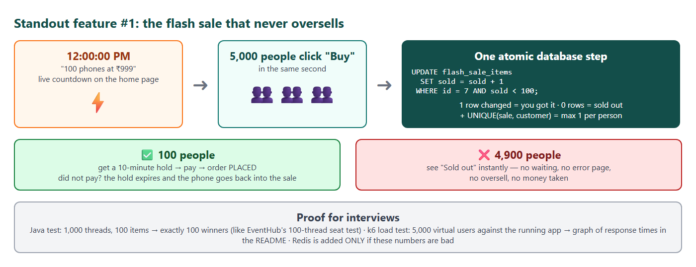
The flash sale that never oversells
What the user sees: a "Flash sale starts in 00:04:59" banner on the home page. At 12:00 the button turns on, a live "73 left" counter drops, and when it reaches 0 the button changes to "Sold out".
How it works:
1. The admin creates a flash sale (start time, end time). Sellers offer variants with a sale price and a fixed quantity (for example 100). That quantity is taken out of normal stock when the sale is scheduled, so normal buyers and flash buyers never fight over the same units.
2. "Buy now" calls POST /api/flash-sales/{id}/items/{itemId}/claim.
3. The server runs one atomic update: UPDATE flash_sale_items SET sold = sold + 1 WHERE id = ? AND sold < quantity AND NOW() BETWEEN start AND end. One row changed = you got one. Zero rows = sold out (or not started / ended).
4. A row in flash_sale_claims with UNIQUE(sale_item, customer) stops anyone buying twice.
5. The winner gets a normal 10-minute checkout hold at the sale price. If they do not pay, the expiry job does sold = sold - 1 and the unit is back in the sale.
6. When the sale ends, unsold units go back to normal stock.

Proof:
- Java test (like EventHub's BookingConcurrencyTest): 1,000 threads, 100 units → exactly 100 claims, sold = 100, never 101.
- k6 load test: 5,000 virtual users hit the running app at once. The README shows the result: requests per second, p95 response time, number of winners (must be exactly 100) and zero errors.
- Only if p95 is too slow (target: under 500 ms on a laptop), the counter moves to Redis (DECR), and we measure again and show both graphs.

Note: You type this part: the claim SQL, the unique check and the expiry give-back. Claude explains first and reviews after.
Interview story: "Instead of reading stock and then writing it - which lets two people both see 1 left - I let MySQL do check-and-decrement in a single statement, so the database itself guarantees no oversell. I proved it with a 1,000-thread test and a 5,000-user k6 run."

5.2 Returns and refunds (standout #2)
The return states are in the diagram in chapter 4.
Rules:
- A return can be requested only for a DELIVERED item, within 7 days, once per order item, with a reason (list) and an optional photo (Cloudinary).
- The seller must answer within 2 days; if not, the request is auto-approved by a job (marketplace protects the buyer).
- If the seller rejects, the customer can escalate once; the admin makes the final decision.
- On PICKED_UP, the server calls Stripe refund for item price × qty − item's coupon share (a partial refund of the original payment). The refund is idempotent: a unique key per return request, so a double click or a retried webhook never refunds twice.
- Refund done → stock +qty, seller ledger minus line, customer email + bell.

Note: You type this part: the ReturnStatus enum with allowedNext(), and the service method that moves states. Claude writes the Stripe refund call and the tests around it.
Interview story: "Returns are a state machine. Every move is validated, every refund is idempotent, and money always matches: the ledger line, the Stripe refund and the stock change happen together."

5.3 Price-drop alerts (standout #3)
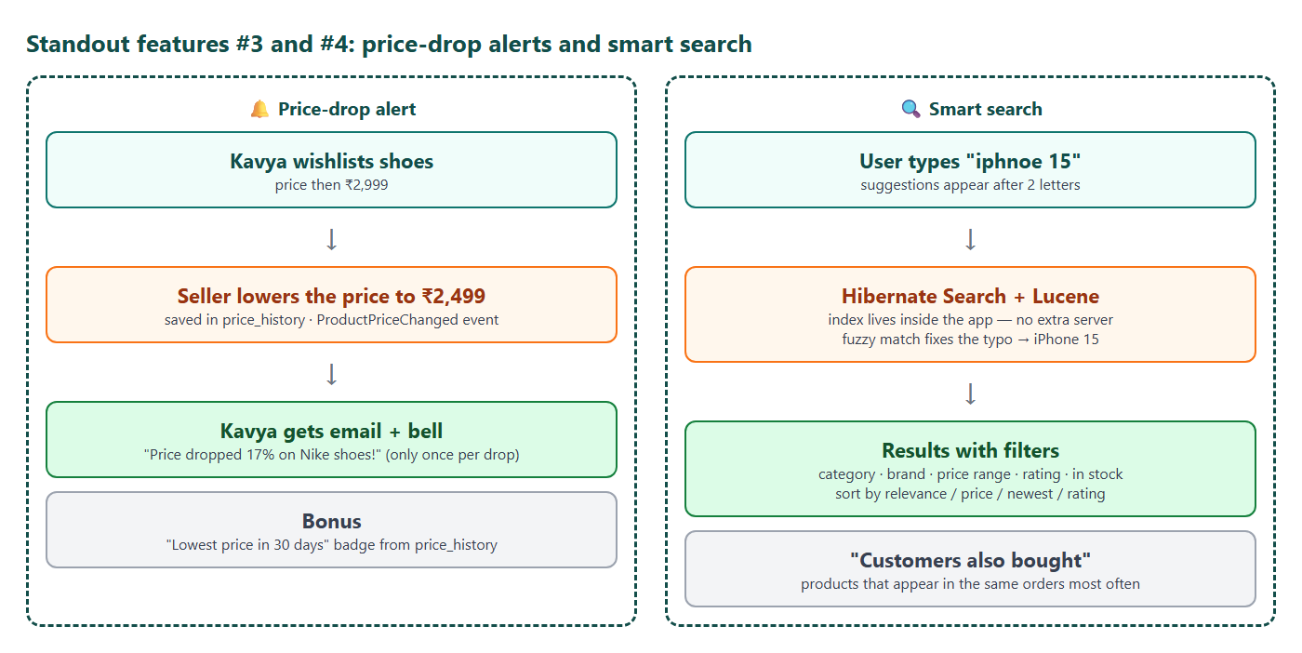
Price-drop alerts and smart search
- Every price change writes a row to price_history and publishes a PriceChanged Spring event.
- A listener finds wishlist entries for that variant where the new price is lower than both the price when added and the last alerted price.
- One notification + email per customer per drop (stored last_alert_price stops spam if the seller changes the price 5 times in a minute - alerts are sent by a job every 10 minutes using the latest price).
- The product page shows "Lowest price in 30 days" using price_history - useful and honest.

5.4 Smart search (standout #4)
- Hibernate Search keeps a Lucene index of products inside the app (no Elasticsearch server to host). It updates automatically when a product changes.
- Typo tolerance: fuzzy matching ("iphnoe" → iPhone). Autocomplete: suggestions after 2 letters.
- Filters and facets: category, brand, price range, rating, in-stock - with counts ("Samsung (12)").
- Sort: relevance, price low/high, newest, rating.
- Customers also bought: products that appear together in paid orders most often (a SQL query, cached for 1 hour).

Note: If Hibernate Search causes trouble on free hosting (the index needs disk space), the fallback is MySQL FULLTEXT search without typo tolerance. This decision is checked in Phase 10.

6. Database, API and pages

6.1 Main tables
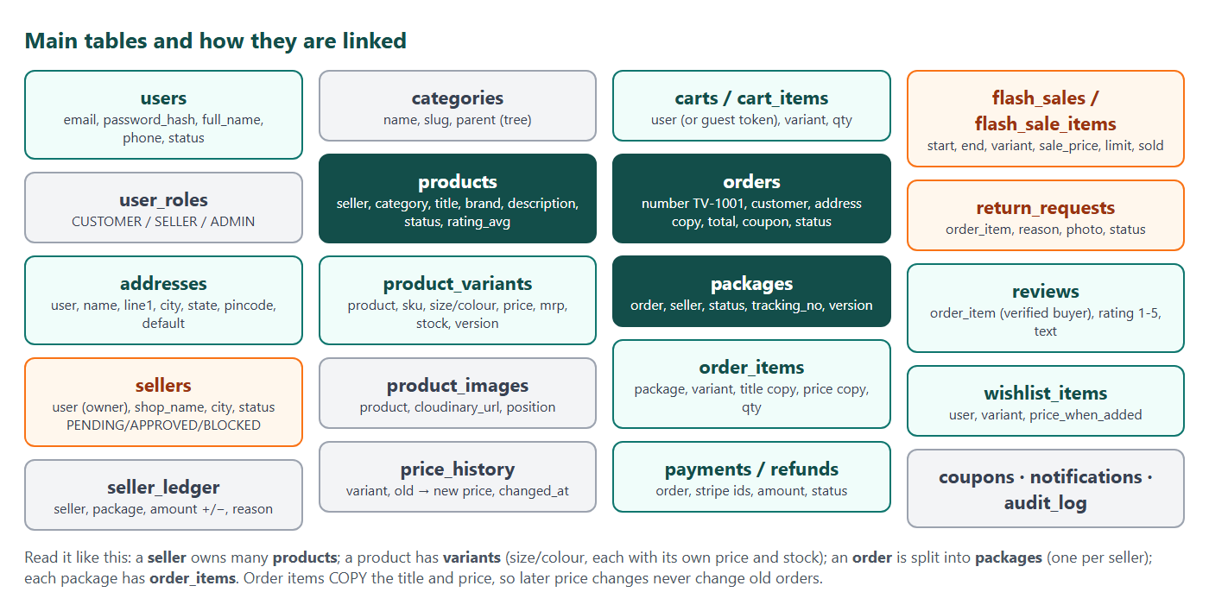
Main tables and how they are linked
Important database rules:
- Order items copy the product title, variant text and price. An old invoice never changes.
- Stock lives on the variant (size M of a T-shirt has its own stock), not on the product.
- Rows that many people change at once (product_variants, packages, flash_sale_items) have a version column or use a single atomic UPDATE ... WHERE.
- Status columns are VARCHAR + CHECK (not MySQL ENUM) - the EventHub rule.
- Every table change is a Flyway migration (V1, V2, ...). Nothing is changed by hand.

6.2 API overview
Group | Examples | Who
Auth | POST /api/auth/register, /login, /logout, GET /api/auth/me | anyone
Catalogue | GET /api/products?q=&category=&brand=&min=&max=&sort=, GET /api/products/{slug}, GET /api/categories | anyone
Search | GET /api/search?q=, GET /api/search/suggest?q= | anyone
Cart | GET/PUT/DELETE /api/cart/items, POST /api/cart/merge | customer
Checkout | POST /api/checkout → order + Stripe URL, POST /api/payments/{session}/verify | customer
Orders | GET /api/orders, GET /api/orders/{number}, POST /api/packages/{id}/cancel, GET /api/orders/{number}/invoice.pdf | customer (own)
Returns | POST /api/order-items/{id}/returns, POST /api/returns/{id}/escalate | customer (own)
Wishlist & reviews | POST/DELETE /api/wishlist/{variantId}, PUT /api/order-items/{id}/review | customer
Flash sales | GET /api/flash-sales/live, POST /api/flash-sales/{id}/items/{itemId}/claim | anyone / customer
Seller | /api/seller/products, /api/seller/packages/{id}/pack, /ship, /deliver, /api/seller/returns/{id}/approve, /reject, /picked-up, /api/seller/earnings, /api/seller/analytics | approved seller (own data only)
Admin | /api/admin/sellers/{id}/approve, /api/admin/products/pending, /api/admin/coupons, /api/admin/flash-sales, /api/admin/returns/{id}/decide, /api/admin/reports | admin
Payments | POST /api/payments/stripe/webhook (signed) | Stripe only

All errors use the EventHub ProblemDetail format (400 / 401 / 403 / 404 / 409 / 429) with a clear message for each field. Swagger shows the full list (admin only when live).

6.3 Frontend pages
Area | Pages
Shop (public) | Home (deals, flash-sale banner, categories), Search/listing with filters, Product page, Seller shop page, Cart, Login, Register, Become a seller
Customer | Checkout, Payment result, My orders, Order detail (tracking timelines, invoice, cancel, return, review), Wishlist, Addresses, Notifications
Seller | Dashboard (today's orders, low stock, earnings), Products list + product editor (variants, photos), Orders to ship, Returns, Flash-sale offers, Earnings ledger, Analytics
Admin | Overview, Seller approvals, Product approvals, Users, Orders, Coupons, Flash sales, Return disputes, Reports, Activity log
Other | 404 page, Style guide (dev only), dark mode on every page, mobile layout on every page

Note: Design: a fresh TriVoKo look (teal + saffron colours, new logo), built on the EventHub UI kit (Button, Card, Badge, Modal, FormField, Toaster). Sketches of the 6 key pages are made in Phase 0 and approved before coding the frontend.

7. Security, testing and quality

7.1 Security checklist
Risk | Protection
Stolen login | JWT in an httpOnly, Secure, SameSite cookie; BCrypt passwords; 5 failed logins → 15-minute lock (EventHub LoginAttemptService)
Forged requests from other sites | CSRF double-submit token (EventHub pattern)
Seller A reading Seller B's orders | Every seller query is filtered by the logged-in seller's id; @PreAuthorize ownership checks; tests that try to read another seller's package must get 403/404
Customer changing prices in the browser | Server recalculates every price, discount and shipping fee at checkout
Fake payment confirmation | Stripe webhook signature check; idempotent processing (EventHub processed_payment_events)
Double refund | One refund key per return request; Stripe idempotency key
Bot spamming the flash sale | Rate limit per user/IP on claim (429 + Retry-After); one claim per customer
Bad file uploads | Signed Cloudinary uploads only, images only, max 5 MB, max 8 photos
Secrets in Git | .env git-ignored; secret scan of the history before launch
Admin tools exposed | Swagger and Actuator for ADMIN only in production

7.2 Testing plan
Level | Tool | What is tested | Target
Unit | JUnit 5 + Mockito | Money maths (coupon split, refund amount, ledger), state machines, rules | Every rule
Integration | @SpringBootTest + MockMvc + Testcontainers MySQL | Every endpoint, security per role, flows (checkout → pay → split → ship → return → refund) | Service coverage ~80% (JaCoCo)
Concurrency | Plain Java threads | Flash sale 1,000 threads / 100 units; checkout stock hold 100 threads / 10 units; cancel-vs-ship race | Never oversell, always one winner
Frontend | Vitest + React Testing Library | Cart maths, forms, countdown, key components | Main components
End-to-end | Playwright | The demo story in a real browser: buy from 2 sellers, seller ships, customer returns | Runs in CI
Load | k6 | Flash sale with 5,000 virtual users; product listing under load | Exactly 100 winners, p95 < 500 ms locally
Manual | Phone + laptop, light + dark | Every page | No layout bugs

Note: Every phase ends with: tests pass locally, CI green on GitHub, commit pushed, and the "done when" checks of that phase shown working in the browser.

8. The phase plan
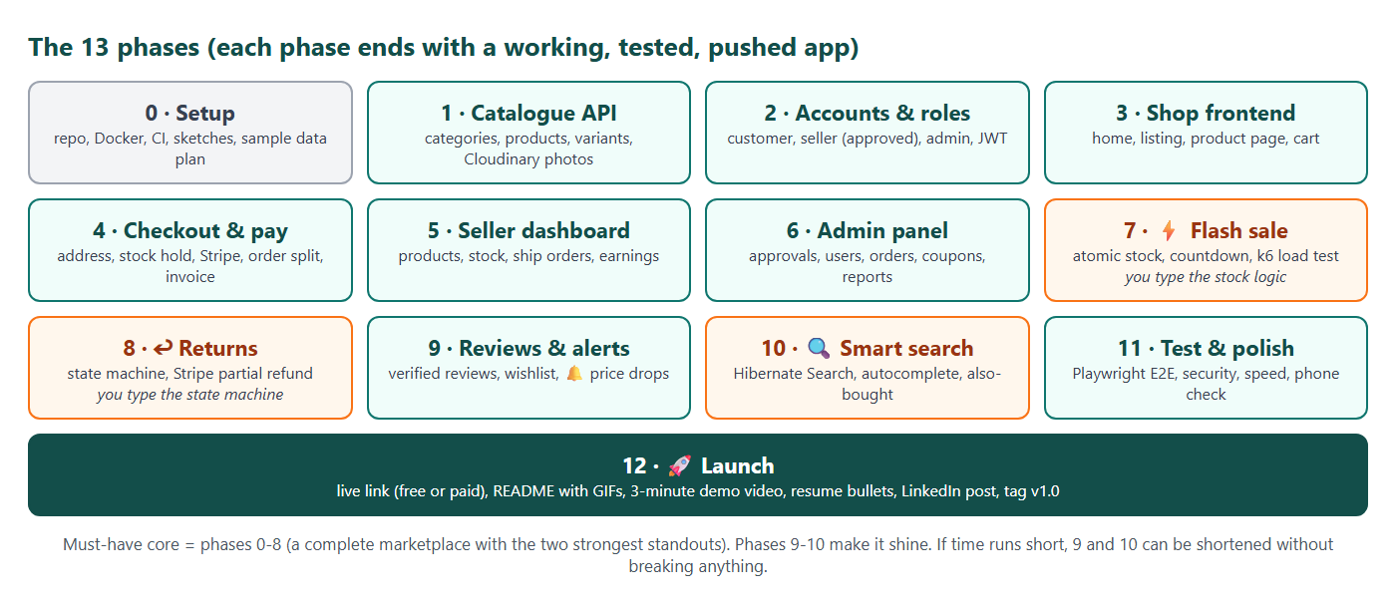
The 13 phases
Each phase gets its own folder (Phase_N_Name) with a checklist document - like EventHub. The table below is the summary; the detailed step checklists are written next, after this master plan is approved.

8.1 Phases at a glance
Phase | Goal | Main work | Done when
0 Setup | Project ready to build | Git repo trivoko on GitHub, Spring Boot + React skeletons, docker-compose (MySQL, Mailpit), CI, .env, logo and colours, sketches of 6 key pages, sample-data plan (8 sellers, 120 products, 10 categories) | React shows "Backend: UP"; CI green; sketches approved
1 Catalogue API | Products exist | Tables categories / products / variants / images / price_history; seed data; listing with filters, paging and sorting; product detail; Cloudinary signed upload | GET /api/products?category=phones&sort=price returns correct pages; Postman checks pass
2 Accounts & roles | Safe login for 3 roles | Register/login/logout/me (EventHub auth), addresses, "Become a seller" + admin approval, ownership checks, demo accounts | Seller cannot touch another seller's product (test proves 403); unapproved seller cannot sell
3 Shop frontend | Customer can shop (no payment yet) | Home, listing with filters in the URL, product page with variant picker and gallery, cart grouped by seller, guest cart + merge on login, dark mode, mobile | Guest adds 3 items from 2 sellers, logs in, cart is kept
4 Checkout & payments | Real orders | Stock hold, order + packages split, coupons, Stripe Checkout + webhook + verify fallback, expiry job, late-payment rule, emails, PDF invoice, real Stripe 4242 test with Stripe CLI (EventHub to-do) | Pay once for 2 sellers → 2 packages PLACED; 100-thread stock test passes
5 Seller dashboard | Sellers run their shop | Product editor with variants + photos, stock warnings, orders to ship (Packed → Shipped → Delivered), earnings ledger, analytics charts | Seller ships a package and the customer sees the timeline update
6 Admin panel | Admin controls the marketplace | Seller + product approvals, users/orders search, block, coupons, reports, audit log | Admin blocks a seller → their products disappear from the shop
7 Flash sale | Standout #1 | Schedule sale, reserve stock, atomic claim, one per customer, countdown + live counter, rate limit, give-back job, 1,000-thread test, k6 5,000 users, Redis only if needed | k6 report: exactly 100 winners, 0 oversell, p95 recorded in README
8 Returns & refunds | Standout #2 | ReturnStatus state machine, photo upload, seller approve/reject, auto-approve job, escalate + admin decision, Stripe partial refund, stock + ledger update | Return one item of a 2-item order → exact partial refund in Stripe test dashboard
9 Reviews, wishlist, alerts | Standout #3 | Verified-buyer reviews + rating average, wishlist, price_history, price-drop job + email + bell, "lowest in 30 days" | Lower a price → wishlisted customer gets one alert (not five)
10 Smart search | Standout #4 | Hibernate Search + Lucene, fuzzy match, autocomplete, facets with counts, "customers also bought" | "iphnoe" finds iPhone; suggestions appear while typing
11 Testing & polish | Portfolio quality | Playwright demo-story test in CI, coverage ~80%, ArchUnit module rule, security review, accessibility + phone check, speed (lazy pages, image sizes), README draft | CI green with E2E; Lighthouse ≥ 90 on home page
12 Launch | Live and shown | Choose hosting (free or paid), deploy backend + DB + frontend, real email, demo accounts, README with GIFs + architecture + k6 graph, 3-minute demo video, resume bullets, LinkedIn post, tag v1.0 | A friend opens the link on a phone, buys, returns, and it all works

8.2 Who types what
Part | Built by
Setup, configuration, copies of EventHub patterns (auth, errors, UI kit, Stripe gateway, emails) | Claude builds and explains line by line
Catalogue, cart, seller and admin pages, reports | Claude builds and explains; Madhavan reviews and asks for changes
Order split (grouping cart lines into packages, coupon share per item) | Madhavan types the key method with guidance, Claude reviews
Flash-sale claim (atomic SQL, one-per-customer, give-back) | Madhavan types with guidance, Claude reviews
Return state machine (ReturnStatus.allowedNext, state-move service) | Madhavan types with guidance, Claude reviews
Tests for the three parts above | Written together - Madhavan writes at least one test for each

8.3 Must-have core and stretch
- Must-have core = Phases 0-8. This is already a complete marketplace with the two strongest standouts (flash sale + returns).
- Shine = Phases 9-10. If time is short, 9 and 10 can be made smaller (for example search without facets) without breaking anything else.
- Always = Phases 11-12. A portfolio project that is not tested, not live and not explained is not finished.

9. Scope, risks and launch

9.1 Not included (on purpose)
Left out | Why | What we do instead
Real courier API (Delhivery, Shiprocket) | Needs a business account | Seller clicks Shipped/Delivered; tracking timeline is simulated
Real bank payouts to sellers | Needs Stripe Connect + KYC | Earnings ledger shows what each seller would receive
Cash on delivery, UPI, EMI | More payment flows, little extra learning | Stripe test card only
Seller-created coupons | Doubles the coupon rules | Admin coupons only
Mobile app, multiple languages | Big extra work | Mobile-friendly website
Full GST invoicing | Tax rules are complex | Simple invoice PDF with price, discount, shipping, total
Chat between buyer and seller | Real-time features are a separate project | Return reason + seller reply text

9.2 Risks and what we do about them
Risk | Plan
Project is too big and never finishes | Core = Phases 0-8 first; every phase ends with a working, pushed app; 9-10 can shrink
Free hosting is slow to wake up | Hosting chosen at Phase 12; uptime pinger for free hosting, or a paid plan only during job-hunting months
Hibernate Search needs disk on the host | Index can be rebuilt on start-up (120-500 products takes seconds); fallback = MySQL FULLTEXT
Stripe test webhooks are hard locally | EventHub "verify on return" fallback; Stripe CLI in Phase 4
Cloudinary or email free limits | Small sample images; emails only for important steps; Mailpit locally
Madhavan cannot explain a part in an interview | The 3 core parts are typed by him; every phase ends with a short "explain it back" check; viva Q&A in the final guide
Spring Boot 4 / Java 25 library gaps | Same versions as EventHub, which already work; check each new library (Hibernate Search, Playwright, k6) in a small spike first

9.3 Launch and the portfolio outcome
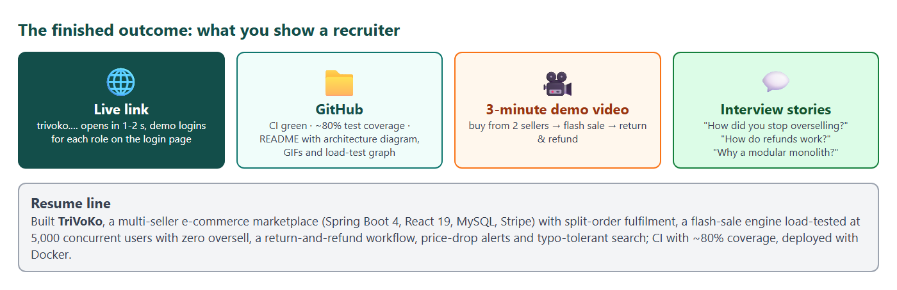
What you show a recruiter
Hosting choices at Phase 12 (the code is the same for all of them):
Choice | Cost | First load | Notes
Free: Render + Aiven MySQL + Vercel | ₹0 | 30-60 s when asleep | Uptime pinger keeps it warm during job hunting
Small paid: Railway or a VPS | about ₹400-600 per month | 1-2 s | Can be paid only for the months of applying

Launch package:
- Live link with demo logins for customer, seller and admin on the login page.
- GitHub README: what it is, GIFs of the demo story, architecture diagram, ER diagram, k6 graph, how to run locally, test coverage badge.
- 3-minute demo video (English; Tamil version optional, like EventHub).
- Resume bullet and LinkedIn post.
- Final project guide + viva Q&A document (like the EventHub 105-page guide).
- Git tag v1.0.

9.4 Next steps after this plan
1. Madhavan reviews this master plan and asks for changes.
2. Claude writes the TriVoKo Phase Plan (step-by-step checklist for every phase, with "done when" checks) and the Phase folders.
3. Phase 0 starts: GitHub repo trivoko, skeleton apps, Docker, CI, logo and sketches.

