TriVoKo
Multi-seller E-commerce Marketplace
Sketches & Sample Data
The 6 key pages sketched before coding, and the plan for the 120 sample products, 8 sellers and their photos
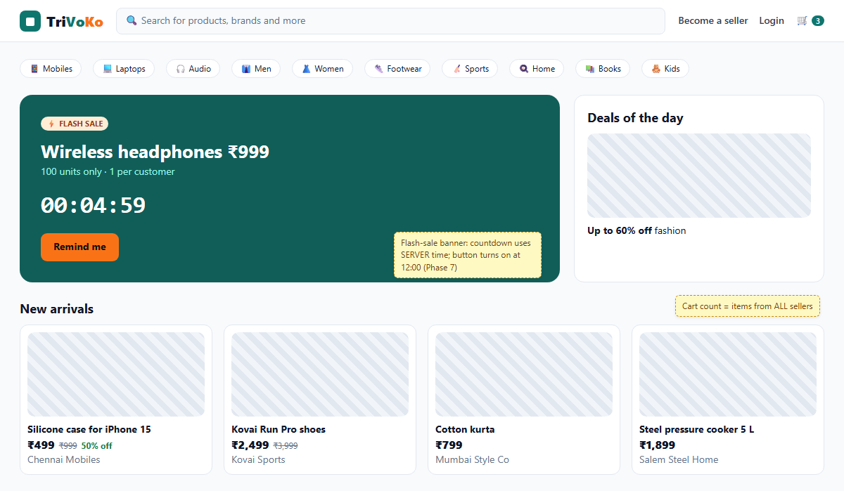
Madhavan Suresh
Java Full Stack main portfolio project · React + Spring Boot + MySQL + Stripe
Version 1.0 · 3 October 2026 · Phase 0 steps 12-13, for approval

Contents
1. Sketches of the 6 key pages 2
1.1 Home 2
1.2 Search / listing 3
1.3 Product page 3
1.4 Cart 4
1.5 Checkout 4
1.6 Seller dashboard 5
2. Sample-data plan 6
2.1 Numbers 6
2.2 The 10 categories 6
2.3 The 8 sellers (+1 pending) 7
2.4 Prices and stock 7
2.5 Where the product photos come from 7
2.6 Demo accounts (created in Phase 2) 8

1. Sketches of the 6 key pages
These are low-detail sketches: they fix the layout, the content of each page and the rules behind it - not the final pixels. Striped boxes are product photos. Yellow notes explain the rule behind a part of the page and the phase that builds it.
Real-life example: An architect shows the family a simple drawing of each room before building: where the door is, where the kitchen goes. Moving a wall on paper costs nothing; moving it after the bricks are laid costs a lot. These sketches are that paper.
Design rules used on every page:
- Teal (brand) for trust: buttons, links, the logo. Saffron (accent) only for deals and the flash sale, so the eye goes there.
- White cards with soft borders on a light grey page; the same cards in dark grey in dark mode.
- Prices: big selling price, crossed-out MRP, green "% off". Money in Indian format (₹2,499; ₹48,210).
- Every page also has a phone layout and a dark mode (checked in Phase 3).

1.1 Home
Home: categories, flash-sale banner with countdown, deals, new arrivals

1.2 Search / listing
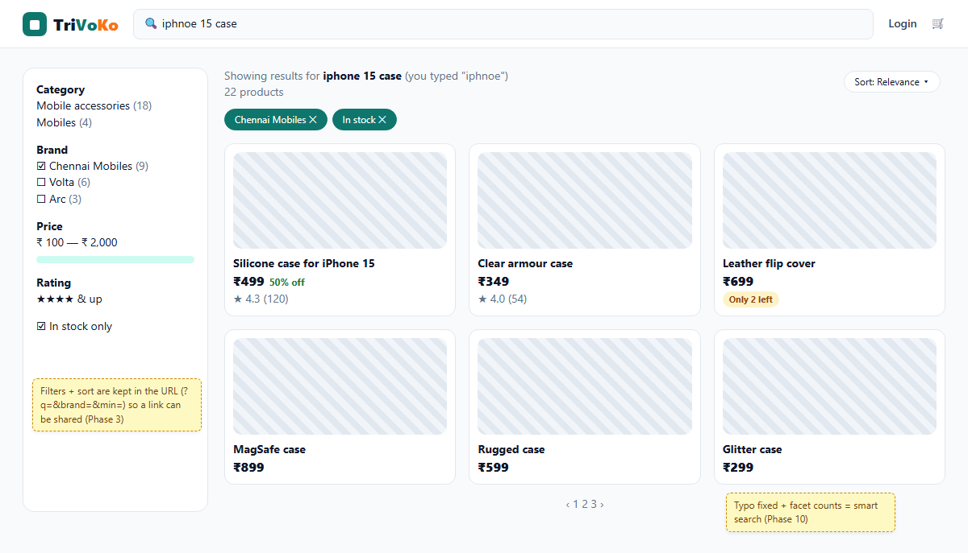
Search: typo fixed, filters with counts, chips for active filters, sort, pages

1.3 Product page
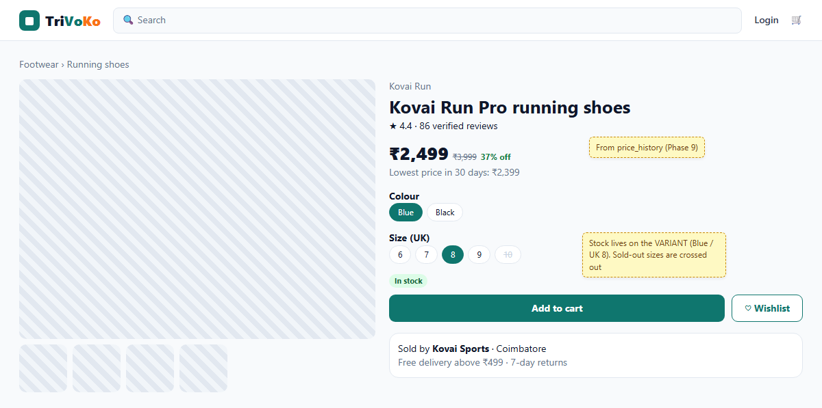
Product: gallery, variant picker (colour, size), price with MRP and lowest price in 30 days, seller box

1.4 Cart
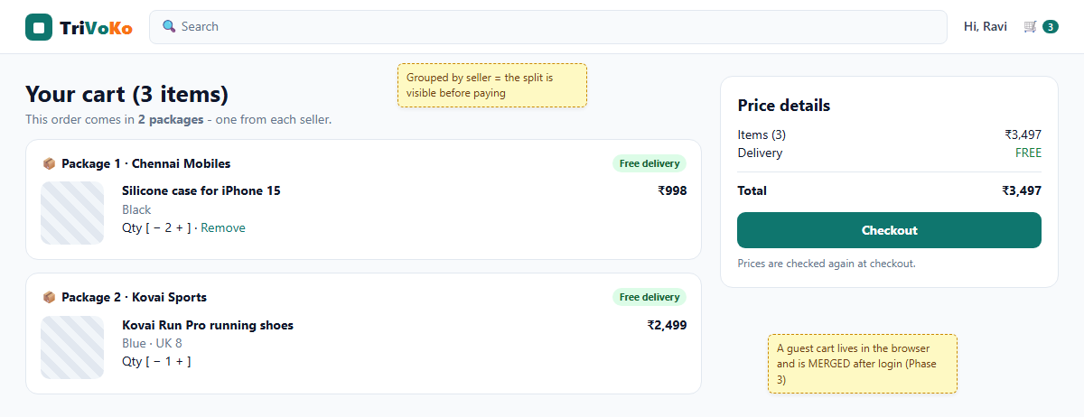
Cart grouped by seller: the customer sees "2 packages" before paying

1.5 Checkout
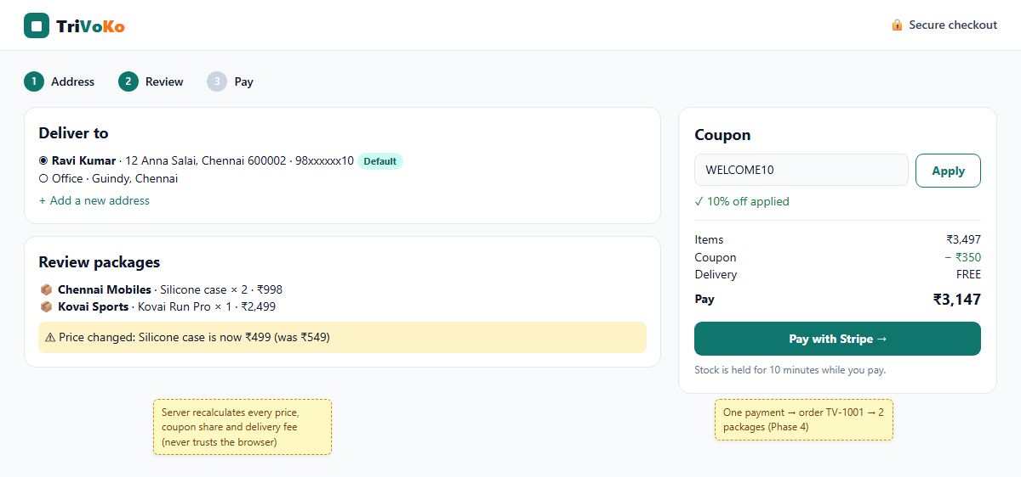
Checkout: address, packages review, price-changed warning, coupon, one Stripe payment

1.6 Seller dashboard
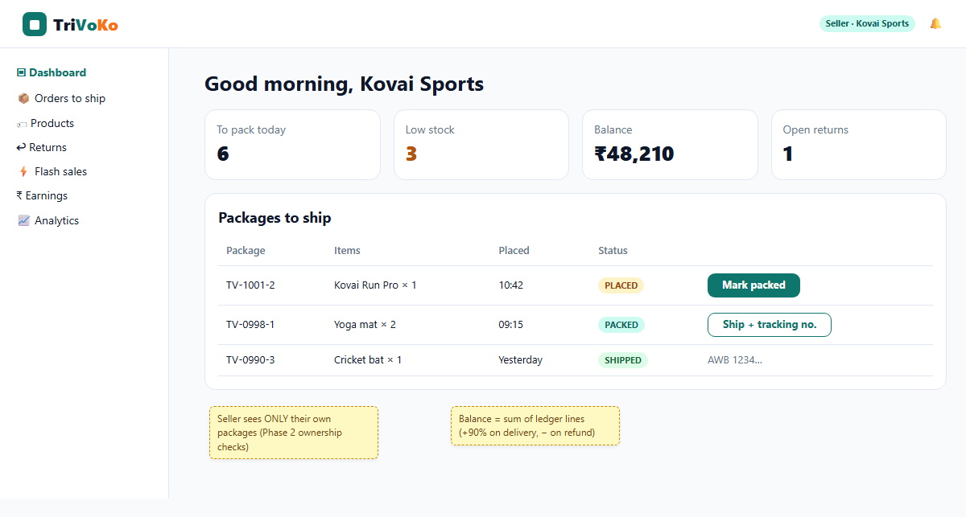
Seller dashboard: today's numbers and the packages this seller must ship
Note: The sketches are made from docs/sketches/sketches.html (render with tools/sketches/render.ps1), so a change is quick: edit the HTML and render again.

2. Sample-data plan
The shop must look real on day one of the demo: enough products to make search, filters and paging meaningful, and sellers whose names tell the demo story. The data is loaded by a Flyway migration in Phase 1 (V2 seed), so every computer and the live server get exactly the same shop.
Real-life example: A new supermarket does not open with empty shelves. Before the first customer walks in, the staff fill every aisle with a few of each item, so the shop looks and works like a real shop.

2.1 Numbers
What | How many | Why this number
Top categories | 10 | One row of category chips on the home page
Sub-categories | 2-3 per category (25) | The category filter has something to filter
Sellers (approved) | 8 | Enough for "top sellers" reports and the shop pages
Sellers (pending, for the approval demo) | 1 | The admin has something to approve in Phase 6
Products | 120 (12 per category) | 5 pages of 24 = real paging; facets with useful counts
Variants | about 300 | Sizes for fashion and shoes, colours / storage for phones
Photos | 1-4 per product (about 250) | Gallery on the product page

2.2 The 10 categories
Category | Sub-categories | Variants by
Mobiles & Accessories | Mobiles, Cases & covers, Chargers & cables | Colour, storage
Laptops & Computers | Laptops, Keyboards & mice, Storage | RAM / storage
Audio & Wearables | Headphones, Speakers, Smartwatches | Colour
Men's Fashion | Shirts, T-shirts, Kurtas | Size S-XXL, colour
Women's Fashion | Sarees, Kurtis, Tops | Size, colour
Footwear | Running shoes, Sandals, Formal shoes | UK size 5-11
Sports & Fitness | Cricket, Yoga & gym, Cycling | Size / weight
Home & Kitchen | Cookware, Storage, Decor | Capacity
Books | Fiction, Programming, Tamil books | Paperback / hardcover
Kids & Toys | Toys, Kids wear, School | Age / size

2.3 The 8 sellers (+1 pending)
Shop | City | Sells | Demo role
Chennai Mobiles | Chennai | Mobiles & accessories | Package 1 of order TV-1001 (iPhone 15 case)
Kovai Sports | Coimbatore | Sports, footwear | Package 2 of TV-1001 (shoes); the return + partial refund
Bengaluru Gadget Hub | Bengaluru | Laptops, audio, wearables | Offers the flash-sale headphones (100 at ₹999)
Madurai Handlooms | Madurai | Women's fashion, sarees | Size variants, price-drop alert for Kavya
Mumbai Style Co | Mumbai | Men's fashion | Size + colour variants
Salem Steel Home | Salem | Home & kitchen | Low-stock warning example
Pondy Books | Puducherry | Books | Simple products without sizes
Tirupur Kids Wear | Tirupur | Kids & toys | Age-size variants
Erode Organics (PENDING) | Erode | Grocery-style home items | Waits for admin approval in the demo

Note: Shop names are made up for the demo. Brands are made up too (for example Kovai Run, Volta, Arc), so no real company's products or prices are copied. Product names may say what they fit ("case for iPhone 15"), as real accessory shops do.

2.4 Prices and stock
- Prices in rupees with realistic ranges: ₹199 (cable) to ₹74,999 (laptop). MRP 10-50% above the selling price, so "% off" looks real.
- Stock between 0 and 60 per variant. On purpose: some variants sold out (crossed-out size), some below 5 (low-stock warning), most comfortable.
- A few products get 3-4 old prices in price_history, so "lowest price in 30 days" and price-drop alerts have data from the start.
- Every seed product is ACTIVE except 3 PENDING products (product-approval demo) and 1 REJECTED with a reason.

2.5 Where the product photos come from
Option | Good | Bad
A. Free stock photos (Pexels / Unsplash licence) → Cloudinary (chosen) | Real photos look professional in the portfolio; free licence allows use without payment; Cloudinary resizes them | About 250 photos to pick; must keep a credits file
B. Generated simple illustrations (SVG per category) | No licence questions; tiny files | Looks like a toy shop, weak in a portfolio
C. Grey placeholders | Zero work | Looks unfinished

Plan: in Phase 1, pick photos from Pexels / Unsplash (free licence), upload them once to the TriVoKo Cloudinary account with a script, and keep docs/photo-credits.csv (product, photo page URL, photographer). The seed migration stores only the Cloudinary URLs. Until the Cloudinary account exists, products show a neutral placeholder.

2.6 Demo accounts (created in Phase 2)
Account | Role | Used for
admin@trivoko.test | ADMIN | Approvals, flash sale, reports
ravi@trivoko.test | CUSTOMER | The main demo story (buys from 2 sellers, returns shoes)
kavya@trivoko.test | CUSTOMER | Wishlist + price-drop alert
chennai@trivoko.test, kovai@trivoko.test ... | SELLER | One login per demo seller

The password comes from .env (DEMO_PASSWORD), never from the code - the EventHub rule.

