POLYNOMIAL REGRESSION

A = np.array([[2, 1], [1, 3]])
This creates the matrix:
A = [2 1
1 3]

Meaning
The matrix contains the coefficients of the variables.
Suppose we have:
2x1+x2=4
x1​+3x2​=7
The coefficients are:
Equation | x₁ coefficient | x₂ coefficient
1 | 2 | 1
2 | 1 | 3

Therefore,
[[2,1],
[1,3]]

B = np.array([4, 7])

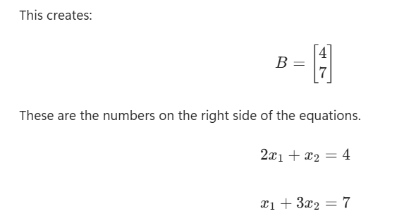

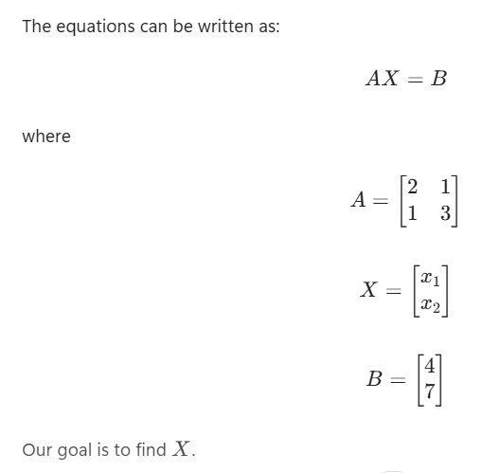

np.linalg.inv(A)

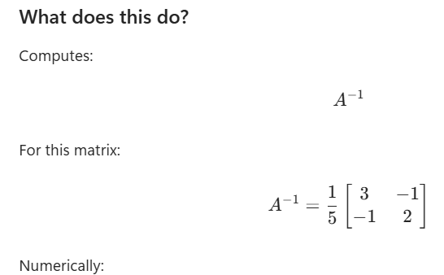

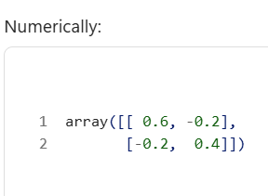

X = np.linalg.inv(A).dot(B)

