

Data Technician

Name:
Course Date:
Table of contents
Day 1: Task 1 3
Day 1: Task 2 3
Day 3: Task 1 4
Day 4: Task 1: Written 6
Day 4: Task 2: SQL Practical 9
Course Notes 19
Additional Information 19

Day 1: Task 1

Please research and complete the below questions relating to key concepts of databases.

What is a primary key? | A primary key is a column (columns) that uniquely identifies each record in a table. It cannot be empty and no two rows can have the same value.
How does this differ from a secondary key? | A secondary key is a column used for searching or sorting data, but it is not unique. Multiple rows can have the same value.
How are primary and foreign keys related? | A foreign key in one table links to the primary key in another table. This creates a relationship between the two tables.
Provide a real-world example of a one-to-one relationship | A person and their passport — one person has one passport, and one passport belongs to one person.
Provide a real-world example of a one-to-many relationship | A customer and their orders — one customer can have many orders, but each order belongs to one customer.
Provide a real-world example of a many-to-many relationship | Students and courses — a student can enrol in many courses, and a course can have many students.

Day 1: Task 2

Please research and complete the below questions relating to key concepts of databases.

What is the difference between a relational and non-relational database? | A relational database stores data in tables with rows and columns and uses structured schema (e.g., SQL databases).  A non-relational database stores data in flexible formats like documents, key-value pairs, or graphs (e.g., NoSQL databases).
What type of data would benefit off the non-relational model?  Why? | Unstructured or semi-structured data such as social media posts, images, JSON documents, or real-time app data.  Because non-relational databases are flexible, scale easily, and can handle changing data structures without needing a fixed schema.

Day 3: Task 1

Please research the below ‘JOIN’ types, explain what they are and provide an example of the types of data it would be used on.

Self-join | S  A self-join is when a table is joined with itself. It is used when data in the same table is related.  Ex.: An employee table where you match employees with their managers (both stored in the same table).
Right join | A right join returns all records from the right table and only the matching records from the left table. If there is no match, the left side shows NULL.  Ex.: A list of all orders (right table) and customer details (left table). You still see orders even if customer data is missing.
Full join | A full join returns all records from both tables. If there is no match, NULL values appear where data is missing.  Ex.: Combining a list of customers and a list of newsletter subscribers to see everyone, whether they appear in one or both lists.
Inner join | An inner join returns only the records that match in both tables.  Ex.: Customers and orders — shows only customers who have placed orders.
Cross join | A cross join returns every possible combination of rows from both tables.  Ex.: Combining a list of products with a list of colours to create all possible product-colour combinations.
Left join | A left join returns all records from the left table and the matching records from the right table. If there is no match, the right side shows NULL.  Ex.: A list of all customers (left table) and their orders (right table) — shows all customers even if they haven’t ordered.

Day 4: Task 1: Written

In your groups, discuss and complete the below activity. You can either nominate one writer or split the elements between you. Everyone however must have the completed work below:

Imagine you have been hired by a small retail business that wants to streamline its operations by creating a new database system. This database will be used to manage inventory, sales, and customer information. The business is a small corner shop that sells a range of groceries and domestic products. It might help to picture your local convenience store and think of what they sell. They also have a loyalty program, which you will need to consider when deciding what tables to create.

Write a 500-word essay explaining the steps you would take to set up and create this database. Your essay should cover the following points:
- Understanding the Business Requirements:
  - What kind of data will the database need to store?
  - Who will be the users of the database, and what will they need to accomplish?
- Designing the Database Schema:
  - How would you structure the database tables to efficiently store inventory, sales, and customer information?
  - What relationships between tables are necessary (e.g., how sales relate to inventory and customers)?
- Implementing the Database:
  - What SQL commands would you use to create the database and its tables?
  - Provide examples of SQL statements for creating tables and defining relationships between them.
- Populating the Database:
  - How would you input initial data into the database? Give examples of SQL INSERT statements.
- Maintaining the Database:
  - What measures would you take to ensure the database remains accurate and up to date?
  - How would you handle backups and data security?

Your essay should include specific examples of SQL commands and explain why each step is necessary for creating a functional and efficient database for the retail business.

Please write your 500-word essay here | - Understanding the Business Requirements:  - What kind of data will the database need to store?  The store will mainly need three types of data – 1. Product (Inventory) 2. Customer 3. Transactional Data ( Sales records) in order to have any kind of data analysis.  - Who will be the users of the database, and what will they need to accomplish?  Business Owner – Access to all data. P/L Analysis, Inventory Management, Marketing Strategy - Figuring out how to increase footfall, Loyalty programme, Staffing requirement during peak hours  Staff – Billing Data Entry and Inventory Management  - Designing the Database Schema:  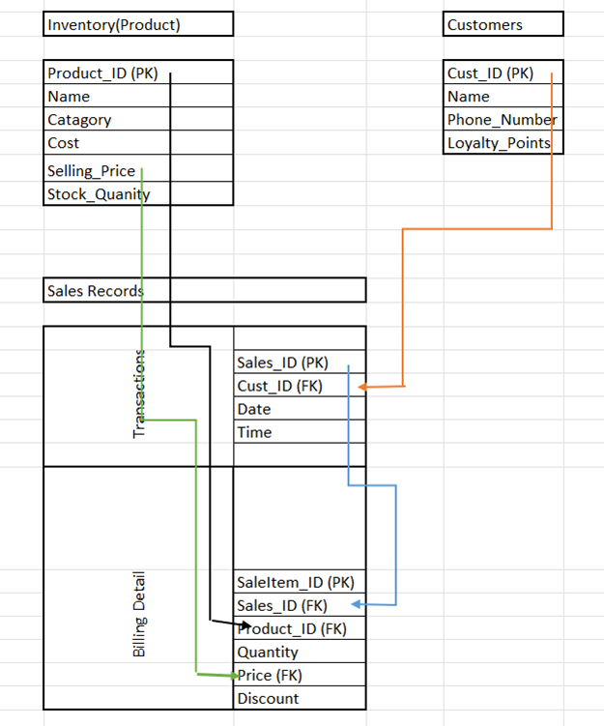  - How would you structure the database tables to efficiently store inventory, sales, and customer information? – As Shown in the above Schema  - What relationships between tables are necessary (e.g., how sales relate to inventory and customers)? As Shown in the above Schema  - Implementing the Database:  - What SQL commands would you use to create the database and its tables?  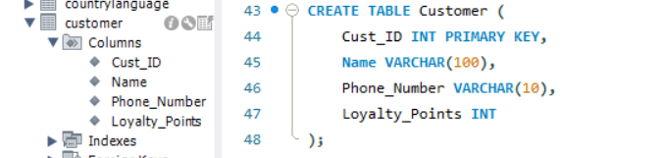  - Provide examples of SQL statements for creating tables and defining relationships between them.  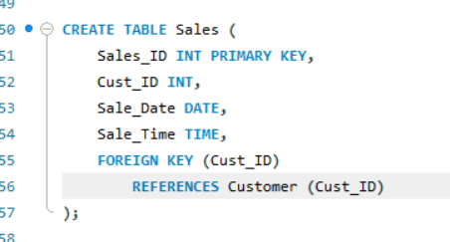  - Populating the Database:  - How would you input initial data into the database? Give examples of SQL INSERT statements.  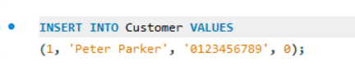  - Maintaining the Database:  - What measures would you take to ensure the database remains accurate and up to date?  - Data Validation – Ex. Name VARCHAR(100) NOT NULL  - How would you handle backups and data security?  - Secure Customer Data 2. Schedule a regular Backup 3. Restricted Access to sensitive data

Day 4: Task 2: SQL Practical

In your groups, work together to answer the below questions. It may be of benefit if one of you shares your screen with the group and as a team answer / take screen shots from there.

Setting up the database:

- Download world_db(1) here
- Follow each step to create your database here

For each question I would like to see both the syntax used and the output.

- Count Cities in USA: Scenario: You've been tasked with conducting a demographic analysis of cities in the United States. Your first step is to determine the total number of cities within the country to provide a baseline for further analysis.

SELECT COUNT(*) AS total_cities
FROM city
WHERE countrycode = 'USA';

- Country with Highest Life Expectancy: Scenario: As part of a global health initiative, you've been assigned to identify the country with the highest life expectancy. This information will be crucial for prioritising healthcare resources and interventions.

SELECT name, lifeexpectancy
FROM country
ORDER BY lifeexpectancy DESC
LIMIT 1;

- "New Year Promotion: Featuring Cities with 'New : Scenario: In anticipation of the upcoming New Year, your travel agency is gearing up for a special promotion featuring cities with names including the word 'New'. You're tasked with swiftly compiling a list of all cities from around the world. This curated selection will be essential in creating promotional materials and enticing travellers with exciting destinations to kick off the New Year in style.

SELECT name
FROM city
WHERE name LIKE '%New%';

- Display Columns with Limit (First 10 Rows): Scenario: You're tasked with providing a brief overview of the most populous cities in the world. To keep the report concise, you're instructed to list only the first 10 cities by population from the database.

SELECT
name AS 'City Name', population AS 'Population'
FROM
city
ORDER BY Population DESC
LIMIT 10;

- Cities with Population Larger than 2,000,000: Scenario: A real estate developer is interested in cities with substantial population sizes for potential investment opportunities. You're tasked with identifying cities from the database with populations exceeding 2 million to focus their research efforts.

SELECT *
FROM city
WHERE population > 2000000;

( For Counting -
SELECT
COUNT(*) AS 'Count'
FROM
city
WHERE
population > 2000000;)

- Cities Beginning with 'Be' Prefix: Scenario: A travel blogger is planning a series of articles featuring cities with unique names. You're tasked with compiling a list of cities from the database that start with the prefix 'Be' to assist in the blogger's content creation process.

SELECT *
FROM city
WHERE name LIKE 'Be%';

- Cities with Population Between 500,000-1,000,000: Scenario: An urban planning committee needs to identify mid-sized cities suitable for infrastructure development projects. You're tasked with identifying cities with populations ranging between 500,000 and 1 million to inform their decision-making process.

SELECT name, population
FROM city
WHERE population BETWEEN 500000 AND 1000000;

- Display Cities Sorted by Name in Ascending Order: Scenario: A geography teacher is preparing a lesson on alphabetical order using city names. You're tasked with providing a sorted list of cities from the database in ascending order by name to support the lesson plan.

SELECT *
FROM city
ORDER BY name ASC;

- Most Populated City: Scenario: A real estate investment firm is interested in cities with significant population densities for potential development projects. You're tasked with identifying the most populated city from the database to guide their investment decisions and strategic planning.

SELECT name, population
FROM city
ORDER BY population DESC
LIMIT 1;

- City Name Frequency Analysis: Supporting Geography Education Scenario: In a geography class, students are learning about the distribution of city names around the world. The teacher, in preparation for a lesson on city name frequencies, wants to provide students with a list of unique city names sorted alphabetically, along with their respective counts of occurrences in the database. You're tasked with this sorted list to support the geography teacher.

SELECT

name,

COUNT(*)

FROM city

GROUP BY name

ORDER BY name ASC;

- City with the Lowest Population: Scenario: A census bureau is conducting an analysis of urban population distribution. You're tasked with identifying the city with the lowest population from the database to provide a comprehensive overview of demographic trends.
SELECT name, population
FROM city
ORDER BY population ASC
LIMIT 1;

- Country with Largest Population: Scenario: A global economic research institute requires data on countries with the largest populations for a comprehensive analysis. You're tasked with identifying the country with the highest population from the database to provide valuable insights into demographic trends.

SELECT name, population
FROM country
ORDER BY population DESC
LIMIT 1;
- Capital of Spain: Scenario: A travel agency is organising tours across Europe and needs accurate information on capital cities. You're tasked with identifying the capital of Spain from the database to ensure itinerary accuracy and provide travellers with essential destination information.

First find out the capital id -

SELECT name, capital
FROM country
WHERE name = 'Spain';

Note - 'Spain', '653'

Select the row where id = capital city id from country table

SELECT
*
FROM
city
WHERE
id = 653

Output - '653', 'Madrid', 'ESP', 'Madrid', '2879052'

With Join -
SELECT
Country.name AS Country_Name, city.name AS Capital
FROM
city
JOIN
country ON city.id = country.capital
WHERE
country.name = 'spain';

- Cities in Europe: Scenario: A European cultural exchange program is seeking to connect students with cities across the continent. You're tasked with compiling a list of cities located in Europe from the database to facilitate program planning and student engagement.
SELECT
city.name AS City,
country.name AS Country
FROM
city
JOIN
country ON city.CountryCode = country.Code
WHERE
country.continent = 'Europe';

- Average Population by Country: Scenario: A demographic research team is conducting a comparative analysis of population distributions across countries. You're tasked with calculating the average population for each country from the database to provide valuable insights into global population trends.

SELECT
country.name AS Country_Name,
Round(AVG(city.population)) AS Average_City_Population
FROM
City
JOIN
country ON city.CountryCode = country.Code
GROUP BY Country_Name;

- Capital Cities Population Comparison: Scenario: A statistical analysis firm is examining population distributions between capital cities worldwide. You're tasked with comparing the populations of capital cities from different countries to identify trends and patterns in urban demographics.

SELECT
city.name AS Capital,
city.population AS Population,
country.name AS Country_Name
FROM
city
JOIN
country ON city.id = country.capital;

- Countries with Low Population Density: Scenario: An agricultural research institute is studying countries with low population densities for potential agricultural development projects. You're tasked with identifying countries with sparse populations from the database to support the institute's research efforts.

SELECT
Name AS Country_Name,
Population / SurfaceArea AS Population_Density
FROM country
where Population / SurfaceArea <= 1000
Order by Population_Density asc

- Cities with High GDP per Capita: Scenario: An economic consulting firm is analysing cities with high GDP per capita for investment opportunities. You're tasked with identifying cities with above-average GDP per capita from the database to assist the firm in identifying potential investment destinations.

SELECT
city.Name AS City_Name,
country.Name AS Country_Name,
ROUND((country.GNP * 1000000 / country.Population) * city.Population, 0) AS Estimated_City_GDP
FROM city
JOIN country ON city.CountryCode = country.Code
WHERE (country.GNP / country.Population) * city.Population > (SELECT AVG((country.GNP / country.Population) * city.Population)
FROM city JOIN country ON city.CountryCode = country.Code) ORDER BY Estimated_City_GDP DESC;

- Display Columns with Limit (Rows 31-40): Scenario: A market research firm requires detailed information on cities beyond the top rankings for a comprehensive analysis. You're tasked with providing data on cities ranked between 31st and 40th by population to ensure a thorough understanding of urban demographics.

SELECT
*
FROM
city
ORDER BY Population DESC
LIMIT 10 OFFSET 30

Course Notes

It is recommended to take notes from the course, use the space below to do so, or use the revision guide shared with the class:

Aditional Information

We have included a range of additional links to further resources and information that you may find useful, these can be found within your revision guide.

END OF WORKBOOK

Please check through your work thoroughly before submitting and update the table of contents if required.

Please send your completed work booklet to your trainer.

