UML DIAGRAMS
Structural Diagrams

Class Diagram
USER
_________
#Id
#Username
#Password
#usertype
Admin
______________________
-confirm_bus_status()
-Confirm_stop_status()
-confirm_Schedule_Status()
-add_Admins()
-remove_Admins()
Casual User
_____________
#Search_bus()
#add_bus_log()
Support User
______________
#edit_buses()
#edit_stops()
#edit_schedule()
Transport User
______________
#claim_bus()

OBJECT DIAGRAMS

user

admin1
admin2
casual1
casual2
contributor1
transport1

Component Diagrams

Home.php
Approvechange.php
Enabledisableuser.php

Adminhome.php
userhome.php
Contributorhome.php
Transporthome.php

Claimbus.php
Log.php

Remsched.php
Addsched.php
Remstop.php
Addstop.php
Rembus.php
Addbuss.php
Profile.php

Deployment DIAGRAM
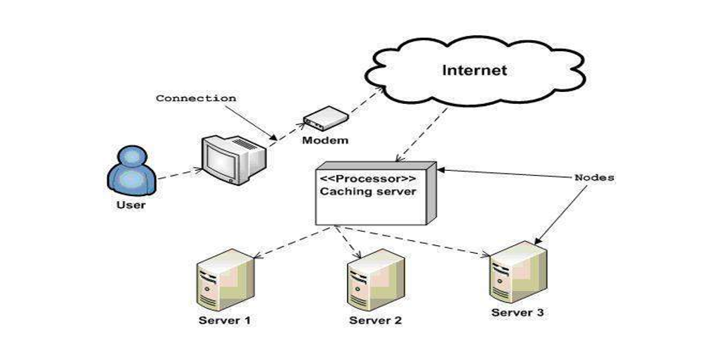

Behaviour DIAGRAMS
USE CASE DIAGRAM

Search bus

User
Register as
contributor
Transport

Register as
transport

enableusers
Manage Bus

Add admins
Manage stops
Admin
Contributor
Manage schedule

SEQUENTIAL DIAGRAMS

COLLABORATION DIAGRAM
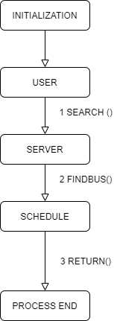

.Activity
.State Chart
left incomplete as there are some issues in the finding algorithm. . . .

