UML DIAGRAMS  
  
Structural Diagrams

Class Diagram

USER

_________

#Id

#Username

#Password

#usertype

Admin

______________________

-confirm_bus_status()

-Confirm_stop_status()

-confirm_Schedule_Status()

-add_Admins()

-remove_Admins()

Casual User

_____________

#Search_bus()

#add_bus_log()

Support User

______________

#edit_buses()

#edit_stops()

#edit_schedule()

Transport User

______________

#claim_bus()

OBJECT DIAGRAMS

user

admin1

admin2

casual1

casual2

contributor1

transport1

Component Diagrams

Home.php

Approvechange.php

Enabledisableuser.php

Adminhome.php

userhome.php

Contributorhome.php

Transporthome.php

Claimbus.php

Log.php

Remsched.php

Addsched.php

Remstop.php

Addstop.php

Rembus.php

Addbuss.php

Profile.php

Deployment DIAGRAM

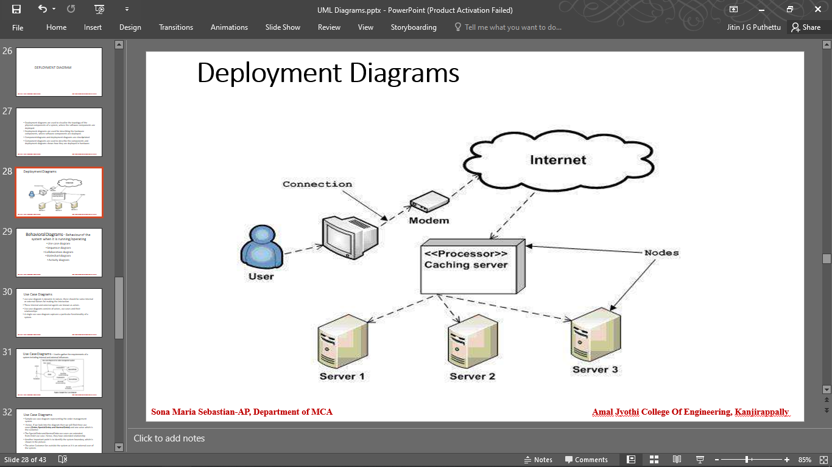

Behaviour DIAGRAMS

USE CASE DIAGRAM

User

Transport

Admin

Contributor

SEQUENTIAL DIAGRAMS

COLLABORATION DIAGRAM

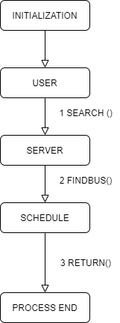

.Activity

.State Chart  
left incomplete as there are some issues in the finding algorithm. . . .