

IMDB – Streaming Platform Use case

ABOUT

This project focuses on Sentiment Analysis of IMDB movie reviews using Natural Language Processing (NLP) techniques and machine learning models.

The goal is to automatically classify movie reviews as positive or negative based on the textual content provided by users.

With the rapid growth of digital platforms, thousands of reviews are generated daily. Manually analysing these reviews is time-consuming and inefficient. This project provides an automated solution that helps understand audience opinions, improve content recommendations, and support decision-making in the entertainment industry.

PROJECT OVERVIEW
- Domain: Entertainment / Movie Analytics
- Dataset: IMDB Dataset (50,000 movie reviews)
- Problem Type: Binary Classification
- Input: Text reviews
- Output: Sentiment (Positive / Negative)
- Approach: NLP + Machine Learning

This project focuses on developing a Sentiment Analysis model using Natural Language Processing (NLP) techniques to classify IMDB movie reviews as positive or negative.
The dataset consists of a large number of user-generated reviews, which are unstructured text data. The project aims to convert this raw text into a structured format and apply machine learning algorithms to automatically predict the sentiment of each review.

PROBLEM STATEMENT
In today’s digital world, platforms receive a large volume of user-generated reviews daily. For movie platforms, analysing these reviews manually to understand audience sentiment is time-consuming and inefficient.
The challenge is to develop an automated system that can accurately classify movie reviews into positive or negative sentiments using Natural Language Processing (NLP) techniques. The system should process unstructured text data, extract meaningful features, and build a model that can predict sentiment effectively.
BUSINESS PROBLEM:
Difficult to manually analyse thousands of reviews
- Need to quickly identify good vs bad content
- Improve recommendations and user experience

DATA UNDERSTANDING
- The dataset was loaded into a pandas DataFrame to begin the analysis process.
- The structure of the dataset was examined to identify columns and their roles.
- It contains two key columns:
- review → unstructured text data
- sentiment → target variable (positive/negative)
- The total number of records was checked to understand dataset size and suitability for model training.
- Data types of each column were verified to ensure correct format (text and categorical).
- The target variable (sentiment) was identified for classification.
- Initial inspection helped in understanding that the problem is a binary classification task



EXPLORATORY DATA ANALYSIS

- Explored the dataset using head() and tail() to visually inspect sample records.
- Analysed sentiment distribution using value_counts() to check class balance.
- Observed that the dataset is balanced, with equal positive and negative reviews.
- Checked for missing values using isnull().sum() and confirmed data completeness.
- Examined review text to identify noise such as HTML tags, numbers, and special characters.
- Performed review length analysis to understand variation in text size.
- Conducted frequency analysis to identify commonly used words in reviews.
- Generated visualizations such as:
- Bar charts for sentiment distribution
- Word clouds for positive and negative reviews
- Identified clear patterns:
- Positive reviews contain words like good, excellent, amazing
- Negative reviews contain words like bad, worst, bori
- These insights confirmed that the dataset contains meaningful patterns suitable for NLP modeling.

TEXT PREPROCESSING
- A user-defined function was created to perform systematic and consistent preprocessing on the entire text dataset. This ensures that all reviews undergo the same cleaning steps.
- The preprocessing function takes raw text as input and applies multiple transformations to convert it into a clean and meaningful format suitable for machine learning models.
1. Lowercasing
- All text was converted to lowercase to ensure uniformity in data.
- This avoids treating words like “Good”, “GOOD”, and “good” as different tokens.
- Helps in reducing the overall vocabulary size.
2. Removal of HTML Tags
- HTML tags such as <br> were removed using regular expressions.
- These tags do not contribute to sentiment and are considered noise in text data.
3. Removal of Numbers and Special Characters
- All numeric values and special symbols were removed.
- This step ensures that only meaningful alphabetic words are retained.
- Helps in improving model performance by reducing irrelevant features.
4. Removal of Extra Whitespaces
- Extra spaces created during cleaning were removed.
- Ensures clean and properly formatted text.
5. Tokenization
- The cleaned text was split into individual words (tokens).
- Tokenization is essential for further steps like stopword removal and lemmatization.
6. Stopword Removal
- Common words such as is, the, and were removed using NLTK stopwords.
- These words do not add meaningful information for sentiment analysis.
- Reduces noise and improves efficiency.
7. Lemmatization
- Words were converted into their base/root form using WordNet Lemmatizer.
- Example: movies → movie, running → run
- Helps in standardizing words and improving model understanding.
8. Joining Tokens
- After processing, tokens were joined back into a single sentence.
- This step is necessary because vectorization techniques require text format.
Function Application
- The preprocessing function was applied to the entire dataset using .apply()
- A new column (clean_review) was created to store processed text
- Ensures original data remains unchanged

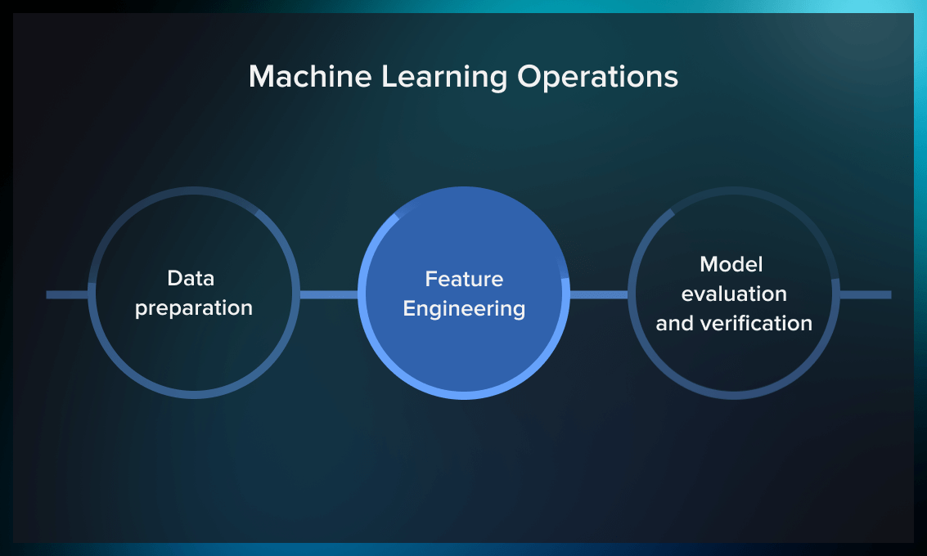
FEATURE ENGNEERING –VECTORIZATION

Feature engineering is the process of transforming raw text data into a numerical format that machine learning models can understand.
- Since machine learning algorithms cannot process text directly, vectorization techniques are used to convert text into feature vectors (numbers).
- In this project, two major vectorization techniques were used:
- Bag of Words (CountVectorizer)
- TF-IDF Vectorizer
1. Need for Vectorization
- Text data is unstructured and cannot be directly used in models
- Models require numerical input
- Vectorization converts words into machine-readable format
- Helps capture patterns in text data
2. Bag of Words (CountVectorizer)
- Bag of Words converts text into a matrix of word counts (frequency)
- It creates a vocabulary of all unique words in the dataset
- Each document is represented based on how many times each word appears
Example:
Text: “movie is good”
Vocabulary: [movie, is, good]
Vector: [1, 1, 1]
Advantages
Simple and easy to implement
Fast computation
Good baseline model

TF-IDF Vectorizer
- TF-IDF stands for Term Frequency – Inverse Document Frequency
It assigns weights to words based on their importance
How It Works
- Term Frequency (TF): frequency of a word in a document
Inverse Document Frequency (IDF): importance of a word across all documents
Advantages
Captures importance of words
Reduces impact of common words
Improves model performance
Better than Bag of Words
4. Feature Matrix
- Output of vectorization is a matrix
- Rows → number of reviews
- Columns → number of unique words (features)
- Values → frequency (BoW) or weight (TF-IDF)
5. Feature Size Control
- Used max_features to limit vocabulary size
- Helps reduce dimensionality and computation cost
- Focuses on most important words

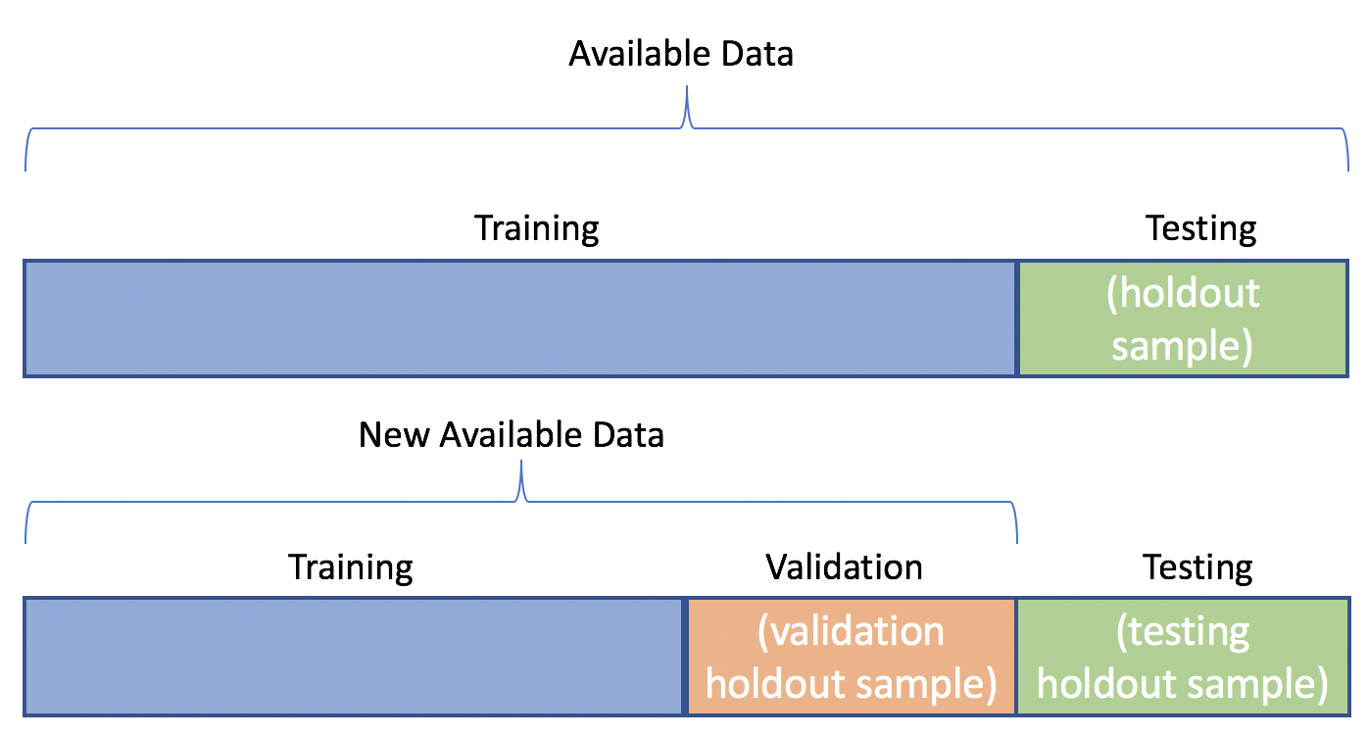
TRAIN – TEST SPLIT

Train-test split is a technique used to divide the dataset into two parts: training data and testing data.
The dataset is typically split in a 75:25 ratio, where:
- 75% → Training set (used to train the model)
- 25% → Testing set (used to evaluate the model)
Purpose of Train-Test Split
- To evaluate how well the model performs on unseen data
- To ensure the model is not just memorizing the training data
- To check the generalization ability of the model
Training Set
- Used to train the machine learning model
- The model learns patterns from input features (X_train) and target labels (y_train)
- Helps build relationships between text features and sentiment
Testing Set
- Used to test the trained model
- Contains unseen data that was not used during training
- Helps evaluate model performance objectively
Key Parameters
- test_size=0.25 → 25% data used for testing
- random_state=42 → ensures reproducibility (same split every time)

MODEL BUILDING – CLASSICAL NLP MODELS

- Model building is the process of training machine learning algorithms on processed text data to predict sentiment (positive/negative).
- After preprocessing and vectorization (BoW / TF-IDF), the data is converted into numerical format, which is then used to train different classical machine learning models.
- Multiple models are used to compare performance and select the best one.
Steps in Model Building
- Split data into training and testing sets
- Train models using training data (X_train, y_train)
- Predict using test data (X_test)
- Evaluate performance using metrics
Models Used:
1. Naive Bayes (MultinomialNB)
- A probabilistic classifier based on Bayes Theorem
- Assumes features are independent
- Works very well for text classification
2. Logistic Regression
- A linear classification algorithm
- Predicts probability of classes
3. Decision Tree
- A tree-based model that splits data based on conditions
- 4. K-Nearest Neighbors multiple decision trees


WORD EMBEDDING & VISUALIZATION

Word Embedding is a technique used to convert words into dense numerical vectors that capture the meaning and context of words.
- Unlike traditional methods (BoW, TF-IDF), embeddings represent words in a continuous vector space, where similar words are placed closer together.
- In this project, Word2Vec is used to generate word embeddings.
1. What is Word Embedding?
- Each word is represented as a vector of numbers (e.g., 100 dimensions)
- Similar words have similar vector values
- Captures semantic relationships between words
Example:
good ≈ excellent
bad ≈ worst
2. Word2Vec Model
- Word2Vec is a popular embedding technique from Gensim
- Learns word relationships based on surrounding words (context)
Types of Word2Vec
- CBOW (Continuous Bag of Words)
- Predicts a word from surrounding context
- Skip-gram
- → Predicts surrounding words from a given word
Key Parameters
- vector_size → size of word vector (e.g., 100)
- window → number of context words
- min_count → ignore rare words

OVERALL INSIGHTS
- The dataset was well-balanced, with equal positive and negative reviews, which helped in building an unbiased model.
- Raw text data contained noise such as HTML tags, special characters, and numbers, making preprocessing a crucial step.
- Text preprocessing (lowercasing, cleaning, tokenization, stopword removal, lemmatization) significantly improved data quality and model performance.
- Feature engineering played a key role:
- Bag of Words provided a simple baseline
- TF-IDF improved performance by capturing word importance
- TF-IDF outperformed Bag of Words, as it reduced the impact of common words and highlighted meaningful terms.
- Among classical models, Naive Bayes performed efficiently and provided strong baseline results for text classification.
- Advanced models like Random Forest and SVM showed improved performance but required more computation.
- Evaluation metrics such as accuracy, confusion matrix, and classification report provided deeper insights into model performance.
- Word cloud and frequency analysis revealed:
- Positive reviews → good, excellent, amazing
- Negative reviews → bad, worst, boring
- Word embeddings (Word2Vec) captured semantic relationships, where similar words were closer in vector space.
- Visualization techniques (word clouds, bar charts, heatmaps) helped in better understanding data patterns and model results.
- The project demonstrated that NLP techniques can effectively convert unstructured text into meaningful insights.
- Overall, combining TF-IDF with machine learning models resulted in accurate sentiment classification.

CONCLUSION
This project demonstrates the use of Natural Language Processing (NLP) techniques to perform sentiment analysis on IMDB movie reviews. Through effective text preprocessing and feature engineering using TF-IDF, the model was able to convert unstructured text into meaningful numerical data. Machine learning models, especially Naive Bayes, provided reliable performance in classifying sentiments. Overall, the project shows that NLP methods can effectively analyse text data and generate accurate insights.

