# Kubernetes

Mithun Technologies

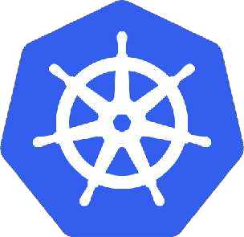Kubernetes

**Agenda**

* What is Kubernetes?
* Advantages of Kubernetes
* Kubernetes Architecture
* Kubernetes Components
* Kubernetes Cluster Setup
* Kubernetes Objects
* Demo

What is Kubernetes?

* Kubernetes is an orchestration engine and open-source platform for managing containerized applications.
* Responsibilities include container deployment, scaling & descaling of containers & container load balancing.
* Actually, Kubernetes is not a replacement for Docker, But Kubernetes can be considered as a replacement for Docker Swarm, Kubernetes is significantly more complex than Swarm, and requires more work to deploy.
* Born in **Google** ,written in Go/Golang. Donated to CNCF(Cloud native computing foundation) in 2014.
* Kubernetes v1.0 was released on **July 21, 2015.**
* Current stable release v1.18.0.



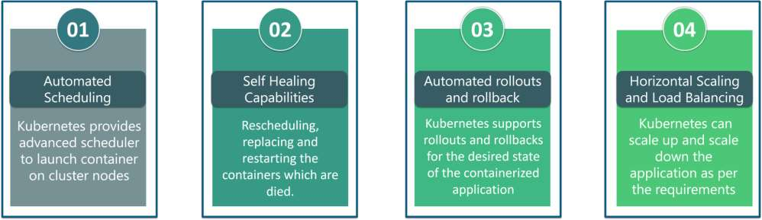

The features of Kubernetes, are as follows:

* **Automated Scheduling:** Kubernetes provides advanced scheduler to launch container on cluster nodes based on their resource

requirements and other constraints, while not sacrificing availability.

* **Self Healing Capabilities:** Kubernetes allows to replaces and reschedules containers when nodes die. It also kills containers that don’t

respond to user-defined health check and doesn’t advertise them to clients until they are ready to serve.

* **Automated rollouts & rollback:** Kubernetes rolls out changes to the application or its configuration while monitoring application health

to ensure it doesn’t kill all your instances at the same time. If something goes wrong, with Kubernetes you can rollback the change.

* **Horizontal Scaling & Load Balancing:** Kubernetes can scale up and scale down the application as per the requirements with a simple

command, using a UI, or automatically based on CPU usage.



1. **Service Discovery & Load balancing**

With Kubernetes, there is no need to worry about networking and communication because Kubernetes will automatically assign IP addresses to

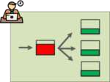containers and a single DNS name for a set of containers, that can load-balance traffic inside the cluster. Containers get their own IP so you can put a set of containers behind a single DNS name for load balancing.

1. **Storage Orchestration**

With Kubernetes, you can mount the storage system of your choice. You can either opt for local storage, or choose a public cloud provider such as

GCP or AWS, or perhaps use a shared network storage system such as NFS, iSCSI, etc.

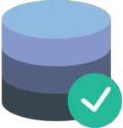

#### Kubernetes Architecture

Kubernetes implements a cluster computing background, everything works from inside a ***Kubernetes***

***Cluster***. This cluster is hosted by one node acting as the ‘master’ of the cluster, and other nodes as

‘nodes’ which do the actual ‘containerization‘. Below is a diagram showing the same.

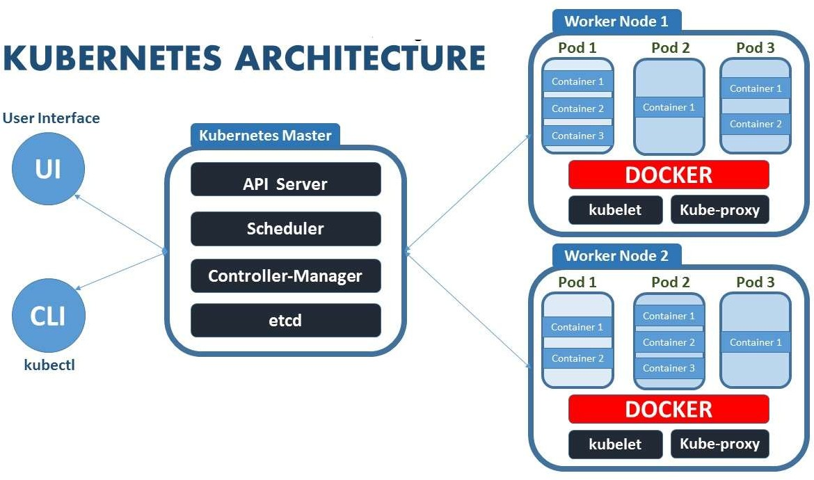

Kubernetes Components

**Web UI (Dashboard)**

Dashboard is a web-based Kubernetes user interface. You can use Dashboard to deploy containerized applications to a

Kubernetes cluster, troubleshoot your containerized application, and manage the cluster itself along with its available resources.

**Kubectl**

Kubectl is a command line configuration tool (CLI) for Kubernetes used to interact with master node of kubernetes. Kubectl has a

config file called kubeconfig, this file has the information about server and authentication information to access the API Server.

**Master Node**

The master node is responsible for the management of Kubernetes cluster. It is mainly the entry point for all administrative tasks. It handles the orchestration of the worker nodes. There can be more than one master node in the cluster to check for fault tolerance.

Master Components

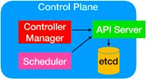It has below components that take care of communication, scheduling and controllers.

**API Server:**

Kube API Server interacts with API, Its a frontend of the kubernetes control plane. Communication

center for developers, sysadmin and other Kubernetes components

**Scheduler**

Scheduler watches the pods and assigns the pods to run on specific hosts.

**Controller Manager**:

Controller manager runs the controllers in background which runs different tasks in Kubernetes cluster. Performs

cluster-level functions (replication, keeping track of worker nodes, handling nodes failures…).

Some of the controllers are,

1. Node controller - Its responsible for noticing and responding when nodes go down.
2. Replication controllers - It maintains the number of pods. It controls how many identical copies of a pod should be running

somewhere on the cluster.

1. Endpoint controllers joins services and pods together.
2. Replicaset controllers ensure number of replication of pods running at all time.
3. Deployment controller provides declarative updates for pods and replicasets.
4. Daemonsets controller ensure all nodes run a copy of specific pods.
5. Jobs controller is the supervisor process for pods carrying out batch jobs

etcd

etcd is a simple distribute key value store. kubernetes uses etcd as its database to store all cluster datas. some of the data stored in etcd is job scheduling information, pods, state information and etc.

**Worker Nodes**

* Worker nodes are the nodes where the application actually running in kubernetes cluster, it is also know as minion.

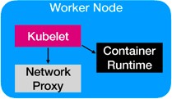These each worker nodes are controlled by the master node using kubelet process.

* Container Platform must be running on each worker nodes and it works together with kubelet to run the containers, This is why we use Docker engine

and takes care of managing images and containers.

* We can also use other container platforms like CoreOS, Rocket.

**Node Components**

**Kubelet**

* Kubelet is the primary node agent runs on each nodes and reads the container manifests which ensures that containers are running and healthy.
* It makes sure that containers are running in a pod. The kubelet doesn’t manage containers which were not created by Kubernetes.

**Kube-proxy**

* kube-proxy enables the Kubernetes service abstraction by maintaining network rules on the host and performing connection forwarding.
* kube-proxy maintains network rules on nodes. These network rules allow network communication to your Pods from inside or outside of your cluster.
* It helps us to have network proxy and load balancer for the services in a single worker node..
* Service is just a logical concept, the real work is being done by the “kube-proxy” pod that is running on each node.
* It redirect requests from Cluster IP(Virtual IP Address) to Pod IP.

**Container Runtime**

* Each node must have a container runtime, such as Docker, rkt, or another container runtime to process instructions from the master server to run

containers.

Installation

#### Different ways to install Kubernetes

Play-with-k8s Google Kubernetes Engine(GKE) [https://labs.play-with-k8s.com](https://labs.play-with-k8s.com/).

Minikube Amazon EKS

kubeadm Azure Kubernetes Service (AKS)

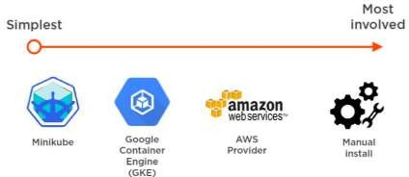

Check required ports

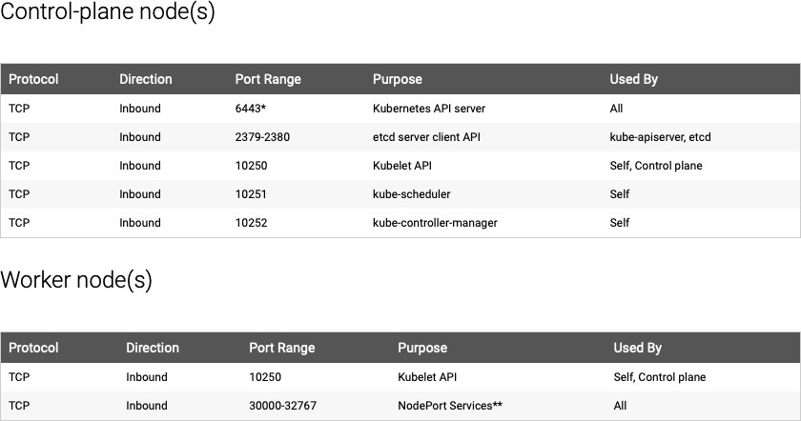

* Kubernetes Objects are persistent entities in the Kubernetes system. Kubernetes uses these entities to represent the state of

your cluster.

* A Kubernetes object is a “record of intent”–once you create the object, the Kubernetes system will constantly work to ensure

that object exists.

* To work with Kubernetes objects–whether to create, modify, or delete them–you’ll need to use the Kubernetes API. When you

use the kubectl command-line interface, for example, the CLI makes the necessary Kubernetes API calls for you.

The basic Kubernetes objects include:

* + Pod
  + Replication Controller
  + ReplicaSet
  + DaemonSet
  + Deployment
  + Service
  + ClusterIP
  + NodePort
  + Volume
  + Job

**What is a Namespace**?

You can think of a Namespace as a virtual cluster inside your Kubernetes cluster. You can have multiple namespaces inside a single Kubernetes cluster, **and they are all logically isolated from each other.** They can help you and your teams with organization, security, and even performance.

The first three namespaces created in a cluster are always **default**, **kube-system**, and **kube-public**. While you can technically deploy within these namespaces, I recommend leaving these for system configuration and not for your projects.

* **Default** is for deployments that are not given a namespace, which is a quick way to create a mess that will be hard to clean up if you do too many deployments without the proper information.
* **Kube-system** is for all things relating to the Kubernetes system. Any deployments to this namespace are playing a dangerous game and can accidentally cause irreparable damage to the system itself.
* **Kube-public** is readable by everyone, but the namespace is reserved for system usage.

##### Using namespaces for isolation

* I have used namespaces for isolation in a couple of ways**. I use them most often to split many users' projects into separate environmen**ts. This is useful in preventing cross-project contamination since namespaces provide independent environments.
* kubectl get namespace
* kubectl create namespace test

<https://cloud.google.com/blog/products/gcp/kubernetes-best-practices-organizing-with-namespaces>

#### POD

* A Pod always runs on a **Node.**
* **A pod is the smallest building block or basic unit of scheduling in Kubernetes.**
* **In a Kubernetes cluster, a pod represents a running process.**
* **Inside a pod, you can have one or more containers**. **Those containers all share a unique network IP, storage, network and any**

**other specification applied to the pod.**

* 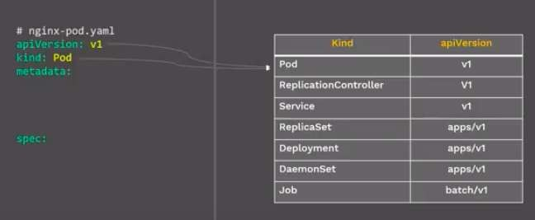POD is a group of one or more containers which will be running on some node.
* Pods abstract network and storage away from the underlying container.
* This lets you move containers around the cluster more easily.
* 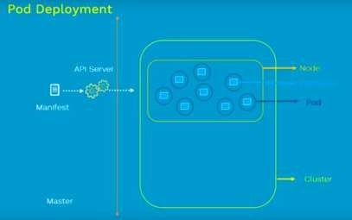Each Pod has its unique IP Address within the cluster.
* 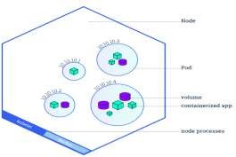Any data saved inside the Pod will disappear wit a pe

rsistent storage.

hout

**apiVersion: v1**

**kind: Pod metadata:**

**name: nginx-pod**

**labels:**

**app: nginx spec: containers:**

**- name: first-container image: nginx**

**ports:**

**- containerPort: 80**

**Command**

kubectl apply –f pod.yml

**Pod Lifecycle**

#### Make a Pod reuqest to API server using a local pod defination file

* The API server saves the info for the pod in ETCD
* The scheduler finds the unscheduled pod and shedules it to node.
* Kubelet running on the node, sees the pod sheduled and fires up docker.
* Docker runs the container
* The entire lifecycle state of the pod is stored in ETCD.

**Pod Concepts**

* Pod is ephemeral(lasting for a very short time) and won’t be rescheduled to a new node once it dies.
* You should not directly create/use Pod for deployment, Kubernetes have controllers like Replica Sets, Deployment, Deamon sets to keep pod alive.

Pod model types

Most often, when you deploy a pod to a Kubernetes cluster, it'll contain a single container. But there are instances when you might need to deploy a pod with multiple containers.

There are two model types of pod you

can create:

* + **One-container-per-pod.** This model is the most popular. POD is the “wrapper” for a single container. Since pod is the smallest object that K8S recognizes, it manages the pods instead of directly managing the containers.
  + **Multi-container-pod or Sidecar containers** In this model, a pod can hold multiple co-located containers primary container **And** utility container that helps or enhances how an application functions (examples of sidecar containers are log shippers/watchers and monitoring agents).

***Shared Network Namespace***

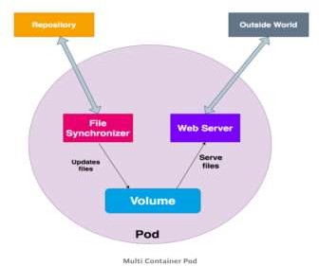All the containers in the pod share the same network namespace which means all containers can communicate with each other on the **localhost**.

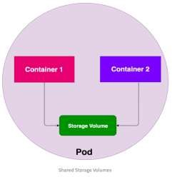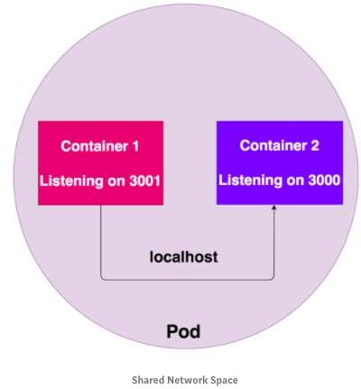

**Shared Storage Volumes**

All the containers in a POD can have the same volume mounted so that they can communicate with each other by reading and modifying files in the storage volume.

## Static Pods

* Static Pods are managed directly by the kubelet and the API server does not have any control over these pods. The kubelet is responsible to watch each static Pod and restart it if it crashes. The static Pods running on a node are visible on the API server but cannot be controlled by the API Server. Static Pod does not have any associated replication controller, kubelet service itself watches it and restarts it when it crashes. There is no health check for static pods.
* The main use for static Pods is to run a self-hosted control plane: in other words, using the kubelet to supervise the individual [control plane components](https://kubernetes.io/docs/concepts/overview/components/#control-plane-components).
* Static Pods are always bound to one [Kubelet](https://kubernetes.io/docs/reference/generated/kubelet) on a specific node.

**Kubernetes Labels and Selectors**

**Labels**

When One thing in k8s needs to find another things in k8s, it uses labels. Labels are key/value pairs attached to Object

You can make your own and apply it.

it’s like tag things in kubernetes For e.g.

labels:

app: nginx role: web env: dev

**Selectors**

Selectors use the label key to find a collection of objects matched with same value

It’s like Filter, Conditions and query to your labels

For e.g. selectors:

env = dev

app != db

release in (1.3,1.4)

Labels and Selectors are used in many places like Services, Deployment and we will see now in Replicasets.

**Service**

**A service is responsible for making our Pods discoverable inside the network or exposing them to the internet. A Service identifies Pods by its LabelSelector.**

**Types of services available:**

***ClusterIP*** – Exposes the service on a cluster-internal IP. Service is only reachable from within the cluster. This is the default Type.

* When we create a service we will get one Virtual IP (Cluster IP) it will get registered to the DNS(kube-dns). Using this Other

PODS can find and talk the pods of this service using service name.

* Service is just a logical concept, the real work is being done by the “kube-proxy” pod that is running on each node.
* It redirect requests from Cluster IP(Virtual IP Address) to Pod IP.

# Service Cluster IP apiVersion: v1 kind: Service metadata:

name: nginxsvc spec:

selector: app: nginx

type: ClusterIP

ports:

- name: http

port: 80

targetPort: 80 protocol: TCP

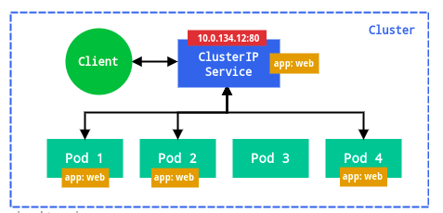

APP 2 POD

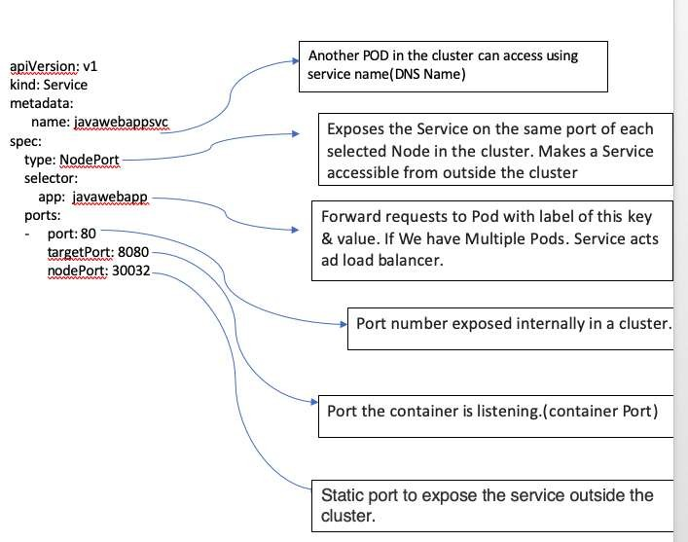***NodePort*** – Exposes the service on each Node’s IP at a static port. A ClusterIP service, to which the NodePort service will route, is automatically created. You’ll be able to contact the NodePort service, from outside the cluster, by using “<*NodeIP*>:<*NodePort*>”.

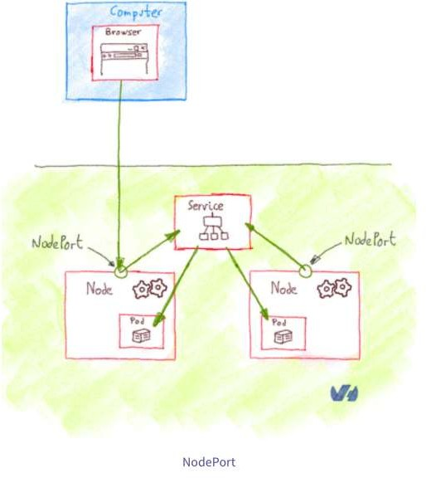

apiVersion: v1 kind: Service metadata:

name: javawebappsvc spec:

selector:

app: javawebapp type: NodePort ports:

- port: 80

targetPort: 8080

nodePort: 30032

Note: If we don’t define nodePort value for NodePort Service. K8’s will randomly

Allocate a nodePort with in 30000—32767.

***LoadBalancer*** – Exposes the service externally using a cloud provider’s load balancer. NodePort and ClusterIP services, to

which the external load balancer will route, are automatically created.

If you are using a custom Kubernetes Cluster

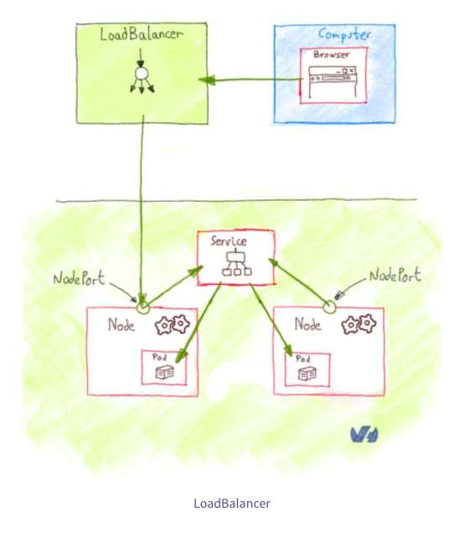

(using minikube, kubeadm or the like). In this case, there is no LoadBalancer integrated (unlike AWS EKS or Google Cloud,KOPS,AKS). With this default setup, you can only

use [NodePort](https://kubernetes.io/docs/concepts/services-networking/service/#type-nodeport).

Configure Load Balancer Externally.

apiVersion: v1

kind: Service

metadata:

name: javawebappsvc

spec:

ports:

- port: 80

targetPort: 8080

selector:

app: javawebapp

type: LoadBalancer

## Replication Controller

* Replication Controller is one of the key features of Kubernetes, which is responsible for managing the pod lifecycle. It is

responsible for making sure that the specified number of pod replicas are running at any point of time.

* A Replication Controller is a structure that enables you to easily create multiple pods, then make sure that that number of

pods always exists. If a pod does crash, the Replication Controller replaces it.

* Replication Controllers and PODS are associated with labels.
* Creating “RC” with count of 1 ensure that a POD is always available.

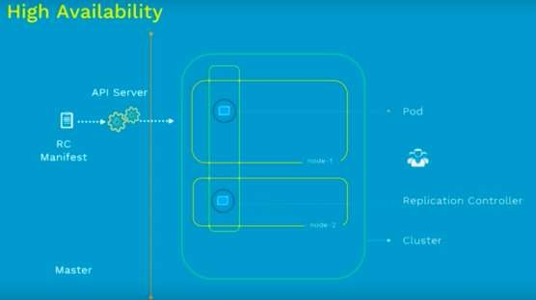

**Command**

kubectl apply –f rc.yml

apiVersion: v1

kind: ReplicationController

metadata:

name: nginx-rc

spec:

replicas: 2 selector:

app: nginx template: metadata:

name: nginx

labels:

app: nginx spec: containers:

- name: nginx image: nginx ports:

- containerPort: 80

## ReplicaSet

* ReplicaSet is the next-generation Replication

Controller.

* The only difference between a *ReplicaSet* and

a *Replication Controller* right now is the selector

support.

* ReplicaSet supports the new set-based selector requirements as described in the labels user guide whereas a Replication Controller only supports equality-based selector requirements.

kubectl apply –f rs.yml

kubectl scale rs nginx-replicaset --replicas 3

apiVersion: apps/v1 kind: ReplicaSet metadata:

name: nginx-replicaset spec:

replicas: 2 selector: matchLabels:

app: nginx-rs-pod

matchExpressions:

- key: env operator: In values:

- dev template: metadata:

labels:

app: nginx-rs-pod

env: dev spec: containers:

- name: nginx image: nginx ports:

- containerPort: 80

## DaemonSet

A *DaemonSet* make sure that all or some kubernetes Nodes run a copy of a Pod.

When a new node is added to the cluster, a Pod is added to it to match the rest of the nodes and when a node is removed from

the cluster, the Pod is garbage collected.

Deleting a DaemonSet will clean up the Pods it created.

# Daemon Set apiVersion: apps/v1 kind: DaemonSet metadata:

name: nginx-ds

spec:

selector: matchLabels:

app: nginx-pod

template:

metadata:

name: nginx-pod

labels:

app: nginx-pod spec: nodeSelector:

name: node1 containers:

* name: webserver image: nginx ports:
  + containerPort: 80

**Command**

kubectl apply –f daemonset.yml

## Kubernetes Objects

**Deployment**

In Kubernetes, Deployment is the recommended way to deploy Pod or RS, simply because of

the advance features it comes with.

Below are some of the key benefits.

* + - Deploy a RS.
    - Updates pods (PodTemplateSpec).
    - Rollback to older Deployment versions.
    - Scale Deployment up or down.
    - Pause and resume the Deployment.
    - Use the status of the Deployment to determine state of replicas.
    - Clean up older RS that you don’t need anymore.

kubectl scale deployment ***[DEPLOYMENT_NAME]*** --replicas ***[NUMBER_OF_REPLICAS]***

kubectl rollout status deployment nginx-deployment

kubectl get deployment

kubectl set image deployment nginx-deployment nginx-container=nginx:latest --record

*kubectl get replicaset*

kubectl rollout history deployment nginx-deployment

kubectl rollout history deployment nginx-deployment **--revision**=1

kubectl rollout undo deployment nginx-deployment --to-revision=1

apiVersion: apps/v1 kind: Deployment metadata:

name: nginx

spec:

replicas: 3

strategy:

type: ReCreate selector: matchLabels:

app: nginx template: metadata:

labels:

app: nginx spec: containers:

* + name: nginx image: nginx:1.7.9 ports:

- containerPort: 80

## Kubernetes Objects

### Deployment Strategies

There are several different types of deployment strategies you can take advantage of depending on your

goal.

### Rolling Deployment

The rolling deployment is the standard default deployment to Kubernetes. It works by slowly, one by one, replacing pods of the previous version of your application with pods of the new version without any cluster downtime.

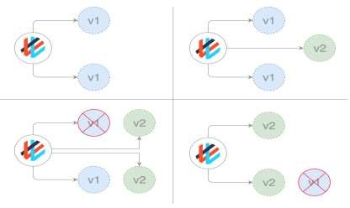A rolling update waits for new pods to become ready before it starts scaling down the old ones. If there is a problem, the rolling update or deployment can be aborted without bringing the whole cluster down. In the YAML definition file for this type of deployment, a new image replaces the old image.

# Deployments Rolling

Update

apiVersion: apps/v1 kind: Deployment metadata:

name: nginx-deployment

spec:

replicas: 2 strategy:

type: RollingUpdate

rollingUpdate: maxSurge: 1

maxUnavailable: 1

minReadySeconds: 30 selector: matchLabels:

app: nginx template: metadata:

name: nginx-pod labels:

app: nginx spec: containers:

* name: nginx-container image: nginx:1.7.9 ports:
  + containerPort: 80

## Kubernetes Objects

### Deployment Strategies Recreate

* In this type of very simple deployment, all of the old pods are killed all at once and

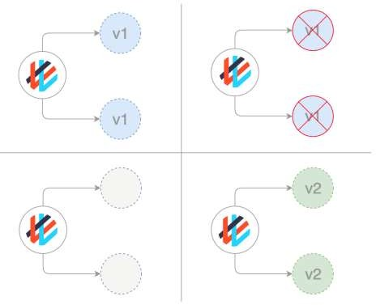get replaced all at once with the new ones.

apiVersion: apps/v1 kind: Deployment metadata:

name: nginx spec:

replicas: 3

strategy:

type: Recreate selector: matchLabels:

app: nginx template: metadata:

labels:

app: nginx spec: containers:

- name: nginx image: nginx:1.7.9 ports:

- containerPort: 80

**Deployment Strategies**

**Blue/ Green (or Red / Black) deployments**

In a blue/green deployment strategy (sometimes referred to as red/black) the old version of the application (green) and the new version (blue) get deployed at the same time. When both of these are deployed, users only have access to the green; whereas, the blue is available to your QA team for test automation on a separate service or via direct port- forwarding.

After the new version has been tested and is signed off for release, the service is switched to the blue version with the

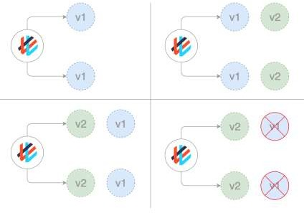old green version being scaled down:

apiVersion: v1 kind: Service metadata:

name: awesomeapp

spec:

selector:

app: awesomeapp

version: "02"

***Ingress*** – *Kubernetes Ingress is a resource to add rules for routing traffic from external sources to the services in the*

*kubernetes cluster.*

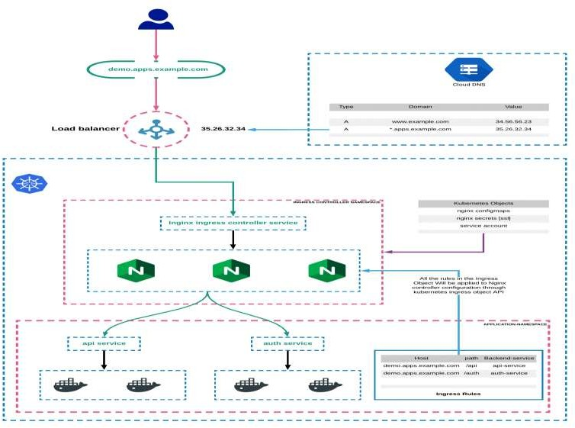**Kubernetes Ingress:**

Kubernetes Ingress is a native kubernetes resource where you can have rules to route traffic from an external source to service endpoints residing inside the cluster. It requires an ingress controller for routing the rules specified in the ingress object.

**Kubernetes Ingress Controller**

Ingress controller is typically a proxy service deployed in the cluster. It is nothing but a [kubernetes deployment](https://devopscube.com/kubernetes-deployment-tutorial/) exposed to a service. Following are the ingress controllers available for kubernetes.

Following are the ingress controllers available for kubernetes. Nginx Ingress Controller ([Community](https://github.com/kubernetes/ingress-nginx) & [From Nginx Inc](https://github.com/nginxinc/kubernetes-ingress)) [Traefik](https://github.com/containous/traefik)

[HAproxy](https://www.haproxy.com/blog/haproxy_ingress_controller_for_kubernetes/) [Contour](https://github.com/heptio/contour)

[GKE Ingress Controller](https://github.com/kubernetes/ingress-gce)

A Container's file system lives only as long as the Container does. So when a Container terminates and restarts, filesystem changes are lost. Volumes in Kubernetes are very easy to manage. It is basically a directory that gets mounted to a pod. After telling the container to use Volumes for storing evergreen information, you can safely modify the pods without ever losing your data.

Kubernetes supports many types of volumes, and a Pod can use any number of them simultaneously. For more consistent storage that is independent of the Container, we can use a Volume. This is especially important for stateful applications, such as databases.

To use a volume, a Pod specifies what volumes to provide for the Pod (the .spec.volumes field) and where to mount those into Containers (the .spec.containers.volumeMounts field) as shown.

**Kubernetes supports several types of Volumes:**

awsElasticBlockStore azureDisk

azureFile configMap emptyDir gcePersistentDisk

gitRepo (deprecated) hostPath

nfs persistentVolumeClaim secret

apiVersion: v1

kind: ReplicationController

metadata:

labels:

name: mongo

name: mongo-controller

spec:

replicas: 1 template:

metadata:

labels:

name: mongo

spec:

containers:

* image: mongo name: mongo ports:
  + name: mongo containerPort: 27017

hostPort: 27017 volumeMounts:

* + name: mongo-persistent-storage mountPath: /data/db

volumes:

* name: mongo-persistent-storage hostPath:

path: /tmp/dbbackup

**Persistent Volumes**

Persistent Volumes are simply a piece of storage in your cluster. Similar to how you have a disk resource in a server, a persistent volume provides storage resources for objects in the cluster. At the most simple terms you can think of a PV as a disk drive. It should be noted that this storage resource exists independently from any pods that may consume it. Meaning, that if the pod dies, the storage should remain intact assuming the claim policies are correct. Persistent Volumes are provisioned in two ways, Statically or Dynamically.

**Static Volumes –** A static PV simply means that some k8s administrator provisioned a persistent volume in the cluster and it’s ready to be

consumed by other resources.

**Dynamic Volumes –** In some circumstances a pod could require a persistent volume that doesn’t exist. In those cases it is possible to have k8s provision the volume as needed if storage classes were configured to demonstrate where the dynamic PVs should be built. This post will focus on static volumes for now.

**Persistent Volume Claims**

Pods that need access to persistent storage, obtain that access through the use of a Persistent Volume Claim. A PVC, binds a persistent volume to

a pod that requested it.

When a pod wants access to a persistent disk, it will request access to the claim which will specify the size , access mode and/or storage classes that it will need from a Persistent Volume. Indirectly the pods get access to the PV, but only through the use of a PVC.

**Claim Policies**

We also reference claim policies earlier. A Persistent Volume can have several different claim policies associated with it including:

**Retain –** When the PVC is deleted, the PV still exists and the volume is considered "released". But it is not yet available for another claim because the previous claimant's data remains on the volume. An administrator we can manually reclaim the volume.

**Recycle –** When the claim is deleted the volume remains but performs a basic scrub(delete data from storage) (rm -rf /volume/*) on the volume and makes it available again for a new claim.

**Delete –** When the claim is deleted, it removes both the Persistent Volume object from Kubernetes, as well as the associated storage.

The claim policy (associated at the PV and not the PVC) is responsible for what happens to the data on when the claim has been deleted.

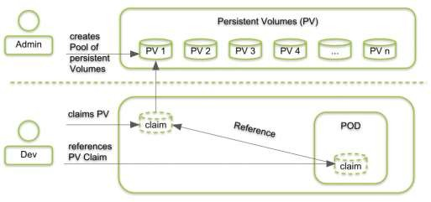

**ConfigMaps and Secrets**

Application’s configuration can change between environments (e.g. development, staging, production, etc.) and that you want your applications to be portable. It is a good practice to make container images as reusable as possible. The same image should be able to be used for development, staging, and production.

Thus, you should store the config(like db connection details, passwords, API Keys ..etc) outside of the application itself.

We externalize things that can change and this in turn helps keep our applications portable. This is critical in the Kubernetes

world where our applications are packaged as Docker images.

With Docker and containers this means we should try to keep configuration out of the container image. Developer should not

hard code configuration details instead they can refer/use **Environment Variables.**

Docker makes it easy to build containers with environment variables baked in. In your Dockerfile, you can specify them with the ENV directive.You can also override the environment variables when running on the command line.

## ConfigMaps and Secrets

An app’s *config* is everything that is likely to vary between [deploys](https://12factor.net/codebase) (staging, production, developer environments, etc). This includes database connections details and

credentials or cloud credentials ..etc.

Kubernetes allows you to provide configuration information to our applications through ConfigMaps or secret resources. The main differentiator between the two is

the way a pod stores the receiving information and how the data is stored in the etcd data store.

Both, ConfigMaps and Secrets store data as a key value pair. The major difference is, **Secrets store data in base64** format meanwhile **ConfigMaps store data in a plain**

**text**.

If you have some critical data like, keys, passwords, service accounts credentials, db connection string, etc then you should always go for **Secrets** rather than Configs.

And if you want to do some application configuration using environment variables which you don't want to keep secret/hidden like, app base platform url, etc then you can go for **ConfigMaps.**

[**Sample Manifest Links: https://github.com/MithunTechnologiesDevOps/Kubernates-Manifests/blob/master/mysql- deployment-configmap.yml**](https://github.com/MithunTechnologiesDevOps/Kubernates-Manifests/blob/master/mysql-deployment-configmap.yml)

[**https://github.com/MithunTechnologiesDevOps/Kubernates-Manifests/blob/master/mysql-deployment-configSecret.yml**](https://github.com/MithunTechnologiesDevOps/Kubernates-Manifests/blob/master/mysql-deployment-configSecret.yml)

**Secret:**

**docker-registry**

This is used by the kubelet when passed in a pod template if there is an **imagePullsecret** to provide the credentials needed to authenticate to a private Docker registry:

kubectl create secret docker-registry registryKey --docker-server <PrivateRepoURL> --docker-username <userName> --docker-

password <password> --docker-email <email> <https://opensource.com/article/19/6/introduction-kubernetes-secrets-and-configmaps> <https://medium.com/google-cloud/kubernetes-configmaps-and-secrets-68d061f7ab5b>

<https://www.oreilly.com/library/view/kubernetes-best-practices/9781492056461/ch04.html>

Liveness And Readiness Probes

Liveness and Readiness probes are used to control the health of an application running inside a Pod’s container.

**Liveness Probe**

* Suppose that a Pod is running our application inside a container, but due to some reason let’s say memory leak, cpu usage, application deadlock etc the

application is not responding to our requests, and stuck in error state.

* Liveness probe checks the container health as we tell it do, and if for some reason the liveness probe fails, it restarts the container.

**Readiness Probe**

* This type of probe is used to detect if a container is ready to accept traffic. You can use this probe to manage which pods are used as

backends for load balancing services. If a pod is not ready, it can then be removed from the list of load balancers.

Manifest File Link:

<https://github.com/MithunTechnologiesDevOps/Kubernates-Manifests/blob/master/liveness_readiness_probes_example.yml>

<https://docs.okd.io/latest/dev_guide/application_health.html>

<https://medium.com/spire-labs/utilizing-kubernetes-liveness-and-readiness-probes-to-automatically-recover-from-failure-2fe0314f2b2e> <https://www.weave.works/blog/resilient-apps-with-liveness-and-readiness-probes-in-kubernetes>

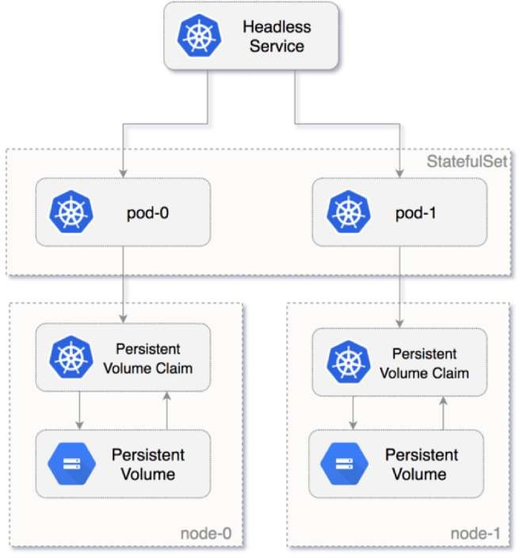Deployments are usually used for stateless applications. However, you can save the state of deployment by attaching a Persistent Volume to it and make it stateful, but all the pods of a deployment will be sharing the same Volume and data across all of them will be same.

* + SatefulSet is a Kubernetes resource used to manage stateful applications. It manages the deployment and scaling of a set of Pods, and provides guarantee about the ordering and uniqueness of these Pods.
  + StatefulSet is also a Controller but unlike Deployments, it doesn’t create

ReplicaSet rather itself creates the Pod with a unique naming convention.

e.g. If you create a StatefulSet with name **mongo,** it will create a pod with name **mongo-0,** and for multiple replicas of a statefulset, their names will increment like **mongo-0**, **mongo-1**, **mongo-2, etc**

* + Every replica of a stateful set will have its own state, and each of the pods will be creating its own PVC(Persistent Volume Claim). So a statefulset with 3 replicas will create 3 pods, each having its own Volume, so total 3 PVCs.
  + By far the most common way to run a database, StatefulSets is a feature fully supported as of the Kubernetes 1.9 release. Using it, each of your pods is guaranteed the same network identity and disk across restarts, even if it's rescheduled to a different physical machine.

###### StatefulSet Deployments provide:

* + - **Stable, unique network identifiers:** Each pod in a StatefulSet is given a hostname that is based on the application name and increment. For example, mongo-1, mongo-2 and mongo-3 for a StatefulSet named “mongo” that has 3 instances running.
    - **Stable, persistent storage:** Each and every pod in the cluster is given its own persistent volume based on the storage class defined, or the default, if none are defined. Deleting or scaling down pods will not automatically delete the volumes associated with them- so that the data persists. you could scale the StatefulSet down to 0 first, prior to deletion of the unused pods.
    - **Ordered, graceful deployment and scaling:** Pods for the StatefulSet are created and brought online in order, from 1 to n, and they are shut down in reverse order to ensure a reliable and repeatable deployment and runtime. The StatefulSet will not even scale until all the required pods are running, so if one dies, it recreates the pod before attempting to add additional instances to meet the scaling criteria.
    - **Ordered, automated rolling updates:** StatefulSets have the ability to handle upgrades in a rolling manner where it shuts down and rebuilds each node in the order it was created originally, continuing this until all the old versions have been shut down and cleaned up. Persistent volumes are reused, and data is automatically migrated to the upgraded version.