AWS Challenge 2

Created Launch Configuration Using launch.json

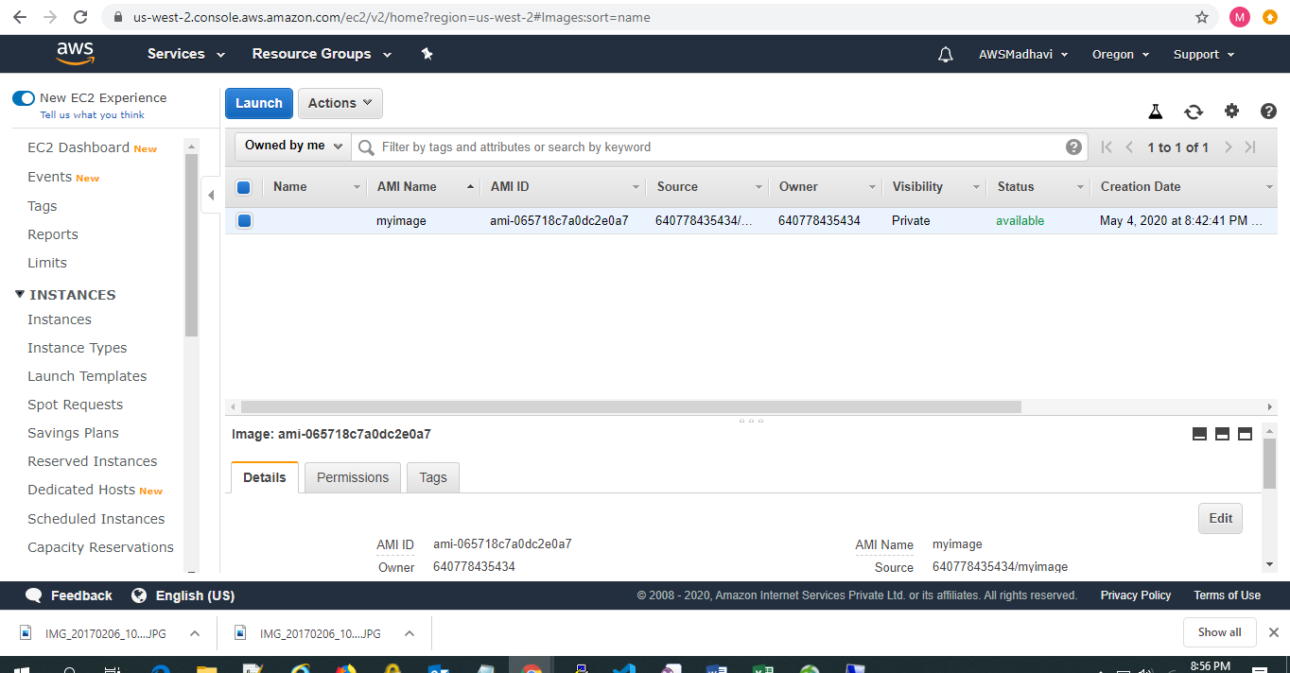

Created Load Balancer Using Load.json

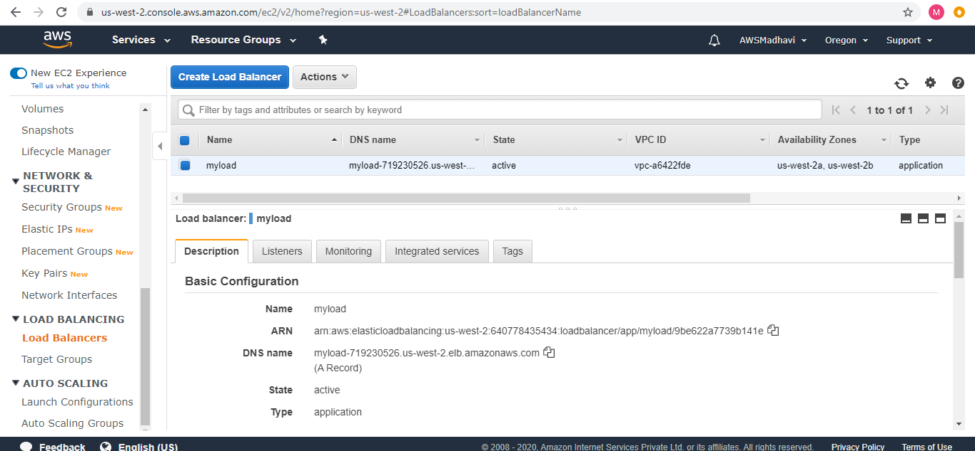

Created Target Group using LBtarget.json

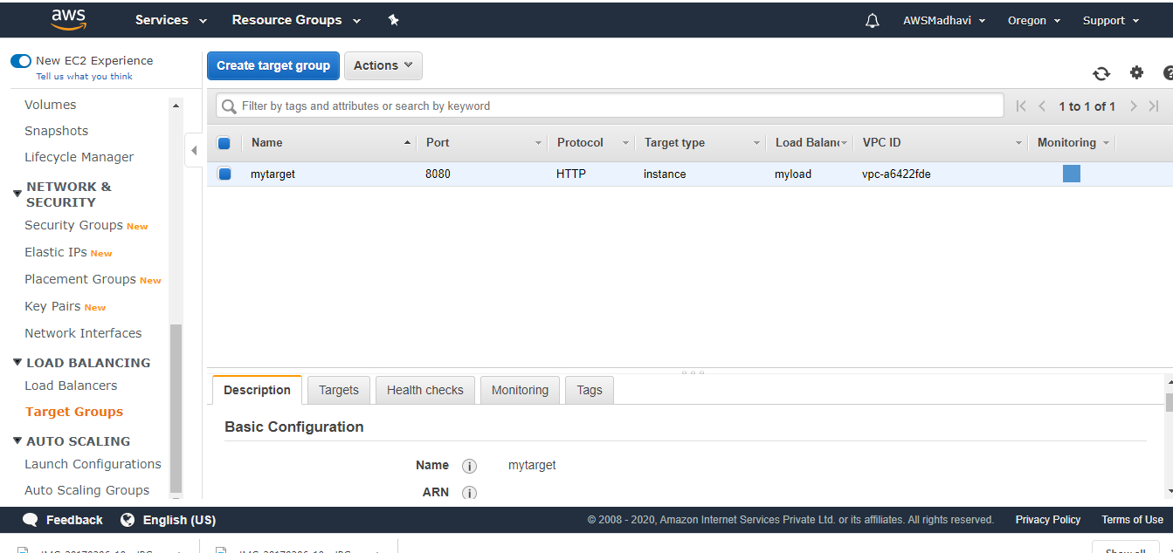

Created Listener using Listener_load.json

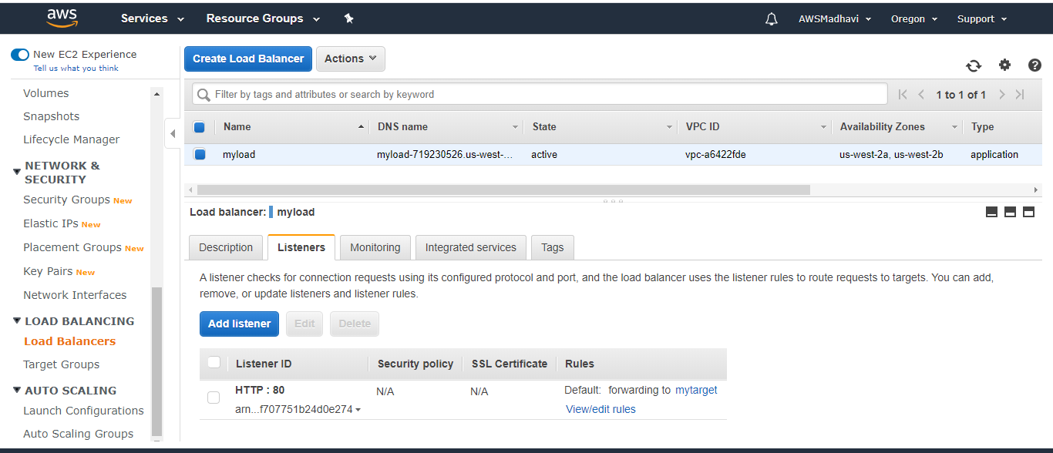

Created Autoscaling group using asg.json

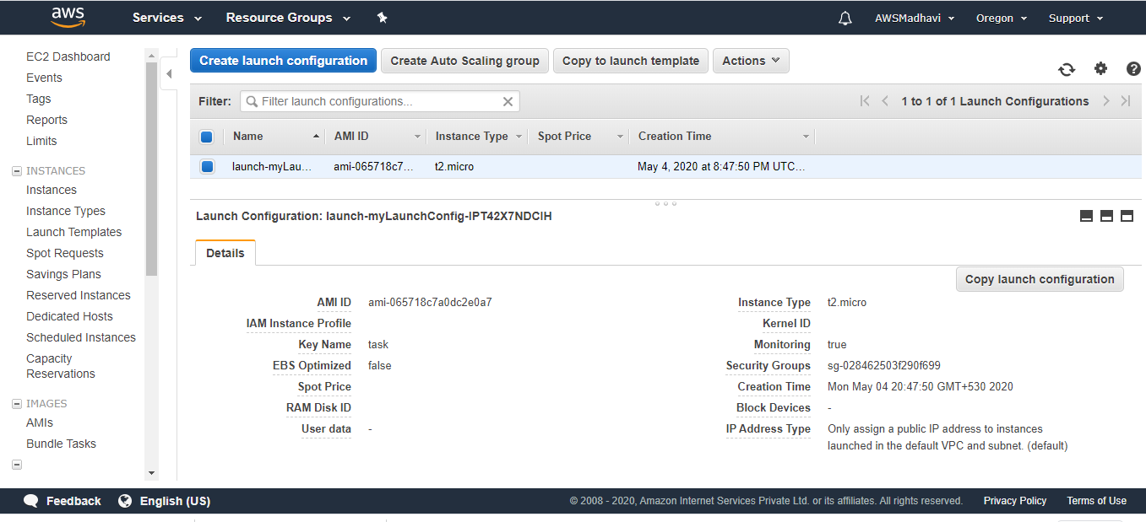 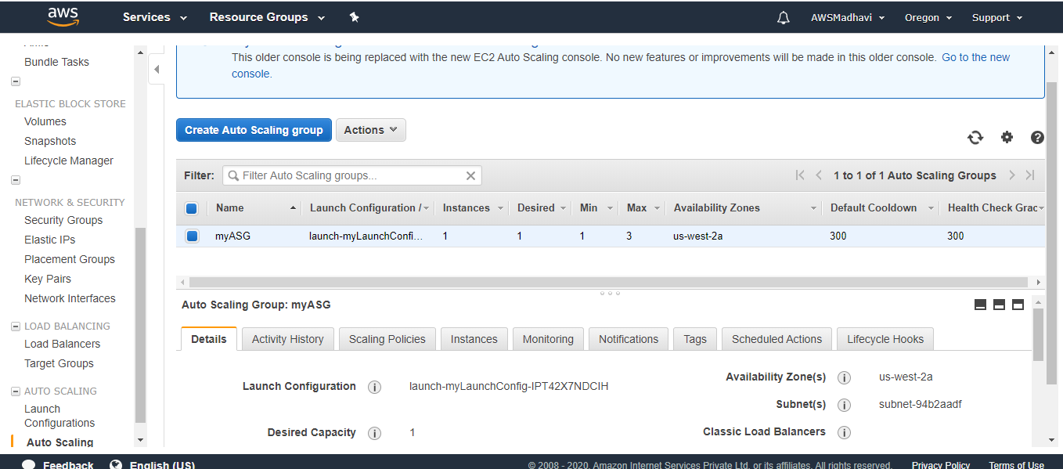

Created Scaling policies using asp.json

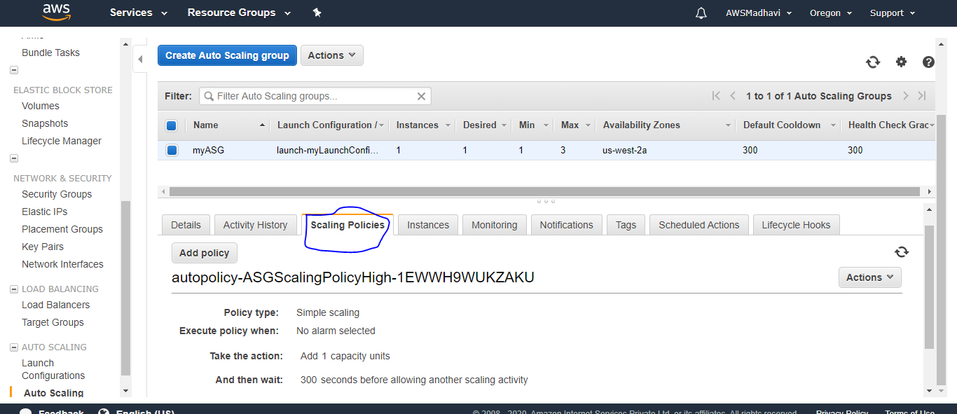

Output

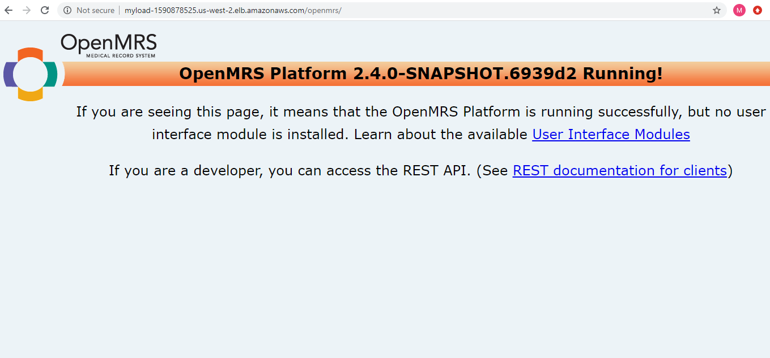

Pending Cloud formation for cloud watch and adding LoadBalancer Details to Route 53.

Will do optimization for the above task