ASSIGNMENT 4_rMarkDown

Madhavi Ghanta

2023-04-21

# Markdown Basics

## Favorite Foods

1. Grilled Fish
2. Mango Fruit
3. Ice Cream

## Images

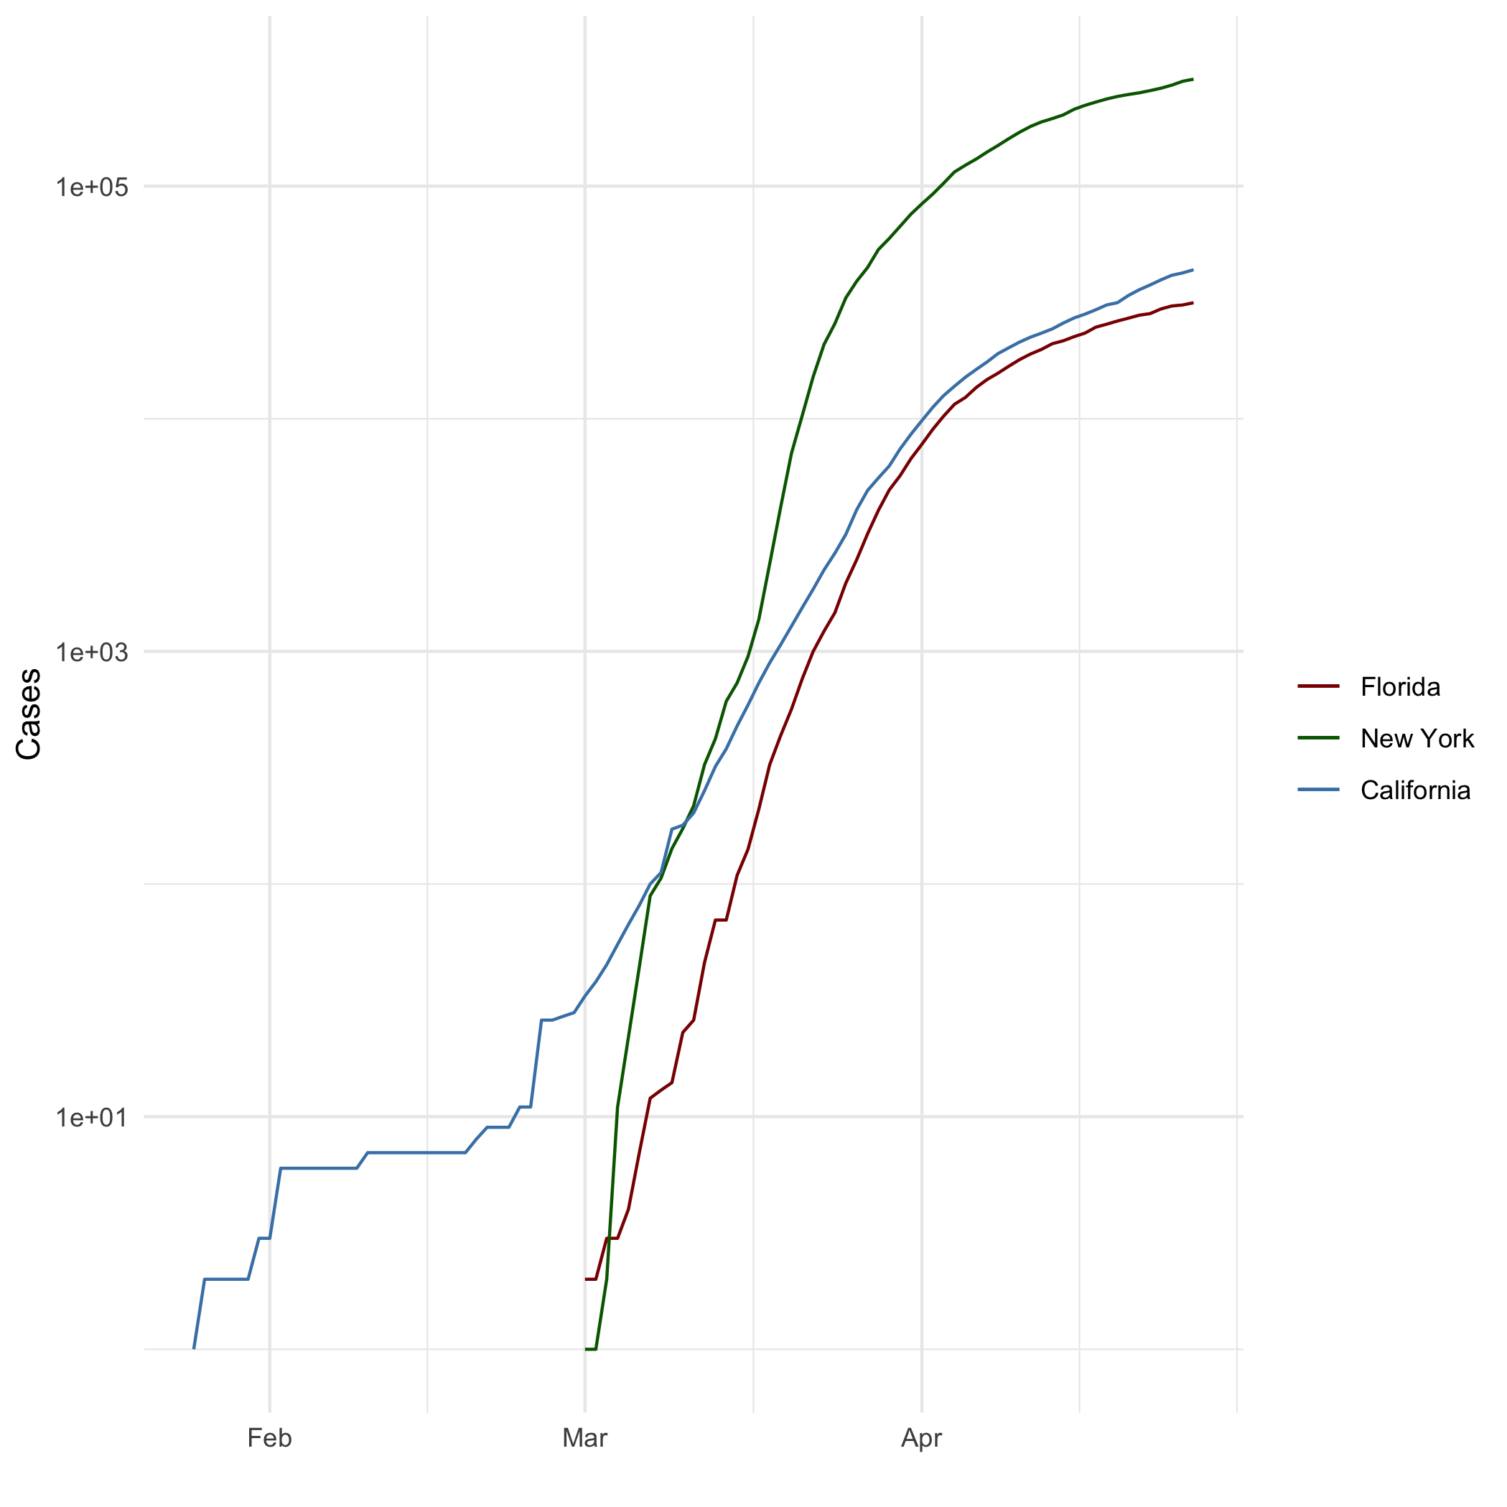

Covid-19 Cases

## Add a Quote

“The future belongs to those who believe in the beauty of their dreams. -Eleanor Roosevelt”

## Add an Equation

$ E=MC^2$

## Add a Footnote

This is a footnote.[^1] [^1]Footnote line

## Add Citations

* R for Everyone (Lander 2014)
* Discovering Statistics Using R (Field, Miles, and Field 2012)

# Inline Code

## NY Times COVID-19 Data

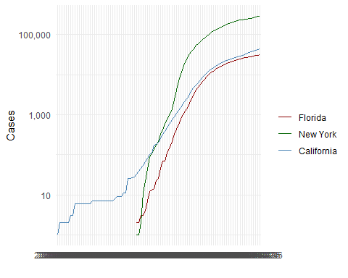

## R4DS Height vs Earnings

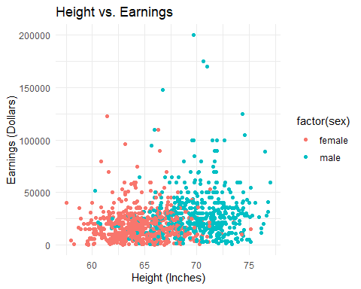

# Tables

name <- c("Aragon", "Bilbo", "Frodo", "Galadriel", "Sam", "Gandalf", "Legolas", "Sauron", "Gollum")  
race <- c("Men", "Hobbit", "Hobbit", "Elf", "Hobbit", "Maia", "Elf", "Maia", "Hobbit")  
in_fellowship <- c(TRUE, FALSE, TRUE, FALSE, TRUE, TRUE, TRUE, FALSE, FALSE)  
ring_bearer <- c(FALSE, TRUE, TRUE, FALSE, TRUE, TRUE, FALSE, TRUE, TRUE)  
age <- c(88, 129, 51, 7000, 36, 2019, 2931, 7052, 589)  
characters_df <- data.frame(name, race, in_fellowship, ring_bearer, age)

## Knitr Table with Kable

library(knitr)

## Warning: package 'knitr' was built under R version 4.2.3

knitr::kable(characters_df, col.names = c("Name", "Race", "In Fellowship?", "Is Ring Bearer?", "Age"), caption='One Ring to Rule Them All.')

One Ring to Rule Them All.

| Name | Race | In Fellowship? | Is Ring Bearer? | Age |
| --- | --- | --- | --- | --- |
| Aragon | Men | TRUE | FALSE | 88 |
| Bilbo | Hobbit | FALSE | TRUE | 129 |
| Frodo | Hobbit | TRUE | TRUE | 51 |
| Galadriel | Elf | FALSE | FALSE | 7000 |
| Sam | Hobbit | TRUE | TRUE | 36 |
| Gandalf | Maia | TRUE | TRUE | 2019 |
| Legolas | Elf | TRUE | FALSE | 2931 |
| Sauron | Maia | FALSE | TRUE | 7052 |
| Gollum | Hobbit | FALSE | TRUE | 589 |

## Pandoc Table

library(pander)

## Warning: package 'pander' was built under R version 4.2.3

library(Rcpp)  
pannames <- c("Aragon", "Bilbo", "Frodo", "Sam", "Sauron")  
panrace <- c("Men", "Hobbit", "Hobbit", "Hobbit", "Maia")  
panfellow <- c("Yes", "No", "Yes", "Yes", "No")  
panring <- c("No", "Yes", "Yes", "Yes", "Yes")  
panage <- c(88, 129, 51, 36, 7052)  
pantable_df <- data.frame(pannames, panrace, panfellow, panring, panage)  
pandoc.table(pantable_df, style='grid')

##   
##   
## +----------+---------+-----------+---------+--------+  
## | pannames | panrace | panfellow | panring | panage |  
## +==========+=========+===========+=========+========+  
## | Aragon | Men | Yes | No | 88 |  
## +----------+---------+-----------+---------+--------+  
## | Bilbo | Hobbit | No | Yes | 129 |  
## +----------+---------+-----------+---------+--------+  
## | Frodo | Hobbit | Yes | Yes | 51 |  
## +----------+---------+-----------+---------+--------+  
## | Sam | Hobbit | Yes | Yes | 36 |  
## +----------+---------+-----------+---------+--------+  
## | Sauron | Maia | No | Yes | 7052 |  
## +----------+---------+-----------+---------+--------+

# References

Field, A, J Miles, and Z Field. 2012. “Discovering Statistics Using r| SAGE Publications Ltd.” SAGE Publications Ltd.

Lander, Jared P. 2014. *R for Everyone: Advanced Analytics and Graphics*. Pearson Education.