Supplementary-B

Article Title : “Automatic rule-based generation of spinal cord connectome model for a neuro-musculoskeletal limb in silico”

Materials and methods to demonstrate the effect of Autogenic Ia-response on the ankle angle using in silico stimulation experiment

Table of contents

S.no |  | Page.no.
1 | Neuron types, models and parameters
2 | Musculoskeletal model and parameters
3 | Neuromuscular synchronization and solvers
4 | Initial conditions
5 | Stimulation procedure

The in silico connectome model that governs the Ia Afferent control of the ankle was generated on NEUROiD and this supplemtary docementation provides additional details as highlighted in the table above.

1. Neuron types, models and parameters

The spinal neuron models in the current in silico experiment are based on the previous cell models developed and published by [1], [2]⁠ .The cell models were built on NEURON[ref]. The details of cell models tabulated in the Table 1

Spinal neuron type | Neuron labels in the model | Neuron model type | Neuron characteristics | .hoc file name | Neuron model Reference
Segmental motoneurons | Human_S1_GasSol9_L_aMot_gasmed,  Human_S3_GasSol9_L_aMot_sol,  Human_S1_GasSol9_L_aMot_sol,  Human_L5_GasSol9_L_aMot_sol,  Human_S2_GasSol9_L_aMot_sol,  Human_L5_GasSol9_L_aMot_gaslat,  Human_L5_GasSol9_L_aMot_gasmed,  Human_L4_Ta9_L_aMot_ta_node,  Human_S1_GasSol9_L_aMot_gaslat | realistic | characterized by spiking soma, passive axon and dendrite | M_cell.hoc
Segmental Afferent neurons | Human_L5_L5_drg_L_Ia_gaslat,  Human_S1_S1_drg_L_Ia_gaslat,  Human_L5_L5_drg_L_Ia_gasmed,  Human_S1_S1_drg_L_Ia_gasmed  Human_L5_L5_drg_L_Ia_sol,  Human_S1_S1_drg_L_Ia_sol,  Human_S2_S2_drg_L_Ia_sol,  Human_S3_S3_drg_L_Ia_sol,  Human_L4_L4_drg_L_Ia_ta | Integrate & Fire |  | aff.hoc
Segmental  Interneurons | Nil (the current model doesn’t | Integrate & Fire

Table 1: Deatils of neurons modelled in the current in silico experiment

Description of M_cell.hoc, aff.hoc, (refer supplementary-B codes)

M_cell is a morphologically detailed model was reconstructed based on the alpha-motoneurons developed by [3], [4] for the simulation studies. The model contains a soma, axon and dendrites. Membrane potential of Soma is based on fast sodium, potassium, channels and potassium-calcium gated channels governed by equations (1,2,3,...) . While, axons and dendrites are passive elements.

Sodium current

2. Musculoskeletal model

The human lumbosacral spinal cord interacts with lower limb. For the in silico simulations experiments, an anthropometrically curated lower limb model was chosen and synchronized with the spinal connectome. This termed as “Arnold human model” based on OpenSim framework [5]⁠.

4. Neuromuscular synchroniczation and solvers
In silico Spinal cord connectome interacts with the musculoskeletal model in the manner shown in the figure - of main text. Here, the output from the connectome, i.e the ensemble alpha-motoneuron activity pertaining to each muscle was calculated based on the

5. Initial conditions

i. musculoskeletal posture

The default posture of the Arnold model was erect and upright. However in such a posture knee is fully flexed and any stimulation to the muscle that actuate knee would result in the hydperextension. Hence a specific musculoskeletal posture was selected for the future testing of carryout of neurmuscular synchronized simulations. Hence the model was set to Supine and knee and Hip angle were adjusted to a least perturbed posture. Figure 3 shows the passive perturbation in Ankle,Hip and knee at three different initial postures. Posture 3 was selected considering the and Musuloskleletal model was allowed to settle in a particular posture. And posture was selected to provide optimum flexion of all joints and prevent knee hyperflexion. Following 3 postures show the

ii.
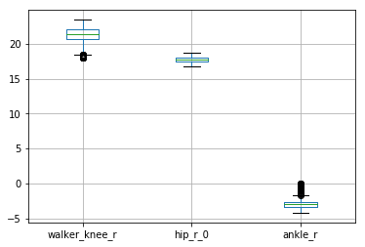
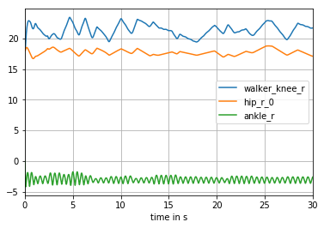
Angle in degrees
Angle in degrees

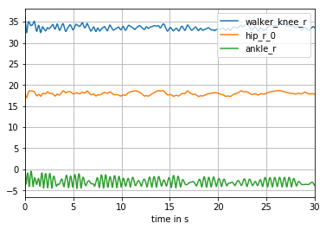
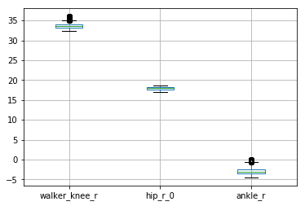
Angle in degrees
Angle in degrees

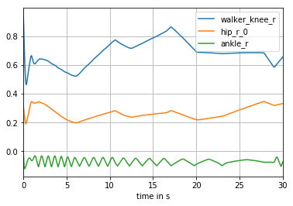
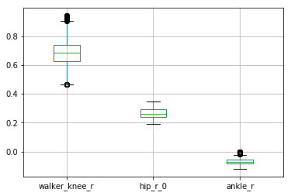
Angle in degrees
Angle in degrees

6. Stimulation procedure

The soma of the

