SESSION 33: TABLEAU DESKTOP (CONTD.)

Assignment 1

**5. Problem Statement**

1. Open the Super Store dashboard.twbx

2. Create a bar graph to show the Total Sales across customer segments for various regions

3. Segregate each region with different colors

Various steps involved for the Assignment are given below.

Open the previously stored superstore dashboard.twbx from the tableau repository folder stored in my documents.

Double click to open in the Tableau desktop version

The given below steps provide the details

Drag sales from measure to the row which will calculate the total sale(sum sales) to create a bar chart

Drag Region from the Dimension to the column to show the bar graphs for each regions

Drag the segment from the Dimension to the column next to region to show the total sales bar graph for segment along with region

Drag the sales to the label icon in the Marks section to show the values against each bar graph.

To Provide the different colour for each region drag the Region from the Dimension to the colour in the Mark section

This meets the assignment objectives

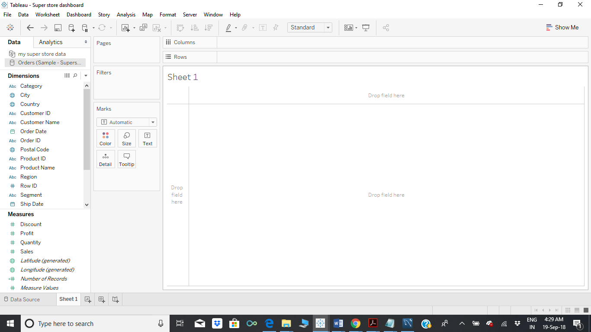

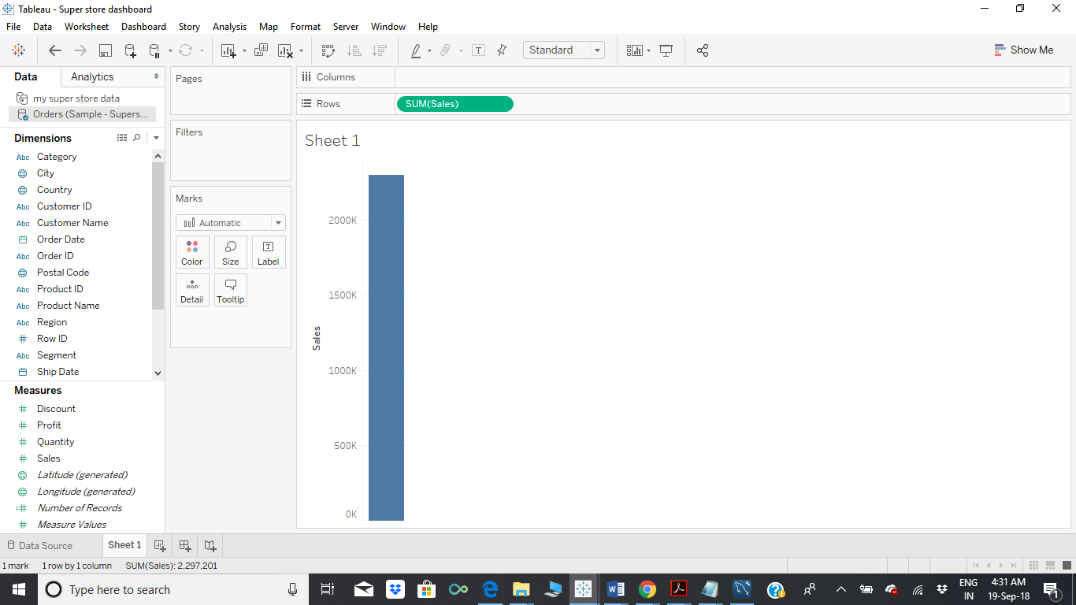

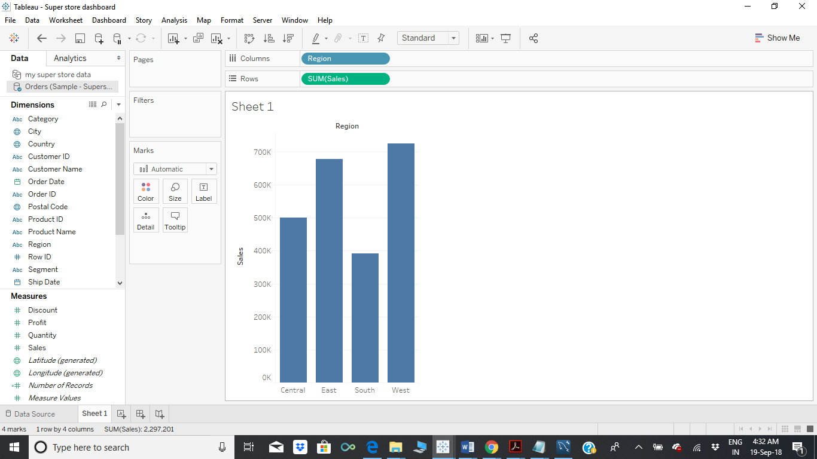

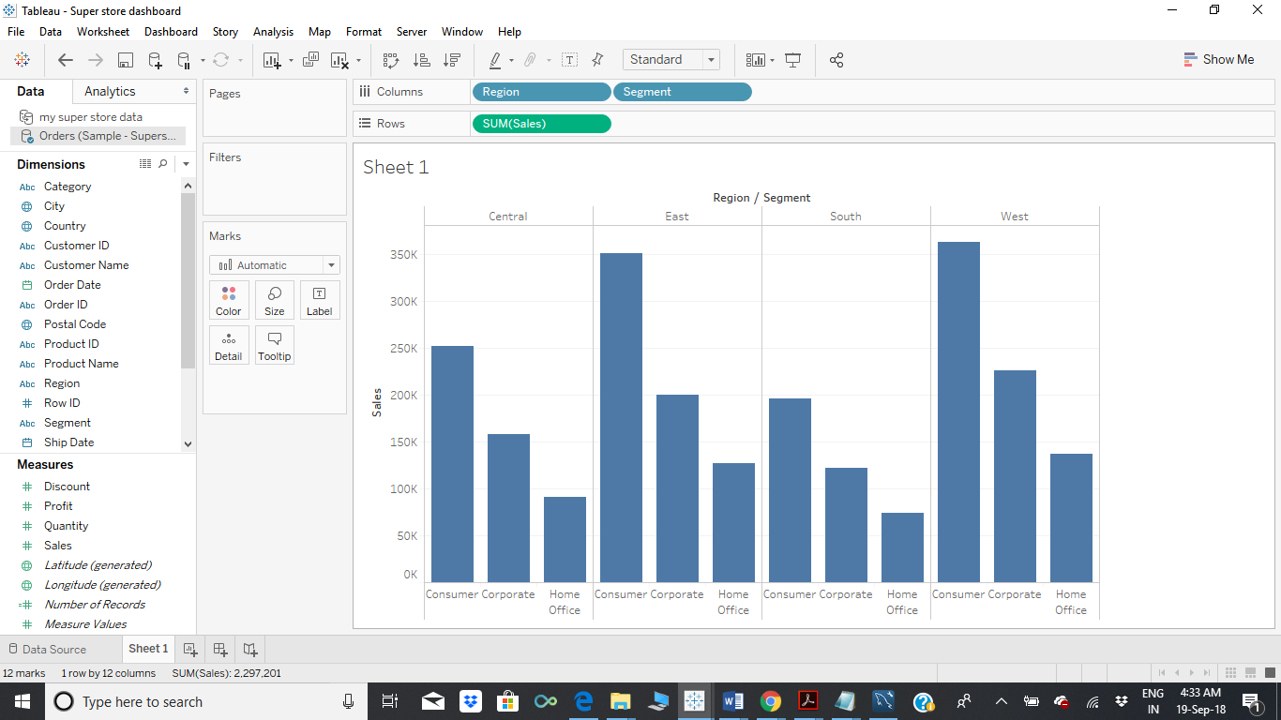

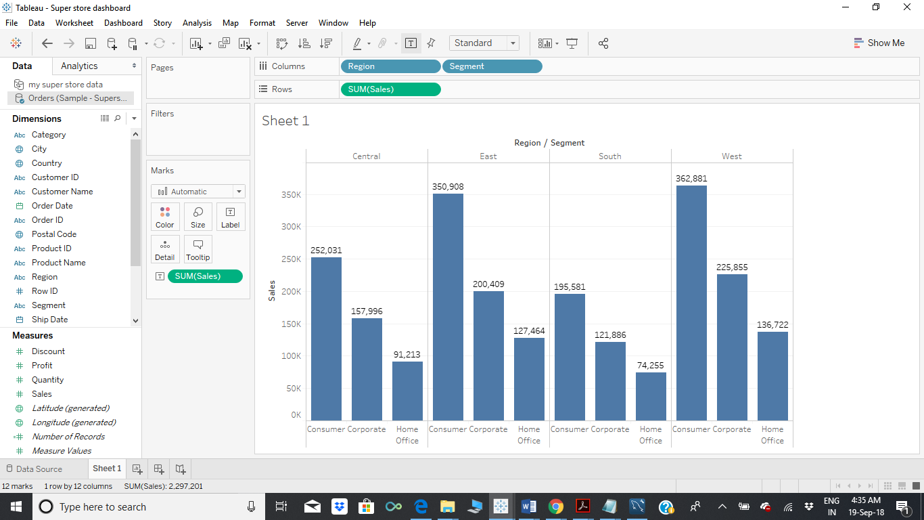

The given below graph provides the Regionwise coloured bar graph for the total sales and each segment.

