1. Histogram for all variables in a dataset mtcars. Write a program to create histograms for all columns.

Ans:

> hist(mtcars$mpg)

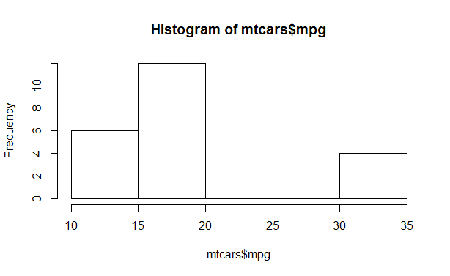

> hist(mtcars$cyl)

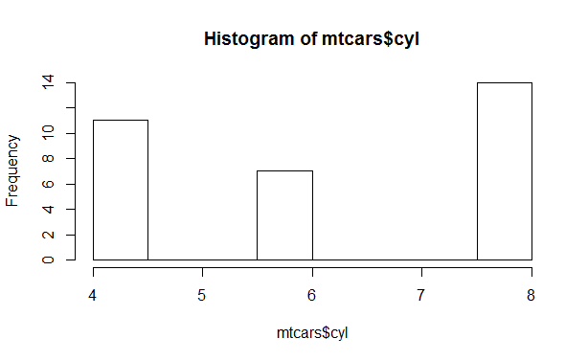

> hist(mtcars$disp)

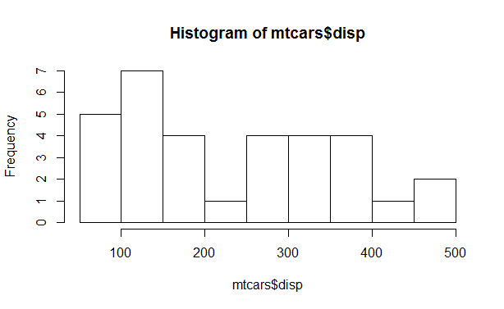

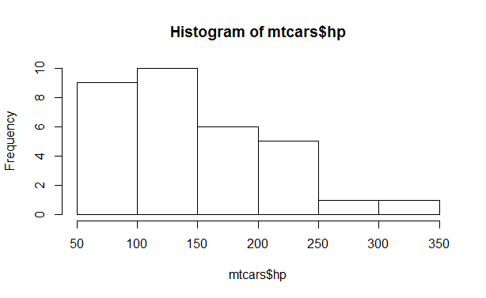

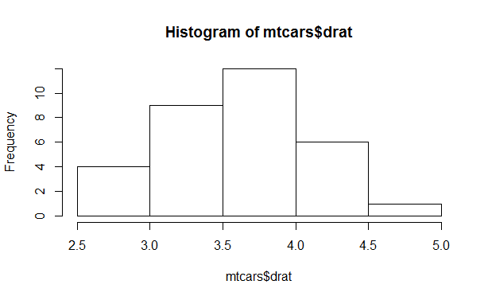

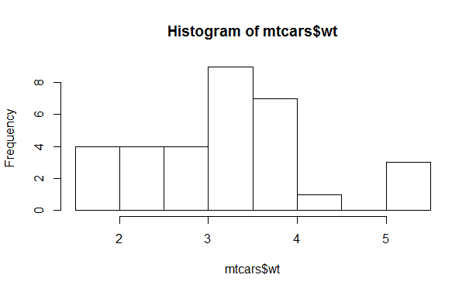

1. Check the probability distribution of all variables in mtcars

Ans:

> summary(mtcars)

mpg cyl disp hp drat

Min. :10.40 Min. :4.000 Min. : 71.1 Min. : 52.0 Min. :2.760

1st Qu.:15.43 1st Qu.:4.000 1st Qu.:120.8 1st Qu.: 96.5 1st Qu.:3.080

Median :19.20 Median :6.000 Median :196.3 Median :123.0 Median :3.695

Mean :20.09 Mean :6.188 Mean :230.7 Mean :146.7 Mean :3.597

3rd Qu.:22.80 3rd Qu.:8.000 3rd Qu.:326.0 3rd Qu.:180.0 3rd Qu.:3.920

Max. :33.90 Max. :8.000 Max. :472.0 Max. :335.0 Max. :4.930

wt qsec vs am gear

Min. :1.513 Min. :14.50 Min. :0.0000 Min. :0.0000 Min. :3.000

1st Qu.:2.581 1st Qu.:16.89 1st Qu.:0.0000 1st Qu.:0.0000 1st Qu.:3.000

Median :3.325 Median :17.71 Median :0.0000 Median :0.0000 Median :4.000

Mean :3.217 Mean :17.85 Mean :0.4375 Mean :0.4062 Mean :3.688

3rd Qu.:3.610 3rd Qu.:18.90 3rd Qu.:1.0000 3rd Qu.:1.0000 3rd Qu.:4.000

Max. :5.424 Max. :22.90 Max. :1.0000 Max. :1.0000 Max. :5.000

carb madhu

Min. :1.000 Length:32

1st Qu.:2.000 Class :character

Median :2.000 Mode :character

Mean :2.812

3rd Qu.:4.000

Max. :8.000

> mode_mpg <- names(sort(-table(mtcars$mpg)))[1]

> mode_cyl <- names(sort(-table(mtcars$cyl)))[1]

> mode_disp <- names(sort(-table(mtcars$disp)))[1]

> mode_hp <- names(sort(-table(mtcars$hp)))[1]

> mode_drat <- names(sort(-table(mtcars$drat)))[1]

> mode_wt <- names(sort(-table(mtcars$wt)))[1]

> mode_qsec <- names(sort(-table(mtcars$qsec)))[1]

> mode_vs <- names(sort(-table(mtcars$vs)))[1]

> mode_am <- names(sort(-table(mtcars$am)))[1]

> mode_gear <- names(sort(-table(mtcars$gear)))[1]

> mode_carb <- names(sort(-table(mtcars$carb)))[1]

> paste("The mode of the miles per gallon data is", mode_mpg)

[1] "The mode of the miles per gallon data is 10.4"

> paste("The mode of the number of cylinders data is", mode_cyl)

[1] "The mode of the number of cylinders data is 8"

> paste("The mode of the displacement data is", mode_disp)

[1] "The mode of the displacement data is 275.8"

> paste("The mode of the horsepower data is", mode_hp)

[1] "The mode of the horsepower data is 110"

> paste("The mode of the rear axle ratio data is", mode_drat)

[1] "The mode of the rear axle ratio data is 3.07"

> paste("The mode of the weight (1000 lbs) data is", mode_wt)

[1] "The mode of the weight (1000 lbs) data is 3.44"

> paste("The mode of the quarter mile time data is", mode_qsec)

[1] "The mode of the quarter mile time data is 17.02"

> paste("The mode of the V/S data is", mode_vs)

[1] "The mode of the V/S data is 0"

> paste("The mode of the transmission data is", mode_am)

[1] "The mode of the transmission data is 0"

> paste("The mode of the number of forward gears data is", mode_gear)

[1] "The mode of the number of forward gears data is 3"

> paste("The mode of the number of carburetors data is", mode_carb)

[1] "The mode of the number of carburetors data is 2"

3. Write a program to create boxplot for all variables.

Ans:

ggplot(mtcars, aes(x=factor(am), y=mpg)) + geom_boxplot()

