**Create a box and whisker plot by class using mtcars dataset.**

**boxplot(mpg~cyl,data=mtcars, main="Car Milage Data",**

**xlab="Number of Cylinders", ylab="Miles Per Gallon")**

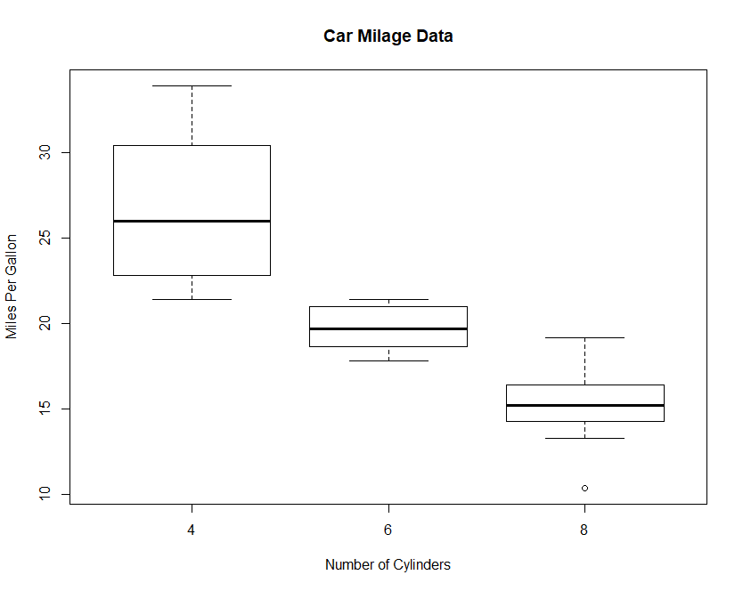

**OR**

**boxplot(mtcars, range=0.0, horizontal=FALSE, varwidth=TRUE, notch=FALSE, outline=TRUE, boxwex=0.3, border=c("blue"), col=c("red"), xlab="Gene-A", ylab="Expression Level")**

