Financial News Sentiment Prediction using Deep Learning & BERT

Model Comparison
Model | Accuracy | Macro F1
Simple RNN | 65.62% | 0.27
LSTM | 73.62% | 0.56
GRU | 80.74% | 0.72
BERT | 88.44% | 0.85

Which RNN Variant Works Best?
Among the baseline models, Embedding + GRU performed the best with 80.74% accuracy and 0.72 Macro F1. GRU captured contextual information better than the Simple RNN while using a simpler architecture than LSTM, resulting in better generalization.

BERT Improvement
The fine-tuned BERT model achieved 88.44% validation accuracy and 0.8472 Macro F1, improving accuracy by about 7.7 percentage points and Macro F1 by about 0.13 over the GRU baseline.

Streamlit Dashboard
The Streamlit application allows users to enter a financial tweet or headline, predicts the sentiment (Bearish, Bullish, or Neutral), displays class probabilities in a bar chart, and shows the predicted sentiment using color-coded text.
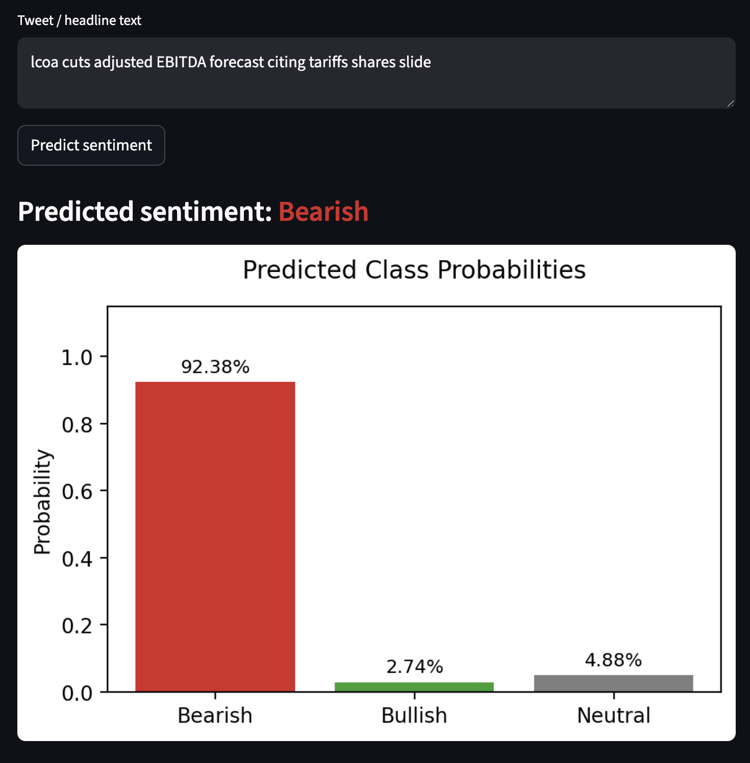
Figure 1. Neutral sentiment prediction example.
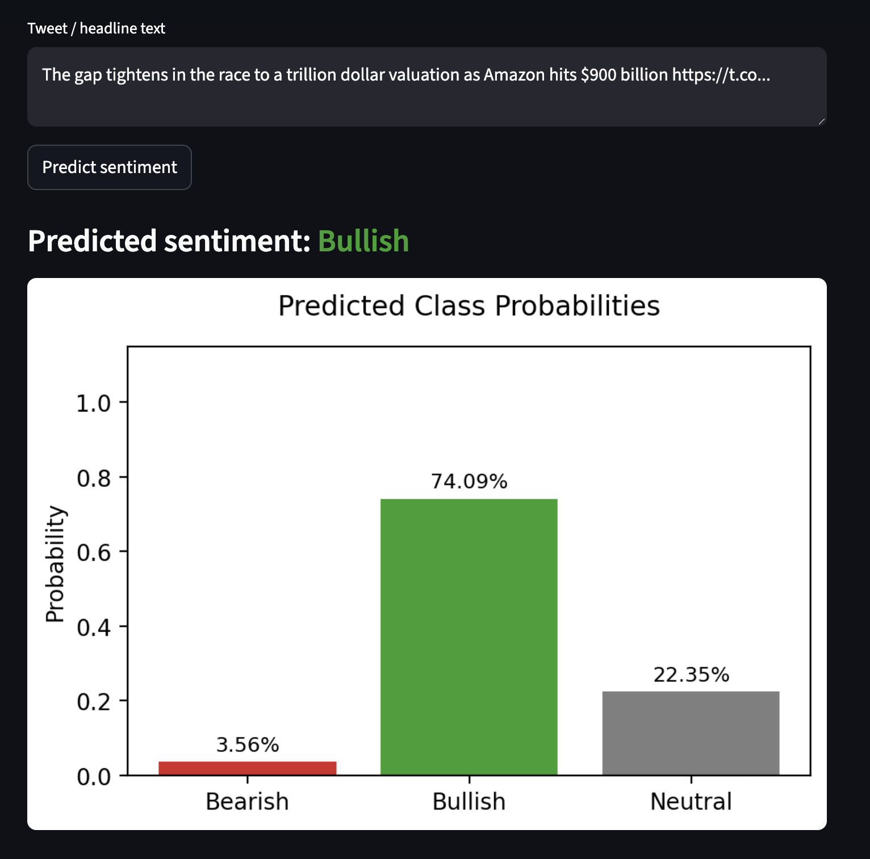
Figure 2. Bullish sentiment prediction example.
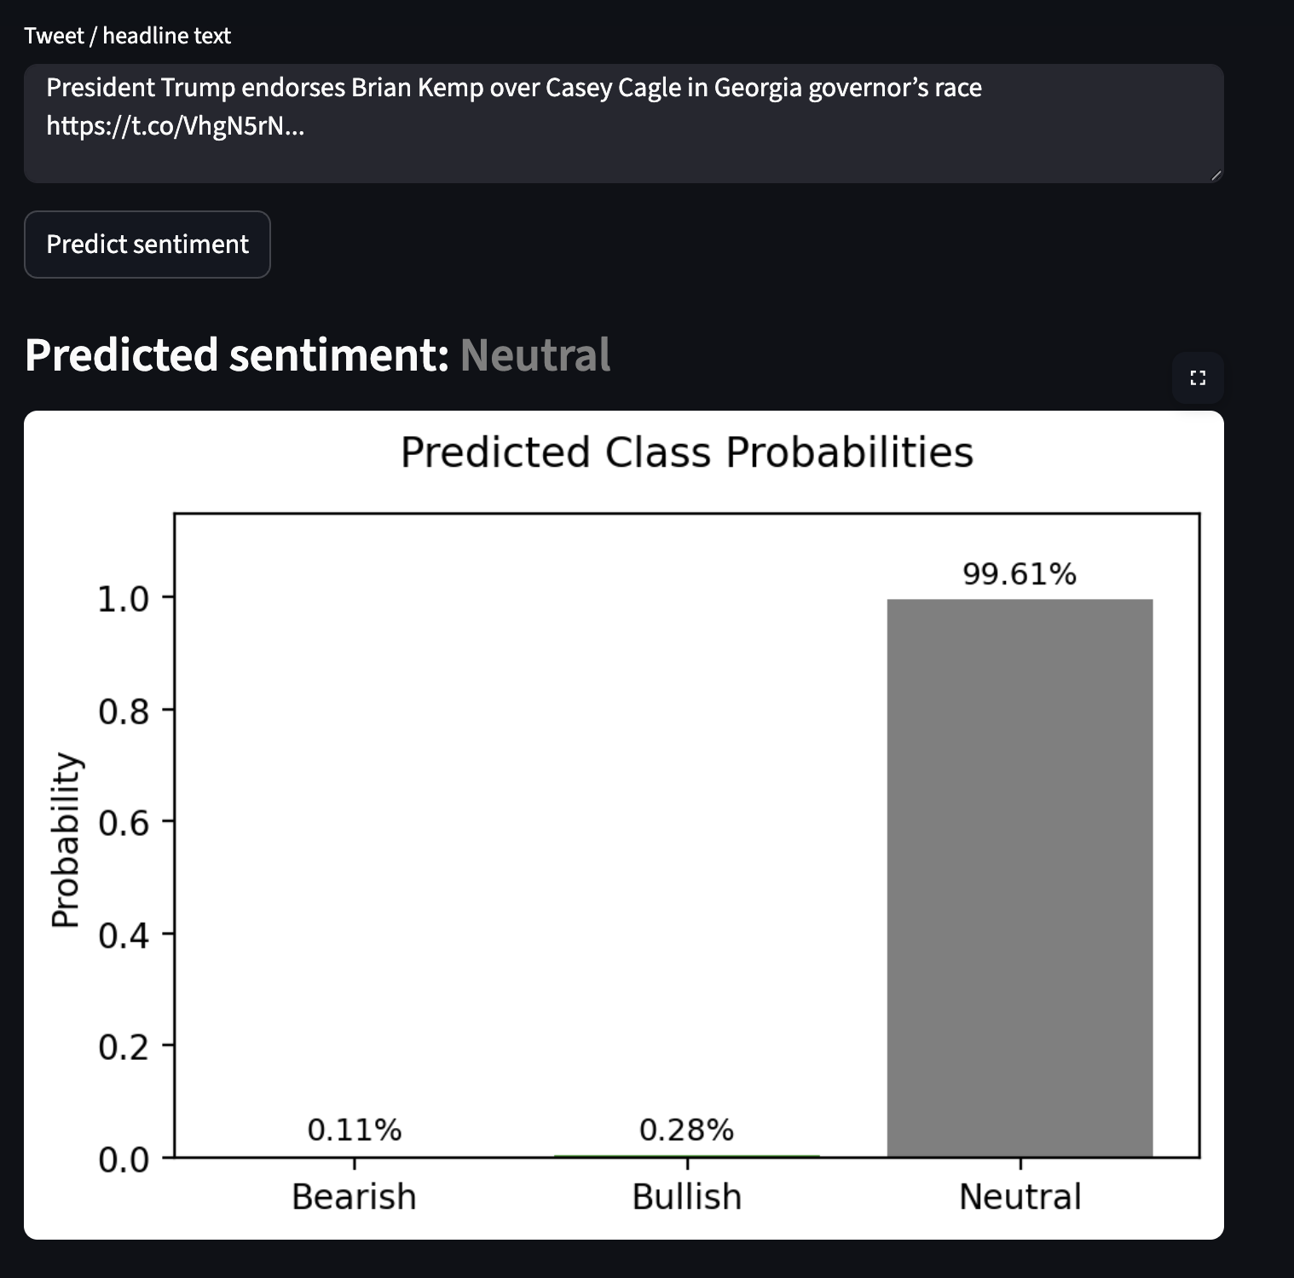
Figure 3. Bearish sentiment prediction example.

