**Assignment #1 : Generic Data Viewer::**

Technology Stack: Spring Boot

Project Name:Products-GDV

Pagination and Sorting:

[URL::::==>localhost:8080/api/v1/products?pageSize=5&pageNo=0&sortBy=Name](URL::::==%3elocalhost:8080/api/v1/products?pageSize=5&pageNo=0&sortBy=Name)

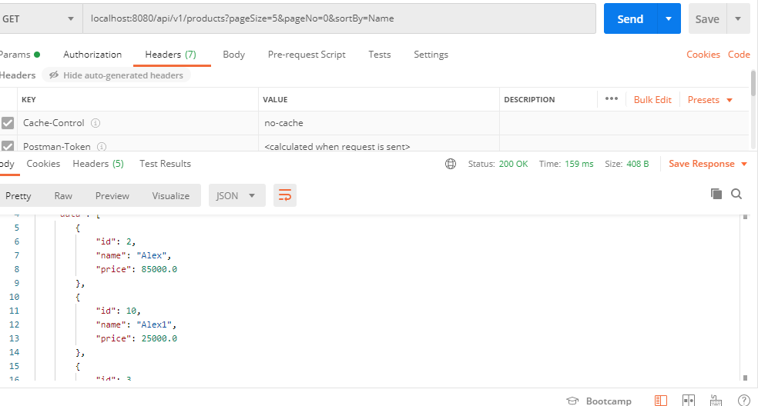

Filtering on Column::

<URL:::==>> localhost:8080/api/v1/products/byNameLike/Al ,here “Al” is the

