B2B myProject

If you have Google Toolbar installed on your PC, please remove it.

- Perform gpupdate /force

Launch IE with your credential ( need admin login)

- Internet Explorer > Click F10 > Tools > Add samsungmobile.com and samsungelectronics.com , samsung.net to ‘Compatability View Settings’
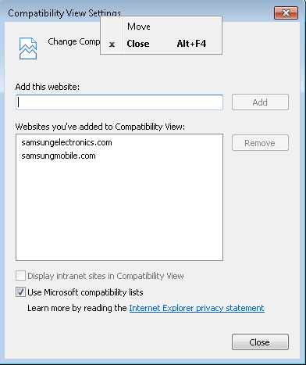

Internet Explorer > Click F10 > Tools > Pop-up Blocker > Turn Off Pop-up Blocker

3. Internet Explorer > Click F10 > Tools > Internet Options > Security > Trusted Site

1) Click Default Level > change to the minimum
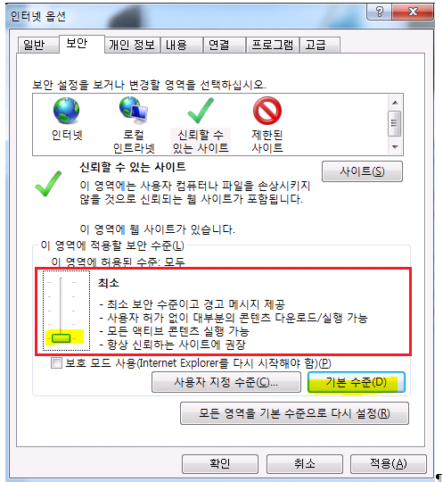

@ Run Internet Explorer as administrator(your credential) and access http://myproject.samsungmobile.com > allow all installation and security allow before log in.

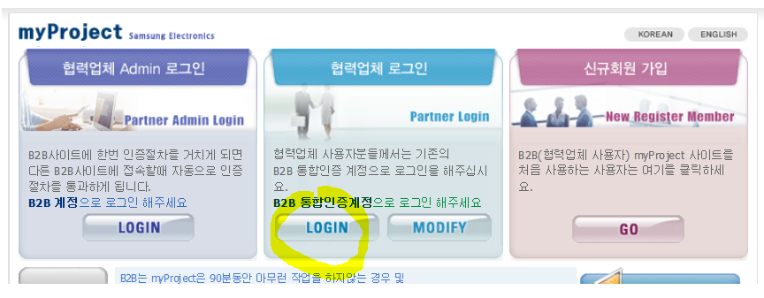
Require NDS installation,
Please Press installation File Download and run after downloading.( You may require to close IE or office etc, close these app)

Can ignore if cannot find

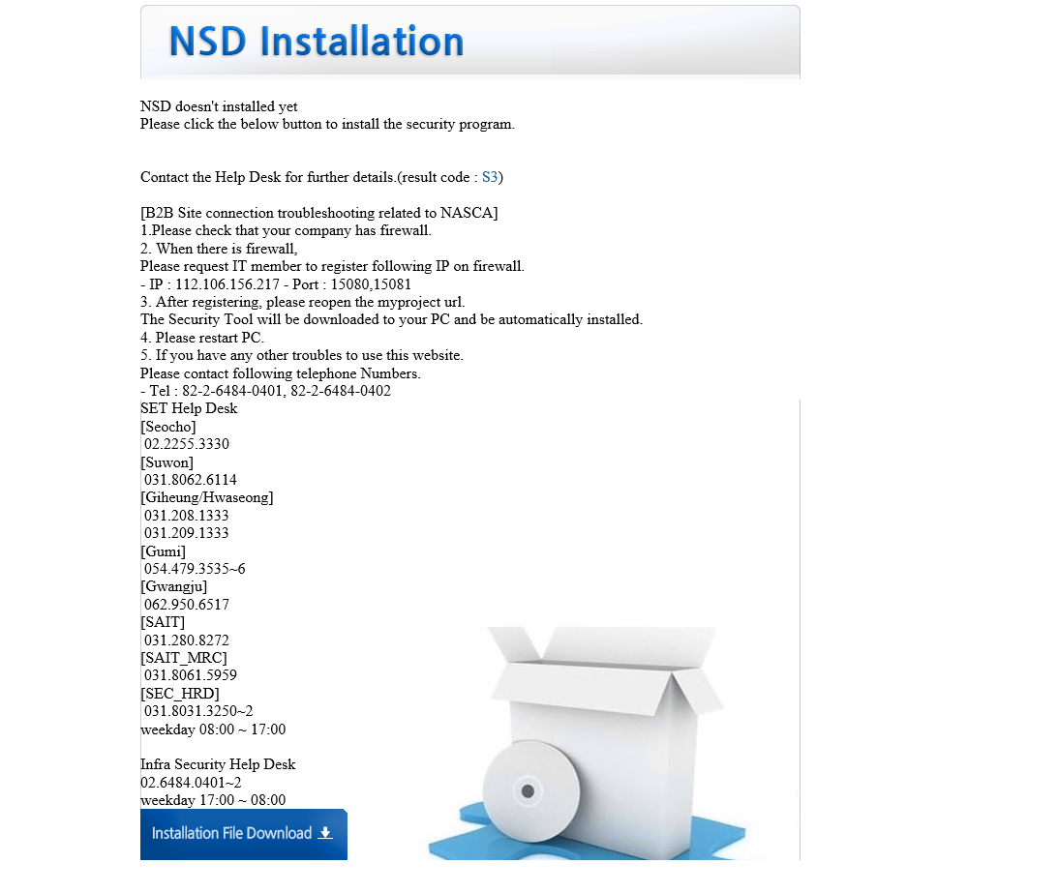

Go to http://myproject.samsungmobile.com

Log in

Ask user about login ID and PW for my project.

After restarting pc, compatibility setting will be lost,,, do not forget to add it each time.

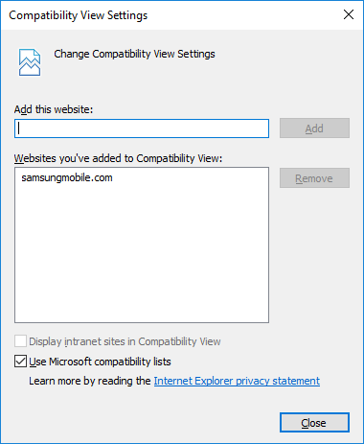

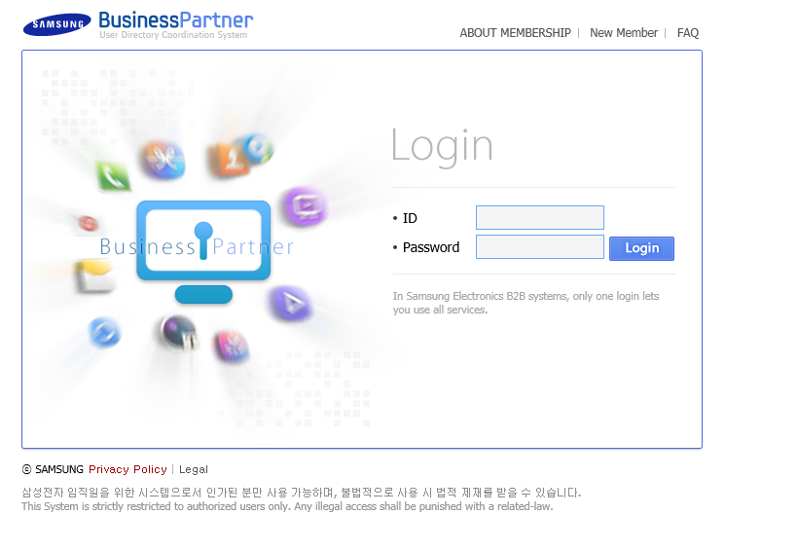
If a popup is coming up, please press yes.

Press STMS tab

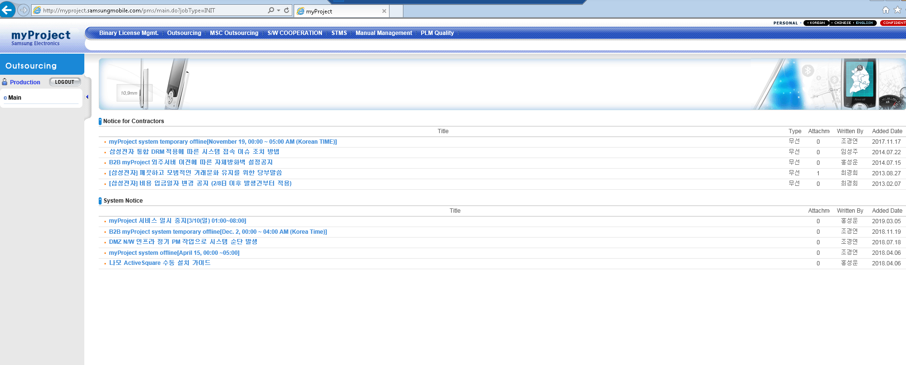

Some files start to download and install automatically, wait for a while.

Open with user credential

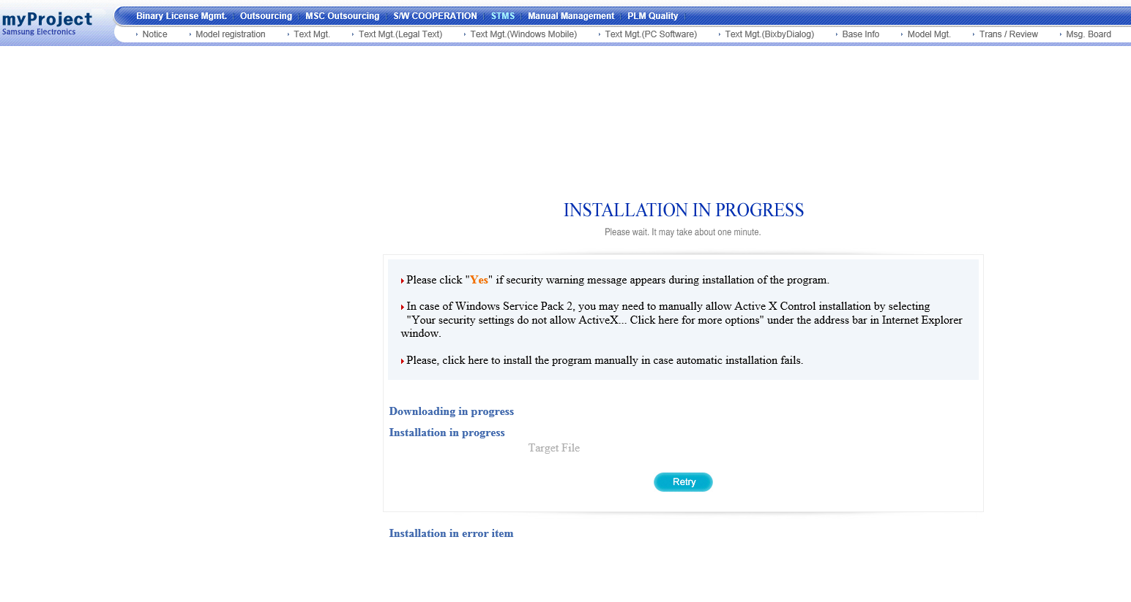

If failed asks to retry ignore….ignore 20 times until gone, log

If you face this popup , please download and install all.
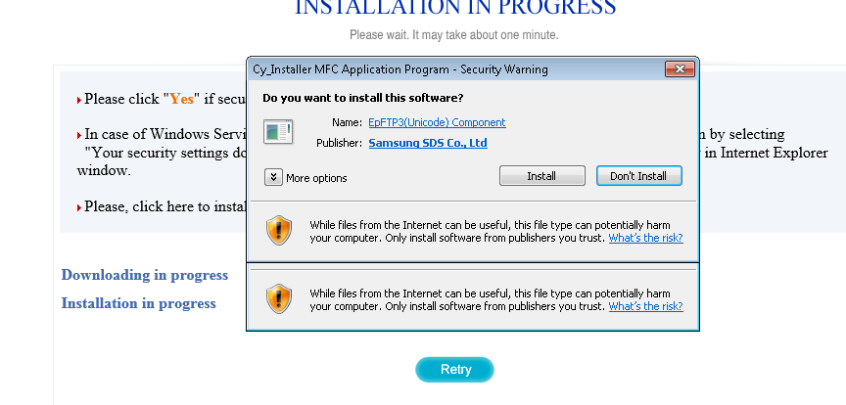

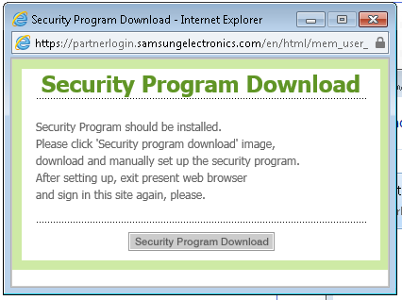

Confirm page is displayed like this.

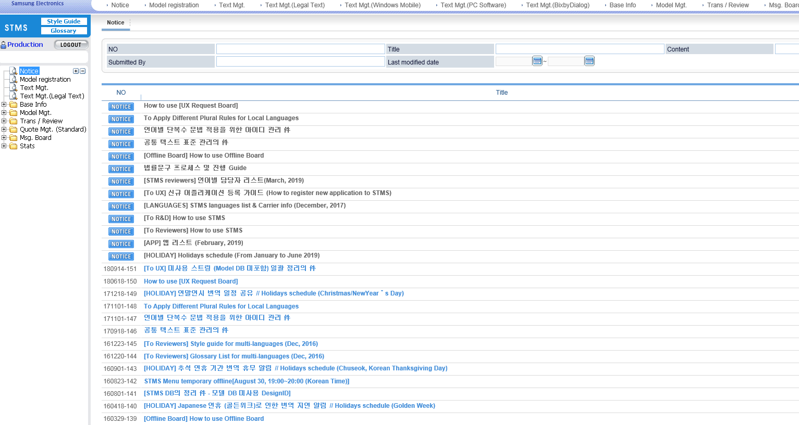

The web page wants to run the following add-on WebPKI Module → Allow for all website
SecuiB2BIE module → Allow for all website

All pop up need to press allow for all website, when it disappears

↓ always allow
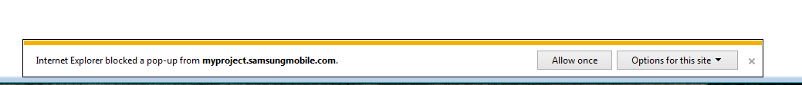

Then log in. 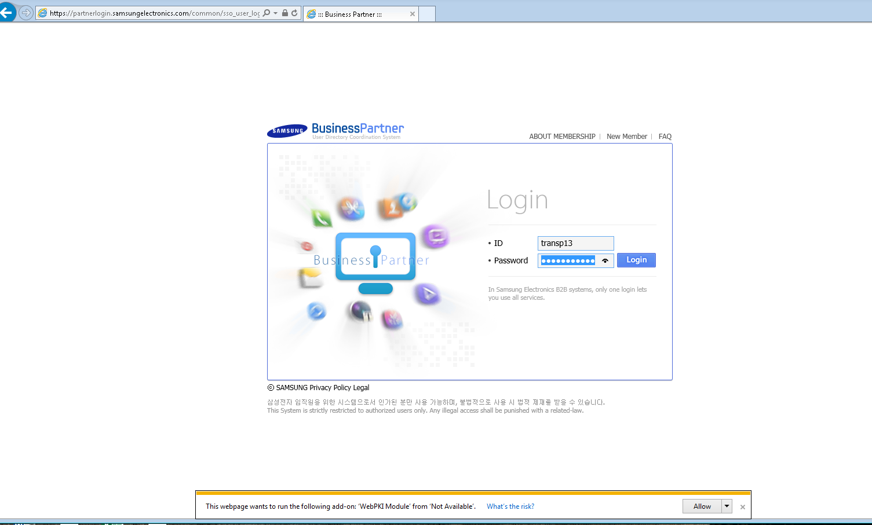

Press STMS again.



