RPM
(Redhat Package Management)

There are three machenisum to install packages/softwares in Linux.
These are:
- Rpm base installation.
- Yum base installation.
- Tarball base installation.

When you work with Redhat Linux then packages comes with .rpm format.
Tarball that is .tar.gx or .tar.bz2, this is architecture nutrall means it works on all O/S.

When you install packages using rpm, all installed packages are stored at one central location. That is /var/lib/rpm.

.rpm = (tar+machine specification + redhat information)

As a SysAdmin we are responsible for these:
- install,erase and upgrade packages.
- Queary of softwares that is who installed, when installed and what is the license information of packages.
- Pakcage health checkup.

We can get packages from:

- RHN (Redhat Network) . These are verified, tested and supported by redhat.but you need to take and redhat subscription.
- Third party companies
like www.rpmfind.net
www.rpmforge.net
epel(extra packages for enterprise linux)

- CD\DVD

Package description:

vsftpd.2.1.el6.i386.rpm

vsftpd = name of the software (very secure ftp deamon)
  - = version at the time of downloaded from open source.

el6 = enterprise Redhat linux6, this means software is tested for this linux version.
I386 = cpu architecture
.rpm = format supported by redhat linux.

#############################################################################|

Usage: rpm [OPTION...]
--quiet

Query/Verify package selection options:
-a, --all query/verify all packages
-f, --file query/verify package(s) owning file
-g, --group query/verify package(s) in group
-p, --package query/verify a package file

Query options (with -q or --query):
-c, --configfiles list all configuration files
-d, --docfiles list all documentation files
--dump dump basic file information
-l, --list list files in package
--queryformat=QUERYFORMAT use the following query format
-s, --state display the states of the listed files

Install/Upgrade/Erase options:
--aid add suggested packages to transaction
--allfiles install all files, even configurations which might otherwise be skipped
--allmatches remove all packages which match <package> (normally an error is generated if <package>
specified multiple packages)
--badreloc relocate files in non-relocatable package
-e, --erase=<package>+ erase (uninstall) package
--excludedocs do not install documentation
--excludepath=<path> skip files with leading component <path>
--fileconflicts detect file conflicts between packages
--force short hand for --replacepkgs --replacefiles
-F, --freshen=<packagefile>+ upgrade package(s) if already installed
-h, --hash print hash marks as package installs (good with -v)
--ignorearch don't verify package architecture
--ignoreos don't verify package operating system
--ignoresize don't check disk space before installing
-i, --install install package(s)
--justdb update the database, but do not modify the filesystem
--nodeps do not verify package dependencies
--nofiledigest don't verify digest of files
--nomd5 don't verify digest of files (obsolete)
--nocontexts don't install file security contexts
--noorder do not reorder package installation to satisfy dependencies
--nosuggest do not suggest missing dependency resolution(s)
--noscripts do not execute package scriptlet(s)
--notriggers do not execute any scriptlet(s) triggered by this package
--oldpackage upgrade to an old version of the package (--force on upgrades does this automatically)
--percent print percentages as package installs
--prefix=<dir> relocate the package to <dir>, if relocatable
--relocate=<old>=<new> relocate files from path <old> to <new>
--replacefiles ignore file conflicts between packages
--replacepkgs reinstall if the package is already present
--test don't install, but tell if it would work or not
-U, --upgrade=<packagefile>+ upgrade package(s)

###############################################################################|
Practical: we will be using CD/DVD.

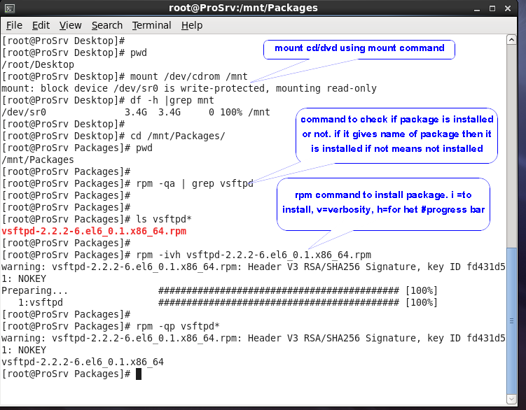

#rpm -Uvh package_name.rpm

#rpm -Fvh package_name.rpm

U = for package upgrade
F=for package freshning

Upgrade = the major version change is called as upgrade like moving form Rhel6 to 7.
Patching = the minor change. Addition of some new features, deletion of buggs from old version.

Note: we should not use U and F for kernel installation.
Security patch should be installed between 24 hours in production environment.

