YUM

Yum is 99% rpm only. Rpm has got one drawback. It could not resolve dependency.
That is the only difference between rpm and yum.
Yum stands for yellow dog update and modified.
Yum is capable of resolving dependencies.
Repodata = if you have no repodata file then you have no yum server. Repodata contains relationship between packages and their locatioins in xml format.
Yum config file location is /etc/yum.repos.d/
yum log file /var/log/yum.log
You can give any name to config file. These are basic components needed to configure any yum server.

[Rhel6_yum_server] #id of your yum server. Space and special char not allowed
name=my local yum server #name for your yum server. You can give any name
baseurl=ftp://192.168.1.40/pub/redhat6dvd #most important entry in yum server config file. It allows ftp, http, https and file protocols. Nfs is not allowed
enabled=1 #unable 1 or disable 0. your yum server
gpgcheck=0

Local yum server installation steps:
server side:
- install vsftpd on your basic linux box
- make it ftp server
- mount cd dvd on /mnt directory
- check mounting with df -h
- go to /mnt/Packages directory
- install vsftpd package
- go to /var/ftp/pub directory
- make dirctory with redhat6dvd name
- copy all whole cd to redhat6dvd folder with cp command
- cp -rvf /mnt/* /var/ftp/pub/redhat6dvd
- start vsftpd service and make it persistant using chkconfig command
- disable firewall and selinux

client side:
- go to this dir using #cd /etc/yum.repos.d/
- copy template file with another name using cp command
- cp rhel-source.repo any.repo
- vi any.repo
make your file exact like this
[Rhel6_yum_server]
name=my local yum server
baseurl=ftp://192.168.1.40/pub/redhat6dvd
enabled=1
gpgcheck=0

- save file
- test yum server
- #yum clean all -to remove cache
- #yum repolist - to check how many repo are installed

some basic commnds are
#yum search firefox - to search package
#yum info firefox.x86_64 -to get more info of package
#yum install firefox.x86_64 -to install package
#yum list dhcp* -to check all available packages of dhcp
#yum remove dhcp.x86_64 -to remove package

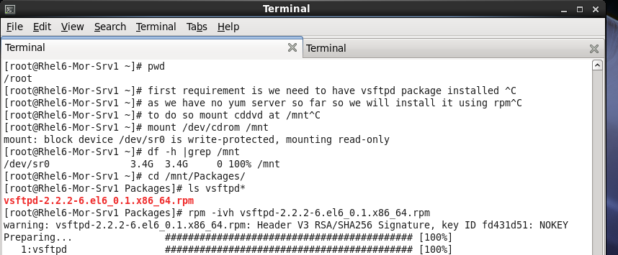

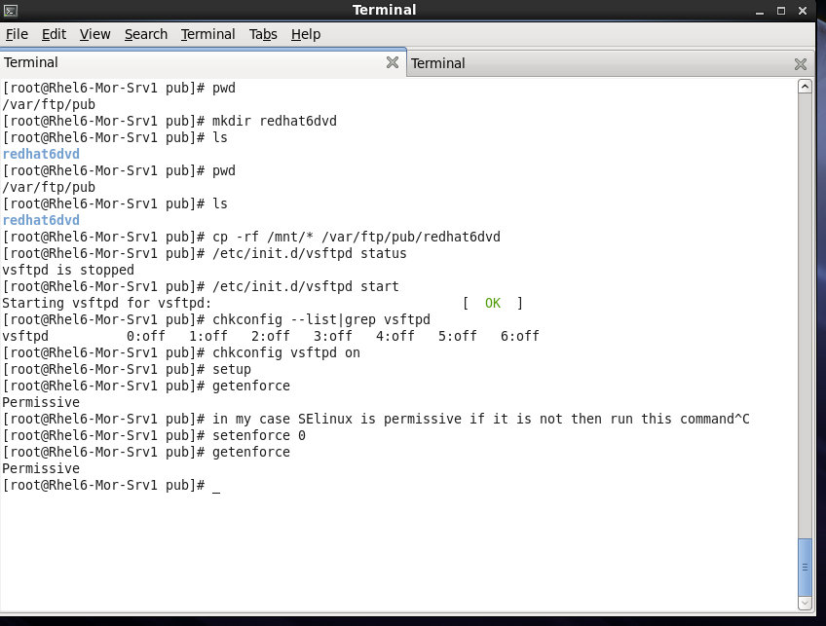

client side:

