DATA SCIENCE (21CSS303T)
Submitted by
Madhav K Mohan (RA2311026050003)
Manu Krishnan (RA2311026050065)
Under the guidance of
Dr. Gunasundari C

(Assistant Professor, Department of Computer Science & Engineering)
in partial fulfilment for the award of the degree of

BACHELOR OF TECHNOLOGY
in

COMPUTER SCIENCE AND ENGINEERING
Of
FACULTY OF ENGINEERING AND TECHNOLOGY


SRM INSTITUTE OF SCIENCE AND TECHNOLOGY TIRUCHIRAPPALLI
SRM INSTITUTE OF SCIENCE AND TECHNOLOGY
TIRUCHIRAPPALLI

(Deemed to be University U/S3 of UGC Act, 1956)

BONAFIDE CERTIFICATE
Certified that this project report titled FraudShield: Detecting Financial Fraud Using Transaction Data Analysis is the Bonafide work of Madhav K Mohan (RA2311026050003) & Manu Krishnan (RA2311026050065) who carried out the project work under my supervision. Certified further, that to the best of my knowledge the work reported herein does not form any other project report or dissertation on the basis of which a degree or award was conferred on an occasion on this or any other candidate.

SIGNATURE  Dr. Gunasundari C  Assistant Professor  School of Computing,  SRM Institute of Science and Technology, Tiruchirappalli. | SIGNATURE  Dr. R. Balaji Ganesh Head of the Department Department of CSE - AIML  SRM Institute of Science and Technology,  Tiruchirappalli.

Submitted for the project viva-voce held on at SRM Institute of Science and Technology, Tiruchirappalli.
SRM INSTITUTE OF SCIENCE AND TECHNOLOGY TIRUCHIRAPPALLI

DECLARATION

We hereby declare that the entire work contained in this project report titled FraudShield: Detecting Financial Fraud Using Transaction Data Analysis is the Bonafide work of Madhav K Mohan (RA2311026050003) & Manu Krishnan (RA2311026050065) at SRM Institute of Science and Technology, Tiruchirappalli, under the guidance of Dr. Gunasundari C, Assistant Professor, School of Computing.

Place: Tiruchirappalli Date:

Table of Contents

- Introduction ......................................................................................... 2
- Objectives ............................................................................................ 3
- Dataset Description ............................................................................. 4
- Data Preprocessing .............................................................................. 5
- Handling Imbalanced Data .................................................................. 6
- Model Development ............................................................................ 7
- Data Analysis ....................................................................................... 8
- Results and Discussion ........................................................................ 9
- Visualization ....................................................................................... 10
- Conclusion ......................................................................................... 11
- Future Scope ...................................................................................... 12

- Introduction

In recent years, the rapid growth of digital financial systems and online payment platforms has significantly transformed the way transactions are carried out. While these advancements have improved convenience and accessibility, they have also introduced new vulnerabilities, particularly in the form of financial fraud. Fraudulent activities such as unauthorized transactions, identity theft, and payment manipulation have become increasingly common, resulting in substantial financial losses for individuals and institutions.
Traditional fraud detection systems are largely rule-based and rely on predefined patterns to identify suspicious activities. However, these systems are often ineffective in detecting new and evolving fraud strategies. As fraudsters continuously adapt their techniques, there is a growing need for intelligent systems that can learn from data and detect anomalies dynamically.
Machine learning offers a powerful solution to this problem by enabling systems to analyze large volumes of transaction data and identify hidden patterns associated with fraudulent behavior. This project, titled FraudShield, aims to develop a machine learning-based model that can accurately detect fraudulent credit card transactions by analyzing transaction-level data.

- Objectives

The primary objective of this project is to design and implement an efficient fraud detection system using machine learning techniques. The project focuses on identifying fraudulent transactions from a large dataset containing real-world financial transaction records.
Another important objective is to address the challenge of class imbalance, as fraudulent transactions represent only a small fraction of the total dataset. The project aims to apply appropriate techniques to ensure that the model does not become biased towards the majority class.
Additionally, the project seeks to evaluate the performance of the model using suitable metrics such as precision, recall, and F1-score, rather than relying solely on accuracy. This ensures a more reliable assessment of the model's effectiveness in detecting fraud.

- Dataset Description

The dataset used in this project is obtained from Kaggle and consists of approximately 1.29 million transaction records. It represents real-world financial transactions and includes a variety of features such as transaction amount, merchant information, customer demographics, geographic details, and timestamps.
The dataset contains both numerical and categorical attributes, making it suitable for applying a wide range of data preprocessing and machine learning techniques. The target variable in the dataset is is_fraud, which indicates whether a transaction is fraudulent (1) or legitimate (0).
One of the most significant characteristics of the dataset is its highly imbalanced nature. Fraudulent transactions constitute less than 1% of the total data, which poses a challenge for model training. Without proper handling, the model may become biased towards predicting non-fraudulent transactions.

- Data Preprocessing

Data preprocessing is a crucial step in the machine learning pipeline, as raw data often contains irrelevant, redundant, or improperly formatted information. In this project, several preprocessing steps were performed to prepare the dataset for model training.
Initially, unnecessary columns such as personal identifiers and irrelevant attributes were removed to reduce noise and prevent potential bias in the model. Columns such as names, addresses, and transaction identifiers were excluded as they do not contribute meaningfully to fraud detection.
Date and time features were transformed into more useful components. For instance, the transaction timestamp was used to extract features such as the hour of the transaction, while the date of birth was used to calculate the age of the customer. These derived features help the model capture temporal and demographic patterns.
Categorical variables such as merchant, category, gender, and job were converted into numerical format using encoding techniques. This step is necessary because machine learning models require numerical input data.

- Handling Imbalanced Data

One of the major challenges in this project is the imbalance in the dataset, where fraudulent transactions are significantly fewer than legitimate ones. If this issue is not addressed, the model may achieve high accuracy while failing to detect fraud effectively.
To overcome this problem, the Synthetic Minority Over-sampling Technique (SMOTE) was applied. SMOTE works by generating synthetic samples for the minority class, thereby balancing the dataset. Instead of simply duplicating existing data, SMOTE creates new data points by interpolating between existing minority class samples.
By balancing the dataset, SMOTE enables the model to learn patterns associated with fraudulent transactions more effectively. This leads to improved performance, particularly in terms of recall, which is critical in fraud detection.

- Model Development

In this project, the Random Forest algorithm was selected as the primary machine learning model. Random Forest is an ensemble learning method that combines multiple decision trees to produce more accurate and robust predictions.
Each decision tree in the Random Forest model is trained on a subset of the data, and the final prediction is determined through majority voting. This approach helps reduce overfitting and improves generalization.
The model was trained on the preprocessed dataset after applying SMOTE. Various parameters such as the number of trees and depth were configured to optimize performance. Random Forest was chosen due to its ability to handle large datasets, its robustness to noise, and its effectiveness in classification tasks.

- Data Analysis

Data analysis plays a crucial role in understanding the relationships between different features in the dataset. In this project, correlation analysis was performed on numerical features to identify patterns and dependencies among variables.
A correlation heatmap was generated to visualize the strength of relationships between different attributes. The heatmap helps in identifying highly correlated features, which can influence model performance. It also provides insights into how certain variables may contribute to fraudulent behavior.
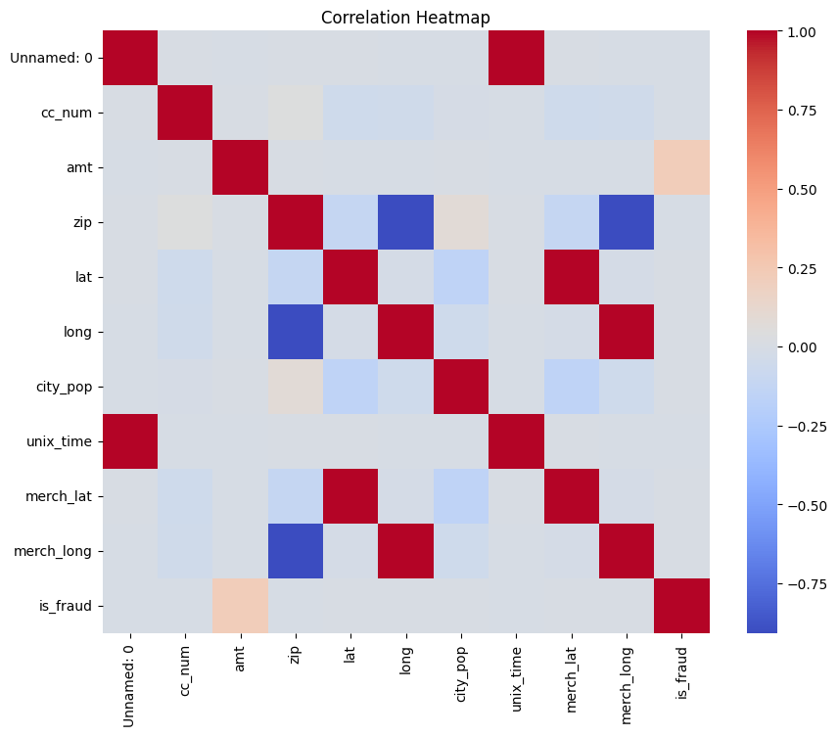
From the analysis, it was observed that most features have low correlation with each other, indicating that the dataset does not suffer from multicollinearity issues. This is beneficial for model training as it ensures that each feature contributes independently to the prediction.
Figure 1: Correlation Heatmap of Numerical Features
- Model Evaluation

Evaluating the performance of a fraud detection model requires careful consideration of appropriate metrics. Since the dataset is imbalanced, accuracy alone is not a reliable measure of performance.
Instead, metrics such as precision, recall, and F1-score were used. Precision measures the proportion of correctly identified fraudulent transactions among all predicted fraud cases. Recall measures the proportion of actual fraud cases that were correctly identified by the model. F1-score provides a balance between precision and recall.
The confusion matrix was also used to visualize the model’s performance. It provides a detailed breakdown of true positives, true negatives, false positives, and false negatives.

- Results and Discussion

The Random Forest model demonstrated strong performance in detecting fraudulent transactions. The model achieved a high recall of approximately 82%, indicating that it successfully identified the majority of fraud cases.
While the precision was moderate, this is acceptable in fraud detection scenarios where minimizing missed fraud cases is more important than reducing false alarms. The model effectively balanced the trade-off between precision and recall.
The confusion matrix showed that the number of correctly identified fraudulent transactions was significantly higher than the number of missed cases. This indicates that the model is reliable for identifying suspicious activities.
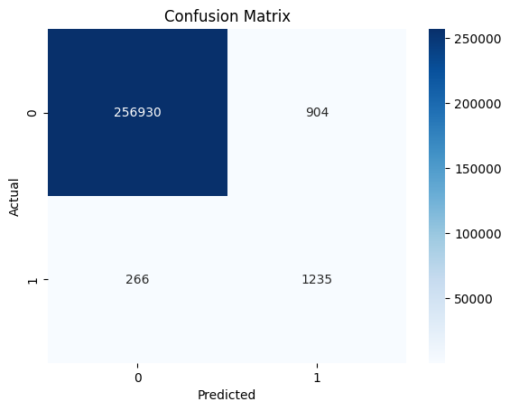
The model achieved a recall of 82%, which indicates strong performance in detecting fraudulent transactions, even in an imbalanced dataset.
Figure 2: Confusion Matrix of Model Predictions

- Visualization

Data visualization played an important role in understanding the dataset and interpreting the results. Various plots such as fraud distribution graphs, transaction amount histograms, and correlation heatmaps were generated.
The fraud distribution graph clearly illustrated the imbalance in the dataset, highlighting the need for techniques such as SMOTE. The correlation heatmap helped identify relationships between numerical features, providing insights into how different variables influence each other.
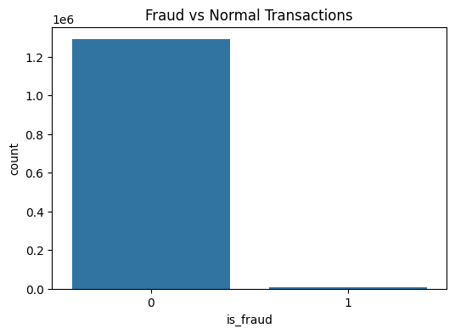
The confusion matrix visualization provided a clear representation of the model’s predictions, making it easier to interpret performance.
Figure 3: Distribution of Fraud vs Normal Transactions
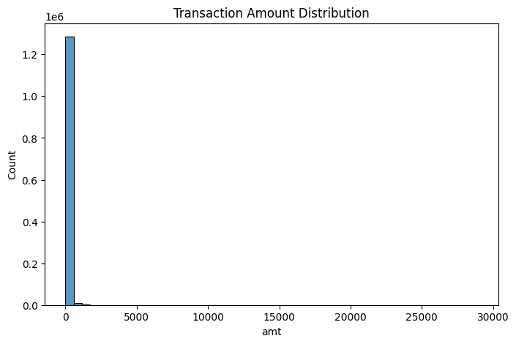
Figure 4: Distribution of Transaction Amounts
- Conclusion

This project successfully demonstrates the use of machine learning techniques for detecting fraudulent financial transactions. By combining data preprocessing, imbalance handling, and a robust classification model, the system is able to identify fraudulent activities with high accuracy and recall.
The use of SMOTE significantly improved the model’s ability to detect fraud, while the Random Forest algorithm provided reliable and consistent predictions. The results indicate that the model is effective and can be used as a foundation for real-world fraud detection systems.
This project contributes to SDG Goal 16: Peace, Justice and Strong Institutions by reducing financial fraud.

- Future Scope

There are several opportunities to enhance this project further. Advanced machine learning techniques such as deep learning and neural networks can be explored to improve detection accuracy.
Real-time fraud detection systems can be developed by integrating the model with live transaction data. Additionally, incorporating more features and using ensemble techniques can further improve performance.
The system can also be extended to detect other types of financial fraud, making it more versatile and applicable in various domains.

