


ACE
Engineering College
An Autonomous Institution

Ghatkesar, Medchal (Dist), Hyderabad, Telangana State – 501 301

(NBA Accredited B.Tech Courses, Accorded NAAC ‘A’ Grade)

DEPARTMENT OF COMPUTER SCIENCE AND ENGINEERING

III Year B.Tech Semester – II Section – A

Bubble Shooter –

A Color-Matching Game Using Python and Pygame

ARTIFICIAL INTELLIGENCE PROJECT

BY

Student Name
Team Number: 01

H.T.Number

Faculty Name Professor & Dean-CSE
Ch. Srivatsa Dr. M. V. Vijaya Saradhi

- Abstract
- Existing System
- Disadvantages of existing system
- Proposed System
- Advantages of Proposed System
- Hardware Requirements
- Software Requirements
- Architecture Diagram
- Modules
10.Code
11.Results
12.Conclusion

Note: Type of font: Times New Roman
Size: Main Heading 14 Bold
Sub Heading 12 Bold
Normal text 12
without bold

Abstract

Bubble Shooter is a desktop arcade game developed using Python and Pygame that recreates the classic
colour-matching gameplay experience. Players use keyboard controls to aim and launch colored bubbles
toward a densely packed grid, leveraging angle-based trigonometric calculations for precise movement.
When three or more bubbles of the same colour form a contiguous group, they pop in a satisfying
animation while triggering score increments. The game highlights key programming concepts, including
sprite rendering,
collision detection, dynamic grid management, and recursive depth-first search (DFS) logic for group
detection. Additional enhancements such as smooth bubble drawing via pygame.gfxdraw, responsive
sound effects, and looping background music enrich the user experience. Victory is achieved by clearing
all bubbles, while a loss occurs if any bubble reaches the screen’s bottom. This project illustrates the
structure and flow of a real-time interactive game loop, container-based sprite architecture, event handling,
animation, and audio integration in Python. Through this, the developer gains a practical understanding of
game design principles, recursive algorithms, and collision handling within a graphical programming environment.

Existing System

Commercial-Grade Bubble Shooter Kit (Unity):

A popular off-the-shelf “Bubble Shooter Kit” in Unity is organized like this:
- Common: Shared systems such as object pooling for bubbles and effects, reusable across projects.
- Game Logic: Divided into thematic modules:
  - Bubbles: Bubble behaviour, color/type definitions.
  - Gameplay: Core matching and popping mechanics.
  - UI & Events: Score display, popups, in-app purchase functionality.
  - Levels & Config: Level data assets, configuration.
  - Audio & Subsystems: Lives, coins, event-driven logic.
- This modular, component-based architecture supports scalability, editor integration, and performance optimizations.

Python + Pygame Implementations:

Several Pygame-based Bubble Shooter clones, such as LucasGab, sowmithnandan, and Akarsh3053, share a simpler design approach:
- Single main script (e.g. Game.py or bubbleshooter.py)
- Core classes:
  - Shooter/Arrow: Handles player aiming.
  - Bubble: Manages position, movement, color.
- 2D grid or list: Tracks bubble placement.
- DFS or BFS algorithms: Detect and pop connected groups of ≥3 same-colored bubbles.
- Event loop: Processes keyboard input (arrow keys & spacebar).
- Collision detection: Typically, rect‐based or spherical proximity checks.
- Audio: Uses pygame.mixer for background music and pop sounds.

Disadvantages of existing system

Performance & Efficiency Limitations:

- Low frame rates for complex scenes: Pygame can struggle with smooth rendering as bubble count increases, leading to choppy gameplay below 60 FPS.
- Python’s interpreter slowness: Real-time physics and collision handling in Python introduce noticeable slowdown—Pygame isn’t optimized for such demands.

Runtime Stability Issues:

- Memory leaks or list buildup: Without proper cleanup (e.g., not clearing stale objects each frame), FPS can gradually drop over time

Grid & Collision Architecture Constraints:

- Inefficient grid scanning: Using DFS/BFS on every bubble each frame can become heavy; naive implementations check many neighbours repeatedly.
- Inaccurate collision handling: Pygame’s basic rectangle-based detection (like colliderect) can struggle at bubble edges or seams, causing glitches.

Deployment & Distribution Challenges:

- Dependency on Python and Pygame: The game requires users to have a Python environment with Pygame installed. Packaging into standalone executables is non-trivial.

Ecosystem Limitations:

- Lack of advanced features: Pygame doesn't natively support 3D, UI frameworks, or advanced rendering (e.g., v-sync, hardware acceleration), limiting its capability compared to modern engines.

Proposed System

Modular & ECS-Inspired Architecture:

To improve code maintainability and extensibility, transition to an Entity–Component–System (ECS) style or modular scene-based architecture. In this setup, game objects—such as the shooter, bubbles, and UI elements—are composed of data components (position, velocity, sprite) while systems (rendering, movement, collision, audio) operate on those. This design reduces tangled logic, encourages reuse, and eases future feature additions like power-ups, level transitions, or multiplayer modes. Scene or state management separates game flow (main menu, gameplay, game-over), making state transitions clean and logical.

Efficient Collision & Grid Management:

A key optimization is reducing collision detection from scanning the entire grid to localized checks. Implement spatial partitioning techniques—either fixed grid cells, quad-trees, or spatial hashing—ensuring only nearby bubbles are tested for collisions or group matching. This reduces complexity from O(n²) to nearly O(n) and maintains high performance even as bubble counts grow Use broad-phase filtering followed by narrow-phase confirmation (e.g., simple bounding box checks, then precise detection).

Performance Optimization & Asset Management:

Improve performance further by optimizing how assets and logic are handled. Preload and reuse assets—loading images with convert() or convert_alpha() once, and using spritesheets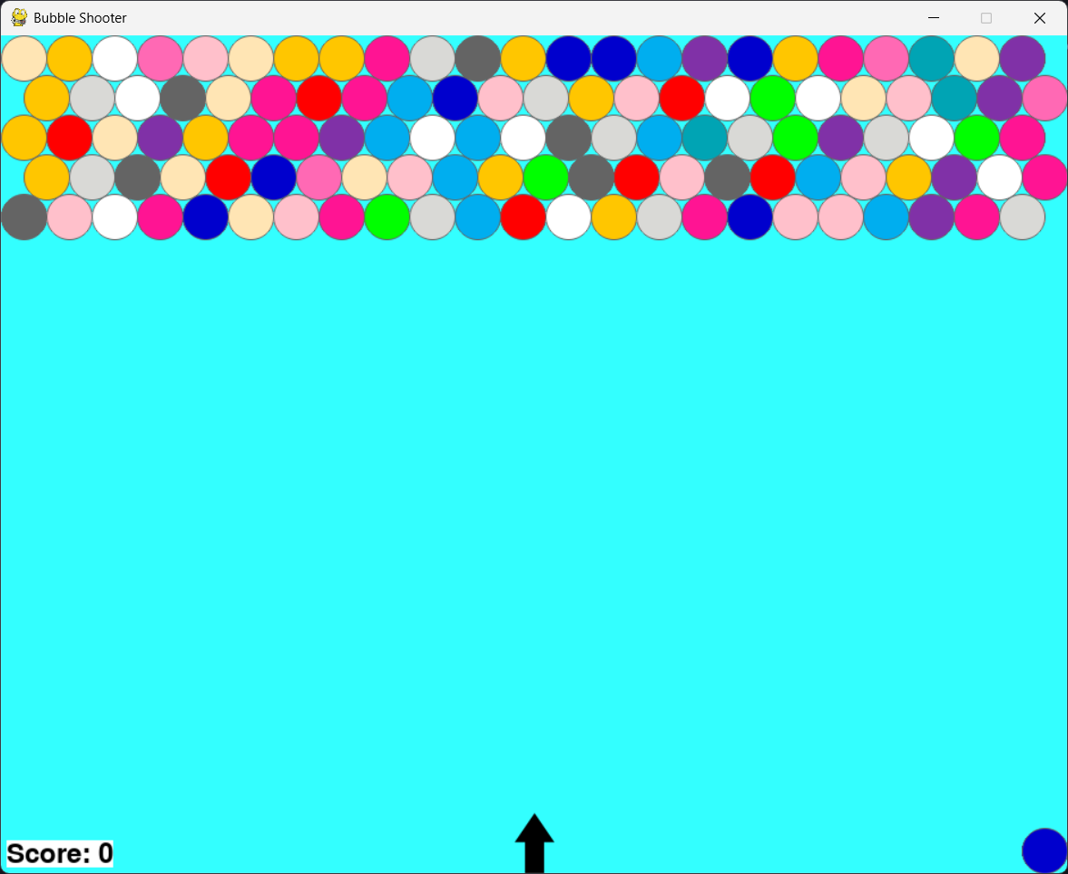 to reduce draw calls . Leverage object pooling for bubbles to avoid frequent allocation/deallocation and minimize garbage collection pause times. Profiling with cProfile can help pinpoint bottlenecks, allowing targeted improvements like caching frequently used values, loop hoisting, and selective updates

Advantages of Proposed System

Enhanced Modularity & Maintainability:
By transitioning to an Entity-Component-System (ECS) or well-structured modular architecture, the game logic becomes clearer and more organized. Systems are executed in a defined sequence (input → physics → rendering), reducing tangled call stacks and making it much easier to trace behaviour and debug issues. This modularity also supports independent development and testing of systems, eliminating monolithic “God code.”

Performance & Scalability Boost:
Implementing spatial partitioning—such as grid-based buckets or quad-trees—ensures collision checks and bubble-match logic are confined to local regions. This shifts complexity from O(n²) to nearly O(n) as bubble counts increase, maintaining smooth frame rates even in dense scenes . Combining this with object pooling—recycling bubble objects instead of re-creating them—further enhances performance by minimizing memory churn.

Extensibility & Reusability:
The component-based architecture lets you easily augment entities with new features—such as power-ups, visual effects, or AI behaviors—without altering existing classes. New systems can then act on entities with the corresponding component sets, enabling rapid development and experimentation.

Seamless Cross-Platform Deployment:
Packaging tools like PyInstaller or Briefcase help distribute the game as standalone executables across Windows, macOS, and Linux, removing the need for users to install Python or Pygame. This greatly enhances accessibility and user adoption.

Event-Driven & Efficient Management:
Using event-based systems—such as dispatching bubble_pop, line_clear, or game_over events—decouples game logic from audio/UI updates. Pygame’s set_timer() can handle recurring behaviors (like lowering the bubble grid) cleanly within the main loop. This approach simplifies logic flow and avoids interwoven conditionals.

Easier Distribution & Cross-Platform Support
Packaging the game with tools like PyInstaller or Briefcase allows easy creation of standalone executables, eliminating the need for manual Python and Pygame setup for end-users. Cross-platform testing across Windows, macOS, and Linux is also simplified thanks to Pygame’s SDL-based portability.

Hardware Requirements

- Processor: Dual-core CPU @ 2.0 GHz or higher Sufficient to run Python interpreter and handle game update loop.

- RAM: At least 4 GB Enough to load Python, Pygame, and standard OS overhead comfortably.

- Storage: ~10 GB free disk space (SSD preferred) Light program assets; SSD yields faster load times and overall responsiveness.

- Graphics: Integrated GPU (e.g., Intel UHD or equivalent)
Pygame handles 2D well on integrated graphics.

Software Requirements

Programming Language & Runtime
Python 3.x :The project is built on Python 3—commonly Python 3.7 or higher. This ensures compatibility with modern syntax, standard libraries, and Pygame support.

Game Development Library
Pygame (v1.9.x or v2.x):A library built upon SDL, designed for 2D game development with graphics, sound, and input handling capabilities.

Dependencies & Libraries
- pygame.gfxdraw
Optional module for anti-aliased circle rendering, included in Pygame but may require separate installation depending on the build.

- pygame.mixer
Used for managing background music and pop sound effects—typically bundled with Pygame.

- Standard Python modules
No extra external dependencies are required besides the Python standard library.

Architecture Diagram

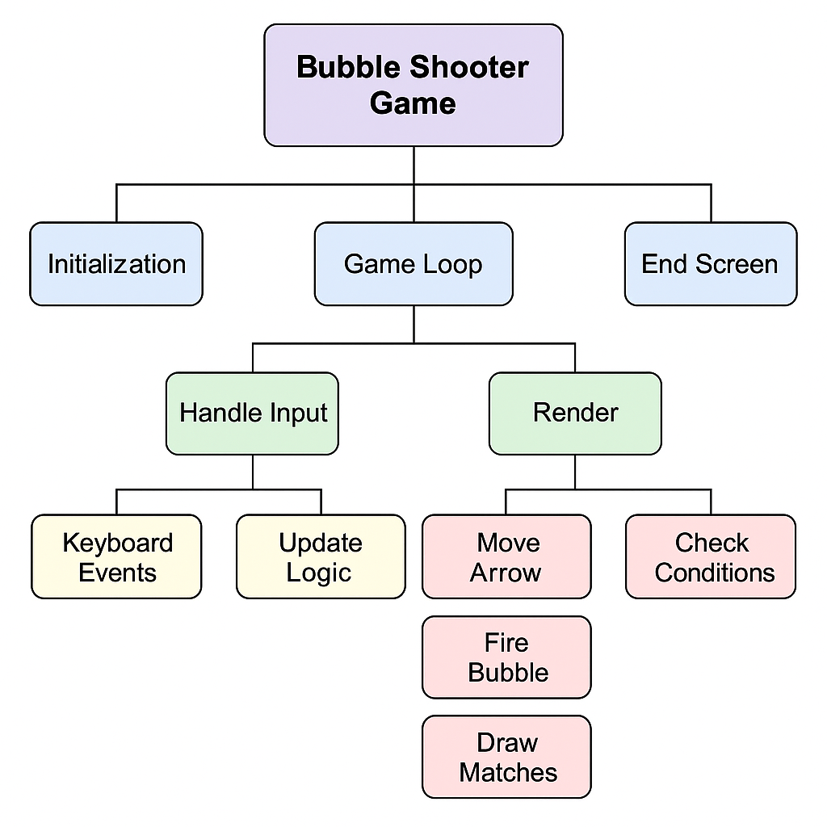

CODE

import math
import pygame
import copy
import time
import sys
import os
import random
import pygame.gfxdraw
from pygame.locals import *

FPS = 120
winwdth = 940
winhgt = 740
txthgt = 20
bubblerad = 20
bubblewdth = bubblerad * 2
bubblelyrs = 5
bubadjst = 5
strx = winwdth / 2
strY = winhgt - 26
arywdth = 25
aryhgt = 20

RIGHT = 'right'
LEFT = 'left'
blank = '.'

vblue = (51, 255, 255)
black = (0, 0, 0)
white = (255, 255, 255)
grey = (100, 100, 100)
blue = (0, 0, 205)
red = (255, 0, 0)
white = (255, 255, 255)
pink = (255, 192, 203)
lightpink = (255, 182, 193)
hotpink = (255, 105, 180)
deeppink = (255, 20, 147)
cyan = (0, 255, 255)
peacockblue = (0, 164, 180)
grapecolor = (128, 49, 167)
amber = (255, 198, 0)
comic = (0, 174, 239)
lytgray = (217, 217, 214)
peach = (255, 229, 180)
green = (0, 255, 0)
GRAY = (100, 100, 100)
white = (255, 255, 255)
cyan = (0, 255, 255)
black = (0, 0, 0)

bgcolor = vblue
clrlist = [grey, blue, red, white, pink, peach, hotpink, green,
deeppink, peacockblue, grapecolor, amber, comic, lytgray]

class Bubble(pygame.sprite.Sprite):
def __init__(self, color, row=0, col=0):
pygame.sprite.Sprite.__init__(self)

self.rect = pygame.Rect(0, 0, 30, 30)
self.rect.centerx = int(strx)
self.rect.centery = strY
self.speed = 10
self.color = color
self.radius = bubblerad
self.angle = 0
self.row = row
self.col = col

def update(self):

if self.angle == 90:
xmove = 0
ymove = self.speed * -1
elif self.angle < 90:
xmove = self.xcalc(self.angle)
ymove = self.ycalc(self.angle)
elif self.angle > 90:
xmove = self.xcalc(180 - self.angle) * -1
ymove = self.ycalc(180 - self.angle)

self.rect.x += int(xmove)
self.rect.y += int(ymove)

def draw(self):
pygame.gfxdraw.filled_circle(
dispsurf, self.rect.centerx, self.rect.centery, self.radius, self.color)
pygame.gfxdraw.aacircle(
dispsurf, self.rect.centerx, self.rect.centery, self.radius, GRAY)

def xcalc(self, angle):
radians = math.radians(angle)

xmove = math.cos(radians)*(self.speed)
return xmove

def ycalc(self, angle):
radians = math.radians(angle)

ymove = math.sin(radians)*(self.speed) * -1
return ymove

class Ary(pygame.sprite.Sprite):
def __init__(self):
pygame.sprite.Sprite.__init__(self)

self.angle = 90
arrimg = pygame.image.load('Arrow.png')
arrimg.convert_alpha()

arrowRect = arrimg.get_rect()
self.image = arrimg
self.transformImage = self.image
self.rect = arrowRect
self.rect.centerx = int(strx)
self.rect.centery = strY

def update(self, dir):

if (dir == LEFT and self.angle < 180):
self.angle += 2
elif (dir == RIGHT and self.angle > 0):
self.angle -= 2

self.transformImage = pygame.transform.rotate(self.image, self.angle)
self.rect = self.transformImage.get_rect()
self.rect.centerx = int(strx)
self.rect.centery = strY

def draw(self):
dispsurf.blit(self.transformImage, self.rect)

class Score(object):
def __init__(self):
self.total = 0
self.font = pygame.font.SysFont('merlin', 35)
self.render = self.font.render(
'Score: ' + str(self.total), True, black, white)
self.rect = self.render.get_rect()
self.rect.left = 5
self.rect.bottom = winhgt - 5

def update(self, dellst):
self.total += ((len(dellst)) * 10)
self.render = self.font.render(
'Score: ' + str(self.total), True, black, white)

def draw(self):
dispsurf.blit(self.render, self.rect)

def main():

global fpsclock, dispsurf, disprect, mainfont
pygame.init()

fpsclock = pygame.time.Clock()
pygame.display.set_caption('Bubble Shooter')
mainfont = pygame.font.SysFont('Comic Sans MS', txthgt)
dispsurf, disprect = makeDisplay()

while True:
score, winorlose = rngame()
endScreen(score, winorlose)

def rngame():
musclist = ['Whatever_It _Takes_OGG.ogg', 'bgmusic.ogg', 'Goofy_Theme.ogg']
pygame.mixer.music.load(musclist[0])
pygame.mixer.music.play()
track = 0
gameclrlist = copy.deepcopy(clrlist)
dir = None
launchbb = False
newbb = None

arrow = Ary()
bbarr = mkeblkbrd()
setbb(bbarr, gameclrlist)

nxtbb = Bubble(gameclrlist[0])
nxtbb.rect.right = winwdth - 5
nxtbb.rect.bottom = winhgt - 5

score = Score()

while True:
dispsurf.fill(bgcolor)

for event in pygame.event.get():
if event.type == QUIT:
terminate()

elif event.type == KEYDOWN:
if (event.key == K_LEFT):
dir = LEFT
elif (event.key == K_RIGHT):
dir = RIGHT

elif event.type == KEYUP:
dir = None
if event.key == K_SPACE:
launchbb = True
elif event.key == K_ESCAPE:
terminate()

if launchbb == True:
if newbb == None:
newbb = Bubble(nxtbb.color)
newbb.angle = arrow.angle

newbb.update()
newbb.draw()

if newbb.rect.right >= winwdth - 5:
newbb.angle = 180 - newbb.angle
elif newbb.rect.left <= 5:
newbb.angle = 180 - newbb.angle
launchbb, newbb, score = stbb(bbarr, newbb, launchbb, score)

fbblist = []
for row in range(len(bbarr)):
for col in range(len(bbarr[0])):
if bbarr[row][col] != blank:
fbblist.append(bbarr[row][col])
if bbarr[row][col].rect.bottom > (winhgt - arrow.rect.height - 10):
return score.total, 'lose'

if len(fbblist) < 1:
return score.total, 'win'
gameclrlist = updtclrlist(bbarr)
random.shuffle(gameclrlist)
if launchbb == False:

nxtbb = Bubble(gameclrlist[0])
nxtbb.rect.right = winwdth - 5
nxtbb.rect.bottom = winhgt - 5

nxtbb.draw()
if launchbb == True:
covnxtbb()

arrow.update(dir)
arrow.draw()

setarrpos(bbarr)
drawbbary(bbarr)

score.draw()

if pygame.mixer.music.get_busy() == False:
if track == len(musclist) - 1:
track = 0
else:
track += 1

pygame.mixer.music.load(musclist[track])
pygame.mixer.music.play()

pygame.display.update()
fpsclock.tick(FPS)

def mkeblkbrd():
array = []

for row in range(aryhgt):
col = []
for i in range(arywdth):
col.append(blank)
array.append(col)

return array

def setbb(array, gameclrlist):
for row in range(bubblelyrs):
for col in range(len(array[row])):
random.shuffle(gameclrlist)
newbb = Bubble(gameclrlist[0], row, col)
array[row][col] = newbb

setarrpos(array)

def setarrpos(array):
for row in range(aryhgt):
for col in range(len(array[row])):
if array[row][col] != blank:
array[row][col].rect.x = (bubblewdth * col) + 5
array[row][col].rect.y = (bubblewdth * row) + 5

for row in range(1, aryhgt, 2):
for col in range(len(array[row])):
if array[row][col] != blank:
array[row][col].rect.x += bubblerad

for row in range(1, aryhgt):
for col in range(len(array[row])):
if array[row][col] != blank:
array[row][col].rect.y -= (bubadjst * row)

delextrbb(array)

def delextrbb(array):
for row in range(aryhgt):
for col in range(len(array[row])):
if array[row][col] != blank:
if array[row][col].rect.right > winwdth:
array[row][col] = blank

def updtclrlist(bbarr):
newColorList = []
for row in range(len(bbarr)):
for col in range(len(bbarr[0])):
if bbarr[row][col] != blank:
newColorList.append(bbarr[row][col].color)

colorSet = set(newColorList)

if len(colorSet) < 1:
colorList = []
colorList.append(white)
return colorList
else:

return list(colorSet)

def chkfflotrs(bbarr):
bubbleList = [col for col in range(len(bbarr[0]))
if bbarr[0][col] != blank]

newbbList = []

for i in range(len(bubbleList)):
if i == 0:
newbbList.append(bubbleList[i])
elif bubbleList[i] > bubbleList[i - 1] + 1:
newbbList.append(bubbleList[i])

cpyofbrd = copy.deepcopy(bbarr)

for row in range(len(bbarr)):
for col in range(len(bbarr[0])):
bbarr[row][col] = blank

for col in newbbList:
popflotrs(bbarr, cpyofbrd, col)

def popflotrs(bbarr, cpyofbrd, col, row=0):
if (row < 0 or row > (len(bbarr)-1)
or col < 0 or col > (len(bbarr[0])-1)):
return
elif cpyofbrd[row][col] == blank:
return
elif bbarr[row][col] == cpyofbrd[row][col]:
return
bbarr[row][col] = cpyofbrd[row][col]
if(row == 0):
popflotrs(bbarr, cpyofbrd, col + 1, row)
popflotrs(bbarr, cpyofbrd, col - 1, row)
popflotrs(bbarr, cpyofbrd, col, row + 1)
popflotrs(bbarr, cpyofbrd, col - 1, row + 1)
elif(row % 2 == 0):
popflotrs(bbarr, cpyofbrd, col + 1, row)
popflotrs(bbarr, cpyofbrd, col - 1, row)
popflotrs(bbarr, cpyofbrd, col, row + 1)
popflotrs(bbarr, cpyofbrd, col - 1, row + 1)
popflotrs(bbarr, cpyofbrd, col, row - 1)
popflotrs(bbarr, cpyofbrd, col - 1, row - 1)
else:
popflotrs(bbarr, cpyofbrd, col + 1, row)
popflotrs(bbarr, cpyofbrd, col - 1, row)
popflotrs(bbarr, cpyofbrd, col, row + 1)
popflotrs(bbarr, cpyofbrd, col + 1, row + 1)
popflotrs(bbarr, cpyofbrd, col, row - 1)
popflotrs(bbarr, cpyofbrd, col + 1, row - 1)

def stbb(bbarr, newbb, launchbb, score):
dellst = []
popSound = pygame.mixer.Sound('popcork.ogg')

for row in range(len(bbarr)):
for col in range(len(bbarr[row])):

if (bbarr[row][col] != blank and newbb != None):
if (pygame.sprite.collide_rect(newbb, bbarr[row][col])) or newbb.rect.top < 0:
if newbb.rect.top < 0:
newRow, newcol = addbbtotop(bbarr, newbb)

elif newbb.rect.centery >= bbarr[row][col].rect.centery:

if newbb.rect.centerx >= bbarr[row][col].rect.centerx:
if row == 0 or (row) % 2 == 0:
newRow = row + 1
newcol = col
if bbarr[newRow][newcol] != blank:
newRow = newRow - 1
bbarr[newRow][newcol] = copy.copy(newbb)
bbarr[newRow][newcol].row = newRow
bbarr[newRow][newcol].col = newcol

else:
newRow = row + 1
newcol = col + 1
if bbarr[newRow][newcol] != blank:
newRow = newRow - 1
bbarr[newRow][newcol] = copy.copy(newbb)
bbarr[newRow][newcol].row = newRow
bbarr[newRow][newcol].col = newcol

elif newbb.rect.centerx < bbarr[row][col].rect.centerx:
if row == 0 or row % 2 == 0:
newRow = row + 1
newcol = col - 1
if newcol < 0:
newcol = 0
if bbarr[newRow][newcol] != blank:
newRow = newRow - 1
bbarr[newRow][newcol] = copy.copy(newbb)
bbarr[newRow][newcol].row = newRow
bbarr[newRow][newcol].col = newcol
else:
newRow = row + 1
newcol = col
if bbarr[newRow][newcol] != blank:
newRow = newRow - 1
bbarr[newRow][newcol] = copy.copy(newbb)
bbarr[newRow][newcol].row = newRow
bbarr[newRow][newcol].col = newcol

elif(newbb.rect.centery < bbarr[row][col].rect.centery):
if(newbb.rect.centerx >= bbarr[row][col].rect.centerx):
if(row == 0 or row % 2 == 0):
newRow = row - 1
newcol = col
if(bbarr[newRow][newcol] != blank):
newRow = newRow + 1
bbarr[newRow][newcol] = copy.copy(newbb)
bbarr[newRow][newcol].row = newRow
bbarr[newRow][newcol].col = newcol
else:
newRow = row - 1
newcol = col + 1
if bbarr[newRow][newcol] != blank:
newRow = newRow + 1
bbarr[newRow][newcol] = copy.copy(newbb)
bbarr[newRow][newcol].row = newRow
bbarr[newRow][newcol].col = newcol

elif newbb.rect.centerx <= bbarr[row][col].rect.centerx:
if(row == 0 or row % 2 == 0):
newRow = row - 1
newcol = col - 1
if(bbarr[newRow][newcol] != blank):
newRow = newRow + 1
bbarr[newRow][newcol] = copy.copy(newbb)
bbarr[newRow][newcol].row = newRow
bbarr[newRow][newcol].col = newcol

else:
newRow = row - 1
newcol = col
if(bbarr[newRow][newcol] != blank):
newRow = newRow + 1
bbarr[newRow][newcol] = copy.copy(newbb)
bbarr[newRow][newcol].row = newRow
bbarr[newRow][newcol].col = newcol

popbb(bbarr, newRow, newcol, newbb.color, dellst)

if(len(dellst) >= 3):
for pos in dellst:
popSound.play()
row = pos[0]
col = pos[1]
bbarr[row][col] = blank
chkfflotrs(bbarr)

score.update(dellst)

launchbb = False
newbb = None

return launchbb, newbb, score

def addbbtotop(bbarr, bubble):
posx = bubble.rect.centerx
leftSidex = posx-bubblerad
coldiv = math.modf(float(leftSidex)/float(bubblewdth))
col = int(coldiv[1])
if (coldiv[0] < 0.5):
bbarr[0][col] = copy.copy(bubble)
else:
col += 1
bbarr[0][col] = copy.copy(bubble)
row = 0
return row, col

def popbb(bbarr, row, col, color, dellst):
if(row < 0 or col < 0 or row > (len(bbarr)-1) or col > (len(bbarr[0])-1)):
return
elif (bbarr[row][col] == blank):
return
elif(bbarr[row][col].color != color):
return
for bubble in dellst:
if(bbarr[bubble[0]][bubble[1]] == bbarr[row][col]):
return
dellst.append((row, col))
if(row == 0):
popbb(bbarr, row, col-1, color, dellst)
popbb(bbarr, row, col+1, color, dellst)
popbb(bbarr, row+1, col, color, dellst)
popbb(bbarr, row+1, col-1, color, dellst)
elif(row % 2 == 0):
popbb(bbarr, row + 1, col, color, dellst)
popbb(bbarr, row + 1, col-1, color, dellst)
popbb(bbarr, row - 1, col, color, dellst)
popbb(bbarr, row - 1, col - 1, color, dellst)
popbb(bbarr, row, col+1, color, dellst)
popbb(bbarr, row, col-1, color, dellst)

else:
popbb(bbarr, row - 1, col, color, dellst)
popbb(bbarr, row - 1, col + 1, color, dellst)
popbb(bbarr, row + 1, col, color, dellst)
popbb(bbarr, row + 1, col + 1, color, dellst)
popbb(bbarr, row, col + 1, color, dellst)
popbb(bbarr, row, col - 1, color, dellst)

def drawbbary(array):
for row in range(aryhgt):
for col in range(len(array[row])):
if(array[row][col] != blank):
array[row][col].draw()

def makeDisplay():
dispsurf = pygame.display.set_mode((winwdth, winhgt))
disprect = dispsurf.get_rect()
dispsurf.fill(bgcolor)
dispsurf.convert()
pygame.display.update()

return dispsurf, disprect

def terminate():
pygame.quit()
sys.exit()

def covnxtbb():
whiteRect = pygame.Rect(0, 0, bubblewdth, bubblewdth)
whiteRect.bottom = winhgt
whiteRect.right = winwdth
pygame.draw.rect(dispsurf, bgcolor, whiteRect)

def endScreen(score, winorlose):
endFont = pygame.font.SysFont('merlin', 50)
endMessage1 = endFont.render('You ' + winorlose + '! Hey Your Scored ' + str(
score) + '. Press Enter to Play Again.', True, black, bgcolor)
endMessage1Rect = endMessage1.get_rect()
endMessage1Rect.center = disprect.center

dispsurf.fill(bgcolor)
dispsurf.blit(endMessage1, endMessage1Rect)
pygame.display.update()

while True:
for event in pygame.event.get():
if(event.type == QUIT):
terminate()
elif(event.type == KEYUP):
if(event.key == K_RETURN):
return
elif(event.key == K_ESCAPE):
terminate()

if __name__ == '__main__':
main()

Results

Conclusion

The Bubble Shooter game, implemented using Python and Pygame, successfully delivers a classic, interactive arcade experience that fulfills its primary objectives: accurate sprite rendering, robust collision detection, angle-based movement, and recursive matching logic. By integrating modules such as pygame.gfxdraw for crisp visuals and pygame.mixer for audio, the game achieves polished aesthetics and engaging feedback, while maintaining consistent performance thanks to an optimized game loop.

Architecturally, the modular design—featuring dedicated sprite classes, a dynamic grid system, event-driven input handling, and score tracking—demonstrates effective game loop management and solidifies the developer's understanding of real-time system structure. The inclusion of victory and loss conditions gives the gameplay meaningful stakes, and the design ensures clear separation between visual rendering, game state logic, and input processing.

During development, the project reinforced key programming skills, including recursive DFS for matching logic and trigonometric calculations for bubble trajectories. The successful implementation of smooth animations and responsive controls reflects a matured grasp of Pygame’s capabilities in managing frame updates and user input.

Looking ahead, the project offers ample scope for extensions—such as introducing power-ups, level progression, advanced effects, or improved UI overlays. The optimized codebase also enables future efforts like ECS patterns or object pooling to scale the game further.

