DS 4400: Machine Learning and Data Mining I
Spring 2026
Project Report

Project Title: NBA All-Star Selection Prediction
TA: Sharon
Team Members: Madhav Nair, Ryan Greene, Ray Gutierrez

Include link to code: https://github.com/madhavnair007/NBA-All-Star-Selection-Prediction/tree/main
Include link to video recording: N/A

Note on repository notebooks: The repository contains two notebooks. NBA-AllStar-Final.ipynb is the FINAL, complete notebook containing all data cleaning, EDA, and the full modeling pipeline (7 models, threshold tuning, position normalization). All results in this report are produced by NBA-AllStar-Final.ipynb. Data-Cleaning.ipynb is an earlier version retained for contribution history purposes only.

Problem Description
The machine learning problem we are trying to solve is predicting whether an NBA player will be selected as an All-Star in a given season based on their performance statistics. Each player-season observation includes a variety of features such as points per game, assists, rebounds, shooting efficiency, and advanced metrics like Player Efficiency Rating (PER) and Win Shares. Using these inputs, our goal is to build a model that can learn patterns associated with All-Star selection and accurately classify players as either All-Stars or non-All-Stars.
This is a binary classification problem, where the target variable takes the value 1 if a player was selected as an All-Star and 0 otherwise. Since the output is a discrete label rather than a continuous value, classification models are the appropriate approach for this task.
This problem is important because All-Star selection is often debated and is not purely determined by one factor. While performance statistics clearly play a major role, other influences such as team success, popularity, and media attention may also impact selection. By applying machine learning techniques, we aim to better understand how much of All-Star selection can be explained by measurable performance metrics alone. This has broader implications for evaluating player performance in a more objective and data-driven way, and it can provide insight into whether recognition in professional sports is primarily merit-based or influenced by external factors.
Several prior works have applied machine learning techniques to basketball analytics, including predicting player performance, game outcomes, and award selections. Research has shown that player statistics and advanced metrics such as PER, Win Shares, and usage rate are strong predictors of performance-related outcomes. Some studies have specifically explored predicting NBA All-Star selections using classification models, demonstrating that these selections can be predicted with relatively high accuracy using statistical features alone. Other work highlights the importance of feature engineering and model selection in improving predictive performance and interpretability in sports analytics tasks.

Dataset and Exploratory Data Analysis
Dataset: NBA Stats (1947-present) by Sumit Rodatta
Link: https://www.kaggle.com/datasets/sumitrodatta/nba-aba-baa-stats
We use the NBA Stats (1947-present) dataset from Kaggle, which contains player-level statistics for each NBA season. For this project, we construct a dataset at the player-season level, where each row represents a player’s performance in a given season.
After merging the relevant tables (player per-game statistics, advanced metrics, and All-Star selections), the dataset contains approximately 52,984 player-season records and 61 features. The majority of features are numerical, including scoring, efficiency, and impact metrics, along with a small number of categorical identifiers such as player and team.
The target variable is a binary label AllStar, which indicates whether a player was selected as an All-Star in that season (1 = selected, 0 = not selected). The dataset is highly imbalanced, with only a small percentage of players being selected as All-Stars compared to the total number of player-seasons.
The features can be grouped into three main categories. First, traditional box-score statistics such as points, assists, rebounds, and shooting percentages capture a player’s basic production. Second, advanced metrics such as Player Efficiency Rating (PER), Win Shares (WS), Box Plus-Minus (BPM), and Value Over Replacement Player (VORP) summarize overall efficiency and impact. Third, we include rate-based or normalized features that account for differences in playing time, allowing for more meaningful comparisons between players.
From exploratory analysis, we observe that All-Star players tend to have significantly higher values across key metrics such as points per game, PER, and Win Shares. Additionally, many advanced statistics are highly correlated with each other, indicating potential multicollinearity. These observations suggest that efficiency and overall impact metrics will play an important role in predicting All-Star selection.
The following exploratory visualizations illustrate key patterns in the data:
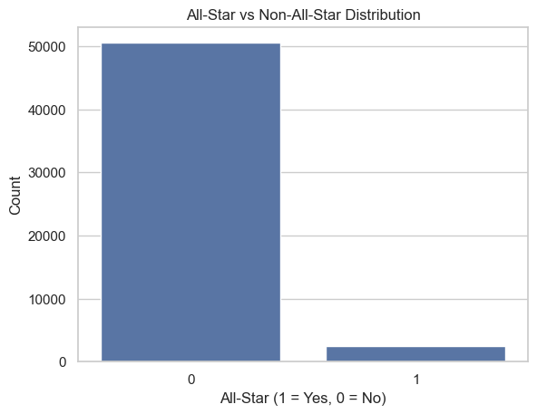
Figure 1: All-Star vs Non-All-Star Class Distribution
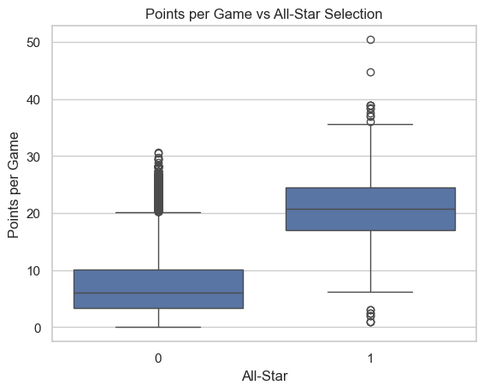
Figure 2: Points per Game vs All-Star Selection
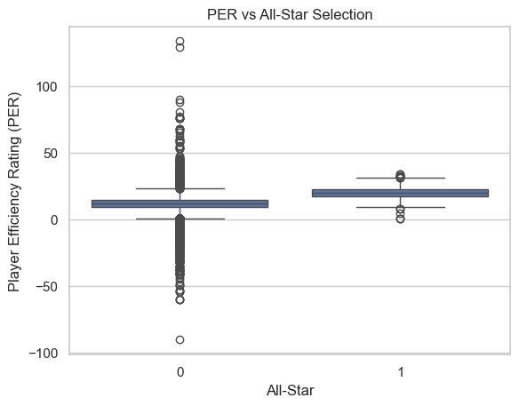
Figure 3: PER vs All-Star Selection
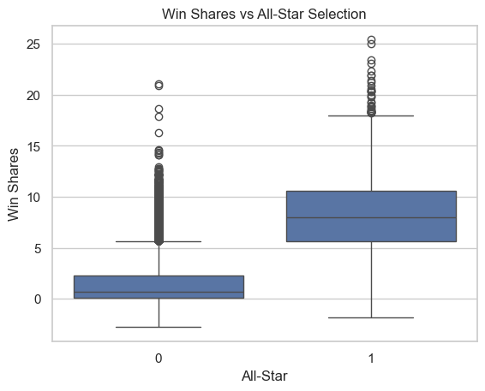
Figure 4: Win Shares vs All-Star Selection
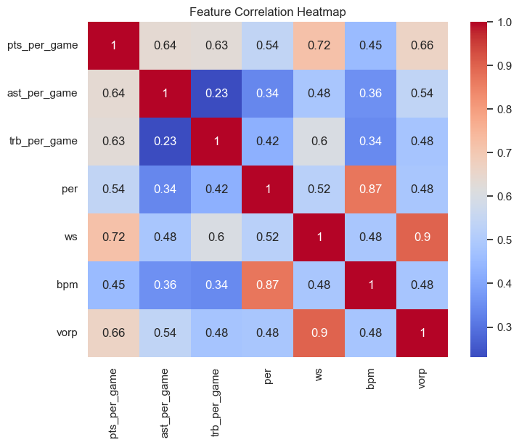
Figure 5: Feature Correlation Heatmap
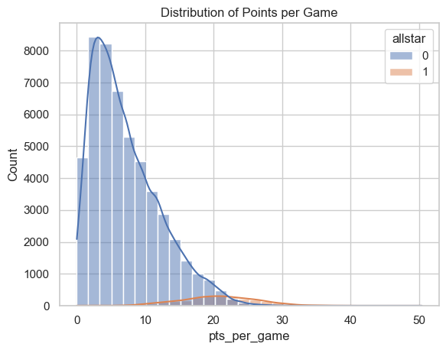
Figure 6: Distribution of Points per Game by All-Star Status

Approach and Methodology
Our general approach involved three main stages: data preparation, feature engineering, and model training with evaluation.

Data Preparation. We filtered the dataset to the modern era (1980-present) since many advanced metrics like BPM, VORP, and usage rate are not available before 1980. We also required a minimum of 20 games played to remove players with very small sample sizes who would never realistically be All-Star candidates. After filtering, our dataset contained 29,093 player-season records with an All-Star rate of 4.52%. We dropped all identifier and categorical columns (player name, team, league) as well as duplicate columns from the merge, leaving 46 numeric features. Remaining missing values were filled with 0, primarily for three-point percentage where players had zero attempts.
All numerical features were standardized using StandardScaler, fit only on the training set to avoid data leakage. We used an 80/20 stratified train-test split to preserve the class imbalance ratio in both sets. For model evaluation, we used stratified 5-fold cross-validation on the training set, reporting accuracy, precision, recall, F1, and AUC-ROC.

Classification Models. We trained seven classification models spanning discriminative, generative, and ensemble approaches: (1) Logistic Regression as a discriminative baseline, (2) L1-Regularized Logistic Regression (Lasso) for automatic feature selection via sparsity, (3) Gaussian Naive Bayes as a generative baseline assuming feature independence, (4) Linear Discriminant Analysis (LDA) as a generative model with shared covariance, (5) Quadratic Discriminant Analysis (QDA) as a generative model with per-class covariance, (6) Random Forest (200 trees), an ensemble of decision trees trained on random subsets that reduces variance through averaging, and (7) Gradient Boosting (200 trees, learning rate 0.1, max depth 4), a sequential ensemble where each tree corrects prior errors, reducing bias through boosting.
This set of models allows us to compare discriminative vs. generative approaches, linear vs. quadratic decision boundaries, and linear models vs. tree-based ensemble methods that can capture nonlinear feature interactions (e.g., high scoring AND high usage together predict All-Star status more strongly than either alone).

Threshold Tuning. By default, classifiers predict class 1 when the predicted probability exceeds 0.5. With imbalanced data, a lower threshold can improve recall at a modest precision cost. We used the precision-recall curve on the best-performing model to find the threshold that maximizes the F1 score on the test set, then re-evaluated with the tuned threshold.

Position Normalization. The bar for All-Star selection varies by position. A point guard scoring 18 points per game may be a borderline candidate, while a center with the same output could be a clear All-Star. To capture position-relative performance, we normalized each feature within position groups (PG, SG, SF, PF, C) using training set statistics only (z-score within each position), then re-evaluated all seven models on the position-normalized features.

Languages and tools: Python was our primary language, using Pandas for preprocessing, Scikit-learn for modeling and evaluation, and Matplotlib/Seaborn for visualization.

Discussion and Result Interpretation
All seven models achieved high AUC-ROC scores (0.977-0.989), confirming that All-Star selection is highly predictable from performance stats alone. However, the models differed substantially in how they handled the precision-recall tradeoff.

Discriminative Models. Logistic Regression and Lasso Logistic Regression performed very similarly, both achieving an AUC-ROC of 0.987. On the test set, Logistic Regression achieved 83.2% precision and 69.6% recall (F1 = 0.758), while Lasso achieved 82.9% precision and 70.0% recall (F1 = 0.759). When these models predict someone is an All-Star, they are right about 5 out of 6 times, and they catch about 70% of actual All-Stars.
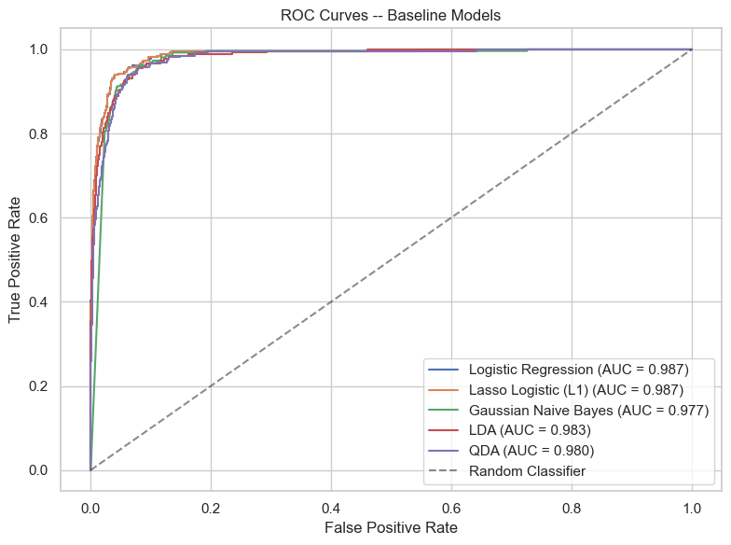
Figure 7: ROC Curves - Baseline Models
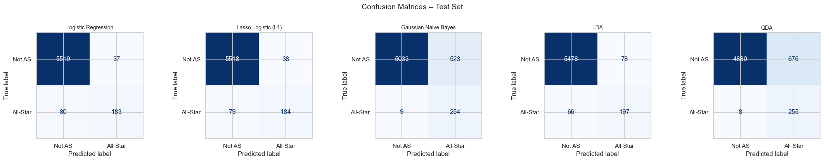
Figure 8: Confusion Matrices for Baseline Models (Test Set)

Generative Models. LDA offered a more balanced tradeoff with 71.6% precision and 74.9% recall (F1 = 0.732, AUC = 0.983). Naive Bayes and QDA both had very high recall (96.6% and 97.0% respectively) but poor precision (32.7% and 27.4%), essentially flagging any above-average player as a potential All-Star. The Naive Bayes independence assumption is clearly violated here since features like points, usage rate, and field goal attempts are highly correlated, which inflates its predicted probabilities. QDA likely overfits given the small number of All-Star examples relative to the 46 features.

Tree-Based Models. Random Forest achieved the best overall performance with an AUC-ROC of 0.989 and an F1 of 0.781, along with the highest precision among all models at 86.6% with 71.1% recall. On the confusion matrix, Random Forest correctly identified 187 out of 263 All-Stars while producing only 29 false positives. Gradient Boosting was also competitive with an AUC of 0.987 and F1 of 0.758, achieving 80.7% precision and 71.5% recall (188 true positives, 45 false positives). Cross-validation results on the training set confirmed this ordering: Random Forest averaged 0.724 F1 and 0.989 AUC across 5 folds, while Gradient Boosting averaged 0.718 F1 and 0.988 AUC. The tree-based models’ ability to capture nonlinear feature interactions gave them an edge, particularly in precision, over the linear discriminative models.
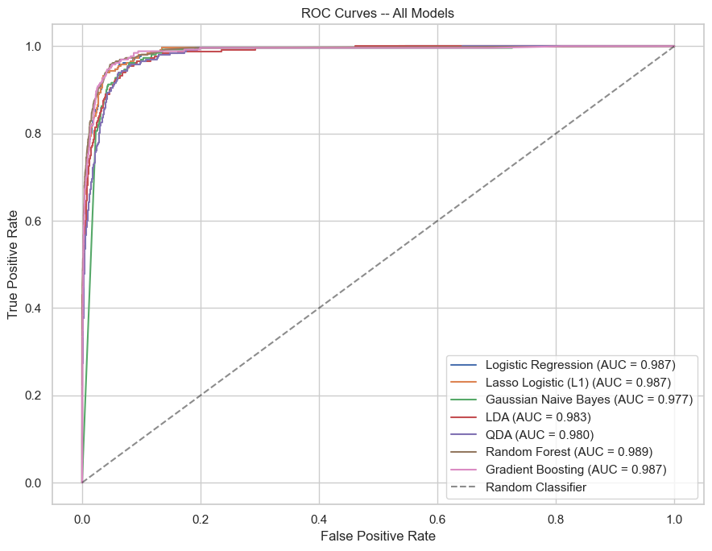
Figure 9: ROC Curves - All Models
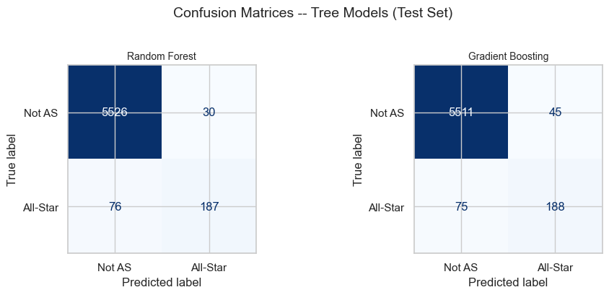
Figure 10: Confusion Matrices for Tree-Based Models (Test Set)

Feature Importance. The Lasso feature importance results show that minutes per game, scoring volume (2-pointers and 3-pointers made), usage rate, and defensive win shares are the strongest predictors. These make basketball sense-All-Stars are high-usage starters who play heavy minutes. An interesting finding is that total minutes (mp) has a negative coefficient while minutes per game is positive, meaning the model values per-game intensity over raw accumulation. Age also has a positive coefficient, suggesting that established veterans with name recognition may have an edge in selection. The Random Forest feature importances provide a complementary view: VORP was the single most important feature (importance = 0.104), followed by Win Shares (0.075), points per game (0.070), field goals per game (0.056), PER (0.042), and BPM (0.041). The tree-based ranking emphasizes holistic impact metrics (VORP, WS) more heavily than the Lasso, which favored volume and rate statistics.
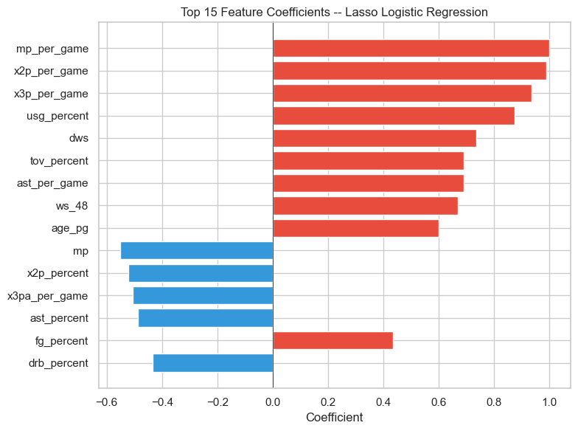
Figure 11: Top 15 Feature Coefficients (Lasso Logistic Regression)
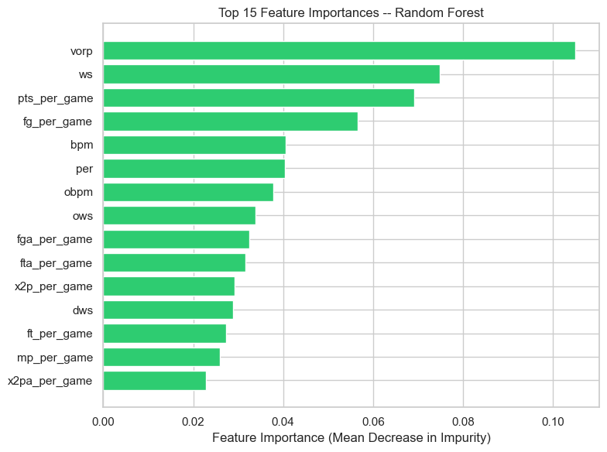
Figure 12: Top 15 Feature Importances (Random Forest)

Threshold Tuning. The best model by AUC-ROC was Random Forest. Lowering the classification threshold from the default 0.5 to the optimal value of 0.43 improved recall from 71.1% to 76.8% at a modest precision cost (86.6% to 80.6%), raising the F1 score from 0.781 to 0.788. This adjustment is especially relevant given the class imbalance, as the default threshold tends to be conservative in predicting the minority class.
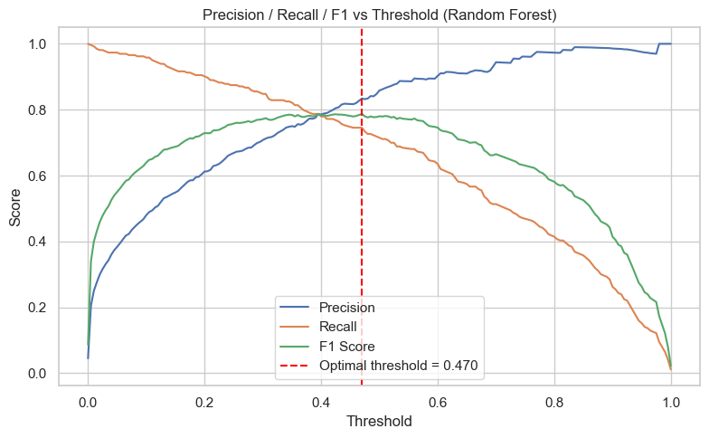
Figure 13: Precision-Recall Curve with Optimal Threshold

Position Normalization. Re-evaluating all models on position-normalized features produced mixed results. For most models, the changes in AUC-ROC were very small (within ±0.003). Logistic Regression and Lasso saw slight AUC improvements (+0.0005 and +0.0003 respectively), while Random Forest saw a small decline (-0.0016). Overall, position normalization did not substantially improve predictions, suggesting that the raw statistics already capture enough information for the models to implicitly learn position-specific patterns. The strongest models on position-normalized features were Logistic Regression (AUC = 0.988), Lasso (AUC = 0.988), and Random Forest (AUC = 0.987).

Error Analysis. The models’ errors likely come from factors that our features don’t capture. False negatives (missed All-Stars) could be players on popular or winning teams who get selected despite slightly lower stats, or injury-replacement All-Stars. False positives (predicted All-Stars who weren’t selected) probably represent players who put up strong numbers but played on small-market teams or faced unusually deep competition at their position that year. A naive model that always predicts “Not All-Star” would get 95.5% accuracy, which is why we focused on F1 and AUC-ROC instead of accuracy as our main evaluation metrics.

Conclusion
We showed that NBA All-Star selection can be predicted with high accuracy using player performance statistics. Our best model, Random Forest, achieved the highest AUC-ROC of 0.989 and an F1 of 0.781 on the All-Star class, with 86.6% precision and 71.1% recall. Lasso Logistic Regression was a close second with an AUC of 0.987 and F1 of 0.759. Across all seven models, discriminative and ensemble methods outperformed generative ones, particularly in precision.
The most predictive features aligned with basketball intuition. The Random Forest ranked VORP, Win Shares, and points per game as the top three features, while the Lasso emphasized minutes per game, scoring volume, and usage rate. Both perspectives confirm that high-usage, high-impact starters are the most likely All-Star candidates.
Threshold tuning on Random Forest improved F1 from 0.781 to 0.788 by lowering the decision boundary from 0.5 to 0.43, boosting recall to 76.8%. Position normalization had minimal impact on model performance (AUC changes within ±0.003), suggesting that raw statistics already encode sufficient position-specific information.
The imperfect recall across all models suggests that non-statistical factors like fan voting, team market size, and media attention also play a role in All-Star selection, representing an inherent ceiling for purely statistics-based prediction.

References
Arteta, C., et al. Predicting NBA All-Star Selections with Machine Learning. Electronics, 2022.
Ouyang, D. Machine Learning-Based Prediction of NBA Game Outcomes Using XGBoost and SHAP, 2024.
Chen, Z. Application of Machine Learning in Basketball Player Performance Evaluation, 2023.
Mahmood, T., et al. Using Machine Learning Techniques for Rising Star Prediction in Basketball, 2021.
Kaur, H., et al. Machine Learning Approaches for Sports Analytics: A Case Study on NBA Data, 2024.

Team Member Contribution
Madhav Nair: Problem description, data cleaning, exploratory data analysis, and EDA visualizations. Expanded EDA section and refined the data pipeline for the final report.
Ryan Greene: Model training and evaluation, cross-validation pipeline, ROC curves, confusion matrices, feature importance analysis. Added Random Forest and Gradient Boosting models, threshold tuning, and expanded evaluation metrics for the final report.
Ray Gutierrez: Analyzed results of models, wrote the approach/methodology, discussion, and conclusion sections. Handled position normalization experiment and presentation for the final report.

Grading Rubric
- Presentation recording - 20 points
- Exploratory data analysis - 20 points
  - Info about the dataset, features, and labels
  - Discuss feature representation and selection
  - Include graphs on selective feature distributions or other visualizations
- Machine learning models - 30 points
  - Train and test at least 4 models
  - Use correct methodology (e.g., cross-validation, random splitting of training and testing set)
- Metrics - 15 points
  - Report several metrics to evaluate and compare models
  - Generate ROC curves or include confusion matrix
- Interpretation of results - 15 points
  - Why the models make errors; which features are most relevant; why is it a challenging task

