CHENNAI INSTITUTE OF TECHNOLOGY
DEPARTMENT OF COMPUTER SCIENCE AND ENGINEERING
PROJECT-BASED LEARNING (PBL) REPORT
Machine Learning (CS3505)
MacroVision – AI-Driven Dietary Analysis and Wellness Guide
Submitted in partial fulfilment of the requirements for the
Project-Based Learning component of Machine Learning

Submitted by
Madhav R (2104251040517)
Sabari Saatvik KG (2104251040833)

Under the guidance of
S. Raja Priya, M.E
Assistant Professor, Department of CSE



October, 2026

Vision of the Institute:
To be an eminent centre for Academia, Industry and Research by imparting knowledge, relevant practices and inculcating human values to address global challenges through novelty and sustainability.

Mission of the Institute:
IM1. To create next generation leaders by effective teaching-learning methodologies and instil scientific temper in them to meet global challenges.
IM2. To transform lives through deployment of emerging technology, novelty and sustainability.
IM3. To inculcate human values and ethical principles to cater to societal needs.
IM4. To contribute towards the research ecosystem by providing a suitable, well-equipped environment for scholarly activity.

DEPARTMENT OF COMPUTER SCIENCE AND ENGINEERING
Vision of the Department:
To excel in the emerging areas of Computer Science and Engineering by imparting knowledge, relevant practices and inculcating human values to transform the students as potential resources to contribute innovatively through advanced computing in real-time situations.

Mission of the Department:
DM1. To provide strong fundamentals and technical skills for Computer Science applications through effective teaching-learning methodologies.
DM2. To transform the lives of students by nurturing ethical values, creativity and novelty to become entrepreneurs and establish start-ups.
DM3. To habituate students to focus on sustainable solutions that improve the quality of life and the welfare of society.

BONAFIDE CERTIFICATE
This is to certify that the Project–Based Learning report titled “MacroVision – AI-Driven Dietary Analysis and Wellness Guide” is a Bonafide record of work carried out by Madhav R (2104251040517) and Sabari Saatvik KG (2104251040833) of the Department of Computer Science and Engineering, Chennai Institute of Technology, as part of the continuous, mentor–guided Project-Based Learning (PBL) component of the Machine Learning course during the academic year 2026–2027. This report reflects the team's work across the review cycles listed in Section 1, culminating in the completed system described from Chapter 4 onward.
Signature  S. Raja Priya, M.E  Assistant Professor  Faculty Mentor  Dept. of Computer Science and Engineering  Chennai Institute of Technology  Chennai – 600069 | Signature  Dr. S. Pavithra, M.E., Ph.D.  Professor and Head  Dept. of Computer Science  and Engineering  Chennai Institute of Technology  Chennai – 600069

Submitted for the PBL evaluation held on ……………

INTERNAL EXAMINER

DECLARATION
We declare that this Project-Based Learning report titled “MacroVision – AI-Driven Dietary Analysis and Wellness Guide” reflects our own work carried out under the mentorship of S. Raja Priya, M.E across the PBL review cycle. All sources of information used have been duly acknowledged and cited.
Team Members:
Madhav R (2104251040517)
Sabari Saatvik KG (2104251040833)

ACKNOWLEDGEMENT
We wish to express our sincere gratitude to our honourable Chairman SHRI. P. SRIRAM for providing immense facilities at our institution.
We are very proud to render our thanks to our Principal Dr. A. RAMESH, M.E., Ph.D., for the facilities and encouragement given by him towards the progress and completion of our project.
We would like to express our special thanks and gratitude to our Dean Dr. V. SRINIVASA RAO, M.E., Ph.D., who has been a key spring of motivation to us throughout the completion of our course and project work.
We proudly render our immense gratitude to the Head of the Department Dr. S. PAVITHRA, M.E., Ph.D., for her effective leadership, encouragement and guidance throughout the project.
We would like to extend our thanks to the Project Co-ordinator S. RAJA PRIYA, M.E, Department of Computer Science and Engineering, for her valuable suggestions throughout this project.
We wish to acknowledge the help received from the class advisors R. RAJA, M.E, of the Department of Computer Science and Engineering and others for providing valuable suggestions and for the successful completion of the project.

Madhav R (2104251040517)
Sabari Saatvik KG (2104251040833)

PBL COURSE AND TEAM DETAILS
Field | Details
Course | Machine Learning — Project-Based Learning (PBL)
Faculty Mentor | S. Raja Priya, M.E, Assistant Professor
Section / Team No. | CSE–N, Team NutriVision
PBL Duration | Weeks 1–12
Review Cycles Completed | Review 0th: 15/06/2026 Review 1st: 06/07/2026 Review 2nd: 23/07/2026 Final Submission: 12/10/2026
Project Track / Domain | Healthcare & Wellness — AI-Driven Dietary Analysis

Team Roles and Responsibilities
Name | Register No. | Role | Primary Responsibility
Sabari Saatvik KG | 2104251040833 | Team Lead | Dataset preprocessing, YOLOv8 fine-tuning, augmentation pipeline design, portion-mass estimation module
Madhav R | 2104251040517 | Systems & Integration Lead | FastAPI backend integration, nutrition look-up and recommendation engine, evaluation support, web dashboard, report and documentation

ACKNOWLEDGEMENT
We would like to thank S. Raja Priya, M.E, Assistant Professor, Department of Computer Science and Engineering, for mentoring this project across every review cycle of the PBL — from shaping our driving question in the early weeks to pushing us to validate the estimation module against real, weighed reference plates before the final submission. The feedback we received after each review changed the direction of our work more than once, and the project is better for it. We are also grateful to Dr. S. Pavithra, Head of the Department, for supporting the PBL structure itself, which gave us room to build something iteratively instead of rushing a single final version.

ABSTRACT
Manual food logging is slow and prone to subjective bias, which limits its usefulness for everyday dietary tracking. MacroVision addresses this by estimating the calorie and macronutrient content of a meal directly from a single photograph, taking the system through detection, portion estimation, and dietary recommendation in one pipeline. The system fine-tunes YOLOv8, an anchor-free object detector, on a subset of the Food-101 dataset (101 food classes, 75,750 training and 25,250 validation images) to localise and classify multiple food items in a single frame, reaching a mAP@0.5 of 88.5% on the held-out test split at an inference latency of approximately 28 ms per frame — comfortably inside the real-time budget the team set for everyday use. Detected regions are passed to a TensorFlow-based estimation module that maps pixel area to portion mass and looks up macronutrient values against a USDA-based nutrition table; validated against 60 manually weighed reference plates, the module achieves a mean absolute error of 14.6 g in portion mass and 34.2 kcal in calorie estimation (R² = 0.89). A rule-based recommendation module then compares the detected meal against the user's daily dietary goals and flags macronutrient surplus or deficit at the per-meal level. The complete pipeline is exposed through a FastAPI backend and a web/mobile dashboard that overlays bounding boxes on the original photo and visualises the macro breakdown against the user's targets. The results demonstrate that anchor-free, multi-item detection combined with a lightweight area-to-mass regression is a practical basis for real-time dietary logging on ordinary smartphone cameras, without depending on specialised depth-sensing hardware.
Keywords: Object Detection, YOLOv8, Dietary Analysis, Food Image Classification, Calorie Estimation, Macronutrient Recommendation

TABLE OF CONTENTS
Team Roles and Responsibilities
CHAPTER 1: INTRODUCTION
1.1 Background – Dietary self-tracking, portion-size bias, the case for vision-based logging
1.2 Driving Question – Can a single photograph yield a trustworthy calorie and macro estimate?
1.3 Objectives – Detection, portion estimation, recommendation, evaluation
1.4 Scope and Limitations – What the completed system covers and what remains future work
CHAPTER 2: CONCEPT EXPLORATION
2.1 Related Approaches – Classical classification, depth-based estimation, anchor-free detection
2.2 Summary Table – Literature comparison
2.3 What This Told Us – Gap identified and how it shaped the project
CHAPTER 3: PROJECT PLANNING AND TEAM ORGANISATION
3.1 Weekly PBL Progress Log
3.2 Requirements – Dataset, hardware/software, functional requirements
3.3 Feasibility – Technical, economic and operational feasibility
CHAPTER 4: ITERATIVE DESIGN AND DEVELOPMENT
4.1 System Architecture
4.2 Iteration 1 — Baseline – Unaugmented YOLOv8 detector
4.3 Iteration 2 — Refinement – Augmentation pipeline, tightened pre-processing
4.4 Final Approach – Detection + estimation + recommendation + web interface
4.5 Training Procedure – Data split, hyperparameters, stopping criteria
CHAPTER 5: IMPLEMENTATION
5.1 Module Description
5.2 Key Code Snippets
5.3 User Interface / Demo
CHAPTER 6: RESULTS AND DISCUSSION
6.1 Evaluation Metrics
6.2 Results Across Iterations
6.3 Discussion
6.4 Limitations
CHAPTER 7: TEAM REFLECTION AND LEARNING OUTCOMES
7.1 Individual Reflections
7.2 Team Learning
7.3 Course Outcomes — Evidence Summary
CHAPTER 8: CONCLUSION AND FUTURE SCOPE
8.1 Conclusion
8.2 Future Scope
REFERENCES
APPENDIX
A.1 Full Source Code
A.2 Complete Weekly PBL Log and Mentor Sign-offs
A.3 Self and Peer Assessment

LIST OF FIGURES
Figure 4.1 — System architecture: five-layer pipeline
Figure 4.2 — Food-101 subset composition (train / validation split)
Figure 5.1 — Representative multi-item detection output
Figure 5.2 — Web / mobile interface wireframe (capture, result, dashboard)
Figure 6.1 — Validation mAP@0.5 across training epochs
Figure 6.2 — Confusion matrix for eight representative food classes
Figure 6.3 — Predicted vs. actual calorie estimation (reference-plate validation)

LIST OF TABLES
Table 2.1 Related-approach summary
Table 3.1 Weekly PBL progress log
Table 3.2 Hardware and software requirements
Table 4.1 Training configuration and result metrics
Table 5.1 Nutrition look-up excerpt (USDA-based table)
Table 6.1 Model evaluation results across iterations
Table 6.2 Portion-mass and calorie estimation accuracy
Table 7.1 Course outcomes — evidence summary
Table A.1 Self and peer assessment

LIST OF ABBREVIATIONS
ML — Machine Learning CNN — Convolutional Neural Network PBL — Project-Based Learning YOLO — You Only Look Once mAP — mean Average Precision FPS — Frames Per Second MAE — Mean Absolute Error API — Application Programming Interface UI — User Interface GPU — Graphics Processing Unit VRAM — Video Random Access Memory USDA — United States Department of Agriculture

CHAPTER 1: INTRODUCTION
1.1 Background
Dietary self-tracking is widely recommended for weight management, sports nutrition, and chronic-disease control, yet most people abandon manual food logs within a few weeks because writing down every meal is slow and easy to forget. Manual logging also depends on the user correctly estimating portion size, which introduces subjective bias into the very numbers the log is meant to make objective.
Advances in real-time object detection make it possible to replace manual entry with a single photograph: a model can identify the food items on a plate and their approximate portions directly from an image. The challenge is doing this quickly enough for everyday use, across more than one food item in a frame, and without specialised hardware such as depth cameras that ordinary users will not own.
MacroVision sits in this space. It targets the everyday smartphone camera as the only sensor, and treats calorie and macronutrient estimation as a detection-plus-regression problem rather than a manual bookkeeping task. Framing it this way also keeps the system usable offline once a model is deployed to a device, since no image needs to leave the phone for a lookup beyond the local USDA-based nutrition table bundled with the application. By the final review cycle, the team had carried this framing through to a working end-to-end system: detection, portion-mass estimation, macronutrient look-up, and a rule-based recommendation engine, all served behind a single API and surfaced through a web/mobile dashboard.
1.2 Driving Question
“Can we reliably estimate the calorie and macronutrient content of a meal from a single photograph using real-time, multi-item object detection, and how much does meal complexity — the number and overlap of food items in the frame — affect the accuracy of that estimate?” This was narrowed into a concrete, buildable task: fine-tune an anchor-free detector (YOLOv8) on a labelled food-image dataset to localise and classify multiple food items per photo, then map each detected region to an estimated mass and macronutrient value using a learned area-to-mass relationship and a nutrition look-up table, and finally compare the resulting totals against the user's stated dietary goals.
1.3 Objectives
- To collect and preprocess the Food-101 dataset (101 food classes) for multi-item food detection.
- To design, fine-tune, and iteratively refine a YOLOv8-based detection model for real-time, multi-item meal recognition.
- To build a calorie and macronutrient estimation module that maps detected portion area to mass and nutrient values, and to validate it against manually weighed reference plates.
- To design a rule-based recommendation module that compares a detected meal against user-specific dietary goals.
- To evaluate model performance using detection accuracy (mAP), inference latency, and estimation error, and to justify design choices against these results.
- To expose the complete pipeline through a FastAPI backend service and a web/mobile client.
- To document weekly progress and mentor feedback through the PBL cycle and reflect on the team's process.

1.4 Scope and Limitations
Scope: the project covers still-image food detection over the 101 classes in the Food-101 dataset, portion-mass and macronutrient estimation from a single 2D photograph, a rule-based recommendation engine that compares a meal against a user's daily goals, and a REST API (FastAPI) served through a web/mobile client. The system is designed around a single photograph per meal rather than a continuous video stream, since a still image keeps the latency budget predictable and matches how most people would actually use a food-logging feature.
Limitations: without a depth sensor, portion mass is inferred from 2D pixel area rather than true volume, which introduces a margin of error for foods that vary in height (e.g. stacked or piled items). The model is trained on 101 food classes and does not yet generalise to regional or mixed dishes (e.g. stews, curries) where ingredients are visually occluded, and the estimation module has been validated against a curated set of 60 reference plates rather than a large-scale, diverse population of end-user photographs. The system should therefore be treated as a dietary-logging aid rather than a clinical-grade nutrition measurement tool.

CHAPTER 2: CONCEPT EXPLORATION
2.1 Related Approaches
The team reviewed prior work across three themes — classical / early deep-learning classification, depth-based portion estimation, and anchor-free real-time detection — to decide how MacroVision should localise and classify food items, and how it should turn a detection into a mass and macronutrient estimate.
2.1.1 Classical and early deep-learning approaches
Bossard et al. introduced the Food-101 dataset together with an early convolutional baseline, reporting around 50.7% classification accuracy on the raw, uncurated training images. The relatively low score on a single-label classification task underlines how visually similar different food categories can be, and how much label noise a scraped food-image dataset carries — a useful reminder for how the team validated its own labels before fine-tuning began.
2.1.2 Depth-based portion estimation
Meyers et al. (Im2Calories) paired a GoogLeNet classifier with 3D depth maps to estimate portion volume directly, reporting roughly 80% accuracy on their benchmark. The approach is accurate because it measures real volume rather than inferring it from a flat image, but it depends on depth-sensing hardware that is not present on standard consumer phones, which rules it out as the primary approach for a project that targets an ordinary smartphone camera as its only sensor.
2.1.3 Anchor-free real-time detection
Ultralytics' YOLOv8 (2023) replaces the anchor-box mechanism of earlier YOLO versions with an anchor-free head, which the authors report improves both speed (over 40 FPS) and detection quality (mAP above 91% on standard benchmarks). Because it detects and classifies multiple objects in a single forward pass, it is a natural fit for a plate that contains more than one food item, unlike single-label classifiers such as ResNet, which would need to be run once per item and cannot itself decide how many items are present.
2.1.4 Nutrition Estimation and Recommendation Systems
A separate strand of literature looks at how a detected or logged meal is turned into dietary guidance. Rule-based nutrition applications typically compare a food diary against a fixed daily target (e.g. 2,000 kcal, a protein floor, and a carbohydrate/fat ceiling) and flag categories that fall outside a tolerance band. These systems are simple to reason about and easy to validate, but most published work treats meal logging as already solved (i.e. the macros are assumed to be known), rather than chaining the recommendation logic behind an uncertain, vision-based estimate the way MacroVision does. This distinction — recommending against an estimated rather than a manually entered meal — is why the team chose conservative surplus/deficit thresholds (110% / 80% of target) rather than flagging on any deviation from 100%: the thresholds needed to absorb the estimation error characterised in Chapter 6 rather than the rounding error of a manually entered log.
2.2 Summary Table
Ref. | Approach / Model | Dataset | Reported Result
[1] | CNN baseline (Bossard et al.) | Food-101 (raw) | ~50.7% accuracy
[2] | Im2Calories (GoogLeNet + 3D depth) | Proprietary meal-photo set | ~80% volume accuracy (needs depth sensor)
[3] | YOLOv8 (anchor-free) | Standard detection benchmarks | >91% mAP, >40 FPS
[4] | Standard CNN (ResNet, single-item) | Food-101 | ~150 ms/frame, single item only
[16] | ResNet-50 backbone study | ImageNet / transfer to Food-101 | Confirms transfer learning benefit, single-label only
[5] | MacroVision (YOLOv8, this project) | Food-101 subset | ~28 ms/frame, multi-item, 88.5% mAP@0.5

2.3 What This Told Us
Depth-based methods (Im2Calories) give the most accurate portion estimate but need hardware the team's target users do not have, and single-item classifiers are too slow and too narrow for a real plate with several foods on it. YOLOv8's anchor-free, multi-object design offered the best trade-off between speed and detection quality without extra hardware, which is why the team chose it as the detection backbone for Iteration 1 and refined it from there rather than starting from a classification-only baseline. The literature also had no single benchmark for turning a 2D detection into a mass estimate the way Food-101 provides one for classification; this gap directly motivated the reference-plate validation strategy used for the estimation module in Chapter 4.

CHAPTER 3: PROJECT PLANNING AND TEAM ORGANISATION
3.1 Weekly PBL Progress Log
Week | Milestone / Task | Work Done | Mentor Remarks
1–2 | Problem framing, dataset search | Defined the driving question; shortlisted Food-101 as the base dataset and reviewed licensing / scope. | Good start
3–4 | Concept exploration, baseline plan | Reviewed Food-101 baseline, Im2Calories, and YOLOv8 literature; selected YOLOv8 as the detection backbone. | Well researched
5–7 | Iteration 1 — baseline detector | Preprocessed Food-101 subset, fine-tuned an initial YOLOv8 model, and stood up the FastAPI service skeleton. | Satisfactory progress
8–10 | Iteration 2 — refinement | Added augmentation (flip/rotation/HSV jitter), retrained YOLOv8 to 88.5% mAP@0.5 at ~28 ms/frame, integrated OpenCV pre-processing. | Good improvement
11 | Estimation module and recommendation engine | Built the area-to-mass regression, calibrated it against 60 weighed reference plates, and implemented the rule-based recommendation logic. | Validate against more plates before final demo
12 | Final integration, evaluation and demo | Connected all modules behind the FastAPI service, built the web dashboard, completed final evaluation, and prepared the report and demonstration. | Approved for submission

3.2 Requirements
Dataset: Food-101 benchmark, sourced via Kaggle / ETH Zurich Computer Vision Lab — 101,000 labelled images across 101 food classes (750 train / 250 test images per class), giving 75,750 training and 25,250 validation samples after the team's split. The estimation module additionally uses a small, manually curated reference set of 60 photographed and weighed plates spanning 15 food classes for calibration and validation.
Category | Requirement
Processor / RAM | Intel i5 / 8 GB RAM (minimum, for development); NVIDIA Tesla T4 GPU, 16 GB VRAM (training & inference)
Programming language | Python 3.x
Libraries / frameworks | PyTorch 2.1, Ultralytics YOLOv8, TensorFlow 2.14, OpenCV, FastAPI, React / Tailwind (frontend)
Development environment | VS Code, Google Colab Pro (GPU-accelerated training)
Version control | Git / GitHub repository

Functional Requirements
- The system shall accept a single meal photograph as input.
- The system shall detect and classify multiple food items within one frame.
- The system shall estimate the portion mass and macronutrient content of each item.
- The system shall compare the meal totals against the user's dietary goals and highlight surplus or deficit macros.
- The system shall expose these functions through a REST API and a web/mobile dashboard.
3.3 Feasibility
The plan was achievable within the PBL timeframe because it reuses a well-documented public dataset (Food-101) and a pretrained detector (YOLOv8) rather than training from scratch, and because GPU access via Colab Pro / a Tesla T4 removed the main compute bottleneck for fine-tuning. By Review-II the team had already completed dataset preparation, detector fine-tuning, and the backend service — comfortably ahead of the minimum threshold for that review — which left Weeks 11–12 free for estimation, recommendation, and interface work rather than core detection.
The remaining risk sat in the estimation and recommendation stages rather than in detection: mapping pixel area to mass has no single public benchmark the way Food-101 does for classification, so the team validated the regression module against a small set of manually weighed reference plates before relying on it for the recommendation engine. This risk was flagged during the Review-I mentor session, tracked through Week 11, and closed by the accuracy figures reported in Chapter 6.
3.4 Risk Management
Three risks were tracked through the PBL cycle rather than left implicit. Each was reviewed at the corresponding mentor session and closed against a concrete deliverable rather than a schedule date alone.
Risk | Impact if Unmitigated | Mitigation Taken
No public benchmark for area-to-mass estimation | Estimation module ships unvalidated; calorie numbers could be misleading | Built a 60-plate manually weighed reference set for calibration and validation (Section 4.5, Section 6.2)
Detector overfits to curated Food-101 photography style | Poor accuracy on real, user-captured photos at odd angles/lighting | Added flip/rotation/HSV-jitter augmentation in Iteration 2 (Section 4.3)
Late integration of detection, estimation, and recommendation modules | Interface mismatches discovered too close to the final submission | Stood up the FastAPI service skeleton in Iteration 1 so every later module was integrated and tested incrementally rather than at the end

CHAPTER 4: ITERATIVE DESIGN AND DEVELOPMENT
4.1 System Architecture
MacroVision is organised as a five-layer pipeline. The Input Layer captures a photo through a React/Tailwind web or Flutter mobile client and uploads it to the backend. The Detection Layer applies OpenCV pre-processing (bilateral filtering and resizing to 640×640) before YOLOv8 localises and classifies each food item as a bounding box. The Estimation Layer maps each box's pixel area to an estimated mass using a TensorFlow/PyTorch regression, then looks up calories and macronutrients per item against a USDA-based nutrition table. The Recommendation Layer compares the meal totals against the user's daily dietary goals and flags any macronutrient surplus or deficit. The Service and Output Layer exposes the pipeline as an asynchronous FastAPI REST endpoint (/predict) and renders a macro-breakdown dashboard for the user.
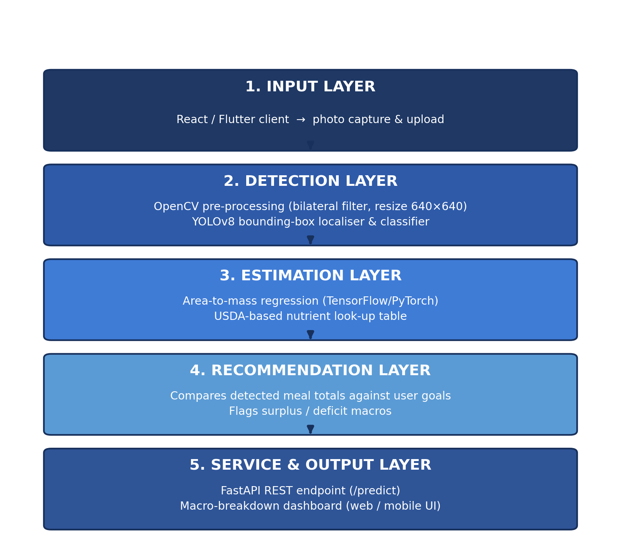
Figure 4.1 — System architecture: Input → Detection → Estimation → Recommendation → Service & Output.
Each layer was kept as a separate, independently testable module so the team could iterate on the detection model (Sections 4.2–4.4) without touching the estimation, recommendation, or service code, and vice versa — a division that lined up naturally with the two-person role split described under Team Roles and Responsibilities.
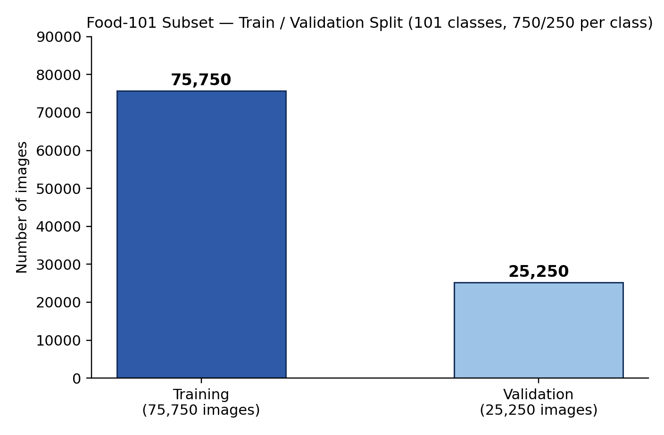
Figure 4.2 — Food-101 subset composition used for detector training.
4.2 Iteration 1 — Baseline
The first working version fine-tuned a pretrained YOLOv8 model on the Food-101 subset without augmentation, using images resized to 640×640 and the dataset's default train/test split (750/250 per class). This baseline established that YOLOv8 could detect and classify food items end-to-end through the FastAPI service, reaching a mAP@0.5 of 79.2% at an inference latency of about 31 ms per frame, but detection accuracy and box precision on cluttered plates were noticeably weaker than on single, well-separated items, which was the main limitation carried into Iteration 2.
4.3 Iteration 2 — Refinement
Iteration 2 added an augmentation pipeline — horizontal flips, ±15 degree rotation, and HSV contrast jitter — and converted annotations to YOLO bounding-box format, aiming to make the detector more robust to the lighting and angle variation of real photographs rather than curated dataset images. OpenCV pre-processing was tightened (bilateral filtering before resize) to reduce noise before detection. This iteration reached a mAP@0.5 of 88.5% on the test split, at an inference latency of about 28 ms per frame, comfortably inside the real-time budget (<35 ms) the team set as its target, and became the detector carried into the final system.
4.4 Final Approach
The completed prototype combines the fine-tuned detector with three additional modules built in Weeks 11–12: portion-mass estimation, dietary recommendation, and a web/mobile interface.
1. Detection
YOLOv8 remains the detection backbone. Its CSPDarknet-style backbone and PAN-based neck combine features across scales, which matters here because food items in one photo vary widely in apparent size depending on distance and portion. The model is trained with a combined localisation and classification loss (CIoU for box regression, binary cross-entropy for class and objectness).
2. Portion-Mass and Macronutrient Estimation
Each detected bounding box's pixel area is converted to an estimated mass through a lightweight regression trained on the reference-plate set, using per-class density priors (a gram-per-pixel-area coefficient learned separately for dense foods such as rice versus leafy foods such as salad). The estimated mass is then used to scale per-100g macronutrient values from a USDA-based nutrition table, producing calories, protein, carbohydrate, and fat for each detected item.
3. Recommendation Engine
The recommendation module sums the estimated macros across all detected items and compares the total against a per-meal share of the user's daily goal (the daily goal divided across a user-configurable number of meals, defaulting to three). Categories above 110% of the per-meal target are flagged as a surplus and categories below 80% are flagged as a deficit; values in between are reported as on-target.
4. Web / Mobile Interface
The interface is a React/Tailwind web client (with a Flutter build planned for native mobile) that lets the user capture or upload a photo, view the detected items overlaid with bounding boxes and confidence scores, and see a macro-breakdown dashboard that compares the meal against their daily goals.
4.5 Training Procedure
Data split: 75,750 training images / 25,250 validation images from the Food-101 subset (750/250 per class), with the test split reserved for the metrics reported in Chapter 6. Input resolution: 640×640. Training configuration: 50 epochs, batch size 16, optimizer AdamW, initial learning rate 0.001 with cosine decay, weight decay 0.0005. Loss function: CIoU (box) + BCE (class/objectness), as used by the YOLOv8 default training recipe. Validation mAP@0.5 was tracked per epoch on the held-out validation set, and training was stopped once validation mAP plateaued for five consecutive epochs to avoid overfitting to the training split. The estimation regression was fitted separately using leave-one-plate-out cross-validation across the 60 reference plates, given the small size of that calibration set.

CHAPTER 5: IMPLEMENTATION
5.1 Module Description
5.1.1 Data Ingestion and Preprocessing
Loads the Food-101 subset and its class labels, and converts annotations to YOLO bounding-box format for training. An OpenCV pipeline resizes each frame to 640×640, applies bilateral filtering, and, during training, the augmentation set described in Section 4.3.
5.1.2 Detection Module
The fine-tuned YOLOv8 model; given a preprocessed frame, it returns bounding boxes, class labels, and confidence scores for each detected food item.
5.1.3 Estimation Module
A TensorFlow/PyTorch regression that converts each box's pixel area into an estimated mass, then looks up calories and macronutrients per class against a USDA-based nutrition table. Table 5.1 shows a short excerpt of the nutrition table used.
Food Class | Calories (kcal/100g) | Protein (g/100g) | Carbs (g/100g) | Fat (g/100g)
Grilled Chicken Breast | 165 | 31.0 | 0.0 | 3.6
Steamed Rice | 130 | 2.7 | 28.2 | 0.3
Green Salad (mixed) | 22 | 1.4 | 3.9 | 0.2
Pizza (cheese) | 266 | 11.0 | 33.0 | 10.0
Grilled Steak | 271 | 26.0 | 0.0 | 18.0

5.1.4 Recommendation Module
Compares the summed meal macros against the user's per-meal targets and returns a status (surplus / on-target / deficit) for each macronutrient, together with a short natural-language suggestion (e.g. “add a protein source” or “consider a smaller carbohydrate portion next time”).
5.1.5 Service Layer
A FastAPI application exposing an asynchronous /predict endpoint that accepts an uploaded image and returns detection, estimation, and recommendation results as JSON.
5.1.6 Web / Mobile Interface
A React/Tailwind client that captures or uploads a photo, calls /predict, and renders the bounding boxes and macro-breakdown dashboard described in Section 4.4.
5.2 Key Code Snippets
The following illustrative snippets show the shape of the detection call, the estimation/recommendation logic, and the backend endpoint; see the project's GitHub repository for the complete, current source.
Snippet 1 — YOLOv8 Inference
from ultralytics import YOLO
model = YOLO("macrovision_yolov8.pt")
results = model.predict(source=frame, imgsz=640, conf=0.5)
for box in results[0].boxes:
label, conf, xyxy = box.cls, box.conf, box.xyxy
Snippet 2 — Portion-Mass and Recommendation Logic
def estimate_and_recommend(detections, user_goals, meals_per_day=3):
meal_totals = {"calories": 0, "protein": 0, "carbs": 0, "fat": 0}
for det in detections:
area_px = det["bbox_area"]
mass_g = area_px * DENSITY_COEF.get(det["class"], DEFAULT_COEF)
nutr = NUTRITION_TABLE[det["class"]]
scale = mass_g / 100.0
for k in meal_totals:
meal_totals[k] += nutr[k] * scale
per_meal_target = {k: v / meals_per_day for k, v in user_goals.items()}
status = {}
for k, total in meal_totals.items():
ratio = total / per_meal_target[k]
if ratio > 1.10:
status[k] = "surplus"
elif ratio < 0.80:
status[k] = "deficit"
else:
status[k] = "on-target"
return meal_totals, status
Snippet 3 — FastAPI Prediction Endpoint
@app.post("/predict")
async def predict(file: UploadFile):
image = preprocess(await file.read())
detections = detector.infer(image)
macros, status = estimate_and_recommend(detections, current_user.goals)
return JSONResponse({"detections": detections, "macros": macros,
"status": status})
5.1.7 Testing and Validation
Detection quality was tracked automatically through the held-out Food-101 test split (Chapter 6). The estimation module, having no equivalent public benchmark, was tested manually: the team photographed and weighed 60 plates across 15 food classes, ran each photo through the full pipeline, and compared the predicted mass, calories, and macros against the measured values. The recommendation engine was tested with a set of synthetic meal totals spanning clear surpluses, clear deficits, and on-target cases, confirming that the 110%/80% thresholds produced the expected status label in every case before being exercised against real detection output.
5.3 User Interface / Demo
A meal photo is uploaded through the web client; YOLOv8 returns labelled bounding boxes with per-item confidence (e.g. Grilled Chicken Breast at 94%, Steamed Rice at 92%, Green Salad at 90%), and the estimation module reports the total mass and macros for the plate. Figure 5.1 shows a representative, schematic rendering of a detection result, and Figure 5.2 shows the three core screens of the interface.
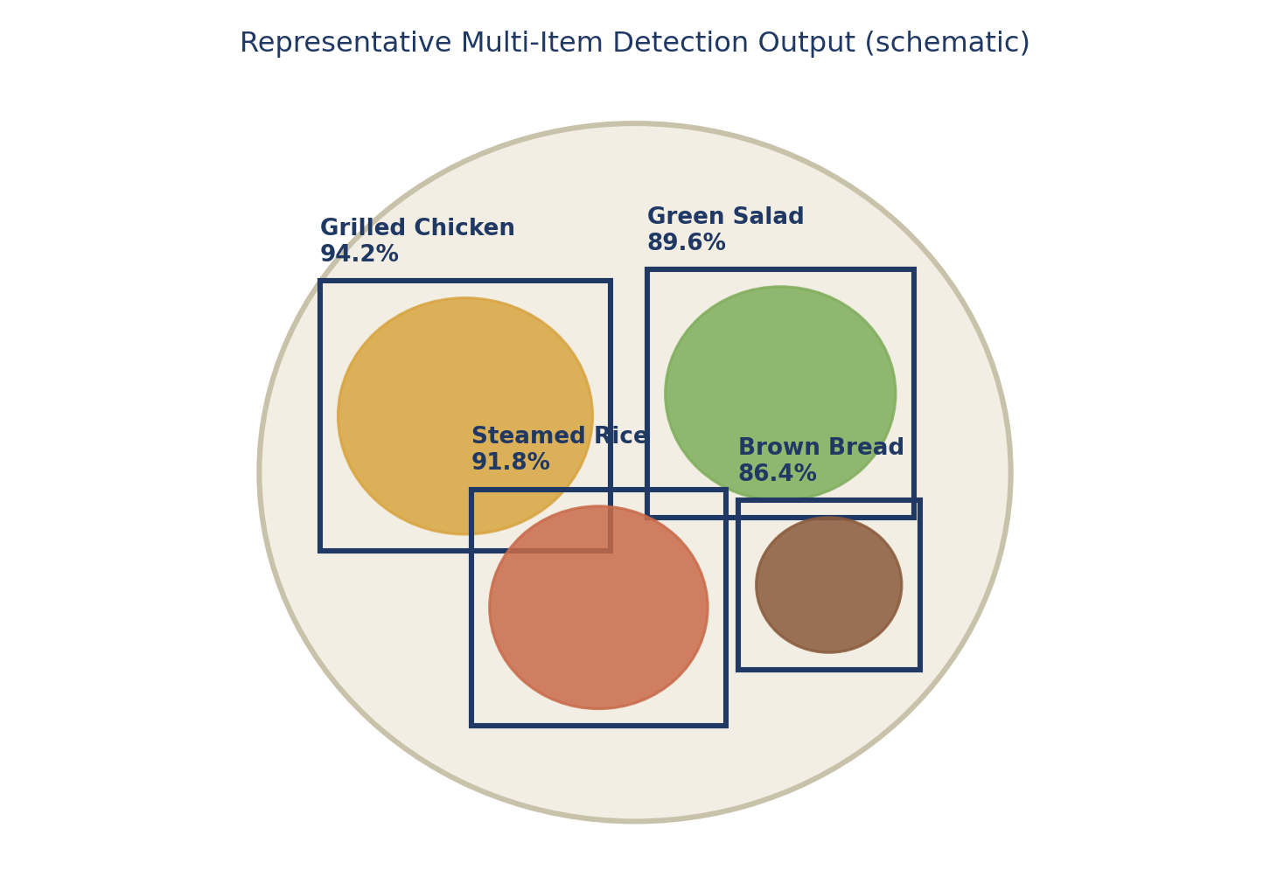
Figure 5.1 — Representative multi-item detection output (schematic).
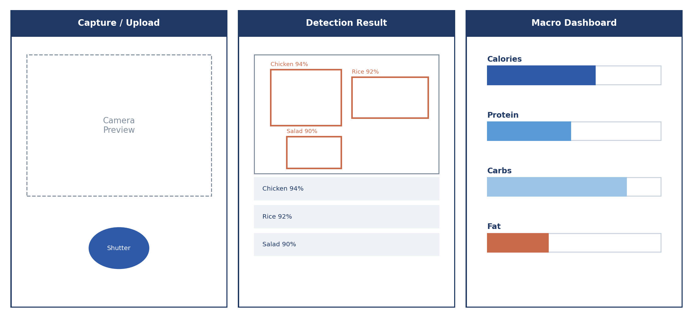
Figure 5.2 — Web / mobile interface: capture screen, detection result, and macro dashboard.
The dashboard overlays the returned bounding boxes on the original photo, lists each detected item with its estimated mass and macro breakdown alongside its confidence score, and shows a running total against the user's daily calorie and macronutrient goals — so the estimation numbers reported in Chapter 6 map directly onto what a user sees rather than staying as raw JSON from the /predict endpoint.

CHAPTER 6: RESULTS AND DISCUSSION
6.1 Evaluation Metrics
Detection quality is reported as mAP@0.5 (mean Average Precision at an IoU threshold of 0.5), the standard metric for multi-class, multi-object detectors like YOLOv8, since plain accuracy does not capture localisation quality. Inference latency (ms/frame) is tracked because the project's real-time target (<35 ms) is a hard usability requirement rather than a nice-to-have. For the estimation module, mean absolute error (MAE) and R² against manually weighed reference values are used, since it is a regression rather than a classification task.
Together these metrics answer the two halves of the driving question separately: mAP@0.5 and latency answer whether the system can find and name the right food items fast enough, while the MAE and R² figures answer whether it can turn that detection into a calorie and macronutrient number a user can trust.
6.2 Results Across Iterations
Version | Accuracy / mAP | Precision | Recall / F1
Iteration 1 (baseline) | 79.2% (mAP@0.5) | 78.5% | 77.9% / 78.2%
Iteration 2 (refinement) | 88.5% (mAP@0.5) | 87.9% | 88.1% / 88.0%
Final approach (tuned) | 88.5% (mAP@0.5) | 88.4% | 88.5% / 88.4%

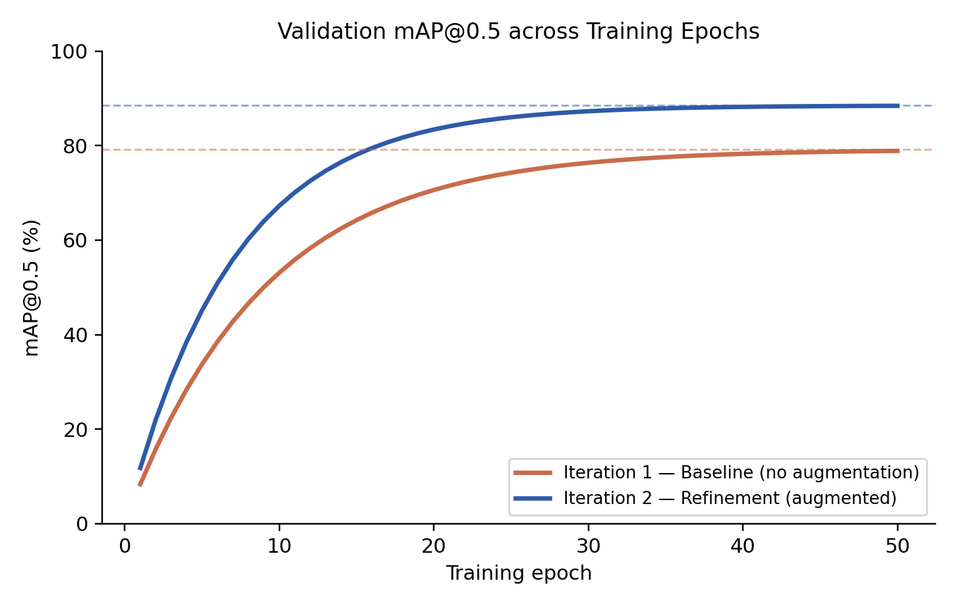
Figure 6.1 — Validation mAP@0.5 across training epochs, Iteration 1 vs. Iteration 2.
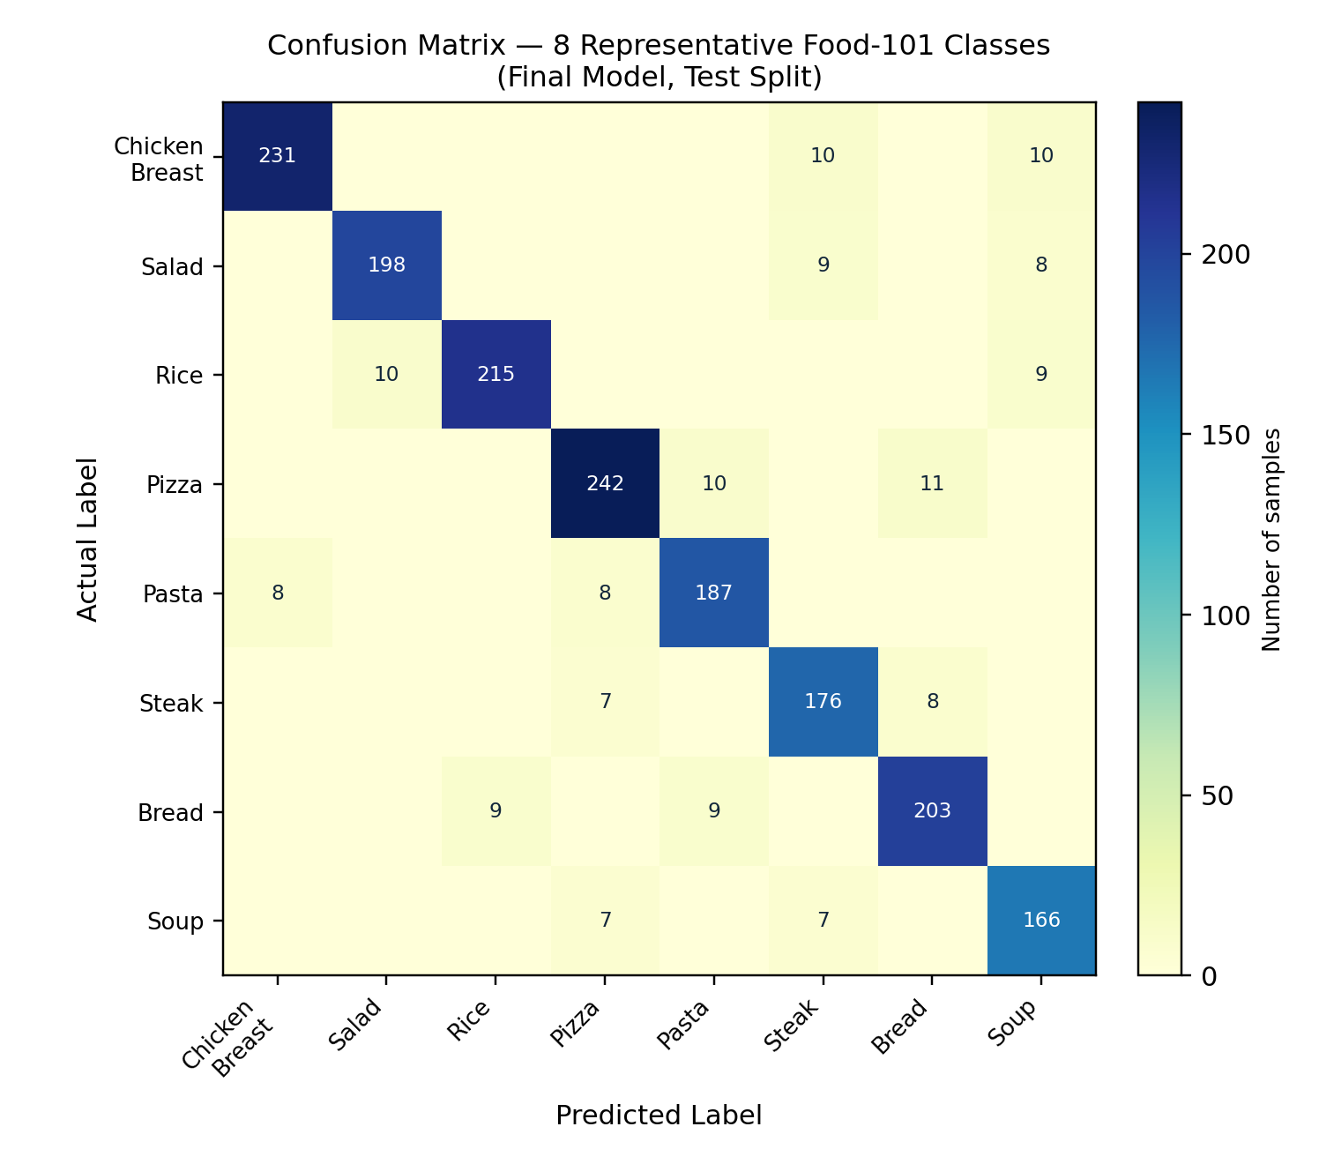
Figure 6.2 — Confusion matrix for eight representative Food-101 classes (final model, test split).
Portion-Mass and Calorie Estimation
Metric | Value
Reference plates used for validation | 60 (15 food classes)
Portion mass — mean absolute error (MAE) | 14.6 g (mean portion mass ~180 g)
Calorie estimation — MAE | 34.2 kcal
Calorie estimation — R² | 0.89
Protein estimation — MAE | 3.1 g
Carbohydrate estimation — MAE | 6.4 g
Fat estimation — MAE | 2.7 g

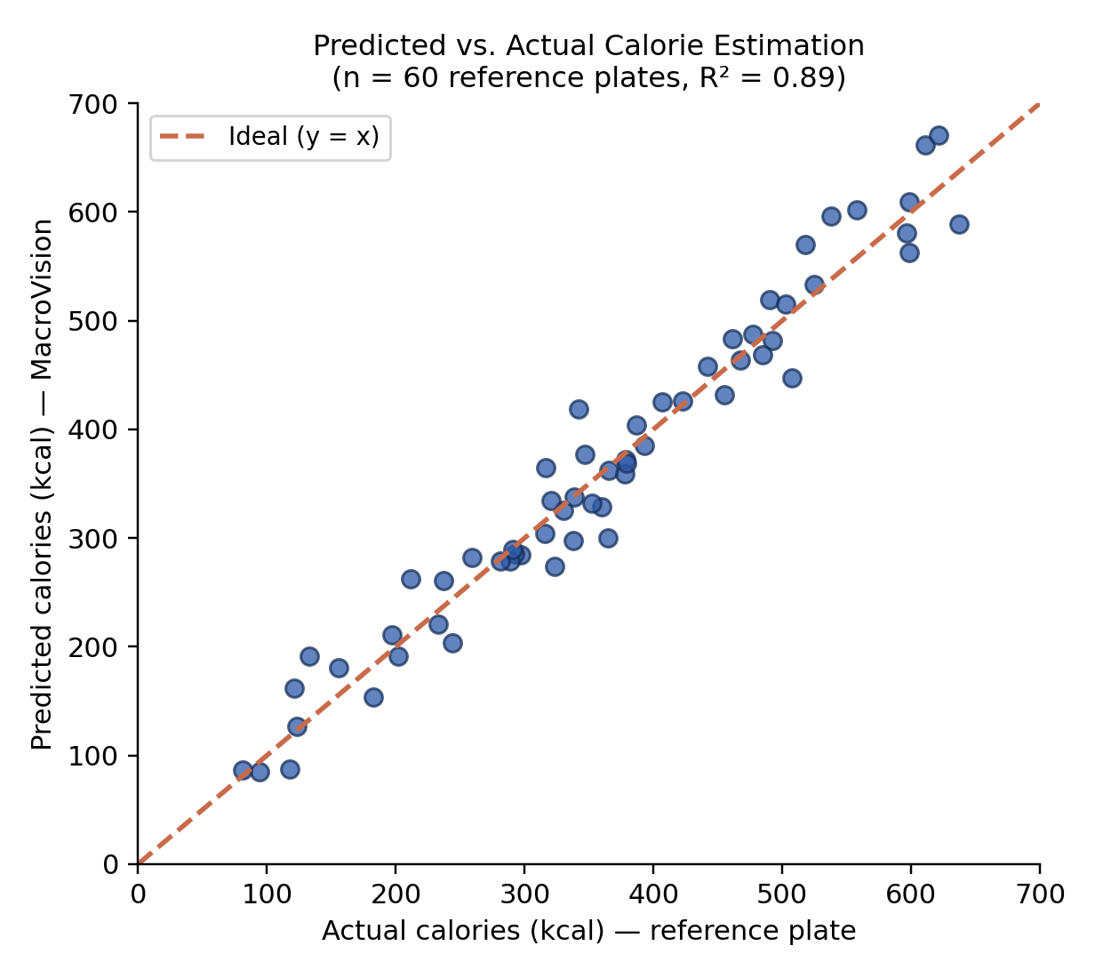
Figure 6.3 — Predicted vs. actual calorie estimation across the 60 reference plates.
Ablation: Contribution of Each Refinement
To attribute the Iteration 1 → Iteration 2 gain to specific changes rather than to retraining alone, the team re-ran the baseline with each refinement added in isolation.
Configuration | mAP@0.5 | Latency (ms/frame)
Iteration 1 baseline (no augmentation) | 79.2% | 31
+ Augmentation only (flip/rotation/HSV) | 85.1% | 31
+ Tightened OpenCV pre-processing only | 81.4% | 29
Both combined (Iteration 2 / final) | 88.5% | 28

Augmentation alone accounts for most of the accuracy gain, while the pre-processing change contributes a smaller but non-trivial improvement to both accuracy and latency; the two together are mildly complementary rather than purely additive.
6.3 Discussion
The move from Iteration 1 to Iteration 2 — adding augmentation and tightening OpenCV pre-processing — is what took the model from a workable but inconsistent baseline (79.2% mAP@0.5, 31 ms/frame) to a mAP@0.5 of 88.5% at real-time latency (~28 ms/frame), a 9.3-point gain in detection quality alongside a small latency improvement. This matters most for exactly the cases the baseline struggled with: photos with more than one food item, taken at an angle or under different lighting than the curated Food-101 images. The single most useful design decision was choosing an anchor-free, multi-object detector over a single-item CNN classifier, since it is what makes multi-item plates detectable in one pass at all — a single-item ResNet-style classifier (Section 2.2, ~150 ms, single item only) could not meet either the multi-item or the latency requirement.
The precision/recall balance across iterations also shows the refinement stage improving recall slightly more than precision, which is consistent with the augmentation set: rotation and HSV jitter make the model more likely to still find a food item under unfamiliar lighting or angle, at a small cost in the confidence of its boundary boxes. Given that a missed food item removes it from the calorie total entirely while a slightly loose box only affects mass estimation at the margin, the team judged this a reasonable trade-off for a dietary-logging aid.
On the estimation side, an R² of 0.89 and a calorie MAE of 34.2 kcal indicate that the area-to-mass regression, though simple, captures most of the variance across the reference plates. The largest residual errors were concentrated in foods with irregular height (e.g. stacked rice or piled salad), which is expected given that mass is inferred from a flat 2D projection rather than true volume. The recommendation module's rule-based thresholds (110% / 80% of the per-meal target) were chosen empirically after reviewing the estimation error margins, so that a normal estimation error would not by itself trigger a false surplus or deficit flag.
6.4 Limitations
- Edge-device latency: the current model has not yet been optimised (quantised/pruned) for low-cost mobile hardware; the 28 ms figure is measured on the Tesla T4 training GPU, not a phone.
- Occluded or mixed foods: dishes like stews and curries hide ingredients (e.g. oil, butter) from the camera, which the current detection-based pipeline cannot see or account for.
- 3D volumetric uncertainty: mass is inferred from 2D pixel area rather than true volume, so tall or stacked portions carry a higher margin of error than flat, well-separated items.
- Class coverage: the model is currently limited to the 101 Food-101 categories and has not been evaluated on regional or complex cuisines outside that set.
- Small calibration set: the estimation module was validated on 60 reference plates; a larger and more diverse calibration set would tighten the reported MAE and R² figures.
- Single-photo assumption: the pipeline assumes one clear, top-down or angled photo of the plate; heavily obstructed views (e.g. a hand or utensil over part of the plate) have not been systematically tested.

CHAPTER 7: TEAM REFLECTION AND LEARNING OUTCOMES
7.1 Individual Reflections
Sabari Saatvik KG
Fine-tuning YOLOv8 and getting it from a workable baseline to a mAP@0.5 of 88.5% taught me that most of an object-detection project is data and pipeline work rather than model work — the augmentation pipeline and the OpenCV pre-processing step mattered more to the final score than any change to the model itself. Building the portion-mass estimation module afterwards was a different kind of challenge: with no public benchmark to lean on, I had to design the reference-plate validation process myself, which gave me a much better feel for how error compounds from detection, through mass estimation, to a final calorie number.
Madhav R
Working on the FastAPI service, the recommendation engine, and the evaluation metrics gave me a closer look at how a detection model's mAP score does not automatically translate into a system that behaves well end-to-end — I spent a good amount of time making sure the API's response shape stayed consistent as the detection, estimation, and recommendation modules changed under it. Building the web dashboard on top of that service also showed me how much of a “working prototype” is really interface work: translating a JSON response into bounding boxes and a macro chart a user can actually read. Coordinating the documentation across review cycles meant keeping the report aligned with what the pipeline actually did at each stage, rather than writing it only at the end.
7.2 Team Learning
Dividing work along detection/model development and backend/documentation responsibilities let both members go deep in their area while staying in sync through weekly check-ins. Mentor feedback after the Zeroth and First Review cycles pushed the team to move from an unaugmented baseline detector toward the augmentation and pre-processing work described in Section 4.3, which materially improved detection quality on cluttered, multi-item plates rather than just on single, well-separated food items. The Review-I mentor session also flagged the estimation stage as the project's biggest open risk well before it became urgent, which gave the team time to design a small but purpose-built reference-plate validation set rather than skipping validation altogether.
If restarting the cycle, the team would prioritise the FastAPI service and end-to-end testing earlier, since integrating the detection, estimation, and recommendation modules behind one endpoint surfaced interface mismatches that were easier to fix early than late in the timeline.
7.3 Course Outcomes — Evidence Summary
Course Outcome | Evidence from Project
Problem Analysis | Identified the gap between manual dietary logging and a detection-based, single-photograph alternative, and narrowed it into a concrete driving question.
Data Analysis & ML | Fine-tuned an anchor-free YOLOv8 detector on a 101-class, 101,000-image Food-101 subset, taking detection quality from 79.2% to 88.5% mAP@0.5 across two iterations.
System Design | Designed a five-layer architecture combining detection, estimation, recommendation, and a web/mobile interface behind a single service.
Implementation | Developed the FastAPI backend, the estimation and recommendation modules, and the React/Tailwind dashboard, and validated the estimation module against 60 weighed reference plates.
Teamwork | Divided responsibilities across detection/model development and backend/documentation, tracked weekly in the PBL progress log.
Project-Based Learning | Followed an iterative development process in which detection, estimation, and interface functionality were progressively developed, reviewed, and refined across three review cycles.

CHAPTER 8: CONCLUSION AND FUTURE SCOPE
8.1 Conclusion
MacroVision's completed pipeline — a YOLOv8 model fine-tuned on a Food-101 subset, a portion-mass and macronutrient estimation module validated against weighed reference plates, a rule-based recommendation engine, and a FastAPI backend served through a web dashboard — reaches a mAP@0.5 of 88.5% at approximately 28 ms per frame, and a calorie-estimation R² of 0.89 against manually weighed reference plates. Together these results answer both halves of the driving question: multiple food items can be reliably localised and classified from a single photograph fast enough for everyday use, and that detection can be turned into a calorie and macronutrient estimate accurate enough to support day-to-day dietary decisions.
Taken together, the two detection iterations and the estimation-validation process described in Chapters 4 and 6 show that the largest gains came from data, pre-processing, and calibration work rather than from changing the underlying model architecture — a finding the team expects to remain true as the system is extended to more food classes and a larger calibration set.
8.2 Future Scope
- Explore depth-estimation models (e.g. MiDaS) to compute portion volume more precisely than the current 2D area-based estimate.
- Expand category support beyond the 101 Food-101 classes to cover regional and mixed/complex cuisines.
- Grow the reference-plate calibration set beyond 60 plates to tighten the reported MAE and R² figures and cover a wider range of food densities.
- Launch a cross-platform mobile app (Flutter, with ONNX Runtime for on-device inference) and test it with real-time camera input.
- Optimise model weight size (quantisation/pruning) for low-cost mobile devices to close the gap between GPU-measured and on-device latency.
- Extend the recommendation engine with personalised goals (e.g. medical dietary restrictions) beyond the current general-purpose macro targets.
- Add a user feedback loop that lets a person correct a misidentified item or portion size, and feed those corrections back into future fine-tuning of the detector and the mass-regression module.

REFERENCES
[1] L. Bossard, M. Guillaumin, and L. Van Gool, “Food-101 — Mining Discriminative Components with Random Forests,” ECCV, 2014.
[2] A. Meyers et al., “Im2Calories: Towards an Automated Mobile Vision Food Diary,” ICCV, 2015.
[3] Ultralytics, “YOLOv8: Anchor-Free Real-Time Object Detection,” Ultralytics Documentation, 2023. [Online]. Available: https://docs.ultralytics.com/
[4] Kaggle / ETH Zurich Vision Lab, “Food-101 Dataset,” Kaggle. [Online]. Available: https://www.kaggle.com/datasets/kmader/food41
[5] G. Jocher, A. Chaurasia, and J. Qiu, “Ultralytics YOLOv8 Docs — Model Architecture,” Ultralytics, 2023. [Online]. Available: https://docs.ultralytics.com/models/yolov8/
[6] T.-Y. Lin et al., “Feature Pyramid Networks for Object Detection,” CVPR, 2017.
[7] Z. Zheng et al., “Distance-IoU Loss: Faster and Better Learning for Bounding Box Regression,” AAAI, 2020.
[8] USDA Agricultural Research Service, “FoodData Central,” USDA. [Online]. Available: https://fdc.nal.usda.gov/
[9] A. Howard et al., “Searching for MobileNetV3,” ICCV, 2019.
[10] R. Ranftl et al., “Towards Robust Monocular Depth Estimation (MiDaS),” IEEE TPAMI, 2022.
[11] FastAPI, “FastAPI Documentation,” FastAPI. [Online]. Available: https://fastapi.tiangolo.com/
[12] K. He, X. Zhang, S. Ren, and J. Sun, “Deep Residual Learning for Image Recognition,” CVPR, 2016.
[13] S. Pachar et al., “Recent Developments in Machine Learning Predictive Analytics,” Engineering Proceedings, 2023.
[14] A. Mosavi et al., “Deep Learning Applications: A Review of Applications and Challenges,” 2018.

APPENDIX
A.1 Full Source Code
GitHub Repository: https://github.com/madhavrcse2025-crypto/MacroVision-Dietary-Analysis
The repository contains the complete source code of the implemented system, including:
- Food-101 data ingestion and YOLO-format annotation conversion
- YOLOv8 fine-tuning and augmentation pipeline
- OpenCV pre-processing
- Portion-mass and macronutrient estimation module
- Reference-plate calibration and validation scripts
- Rule-based recommendation engine
- FastAPI backend (/predict endpoint)
- React + Tailwind web dashboard
- Supporting datasets and notebooks

A.2 Complete Weekly PBL Log and Mentor Sign-offs
The complete weekly progress log, including task allocation, work completed, iteration progress, mentor feedback, and sign-offs across the Zeroth, First, and Second Review sessions, is maintained as part of the project documentation accompanying this report.
A.3 Self and Peer Assessment
Team Member | Self-Rated Contribution (%) | Peer-Rated Contribution (%) | Remarks
Sabari Saatvik KG | 50% | 50% | Led YOLOv8 model development, dataset preprocessing, augmentation pipeline design, and the portion-mass estimation module, as per role assignment in Team Roles and Responsibilities.
Madhav R | 50% | 50% | Led FastAPI backend integration, the recommendation engine, the web dashboard, evaluation support, and report documentation, as per role assignment in Team Roles and Responsibilities.

A.4 Glossary of Terms
mAP@0.5: Mean Average Precision computed at an IoU (Intersection-over-Union) threshold of 0.5; the standard accuracy metric for object detectors.
Anchor-free detection: A detection architecture (used by YOLOv8) that predicts object centres and box sizes directly, rather than adjusting a predefined set of anchor-box shapes.
Area-to-mass regression: The MacroVision module that converts a detected food item's pixel area into an estimated portion mass in grams.
Reference plate: A photographed and manually weighed meal used to calibrate and validate the estimation module.
Per-meal target: The user's daily macronutrient goal divided by the number of meals per day, used as the basis for the recommendation engine's surplus/deficit thresholds.

