AI ASSISTED CODING (ASSIGNMENT-5.1)

Name: V .Madhav Reddy
Roll No: 2503A52698
Batch:24

Task1: Use an AI tool to generate a Python program that connects to a weather API.
Prompt: Generate code to fetch weather data securely without exposing API keys in the code
Code:
import json
import os
import sys
from typing import Any
from urllib.error import HTTPError, URLError
from urllib.parse import urlencode
from urllib.request import Request, urlopen
WEATHER_ENDPOINT = "https://api.openweathermap.org/data/2.5/weather"
def fetch_weather(city: str, units: str = "metric") -> dict[str, Any]:
"""Return current weather data for a city from OpenWeather."""
api_key = os.environ.get("WEATHER_API_KEY")
if not api_key:
raise RuntimeError(
"WEATHER_API_KEY is not set. Set it in your environment before running."
)
query = urlencode({"q": city, "appid": api_key, "units": units})
request = Request(
f"{WEATHER_ENDPOINT}?{query}",
headers={"Accept": "application/json", "User-Agent": "weather-client/1.0"},
)
try:
with urlopen(request, timeout=10) as response:
return json.load(response)
except HTTPError as error:
if error.code in (401, 403):
raise RuntimeError("The weather API rejected the API key.") from error
if error.code == 404:
raise RuntimeError(f"City not found: {city}") from error
raise RuntimeError(f"Weather service returned HTTP {error.code}.") from error
except URLError as error:
raise RuntimeError("Could not connect to the weather service.") from error
except json.JSONDecodeError as error:
raise RuntimeError("Weather service returned invalid JSON.") from error
def main() ->int:
if len(sys.argv) != 2:
print(f"Usage: python {os.path.basename(sys.argv[0])} CITY", file=sys.stderr)
return 2
try:
weather = fetch_weather(sys.argv[1])
except RuntimeError as error:
print(error, file=sys.stderr)
return 1
print(
f"{weather['name']}: {weather['main']['temp']} C, "
f"{weather['weather'][0]['description']}"
)
return 0
if __name__ == "__main__":
raise SystemExit(main())
output:
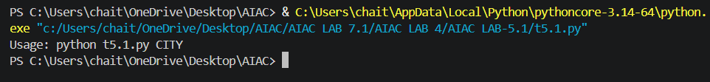
Task2: Use an AI tool to generate a Python script that stores user data (name, email, password) in a file.
Analyze: Check if the AI stores sensitive data in plain text or without encryption.
Prompt: generate a Python script that stores user data (name, email, password) in a file.
Code:
import json
from pathlib import Path
DATA_FILE = Path(__file__).resolve().parents[3] / "users.json"
def main() ->None:
if not DATA_FILE.exists():
users = []
else:
with DATA_FILE.open("r", encoding="utf-8") as file:
users = json.load(file)
name = input("Enter name: ")
email = input("Enter email: ")
password = input("Enter password: ")
users.append(
{
"name": name,
"email": email,
"password": password,
}
)

with DATA_FILE.open("w", encoding="utf-8") as file:
json.dump(users, file, indent=2)
file.write("\n")
print("User data saved successfully.")
if __name__ == "__main__":
main()
output:
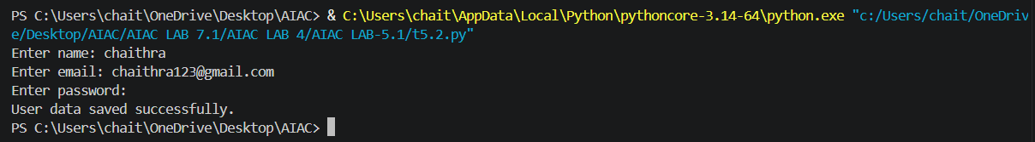
Task3: Use AI to generate an Armstrong number checking function with comments and explanations.
Instructions:
- Ask AI to explain the code line-by-line.
- Compare the explanation with code functionality.
Prompt: generate a python program of an Armstrong number checking function with comments and explanations
Code:
def is_armstrong(number):
# Count the number of digits.
digits = str(number)
power = len(digits)
# Add each digit raised to the power of the digit count.
total = 0
for digit in digits:
total += int(digit) ** power

# The number is Armstrong if the total equals the original number.
return total == number
number = int(input("Enter a number: "))
if is_armstrong(number):
print("Armstrong number")
else:
print("Not an Armstrong number")
output:
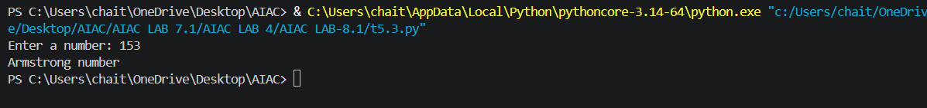
Task4: Use AI to implement two sorting algorithms (e.g., QuickSort and BubbleSort).
Prompt: Generate Python code for QuickSort and BubbleSort, and include comments explaining step-by-step how each works and where they differ.
Code:
def bubble_sort(values):
values = values.copy()
# Repeatedly swap neighboring values that are in the wrong order.
for end in range(len(values) - 1, 0, -1):
for index in range(end):
if values[index] > values[index + 1]:
values[index], values[index + 1] = values[index + 1], values[index]
return values
def quick_sort(values):
# Pick a pivot, split into smaller/larger parts, then sort each part.
if len(values)<= 1:
return values
pivot = values[-1]
smaller = [value for value in values[:-1] if value<= pivot]
larger = [value for value in values[:-1] if value>pivot]
return quick_sort(smaller) + [pivot] + quick_sort(larger)
numbers = [5, 2, 9, 1, 3]
print("Bubble Sort:", bubble_sort(numbers))
print("QuickSort: ", quick_sort(numbers))
# Difference: Bubble Sort compares neighbors and is usually O(n^2).
# QuickSort uses a pivot and is usually faster: O(n log n).
Output:
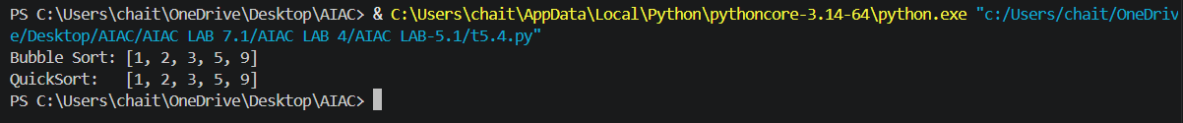
Task5: Use AI to create a product recommendation system.
Prompt: Generate a recommendation system that also provides reasons for each suggestion.
Code:
items = {
"Python Course": {"programming", "python", "beginner"},
"Data Science Course": {"programming", "python", "data", "intermediate"},
"Cybersecurity Course": {"cybersecurity", "security", "beginner"},
}
category = input("Category: ").lower()
interest = input("Interest: ").lower()
level = input("Level: ").lower()
scores = []
for name, features in items.items():
reasons = [f"matches {word}" for word in (category, interest, level) if word in features]
if reasons:
scores.append((len(reasons), name, reasons))

print("\nRecommendations:")
for score, name, reasons in sorted(scores, reverse=True):
print(f"- {name}: {', '.join(reasons)}")
output:
