**Project Report On**

**City Taxi Call Center Database Management**

**System**



## Academic Year 2023-24

**Under the guidance of**

**Prof. Sachin Bhandari**

**Submitted By**

**Madhav Gupta E212**

Case Study: City Taxi Call Center Database Management System

# Problem Statement:

In the bustling urban environment of CityX, a taxi call center is striving to enhance its operations by implementing a Database Management System (DBMS). This beginner-level project aims to streamline the management of taxi bookings, drivers, and customer data.

# Background:

City Taxi Call Center currently relies on manual record-keeping and traditional filing systems, leading to inefficiencies, data inaccuracies, and delayed response times. To address these challenges, the decision was made to implement a DBMS.

# Objective:

The primary goal of this project is to design and implement a DBMS that can efficiently manage taxi bookings, driver information, and customer details. The system should ensure quick retrieval of data, easy updates, and enhanced overall performance.

# Motivation for Developing the Project:

We'd like to share the journey that led us to conceptualize and work on the City Taxi Call Center Database Management System project. It all started with a series of observations and experiences that highlighted significant challenges faced by both the taxi company and its customers.

Firstly, we noticed the frustration among customers due to long wait times when calling for a taxi. Many times, incorrect information or delays in dispatching contributed to this dissatisfaction. Similarly, the taxi drivers

often struggled with inefficient allocation of rides and lacked real-time updates on customer locations and demand patterns.

Driven by these real-world challenges, our team felt compelled to find a solution that would not only address the immediate issues but also lay the groundwork for a more efficient and customer-centric taxi service.

However, the journey wasn't without its hurdles. We encountered various challenges along the way, ranging from understanding the complexities of the taxi industry to designing a scalable and user-friendly database management system.

One of the major obstacles we faced was integrating real-time data updates into the system. Ensuring that both the call center operators and drivers had access to accurate and up-to-date information posed a significant technical challenge. Additionally, designing a user interface that was intuitive for both the call center staff and the drivers required careful consideration of usability principles and feedback from stakeholders.

Moreover, navigating the regulatory landscape and ensuring compliance with data protection laws added another layer of complexity to the project. We had to carefully balance the need for data security and privacy with the requirements for seamless information sharing and communication within the system.

Despite these challenges, working on this project has been an invaluable learning experience for our team. We've gained a deeper understanding of database management principles, software development methodologies, and the nuances of the transportation industry.

In conclusion, our motivation for developing the City Taxi Call Center Database Management System stemmed from a genuine desire to improve the taxi service experience for both customers and drivers. Through perseverance, teamwork, and a commitment to excellence, we overcame

challenges and gained valuable insights that will undoubtedly shape our future endeavours in the field of software development.

# ER Diagram:

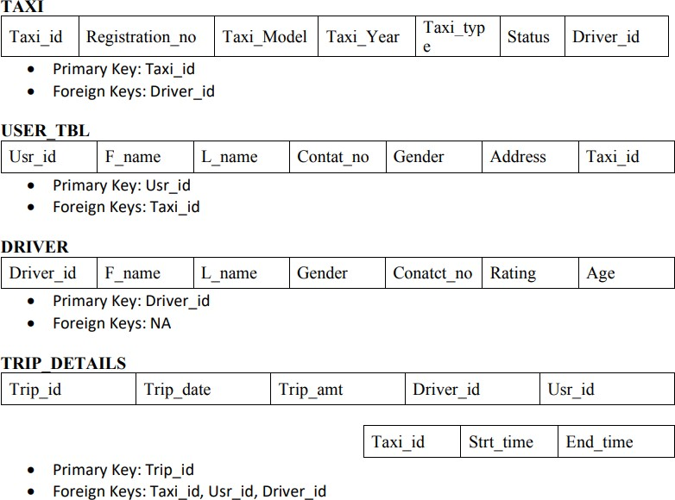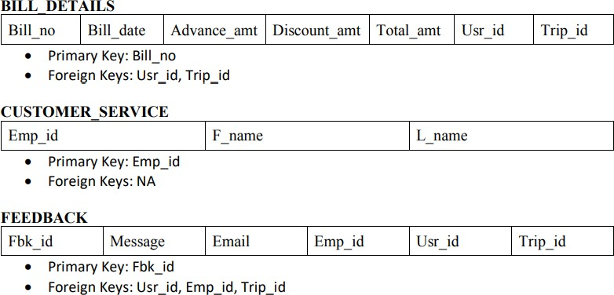**Schema:**

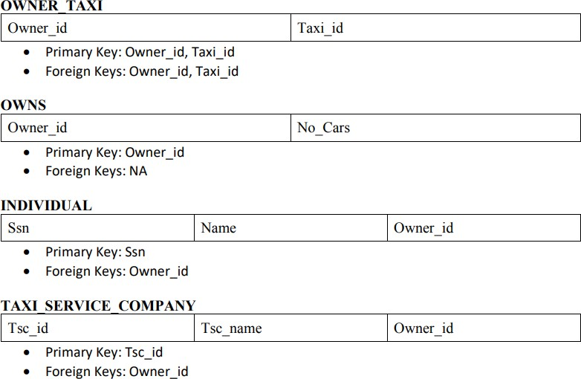

# Normalization:

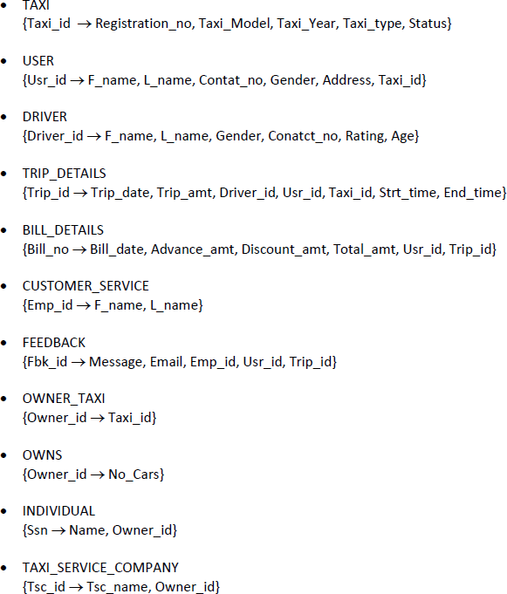

**CREATE And INSERT Queries:**

import sqlite3

db_file = 'example.db'

conn = sqlite3.connect(db_file) cursor = conn.cursor()

sql_script = """

PRAGMA foreign_keys = ON;

CREATE TABLE IF NOT EXISTS TAXI ( Taxi_id INTEGER PRIMARY KEY,

Registration_no TEXT UNIQUE, Model TEXT,

Taxi_Year DATE, Taxi_type TEXT, Taxi_status TEXT, Driver_id INTEGER,

FOREIGN KEY (Driver_id) REFERENCES DRIVER(Driver_id) ON DELETE CASCADE

);

CREATE TABLE IF NOT EXISTS USER_TBL ( Usr_id INTEGER PRIMARY KEY,

F_name TEXT, L_name TEXT, Contat_no INTEGER, Gender TEXT, USR_Address TEXT, Taxi_id INTEGER,

FOREIGN KEY (Taxi_id) REFERENCES TAXI(Taxi_id) ON DELETE CASCADE

);

CREATE TABLE IF NOT EXISTS DRIVER ( Driver_id INTEGER PRIMARY KEY,

F_name TEXT, L_name TEXT, Gender TEXT, Contact_no TEXT, Rating INTEGER, Age INTEGER

);

CREATE TABLE IF NOT EXISTS TRIP_DETAILS ( Trip_id INTEGER PRIMARY KEY,

Trip_date DATE, Trip_amt DECIMAL(10,2),

Driver_id INTEGER NOT NULL, Usr_id INTEGER NOT NULL,

ACTION,

);

Taxi_id INTEGER NOT NULL,

Strt_time DATETIME, End_time DATETIME, T_Source VARCHAR(20), T_Destination VARCHAR(20),

FOREIGN KEY (Driver_id) REFERENCES DRIVER(Driver_id) ON DELETE NO

FOREIGN KEY (Usr_id) REFERENCES USER_TBL(Usr_id) ON DELETE NO ACTION, FOREIGN KEY (Taxi_id) REFERENCES TAXI(Taxi_id) ON DELETE NO ACTION

CREATE TABLE IF NOT EXISTS BILL_DETAILS ( Bill_no INTEGER PRIMARY KEY,

Bill_date DATE, Advance_amt DECIMAL(10,2), Discount_amt DECIMAL(10,2), Total_amt DECIMAL(10,2), Usr_id INTEGER,

Trip_id INTEGER,

FOREIGN KEY (Usr_id) REFERENCES USER_TBL(Usr_id) ON DELETE CASCADE, FOREIGN KEY (Trip_id) REFERENCES TRIP_DETAILS(Trip_id) ON DELETE NO

ACTION

);

CREATE TABLE IF NOT EXISTS CUSTOMER_SERVICE ( Emp_id INTEGER PRIMARY KEY,

F_name TEXT, L_name TEXT

);

CREATE TABLE IF NOT EXISTS FEEDBACK ( Fbk_id INTEGER PRIMARY KEY,

Message TEXT, Email TEXT, Emp_id INTEGER, Usr_id INTEGER, Trip_id INTEGER, F_Type TEXT,

FOREIGN KEY (Emp_id) REFERENCES CUSTOMER_SERVICE(Emp_id) ON DELETE CASCADE,

FOREIGN KEY (Usr_id) REFERENCES USER_TBL(Usr_id) ON DELETE NO ACTION, FOREIGN KEY (Trip_id) REFERENCES TRIP_DETAILS(Trip_id) ON DELETE

CASCADE

);

CREATE TABLE IF NOT EXISTS OWNS ( Owner_id INTEGER PRIMARY KEY,

No_Cars INTEGER

);

CREATE TABLE IF NOT EXISTS OWNER_TAXI (

Owner_id INTEGER, Taxi_id INTEGER,

PRIMARY KEY (Owner_id, Taxi_id),

FOREIGN KEY (Owner_id) REFERENCES OWNS(Owner_id) ON DELETE CASCADE, FOREIGN KEY (Taxi_id) REFERENCES TAXI(Taxi_id) ON DELETE CASCADE

);

CREATE TABLE IF NOT EXISTS INDIVIDUAL ( Ssn INTEGER PRIMARY KEY,

Name TEXT, Owner_id INTEGER,

FOREIGN KEY (Owner_id) REFERENCES OWNS(Owner_id) ON DELETE CASCADE

);

CREATE TABLE IF NOT EXISTS TAXI_SERVICE_COMPANY ( Tsc_id INTEGER PRIMARY KEY,

Tsc_name TEXT, Owner_id INTEGER,

FOREIGN KEY (Owner_id) REFERENCES OWNS(Owner_id) ON DELETE CASCADE

);

CREATE TABLE TMP_TRIP_DETAILS AS SELECT * FROM TRIP_DETAILS;

DROP TABLE TRIP_DETAILS;

CREATE TABLE TRIP_DETAILS ( Trip_id INTEGER PRIMARY KEY,

Trip_date DATE, Trip_amt DECIMAL(10,2),

Driver_id INTEGER NOT NULL, Usr_id INTEGER NOT NULL, Taxi_id INTEGER NOT NULL,

Strt_time DATETIME, End_time DATETIME, T_Source VARCHAR(20), T_Destination VARCHAR(20),

FOREIGN KEY (Driver_id) REFERENCES DRIVER(Driver_id) ON DELETE NO

ACTION,

);

FOREIGN KEY (Usr_id) REFERENCES USER_TBL(Usr_id) ON DELETE NO ACTION, FOREIGN KEY (Taxi_id) REFERENCES TAXI(Taxi_id) ON DELETE NO ACTION

INSERT INTO TRIP_DETAILS SELECT * FROM TMP_TRIP_DETAILS;

DROP TABLE TMP_TRIP_DETAILS;

"""

print("Table created successfully") print("Inserting Data into Tables")

*# TAXI Insertion*

cursor.execute("INSERT OR IGNORE INTO TAXI (Taxi_id, Registration_no, Model, Taxi_Year, Taxi_type, Taxi_status, Driver_id) VALUES (1, 'GJ152004', 'BENZE', '2024-03-11', 'SUV', 'Available', NULL)")

cursor.execute("INSERT OR IGNORE INTO TAXI (Taxi_id, Registration_no, Model, Taxi_Year, Taxi_type, Taxi_status, Driver_id) VALUES (2, 'MH432010', 'MARUTI', '2024-03-12', 'Hatchback', 'Available', NULL)")

cursor.execute("INSERT OR IGNORE INTO TAXI (Taxi_id, Registration_no, Model, Taxi_Year, Taxi_type, Taxi_status, Driver_id) VALUES (3, 'DL678003', 'HYUNDAI', '2024-03-13', 'Sedan', 'Available', NULL)")

cursor.execute("INSERT OR IGNORE INTO TAXI (Taxi_id, Registration_no, Model, Taxi_Year, Taxi_type, Taxi_status, Driver_id) VALUES (4, 'KA987007', 'TATA', '2024-03-14', 'SUV', 'Available', NULL)")

cursor.execute("INSERT OR IGNORE INTO TAXI (Taxi_id, Registration_no, Model, Taxi_Year, Taxi_type, Taxi_status, Driver_id) VALUES (5, 'UP765005', 'MAHINDRA', '2024-03-15', 'SUV', 'Available', NULL)")

cursor.execute("INSERT OR IGNORE INTO TAXI (Taxi_id, Registration_no, Model, Taxi_Year, Taxi_type, Taxi_status, Driver_id) VALUES (6, 'TN876006', 'TOYOTA', '2024-03-16', 'Sedan', 'Available', NULL)")

cursor.execute("INSERT OR IGNORE INTO TAXI (Taxi_id, Registration_no, Model, Taxi_Year, Taxi_type, Taxi_status, Driver_id) VALUES (7, 'AP543001', 'HONDA', '2024-03-17', 'Hatchback', 'Available', NULL)")

cursor.execute("INSERT OR IGNORE INTO TAXI (Taxi_id, Registration_no, Model, Taxi_Year, Taxi_type, Taxi_status, Driver_id) VALUES (8, 'PB234008', 'FORD', '2024-03-18', 'SUV', 'Available', NULL)")

cursor.execute("INSERT OR IGNORE INTO TAXI (Taxi_id, Registration_no, Model, Taxi_Year, Taxi_type, Taxi_status, Driver_id) VALUES (9, 'HR654009', 'VOLKSWAGEN', '2024-03-19', 'Hatchback', 'Available', NULL)")

cursor.execute("INSERT OR IGNORE INTO TAXI (Taxi_id, Registration_no, Model, Taxi_Year, Taxi_type, Taxi_status, Driver_id) VALUES (10, 'MP876002', 'CHEVROLET', '2024-03-20', 'SUV', 'Available', NULL)")

*# USER_TBL Insertion*

cursor.execute("INSERT OR IGNORE INTO USER_TBL VALUES(1, 'Yash', 'Taneja', 7987845578, 'Male', 'Chhindwara', 1)")

cursor.execute("INSERT OR IGNORE INTO USER_TBL VALUES(2, 'Riya', 'Sharma', 9090909090, 'Female', 'Delhi', 2)")

cursor.execute("INSERT OR IGNORE INTO USER_TBL VALUES(3, 'Amit', 'Singh', 9876543210, 'Male', 'Mumbai', 3)")

cursor.execute("INSERT OR IGNORE INTO USER_TBL VALUES(4, 'Priya', 'Patel', 8765432109, 'Female', 'Ahmedabad', 4)")

cursor.execute("INSERT OR IGNORE INTO USER_TBL VALUES(5, 'Kunal', 'Gupta', 7654321098, 'Male', 'Bangalore', 5)")

*# TRIP_DETAILS Insertion */*

cursor.execute("INSERT OR IGNORE INTO TRIP_DETAILS VALUES(1, '2024-03-11', 150.45, 1, 1, 1, '2024-03-11 12:00:00', '2024-03-11 13:05:00', 'Chhindwara',

'Sendhwa')")

cursor.execute("INSERT OR IGNORE INTO TRIP_DETAILS VALUES(2, '2024-03-13', 175.50, 2, 2, 2, '2024-03-13 12:00:00', '2024-03-13 13:05:00', 'Delhi',

'Mumbai')")

cursor.execute("INSERT OR IGNORE INTO TRIP_DETAILS VALUES(3, '2024-03-14', 200.00, 3, 3, 3, '2024-03-14 12:00:00', '2024-03-14 13:05:00', 'Kolkata',

'Chennai')")

cursor.execute("INSERT OR IGNORE INTO TRIP_DETAILS VALUES(4, '2024-03-15', 120.75, 4, 4, 4, '2024-03-15 12:00:00', '2024-03-15 13:05:00', 'Bangalore',

'Hyderabad')")

cursor.execute("INSERT OR IGNORE INTO TRIP_DETAILS VALUES(5, '2024-03-16', 95.25, 5, 5, 5, '2024-03-16 12:00:00', '2024-03-16 13:05:00', 'Pune',

'Ahmedabad')")

*# BILL_DETAILS Insertion */*

cursor.execute("INSERT OR IGNORE INTO BILL_DETAILS VALUES(1, '2024-03-11', 100, 0, 50.45, 1, 1)")

cursor.execute("INSERT OR IGNORE INTO BILL_DETAILS VALUES(2, '2024-03-13', 100, 0, 75.50, 2, 2)")

cursor.execute("INSERT OR IGNORE INTO BILL_DETAILS VALUES(3, '2024-03-14', 100, 0, 200.00, 3, 3)")

cursor.execute("INSERT OR IGNORE INTO BILL_DETAILS VALUES(4, '2024-03-15', 100, 0, 20.75, 4, 4)")

cursor.execute("INSERT OR IGNORE INTO BILL_DETAILS VALUES(5, '2024-03-16', 0, 0, 95.25, 5, 5)")

*# Customer_Service Insertion */*

cursor.execute("INSERT OR IGNORE INTO CUSTOMER_SERVICE VALUES(1, 'Madhav',

'Patel')")

cursor.execute("INSERT OR IGNORE INTO CUSTOMER_SERVICE VALUES(2, 'Aarav',

'Shah')")

cursor.execute("INSERT OR IGNORE INTO CUSTOMER_SERVICE VALUES(3, 'Diya',

'Verma')")

cursor.execute("INSERT OR IGNORE INTO CUSTOMER_SERVICE VALUES(4, 'Rohan',

'Singh')")

cursor.execute("INSERT OR IGNORE INTO CUSTOMER_SERVICE VALUES(5, 'Neha',

'Gupta')")

*# FEEDBACK Insertion */*

cursor.execute("INSERT OR IGNORE INTO FEEDBACK VALUES(1, 'so good', 'abhi@gmail.com', 1, 1, 1, 'good')")

cursor.execute("INSERT OR IGNORE INTO FEEDBACK VALUES(2, 'bad experience', 'john@example.com', 2, 2, 2, 'bad')")

cursor.execute("INSERT OR IGNORE INTO FEEDBACK VALUES(3, 'could be better', 'jane@example.com', 3, 3, 3, 'bad')")

cursor.execute("INSERT OR IGNORE INTO FEEDBACK VALUES(4, 'excellent service', 'smith@example.com', 4, 4, 4, 'good')")

cursor.execute("INSERT OR IGNORE INTO FEEDBACK VALUES(5, 'friendly staff', 'emma@example.com', 5, 5, 5, 'good')")

*# owns Insertion */*

cursor.execute("INSERT OR IGNORE INTO OWNS VALUES(1, 1)") cursor.execute("INSERT OR IGNORE INTO OWNS VALUES(2, 2)") cursor.execute("INSERT OR IGNORE INTO OWNS VALUES(3, 3)") cursor.execute("INSERT OR IGNORE INTO OWNS VALUES(4, 4)") cursor.execute("INSERT OR IGNORE INTO OWNS VALUES(5, 5)")

*# OWNER_TAXI Insertion */*

cursor.execute("INSERT OR IGNORE INTO OWNER_TAXI VALUES (1, 1)") cursor.execute("INSERT OR IGNORE INTO OWNER_TAXI VALUES (2, 2)") cursor.execute("INSERT OR IGNORE INTO OWNER_TAXI VALUES (3, 3)") cursor.execute("INSERT OR IGNORE INTO OWNER_TAXI VALUES (4, 4)") cursor.execute("INSERT OR IGNORE INTO OWNER_TAXI VALUES (5, 5)")

*# INDIVIDUAL Insertion*

cursor.execute("INSERT OR IGNORE INTO INDIVIDUAL VALUES (123, 'abhi owner ind', 1)")

cursor.execute("INSERT OR IGNORE INTO INDIVIDUAL VALUES (456, 'john owner ind', 2)")

cursor.execute("INSERT OR IGNORE INTO INDIVIDUAL VALUES (789, 'harsh owner ind', 3)")

cursor.execute("INSERT OR IGNORE INTO INDIVIDUAL VALUES (101112, 'shan

owner ind', 4)")

cursor.execute("INSERT OR IGNORE INTO INDIVIDUAL VALUES (131415, 'ramesh

owner ind', 5)")

*# TAXI_SERVICE_COMPANY Insertion*

cursor.execute("INSERT OR IGNORE INTO TAXI_SERVICE_COMPANY VALUES (1,

'abhi taxi comp', 2)")

cursor.execute("INSERT OR IGNORE INTO TAXI_SERVICE_COMPANY VALUES (2, 'Raj

Taxi Services', 3)")

cursor.execute("INSERT OR IGNORE INTO TAXI_SERVICE_COMPANY VALUES (3,

'Mumbai Cabs Pvt Ltd', 4)")

cursor.execute("INSERT OR IGNORE INTO TAXI_SERVICE_COMPANY VALUES (4,

'Delhi Taxi Solutions', 5)")

cursor.execute("INSERT OR IGNORE INTO TAXI_SERVICE_COMPANY VALUES (5,

'Bangalore Taxi Corp', 5)")

print("All data inserted successfully")

/* Agrregate Functions */

/* Calculate the total number of taxi models available in the system. */ SELECT COUNT(DISTINCT Model) AS Total_Taxi_Models FROM TAXI;

/* Calculate the total number of trips made by a specific driver */

SELECT DRIVER.Driver_id, SUM(CASE WHEN TRIP_DETAILS.Trip_id IS NOT NULL THEN 1 ELSE 0

END) AS Total_Trips FROM DRIVER

LEFT JOIN TRIP_DETAILS ON DRIVER.Driver_id = TRIP_DETAILS.Driver_id

GROUP BY DRIVER.Driver_id;

/* Calculate the average age of drivers in the system. */ SELECT AVG(Age) AS Average_Driver_Age FROM DRIVER;

/* Find the minimum trip amount recorded in the system. */ SELECT MIN(Trip_amt) AS Min_Trip_Amount FROM TRIP_DETAILS;

/* Find the maximum rating achieved by any driver in the system. */ SELECT MAX(Rating) AS Max_Driver_Rating FROM DRIVER;

/* Calculate the total number of trips made by each taxi type. */

SELECT Taxi_type, COUNT(Trip_id) AS Total_Trips FROM TAXI INNER JOIN TRIP_DETAILS ON TAXI.Taxi_id = TRIP_DETAILS.Taxi_id GROUP BY Taxi_type;

/* Find the taxi types with more than 10 trips recorded. */

SELECT Taxi_type, COUNT(Trip_id) AS Total_Trips FROM TAXI INNER JOIN TRIP_DETAILS

ON TAXI.Taxi_id = TRIP_DETAILS.Taxi_id GROUP BY Taxi_type HAVING COUNT(Trip_id) > 10;

/* List all unique taxi models available in the system. */ SELECT DISTINCT Model FROM TAXI;

/* JOINS */

/* Inner Join The taxi service company wants to retrieve a list of all trips along with their corresponding driver and user details. */

SELECT TD.Trip_id, TD.Trip_date, TD.Strt_time, TD.End_time, D.F_name AS Driver_FirstName, D.L_name AS Driver_LastName,

D.Gender AS Driver_Gender, D.Conatct_no AS Driver_Contact,

U.F_name AS User_FirstName, U.L_name AS User_LastName, U.Gender AS User_Gender, U.Contat_no AS User_Contact

FROM TRIP_DETAILS TD

INNER JOIN DRIVER D ON TD.Driver_id = D.Driver_id INNER JOIN USER_TBL U ON TD.Usr_id = U.Usr_id;

/* Left Join The taxi service company wants to list all taxis along with their associated driver information.

Some taxis may not have assigned drivers yet. */

SELECT T.Taxi_id, T.Registration_no, T.Model, T.Taxi_Year, T.Taxi_type, T.Taxi_status, D.F_name AS Driver_FirstName,

D.L_name AS Driver_LastName, D.Gender AS Driver_Gender, D.Conatct_no AS Driver_Contact FROM TAXI T

LEFT JOIN DRIVER D ON T.Driver_id = D.Driver_id;

/* Right Join The taxi service company wants to see a list of all drivers along with the details of the

trips they have completed, even if some drivers haven't completed any trips yet. */ SELECT D.Driver_id, D.F_name, D.L_name, D.Gender, D.Conatct_no, TD.Trip_id, TD.Trip_date, TD.Strt_time, TD.End_time

FROM DRIVER D

RIGHT JOIN TRIP_DETAILS TD ON D.Driver_id = TD.Driver_id;

/* Full Outer Join he taxi service company wants to generate a comprehensive report that lists

all taxis, drivers, and their associated trip details, regardless of whether each taxi has been

assigned a driver or has completed any trips yet. */

SELECT T.Taxi_id, T.Registration_no, Model, T.Taxi_Year, T.Taxi_type, T.Taxi_status, D.Driver_id, D.F_name AS Driver_FirstName, D.L_name AS Driver_LastName, D.Gender AS Driver_Gender, D.Conatct_no AS Driver_Contact,

TD.Trip_id, TD.Trip_date, TD.Strt_time, TD.End_time FROM TAXI T

FULL OUTER JOIN DRIVER D ON T.Driver_id = D.Driver_id

FULL OUTER JOIN TRIP_DETAILS TD ON T.Taxi_id = TD.Taxi_id;

/* Set Operations */

--Query to Combine All Unique Driver Names from Two Tables:

SELECT F_name AS Entity_Name FROM DRIVER UNION

SELECT F_name AS Entity_Name FROM CUSTOMER_SERVICE;

--Query to Find All Taxi Models Owned by Individual Owners but Not Owned by Taxi Service Companies:

SELECT Name AS Entity_Name FROM INDIVIDUAL EXCEPT

SELECT Tsc_name AS Entity_Name FROM TAXI_SERVICE_COMPANY;

--It finds the intersection of taxi IDs owned by individual owners and taxi IDs in the general taxi pool.

SELECT Taxi_id FROM TAXI INTERSECT

SELECT Taxi_id FROM OWNER_TAXI;

--Retrieve a list of all unique taxi IDs, including those owned by individual owners and

--those managed by the taxi service company, ensuring that each taxi ID is listed only once.

SELECT Taxi_id FROM TAXI UNION

SELECT Taxi_id FROM OWNER_TAXI;

--Group by and having clause

--The taxi service company wants to generate a report showing the total number of trips made by

--each taxi, along with the average trip amount for taxis that have completed more than 10 trips.

SELECT T.Taxi_id, COUNT(TD.Trip_id) AS Total_Trips, AVG(TD.Trip_amt) AS Average_Trip_Amount

FROM TAXI T

LEFT JOIN TRIP_DETAILS TD ON T.Taxi_id = TD.Taxi_id

GROUP BY T.Taxi_id

HAVING COUNT(TD.Trip_id) > 10;

--The taxi service company wants to find out the total number of trips completed by each driver,

--along with their average rating.

SELECT D.Driver_id, D.F_name, D.L_name, COUNT(TD.Trip_id) AS Total_Trips, AVG(D.Rating) AS Average_Rating

FROM DRIVER D

LEFT JOIN TRIP_DETAILS TD ON D.Driver_id = TD.Driver_id GROUP BY D.Driver_id, D.F_name, D.L_name;

--The taxi service company wants to identify users who have taken more than 5 trips and have spent a total amount

--greater than $500 on trips.

SELECT U.Usr_id, U.F_name, U.L_name, COUNT(TD.Trip_id) AS Total_Trips, SUM(BD.Total_amt) AS Total_Amount_Spent

FROM USER_TBL U

LEFT JOIN TRIP_DETAILS TD ON U.Usr_id = TD.Usr_id LEFT JOIN BILL_DETAILS BD ON U.Usr_id = BD.Usr_id

GROUP BY U.Usr_id, U.F_name, U.L_name

HAVING COUNT(TD.Trip_id) > 5 AND SUM(BD.Total_amt) > 500;

-- Simple Queries

--Retrieve the registration number, taxi model, and status of taxis driven by female drivers under the age of 30.

SELECT T.Registration_no, T.Model, T.Taxi_status FROM TAXI T, DRIVER D

WHERE T.Driver_id = D.Driver_id AND D.Gender = 'Female' AND D.Age < 30;

--Retrieve the names and contact numbers of drivers who have received feedback messages containing the word "excellent".

SELECT D.F_name, D.L_name, D.Conatct_no FROM DRIVER D, FEEDBACK F

WHERE D.Driver_id = F.Emp_id AND F.Message LIKE '%excellent%';

--Retrieve the names and addresses of users who have taken trips in taxis registered in 2022.

SELECT U.F_name, U.L_name, U.USR_Address FROM USER_TBL U, TAXI T, TRIP_DETAILS TD

WHERE U.Usr_id = TD.Usr_id AND TD.Taxi_id = T.Taxi_id AND T.Taxi_Year = '2022';

--Retrieve the owner names and the total number of taxis they own, excluding owners who do not have any taxis.

SELECT I.Name AS Owner_Name, O.No_Cars AS Total_Taxis_Owned FROM INDIVIDUAL I, OWNS O

WHERE I.Owner_id = O.Owner_id AND O.No_Cars > 0;

--To retrieve all feedback provided by users and sort them based on the feedback, bad to good

SELECT F.Fbk_id, F.Message, F.Email, CASE

WHEN F.Message LIKE '%poor%' THEN 'Poor' WHEN F.Message LIKE '%bad%' THEN 'Bad'

WHEN F.Message LIKE '%average%' THEN 'Average' WHEN F.Message LIKE '%better%' THEN 'Average'

WHEN F.Message LIKE '%good%' THEN 'Good'

WHEN F.Message LIKE '%excellent%' THEN 'Excellent' WHEN F.Message LIKE '%best%' THEN 'Excellent'

ELSE 'Unknown' END AS Feedback_Rating

FROM FEEDBACK F

ORDER BY Feedback_Rating DESC;

--Nested queries:

--Retrieve the names of users who have taken trips using taxis owned by individuals named "John".

SELECT DISTINCT U.F_name, U.L_name FROM USER_TBL U

WHERE U.Usr_id IN (

SELECT TD.Usr_id FROM TRIP_DETAILS TD

WHERE TD.Taxi_id IN (

SELECT OT.Taxi_id FROM OWNER_TAXI OT

JOIN INDIVIDUAL I ON OT.Owner_id = I.Owner_id WHERE I.Name = 'John'

));

--Retrieve the total number of trips taken by users who have given feedback with a message containing the word "complaint".

SELECT COUNT(*) FROM TRIP_DETAILS

WHERE Usr_id IN (

SELECT DISTINCT Usr_id FROM FEEDBACK

WHERE Message LIKE '%complaint%'

);

--Retrieve the names and contact numbers of drivers who have received feedback from users residing in "Chhindwara".

SELECT DISTINCT D.F_name, D.L_name, D.Conatct_no FROM DRIVER D

WHERE D.Driver_id IN ( SELECT DISTINCT F.Emp_id

FROM FEEDBACK F

JOIN USER_TBL U ON F.Usr_id = U.Usr_id WHERE U.USR_Address LIKE '%Chhindwara%'

);

--Retrieve the registration numbers of taxis driven by male drivers under the age of 25.

SELECT DISTINCT T.Registration_no FROM TAXI T

WHERE T.Driver_id IN ( SELECT DISTINCT Driver_id FROM DRIVER

WHERE Gender = 'Male' AND Age < 25

);

--UPDATE QUERIES

--Update Driver's Contact Number UPDATE DRIVER

SET Conatct_no = 'New_Contact_Number' WHERE Driver_id = 'Driver_ID';

--Change Taxi Model for a Specific Taxi UPDATE TAXI

SET Model = 'New_Taxi_Model' WHERE Taxi_id = 'Taxi_ID';

--Update Trip Amount for a Specific Trip UPDATE TRIP_DETAILS

SET Trip_amt = 'New_Trip_Amount' WHERE Trip_id = 'Trip_ID';

--Update User's Address UPDATE USER_TBL

SET USR_Address = 'New_Address' WHERE Usr_id = 'User_ID';

--Change Taxi Status UPDATE TAXI

SET Taxi_status = 'Unavailable' WHERE Taxi_type = 'Taxi_Type';

--DELETE QUERIES

--Delete a Specific Taxi DELETE FROM TAXI

WHERE Taxi_id = 'Taxi_ID';

--Remove a Driver Record DELETE FROM DRIVER

WHERE Driver_id = 'Driver_ID';

--Delete a User Record DELETE FROM USER_TBL

WHERE Usr_id = 'User_ID';

--Cancel a Trip

DELETE FROM TRIP_DETAILS

WHERE Trip_id = 'Trip_ID';

--Remove an Individual Owner DELETE FROM INDIVIDUAL

WHERE Owner_id = 'Owner_ID';

# Modules In The Project:

## User Interface Module (Tkinter):

This module utilizes the Tkinter library to create a graphical user interface (GUI) for the application. It presents users with buttons that execute aggregated functions when clicked, allowing them to interact with the system efficiently. Additionally, the module displays the contents of relevant database tables within the GUI, providing users with real-time information. Functions include aggregating data from various tables, processing user requests, and displaying results dynamically on the interface. This module plays a crucial role in facilitating user interaction and system navigation, enhancing the overall user experience.

## Database Connection Module (SQLite3):

This module is responsible for managing the SQLite database utilized by the application. It establishes connections to the SQLite database where various types of information such as customer details, taxi records, and bookings are stored. Within this module, tables are created to structure the database, defining the schema for organizing data efficiently. Using the SQLite3 module in

Python, the application performs operations such as creating tables, inserting rows of data, and applying constraints to ensure data integrity.

## Customer Management Module:

Allows the call center staff to manage customer information such as adding new customers, updating existing records, and searching for customer details based on specific criteria.

## Taxi Management Module:

Handles taxi-related functionalities such as adding new taxis to the system, updating their availability status, and retrieving information about available taxis based on location or other parameters.

## Booking Module:

Facilitates the process of making and managing bookings. It includes functions to schedule taxi rides for customers, assign available taxis to bookings, update booking status, and handle cancellations or modifications.

## Customer Service Module:

The Customer Service Module is dedicated to managing all aspects of customer interactions and service requests within the taxi call center system. It serves as a central hub for handling customer inquiries, bookings, and resolving issues efficiently.

## Feedback Module:

The Feedback Module is responsible for collecting, managing, and analyzing customer feedback to improve service quality and customer satisfaction. It provides a mechanism for customers to share their experiences, suggestions, and concerns with the taxi call center system.

# Implementation:

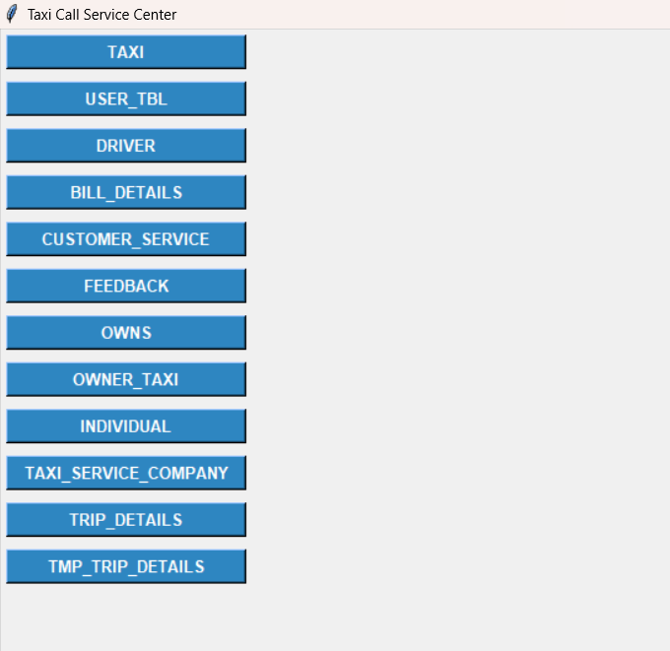

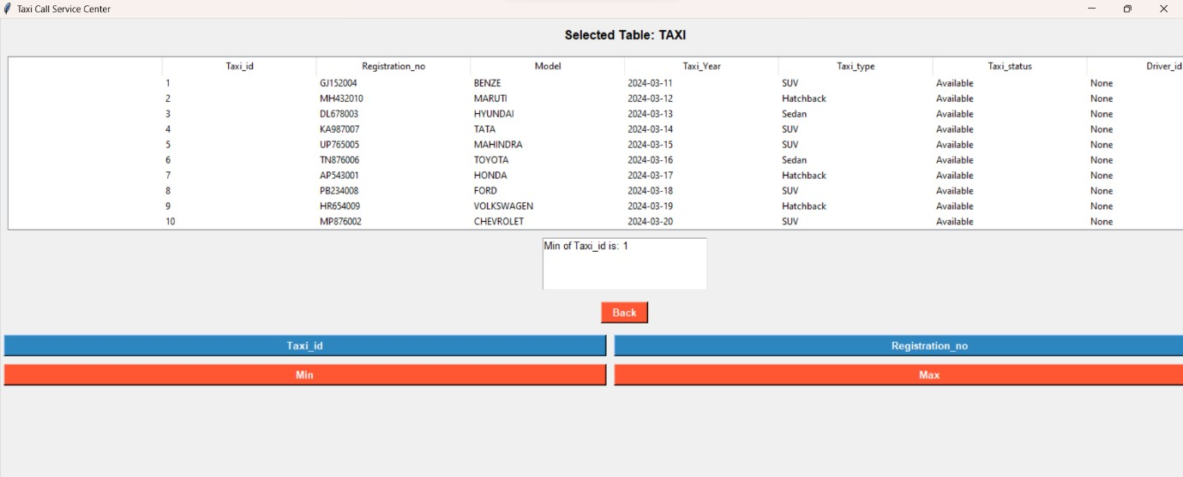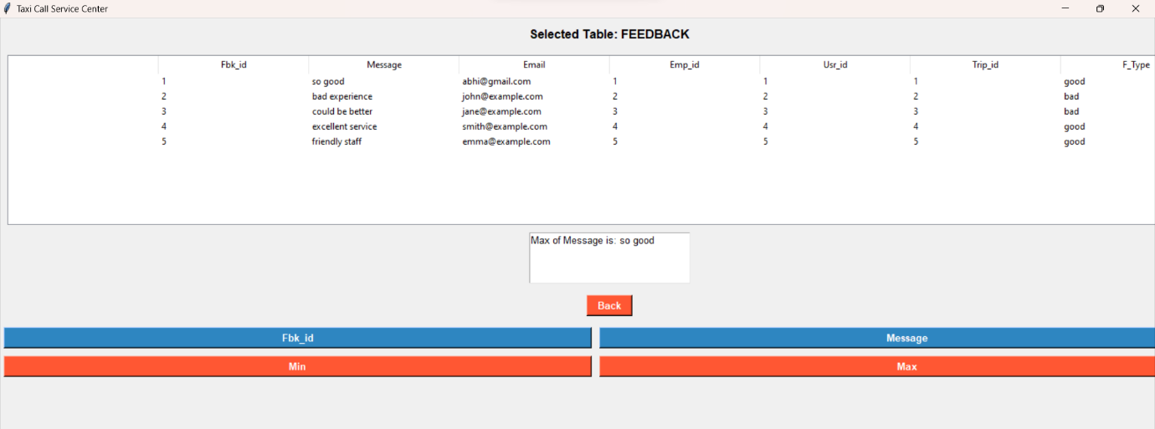

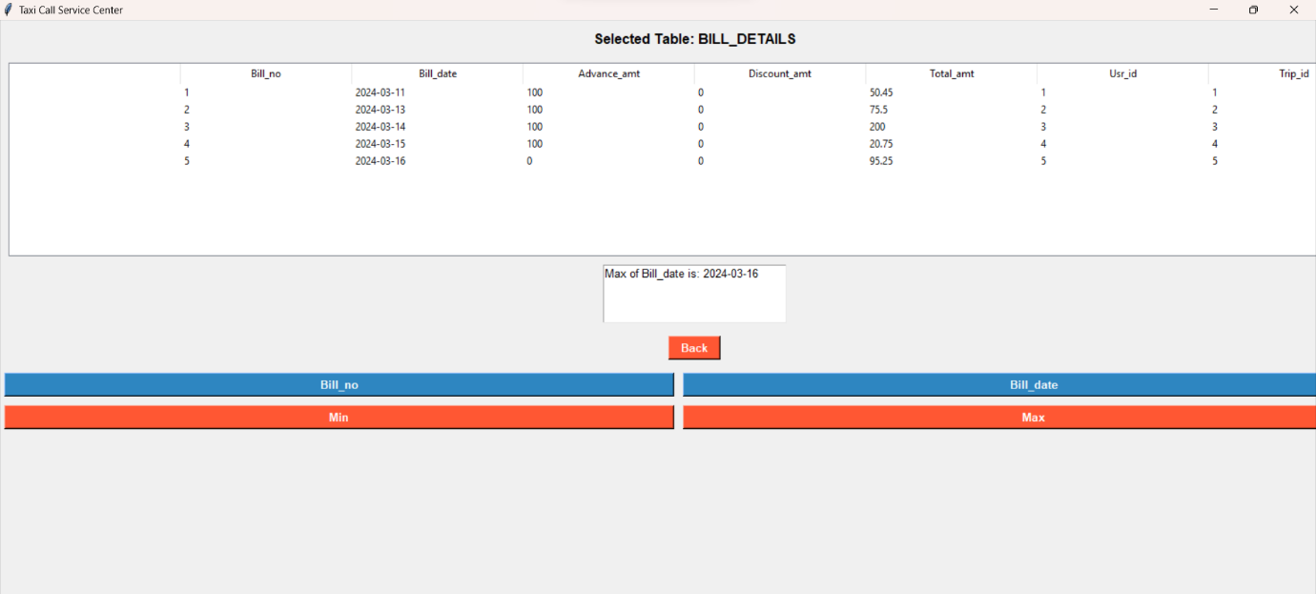

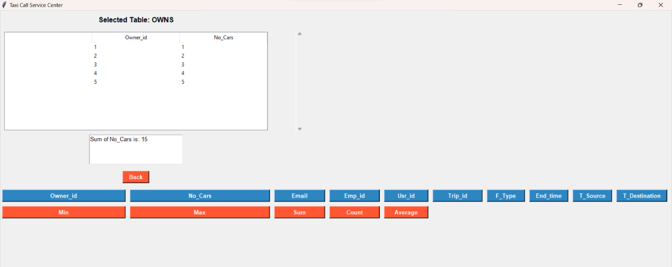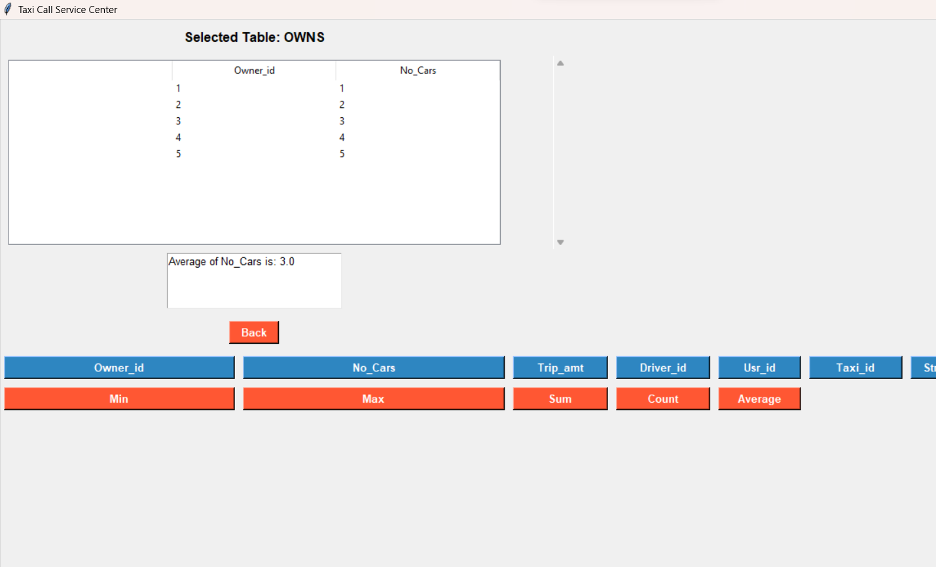

**Conclusion:**

The City Taxi Call Center DBMS project is a crucial step towards modernizing operations and improving overall efficiency. By embracing this technology, the call center aims to offer a seamless experience for both customers and drivers, ultimately establishing itself as a leader in the city's transportation services.