**COMPANY PROFILE**

***Nuwan Constructions***

***130/1 S. De. S. Jayasingha***

***Mawatha,***

***Nugegoda.***

*Tel: 0112-811244*

*Mobile: (+94)777-907545, (+94)778-837676*

*Email: nuwanconstructions2015@gmail.com*

**NUWAN CONSTRUCTIONS**

***OUR VISION***

*To achieve the status of a recognized and reputed building contractor, thereby contributing to the advancement of the industry and also participate in the development of the country.*

***OUR MISION***

*To deliver quality building projects at a reasonable cost with the service of an inspired team while complying to due dates*

*To deliver quality building projects constructed in time and reasonable cost using the service of an inspired team.*

***INTRODUCTION***

*Our business commenced in 1987, under the name of NUWAN BUILDERS and have been active member of the construction field since then. And also during the year 2015 our organization was renamed as Nuwan Constructions.*

*The founding director of the organization has handed over his responsibilities to his next generation founders in year 2015, due to ill, which resulted the incorporation of Nuwan Constructions.*

*The history of our construction business commenced in 1987 and continued to flourish. The hallmark of our construction business is customer satisfaction with proper documentation, timely completion, quality workmanship and finishes…etc.*

*During the span of 29 years, in the field of trade we have won the heart and confidence of reputed charted architects and engineers, whom we have been working with, as well as the clients. We are now graded as M6/C7 contractors by CIDA & possess the working capacity of 60 labours and staff. We are proud to state that with our well experienced staff and workers, we have executed several projects such as multi storied buildings, luxury houses, interior work for houses and others, designing luxury houses and many other new building constructions for the state and private sector.*

**COMPANY DETAILS**

1. ***ORGANIZATIONAL INFORMATION***

*Registered Name Of Company - NUWAN CONSTRUCTIONS.*

*Nature of Business - Contractors for building and maintenance of houses, commercial buildings, Highways, irrigation, Water supply & sewerage, Bridges etc..*

*Registered Address - 130/1 S. De. S. Jayasingha*

*Mawatha, Kohuwala.*

*Telephone No - (+94)112-811244*

*Mobile Number - (+94)777-907545,*

*(+94)778-837676*

*Email - nuwanconstructions2015@gmail.com*

*Stores Address - 130/1 S. De. S. Jayasingha*

*Mawatha, Kohuwala.*

*Name and Designation of Key Personnel -*

***Name Designation Experience qualifications***

*1. W. D. E. Piyadasa Founder / Former Managing Director 40 Years’ Experience In*

*Building Constructions*

*Trade.*

*2. D. N. S. Withanage Managing Director 8 Years’ Experience In*

*Building Constructions*

*Trade.*

**COMPANY DETAILS**

1. ***ORGANIZATIONAL DETAILS***

*Registration No (Old) - W/ 32223*

*Date of Registration - 08-10-1987*

*Re – Registration No - W/ 203503*

*Date of Registration - 16-11-2015*

*State Capital - 10,000,000.00*

1. ***COMPANY GRADING***

*3.1 ICTAD Registration No (Old) - M/ 5203*

*CIDA Registration No - C/ 13963*

*3.2 Category of CIDA Registration -*

*(a) Building - C 7*

*(b) Highways - C 7*

*(c) Water Supply & Sewerage - C 7*

*(d) Bridge - C 7*

*(e) Irrigation & Drainage Canals - C 7*

*(f) Dredging & Reclamation - C 7*

**OUR RESOURCES**

1. ***PERSONNEL RESOURCES***
   1. ***KEY MANAGEMENT***

***Managing Directors*** *- D. N. S. Withanage*

*W. D. E. Piyadasa*

***Designation******Field Of Specialty***

***Accountant***

*S. W. Withanage - Bachelors of business*

*Addministration (Hons)*

*University of Colombo*

***4.2 CLERICAL STAFF***

*K. D. M. S. Jayasekara - 8 Years’ Experience*

*S. M. Gorakapitiya - 2 Years’ Experience*

**OUR RESOURCES**

***5.0 TECHNICAL PROFESSIONALS***

***Designation Field Of Specialty***

***Quantity Surveyors***

* *K. D. S. G. Jayasekara - B. Tech HND in Quantity Surveying &*

*Building Environment.*

*Diploma in AutoCAD.*

* *T. D. Rambukkanage - National Certificate in*

*Technology (N. C. T).*

***Drafts Person***

* *P. A. Kanchana Dilrukshi - National Vocational Qualification*

*(NVQ) Level 05 (Engineering*

*Draftsmanship).*

***Technical Staff***

* *K. D. S. G. Jayasekara - 4 Years of Experience in Building*

*Construction Field*

* *P. M. L. Wijegunawardana - 4 Years of Experience in Building*

*Construction Field*

**PROJECTS**

1. ***FEW PROJECTS COMPLETED DURING LAST YEARS***

***PROJECTS CONSULTANT CLIENT***

*Residential Bungalow Denis R. Saunders Associates Miss. M. Fernando*

*Bryde Place*

*Residential Bungalow Denis R. Saunders Associates Dr. Vidyasagara*

*Ramya Road*

*Residential Bungalow Denis R. Saunders Associates Mr. Arther Fernandes*

*Pallidora Road,*

*Dehiwala*

*Residential Bungalow Denis R. Saunders Associates Dr. Vidyasagara*

*Ramya Road*

*Three Storied Building Denis R. Saunders Associates Mr. Wasula*

*Wijaya Kumarathunga Wijegunawaradana*

*MAwatha, Colombo 05*

*Three Storied Building S. K. S. Wickramasiri S. W. Withanage*

*Kottawa, Pannipitiya*

*Two storied building S. K. S. Wickramasiri D. N. S. Withanage*

*Kottawa, Pannipitiya*

**PROJECTS**

***PROJECTS CONSULTANT CLIENT***

*Type ‘F’ Building with N. S. Geethanjan Sri Lanka Telecom*

*Supporting Structures Ltd.*

*Govinna*

*Type ‘F’ Building with N. S. Geethanjan Sri Lanka Telecom*

*Supporting Structures Ltd.*

*Moragahahena*

*Type ‘F’ Building with N. S. Geethanjan Sri Lanka Telecom*

*Supporting Structures Ltd.*

*Millaniya*

*Proposed Municipal Eng. Shahina Anver Colombo Municipal*

*Quarters Slave Island Council*

*Three storied Mr. Samaranayake*

*Office building at*

*Kalubowila*

*Three Storied Building W. D. E. Piyadasa*

*At Kohuwala*

**PROJECTS**

***PROJECTS CONSULTANT CLIENT***

*Luxury House Bandusena Associates Mr. L. W. Silva*

*At Flower Road, (PVT) Ltd.*

*Colombo 07*

*Residential Bungalow Denis R. Saunders Associates Mr. D. D. D. Silvedurei*

*At Thalakotuwa Road,*

*Colombo 05*

*Residential Bungalow Thurairajah Associates Mr. T. B. Ilangarathne*

*At Highlevel Road,*

*Colombo 06*

*Proposed Bungalow Denis R. Saunders Associates Dr. Shanthi*

*At Epitamulla Road, Paranawithana*

*Kotte.*

*Recidential Bungalow Denis R. Saunders Associates Mr. P. Vijendran*

*At Ramya Road,*

*Colombo 05*

*Luxury House Denis R. Saunders Associates Mr. Pandu*

*At Angampitiya Road, Bandaranayake*

*Kotte*

*Luxuary House Denis R. Saunders Associates Mr. A. Gunawardana*

*At Angampitiya Road,*

*Kotte*

**PROJECTS**

***PROJECTS CONSULTANT CLIENT***

*Luxury House NCD Consultants Mr. M. Uvaiz*

*At Bandaranayake*

*Mawatha, Colombo 12*

*Luxury House Mihindu Keerthiratne Dr. B. K. Nawinna*

*At Guilford, Crescent, Associates*

*Colombo 07*

*Luxury House Mihindu Keerthirathne Mr. N. Wimalasena*

*At Kirulapone Associates*

*Luxury House Denis R. Saunders Associates Mr. R. Abdeen*

*At Thimbirigasyaya*

*Road, Colombo 05*

*Luxury House Design Studio Mr. Ravi Wicramasinghe*

*At Thalakotuwa*

*Gardens, Colombo 05*

*Luxury House NCD Consultants Mr. M. Y. M. Refai*

*At Union Place,*

*Colombo 02*

*Residential Bungalow DCL Group Mr. L. M. Somarathne*

*At Balika Niwasa Road,*

*Rukmale, Pannipitiya*

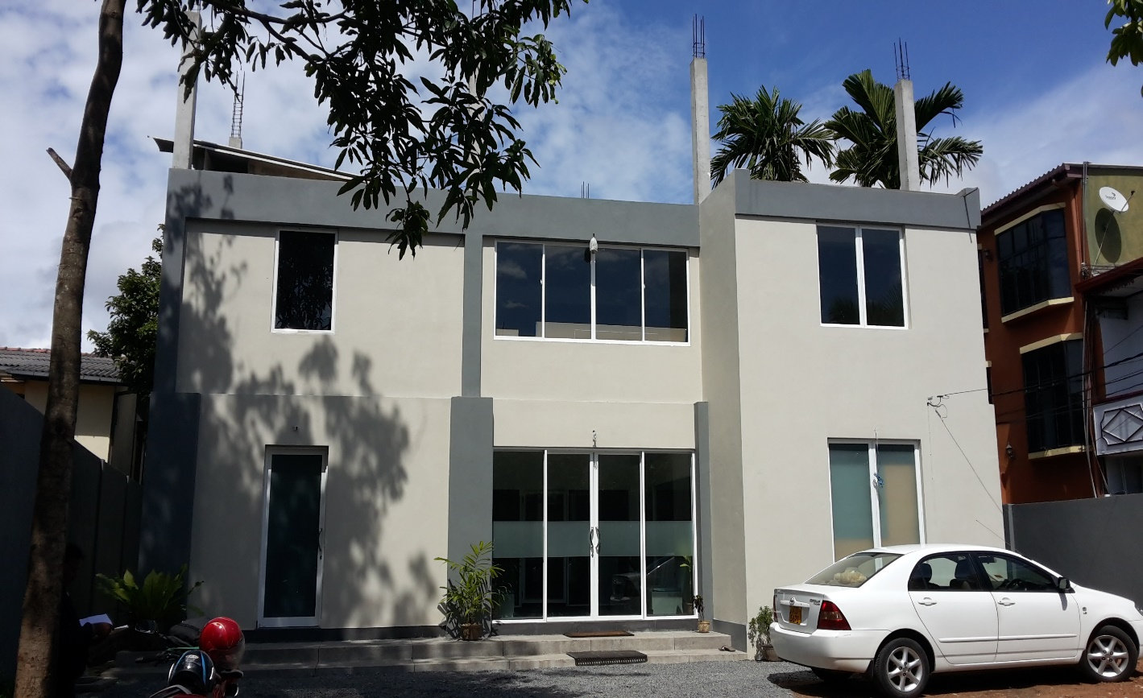

**Project - Office Building**

**At Kalubowila**

*CLIENT – MR. & MRS. SAMARANAYAKE*

**Description of the Building**

*Three Storied Building*

*Floor Area – 4500 SQ. FT*

*Project Cost – RS. 19,600,000.00*

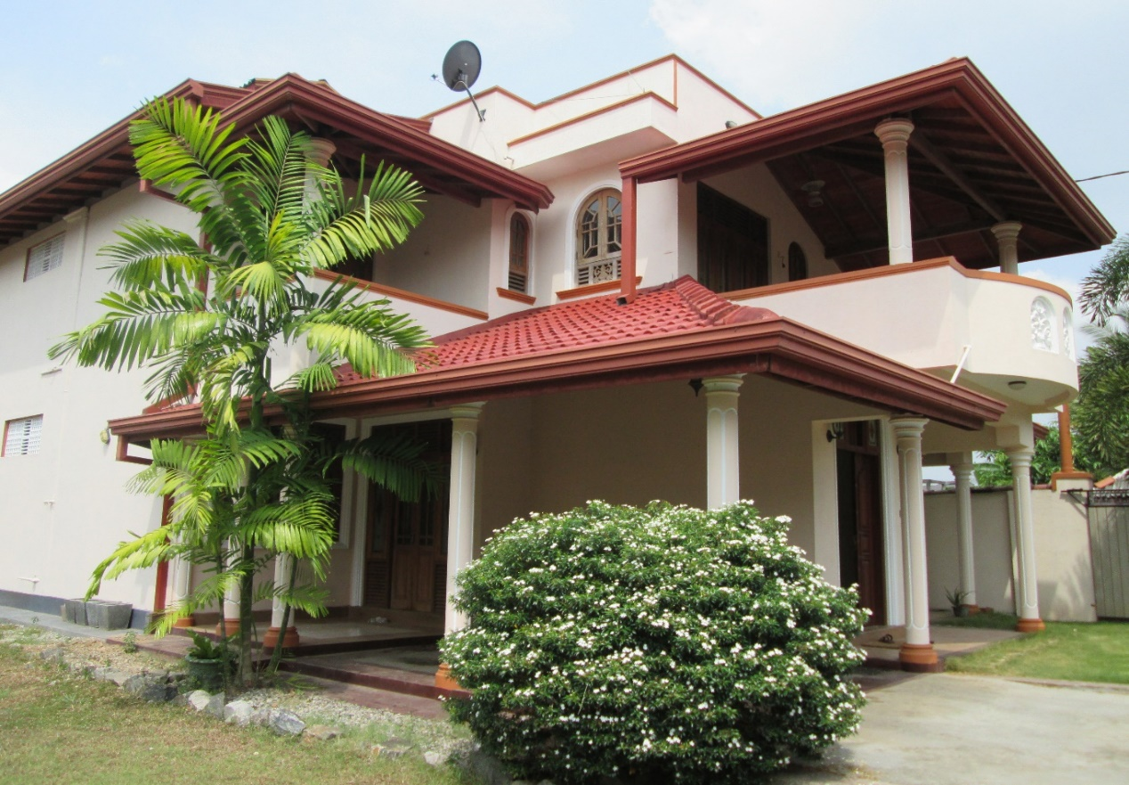

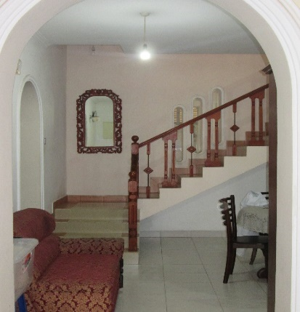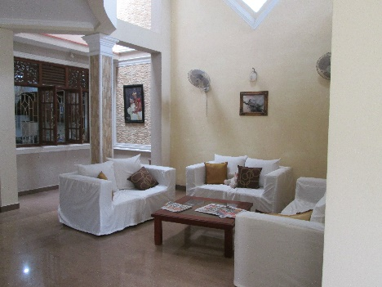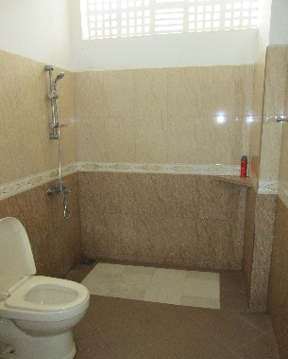  
**Project - Residence Building**

**At Kottawa**

*CLIENT* – S. W. WITHANAGE

**Description of the Building**

*Three Storied Building*

*Floor Area – 3000 SQ. FT*

*Project Cost – RS. 15,000,000.00*

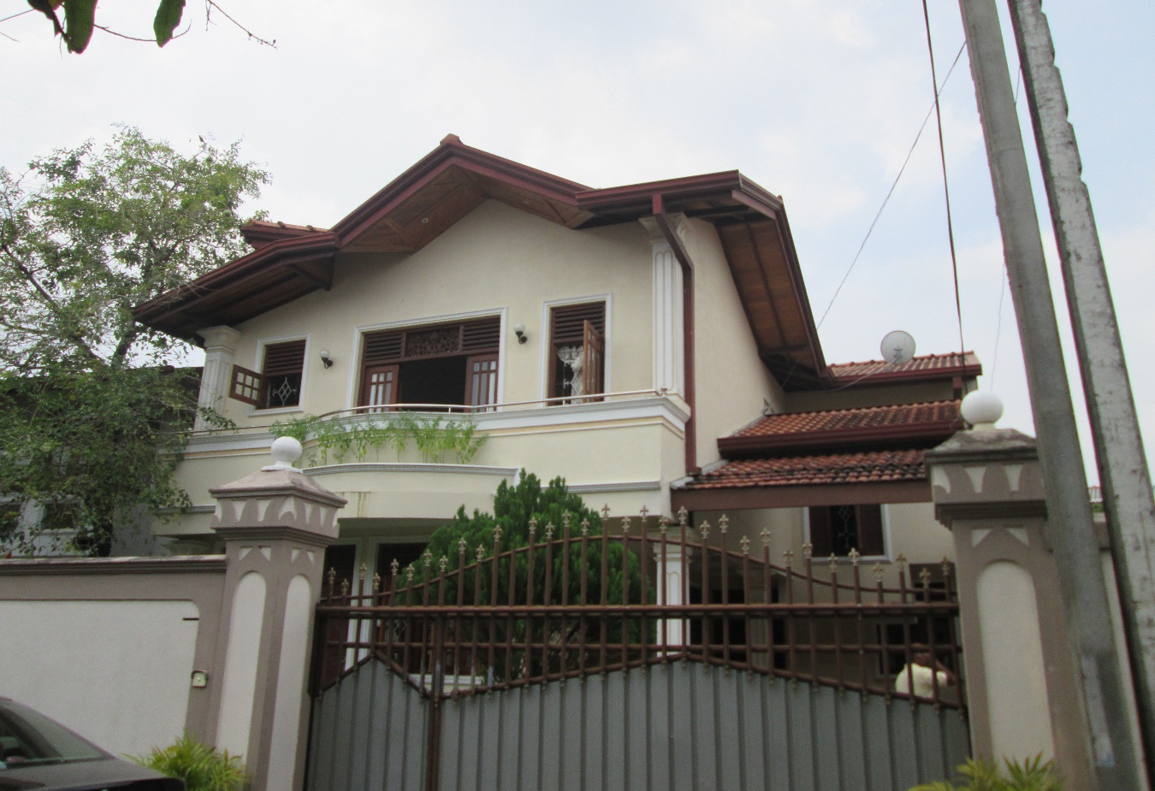

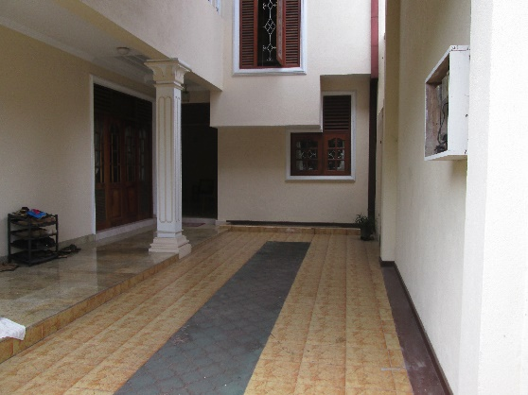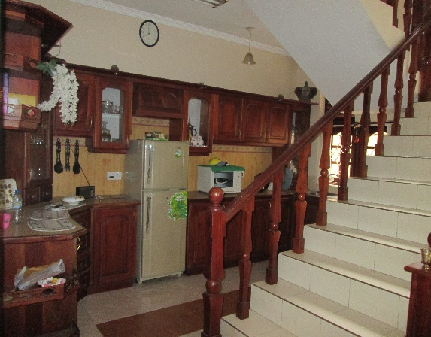

**Project - Residence Building**

**At Kottawa**

*CLIENT – D. N. S. WITHANAGE*

**Description of the Building**

*Two Storied Building*

*Floor Area – 2995 SQ. FT*

*Project Cost – RS. 9,800,000.00*

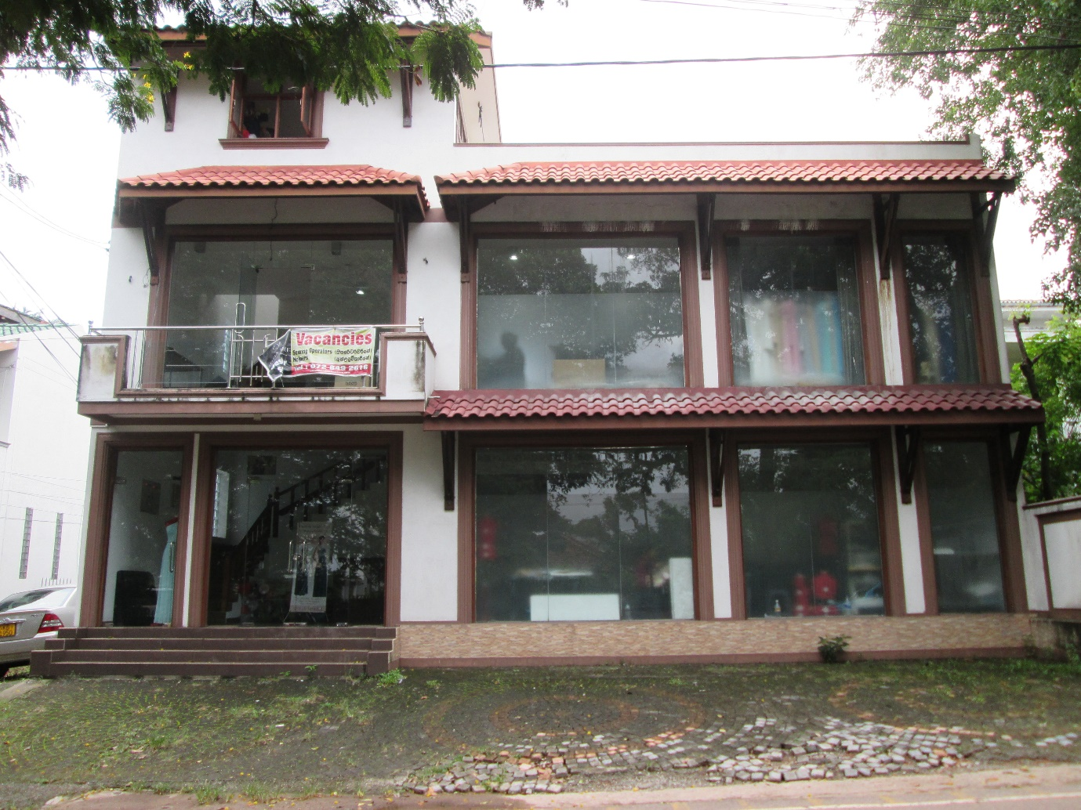

**PROJECT - COMMERCIAL BUILDING**

**AT CHAPEL ROAD**

CLIENT – DR. SHANTHI PARANAWITHANA

**Description of the Building**

*Two Storied Building*

*Floor Area – 2700 SQ. FT*

*Project Cost – RS. 13,700,000.00*

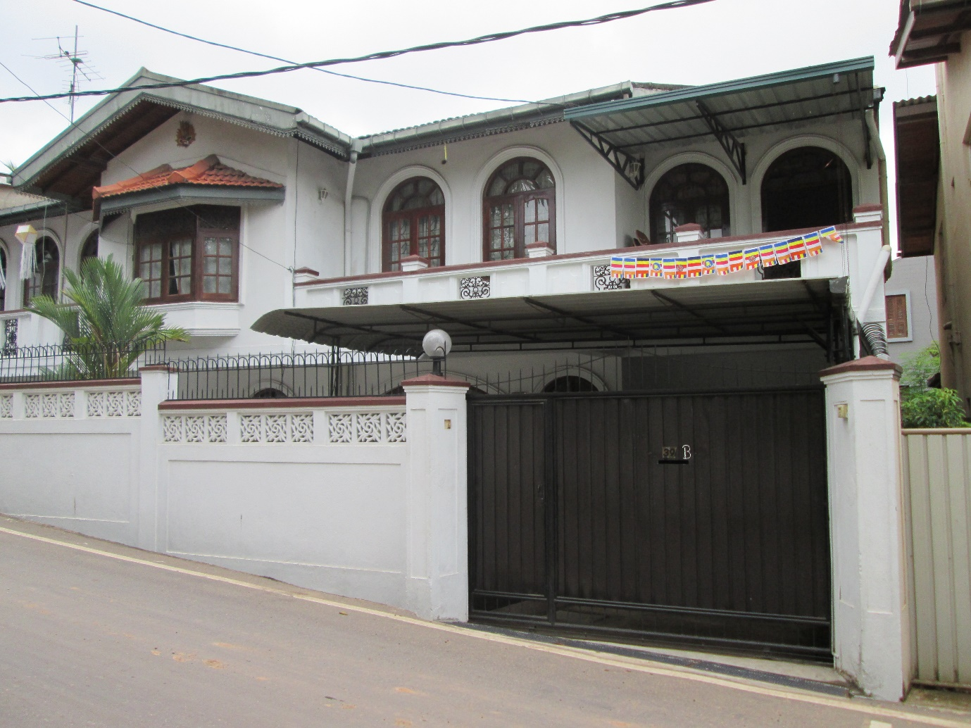

**PROJECT - RESIDENCE BUILDING**

**AT KOTTE**

CLIENT – MR. PANDU BANDARANAYAKE

**Description of the Building**

*Two Storied Building*

*Floor Area –2550 SQ. FT*

*Project Cost – RS. 5,300,000.00*

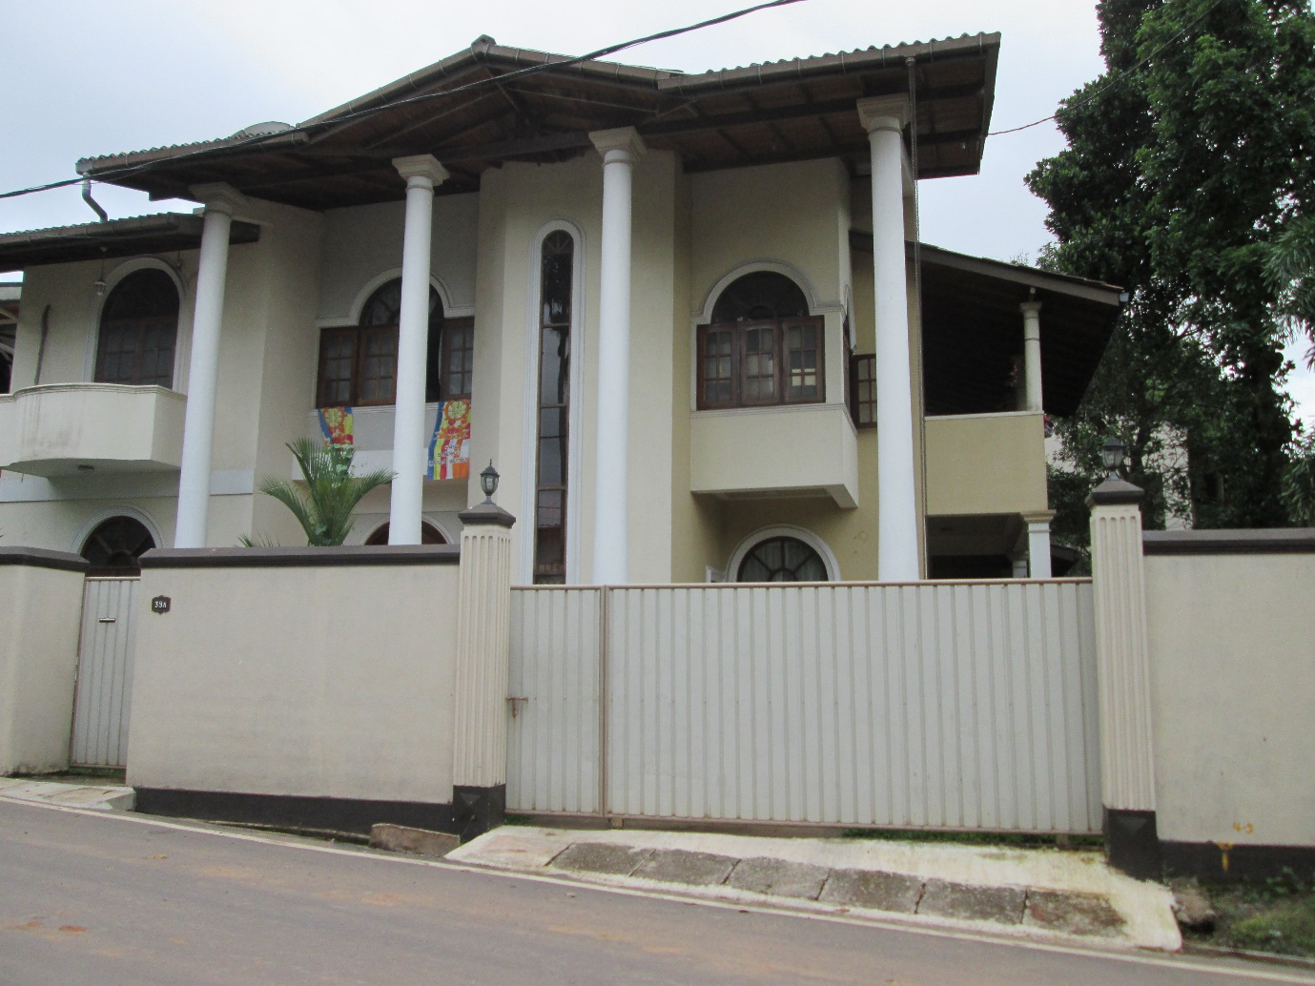

**PROJECT - RESIDENCE BUILDING**

**AT KOTTE**

CLIENT – MR. A. GUNAWARADANA

**Description of the Building**

*Two Storied Building*

*Floor Area –2765 SQ. FT*

*Project Cost – RS. 5,600,000.00*

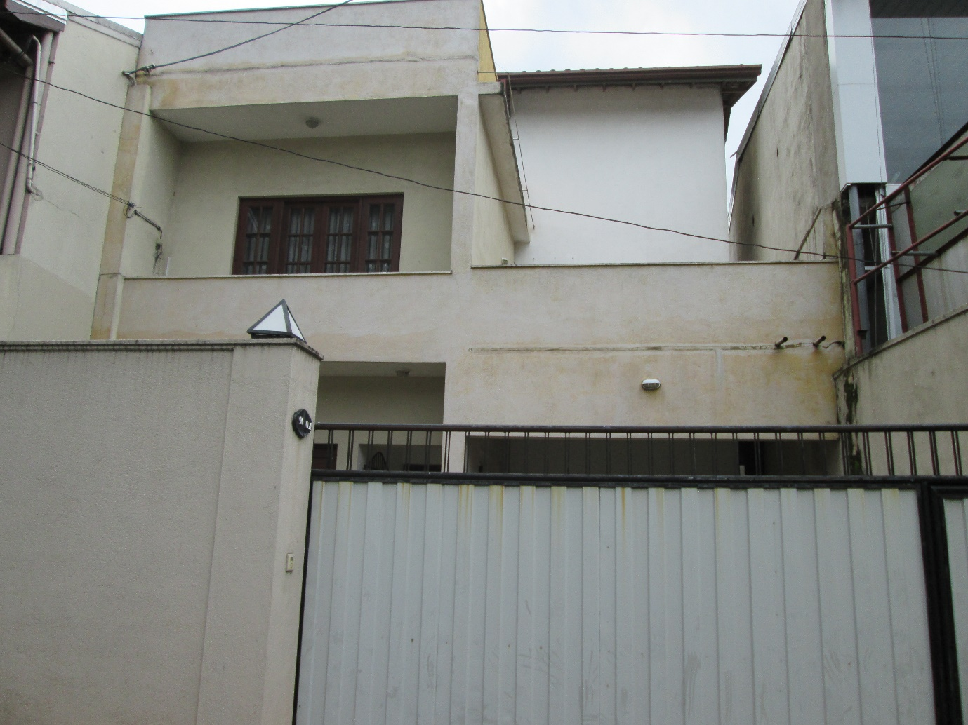

**PROJECT - RESIDENCE BUILDING**

**AT KIRULAPANA**

CLIENT – MR. N. WIMALASENA

**Description of the Building**

*Two Storied Building*

*Floor Area –2300 SQ. FT*

*Project Cost – RS. 5,000,000.00*

**PROJECTS**

1. ***WORK IN HAND***

***PROJECTS CONSULTANT CLIENT***

*Proposed Renovation CECB National Health*

*Work At Kaluthara Science*

*Nagoda*

*Proposed Three Storied Kesar Design Associates Mr. Rajapaksha*

*House at Pepiliyana*

**COMPANY ASSETS**

1. ***PLANT & EQUIPMENT***

* *Baro Mixture 7.5 With Lister Desel Engine Concrete Mixture*
* *Bridges & Stration Vibrator*
* *Robin Poker Vibrator*
* *Kubota Water Pump*
* *Cervo 555w Drill Machine*
* *Stanlis Drill Machine*
* *Makita Sanding Machine*
* *Makita Hand drill*
* *Makita Screw Drivers*
* *Steel Jacks*
* *Scaffoldings*
* *Hammer Drills*

1. ***VEHICLES***

* *Nissan Double Cab - PA – 7263*
* *Mahendra Supro Lorry - DAD – 1148*
* *Mitsubishi Canter Lorry - LH - 9131*
* *Honda Fitaria - KL - 4687*

**CONTACT REFEREES**

1. ***REFEREES***
2. Mr. G. D. Chandana Fernando

Director Architectural

NCD Consultants

70A, Melders Place,

Nugegoda.

1. Mr. D. B. S. K. Disanayake

Deputy Director (Planning)

Urban Development Authority

North Central Province Office,

Stage 2 New Bus Stand,

Anuradhapura.