EngX

Epam culture-

Humble Hungry Smart

------------

Fearless Innovation

Innovation Enabler – Batch award – 1 month salary

Team player – Ownership

---------------

Introduction

1.Module Intro

Agile Fundamentals-

**Agile** is a value-driven approach to developing solutions. It is focused on people, adaptability, and providing maximum value to customers.

Elements of Agile development-

1.Agile mindset

-put customer first

- trust In team

- emphasize experimentation

2. Agile values –

1. **Individuals and interactions** over processes and tools.
2. **Working software** over comprehensive documentation.
3. **Customer collaboration** over contract negotiation.
4. **Responding to change** over following a plan.

3.Agile principles-

12 principles – Deliver working software

-Agile scrum- Sprint planning , sprint review, Sprint retrospective

**Best Practices for Agile**

* Create and maintain a product backlog that is used as a single source for your tasks.
* Update and prioritize a backlog regularly with the team.
* Create a business roadmap aligned with the product backlog.
* Have regular sprint reviews.
* A Product Owner provides detailed positive or negative feedback on regular sprint reviews.
* Reprioritize a backlog based on the feedback from PO and stakeholders during regular demo/review sessions.
* Involve the whole team in the decision negotiations.

The EngX culture-

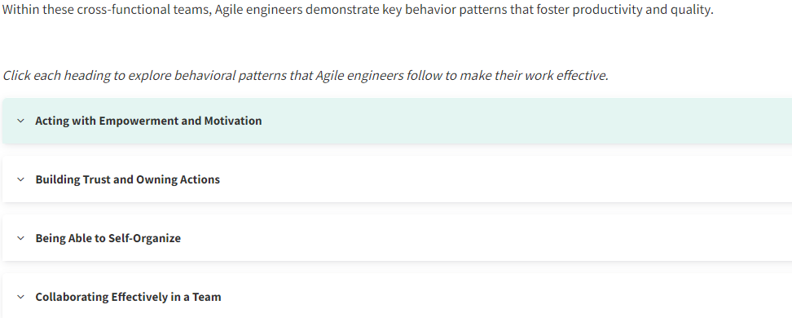

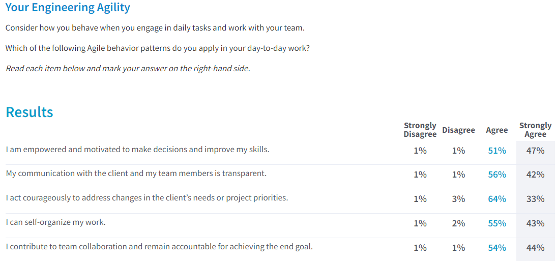

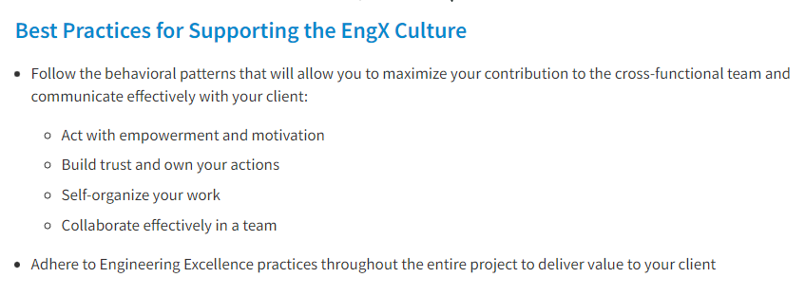

Eng practices in Agile driven sw development=

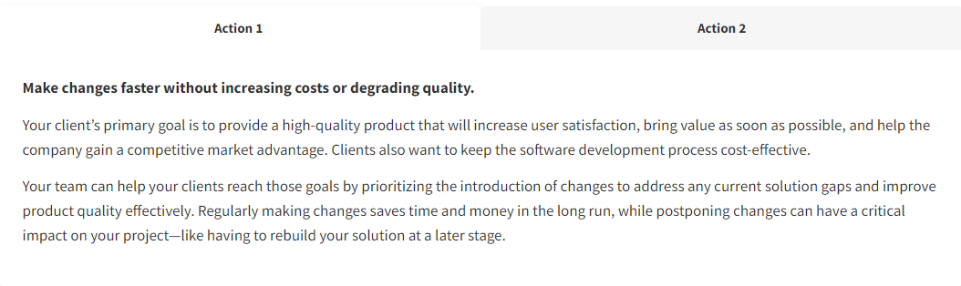

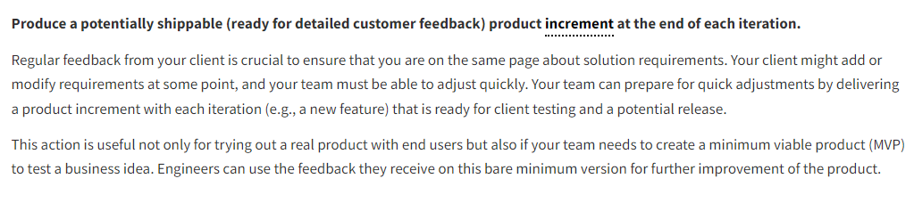

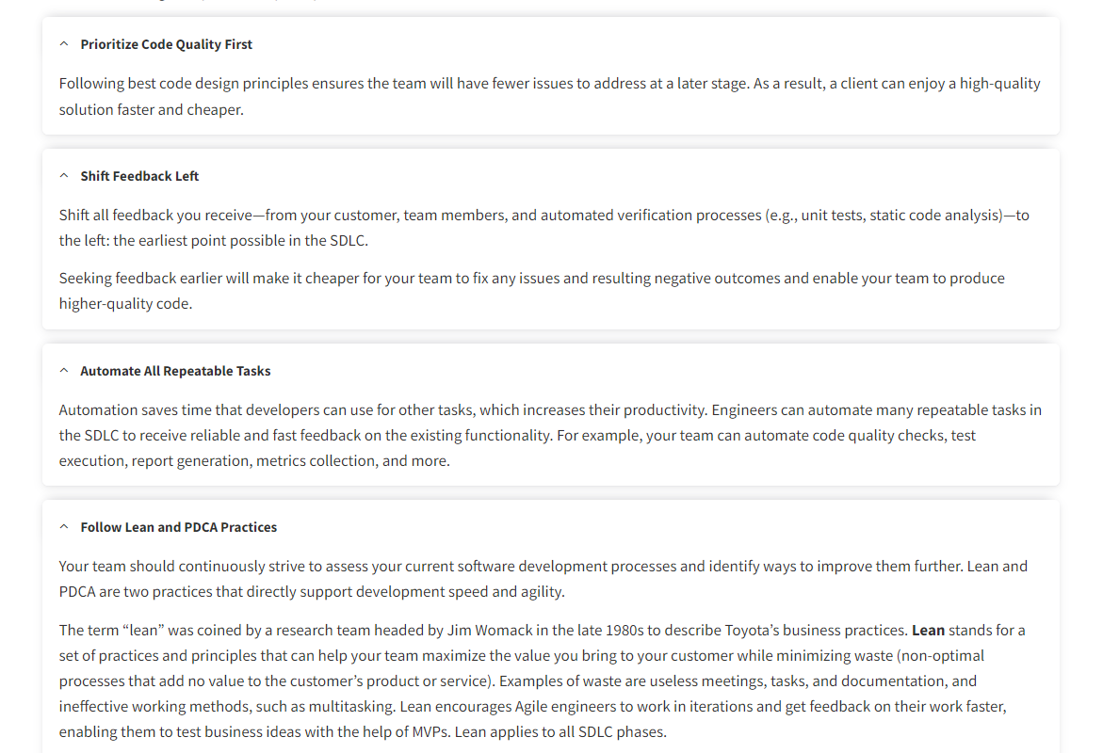

Striving for eng excellence:The foundation of EngX

2.Development

3.Quality Assurance

4.Systems engineering

5. Secure SDLC

6.Complete the course