**Project Title: Media Streaming with IBM Cloud Video Streaming  
Phase 4: Documentation**

**Project Objective:**

The project's main objective is to develop a media streaming web application that emulates popular platforms like YouTube, Amazon Prime, and Hotstar. This application is designed to provide users with on-demand video streaming and create an immersive and seamless movie-watching experience. Key project objectives include:

1. **User Registration**: Implement a secure user registration system to allow users to create accounts and access the platform.
2. **Video Upload**: Enable users to upload their videos to the platform, which will be stored in IBM Cloud Object Storage.
3. **Smooth Video Streaming**: Integrate IBM Cloud Video Streaming services to ensure the smooth and high-quality playback of videos.
4. **User Interaction**: Implement real-time chat functionality to allow users to interact while watching videos, fostering a social experience.
5. **Content Categorization**: Categorize videos by language and genre, making it easier for users to discover and choose videos to watch.
6. **User-Generated Playlists**: Allow users to create their playlists for a personalized viewing experience.

**Design Thinking Process:**

The project follows a design thinking process that encompasses the following phases:

**1. Platform Definition:**

* Define the core features and functionalities of the virtual cinema platform.
* Features include user registration, video upload, video playback, and chat functionality.

**2. User Interface Design:**

* Create an intuitive and user-friendly interface that promotes easy navigation and video selection.

**3. Video Upload:**

* Implement a video upload system that enables users to add their videos to the platform.

**4. Streaming Integration:**

* Integrate IBM Cloud Video Streaming services to ensure a seamless and high-quality video playback experience.

**5. User Experience:**

* Focus on creating a seamless and immersive movie-watching experience through responsive design and real-time interaction.

**Development Phases:**

The project is divided into several development phases to achieve the outlined objectives:

**Phase 1: Problem Definition and Design Thinking**

* Define the project's problem statement and establish a design thinking framework for the virtual cinema platform.

**Phase 2: Innovation**

* Explore innovative features like user-generated playlists and real-time chat to enhance the movie-watching experience.

**Phase 3: Development Part 1**

* Develop essential components, including user registration, user interface design, and the home page.

**Phase 4: Development Part 2**

* Continue development by creating the video upload page and video player page, which includes the real-time chat functionality.

**Platform's Features:**

1. **User Registration:** Users can create accounts, providing their credentials for secure access to the platform. Registration includes username, password, and email address.
2. **Video Upload:** Users can upload their videos to the platform. This process involves selecting a video file from their local storage, giving it a name, specifying the video format, and then initiating the upload.
3. **Smooth Video Streaming:** The platform integrates IBM Cloud Video Streaming services to ensure high-quality video playback. This means videos are streamed efficiently, with minimal buffering, and offer a smooth viewing experience.
4. **User Interaction:** Real-time chat functionality is available while watching videos. Users can engage in conversations with each other, creating a social and interactive experience similar to watching movies with friends.
5. **Content Categorization:** Videos are categorized by language and genre. This allows users to easily filter and discover content that matches their preferences, enhancing their viewing experience.
6. **User-Generated Playlists:** Users have the ability to create and manage playlists. This feature allows for personalized curation of videos for an individualized viewing experience.

**User Interface Design:**

The user interface is designed to be intuitive and user-friendly, promoting easy navigation and video selection. Key design elements include:

* **Login Page:** A login page that allows users to securely access their accounts.
* **Home Page:** The central hub of the application featuring video thumbnails stored in IBM Cloud Object Storage. The home page includes two drawers on the left and right side. The left-side drawer allows users to filter videos by language and genre. The right-side drawer provides access to account management, platform information, support, and contact options.
* **Video Thumbnails:** Thumbnail images of videos are displayed on the home page. Clicking on a thumbnail redirect’s users to the video player page.
* **Video Player Page:** This page displays the selected video and includes a live chat box for real-time interaction. The user can also access additional options, such as uploading a video and creating user-generated playlists.

**Video Upload Process:**

The video upload process involves the following steps:

1. Users click the "Upload" button from the video player page.
2. Users are prompted to select a video file from their local storage.
3. After selecting the video, they provide a name for the video.
4. Users specify the video format or other relevant details.
5. Finally, they click the "Upload" button to initiate the upload process.

The uploaded video is then stored in IBM Cloud Object Storage, making it accessible for other users on the platform.

**Streaming Integration:**

IBM Cloud Video Streaming services are integrated into the platform to ensure smooth video playback. This includes:

* Efficient streaming: Videos are delivered with minimal buffering and latency, providing a seamless viewing experience.
* High-quality playback: Users can enjoy videos in high resolution, contributing to an immersive movie-watching experience.
* Reliability: IBM Cloud Video Streaming services offer a robust infrastructure to ensure consistent and reliable video streaming.

The integration of these services enhances the overall user experience, making it easy for users to watch videos without interruptions and enjoy high-quality content.

**Enhancing the Movie-Watching Experience: A Seamless and Immersive Journey**

The platform is designed to provide a seamless and immersive movie-watching experience by incorporating various features and elements that enhance the user's interaction with the content and the platform itself. Here's how the platform achieves a seamless and immersive movie-watching experience:

**1. High-Quality Video Playback:**

* The integration of IBM Cloud Video Streaming services ensures high-quality video playback.
* Users can enjoy videos in high resolution, contributing to a visually immersive experience.
* Smooth and efficient streaming minimizes buffering and latency, providing uninterrupted viewing.

**2. Real-Time Chat Functionality:**

* The inclusion of a real-time chat box on the video player page allows users to interact while watching videos.
* Users can engage in conversations, share reactions, and discuss the content in real-time, simulating the social experience of watching movies with friends and family.
* Real-time chat adds an interactive layer to the movie-watching experience, making it more engaging and immersive.

**3. Content Categorization:**

* Videos are categorized by language and genre, making it easy for users to discover content that aligns with their preferences.
* Users can filter and explore a wide range of videos, narrowing down their choices to find the content they enjoy the most.
* This categorization enhances the user's ability to find and watch movies and videos that cater to their specific tastes.

**4. User-Generated Playlists:**

* Users have the option to create and manage their playlists, adding videos of their choice.
* This feature allows for a personalized viewing experience, enabling users to curate their movie-watching sessions.
* Users can create thematic playlists, organize their favorite content, and have a customized movie night.

**5. Responsive User Interface:**

* The user interface is designed to be intuitive and user-friendly.
* Easy navigation and user-friendly design elements help users find and select videos effortlessly.
* The platform's responsive design ensures that users can access and enjoy content from various devices, further contributing to a seamless experience.

**6. Easy Video Upload Process:**

* The platform allows users to upload their videos to expand the content library.
* The video upload process is straightforward and user-friendly, making it easy for content creators to contribute to the platform.
* A diverse and growing content library enhances the options available for users to choose from.

**7. Interaction and Engagement:**

* The combination of real-time chat, user-generated playlists, and content categorization fosters interaction and engagement among users.
* Users can chat, share recommendations, and collaboratively create playlists, creating a sense of community and involvement.

**My project Images:**

**Login page:** A login page that allows users to securely access their accounts.  
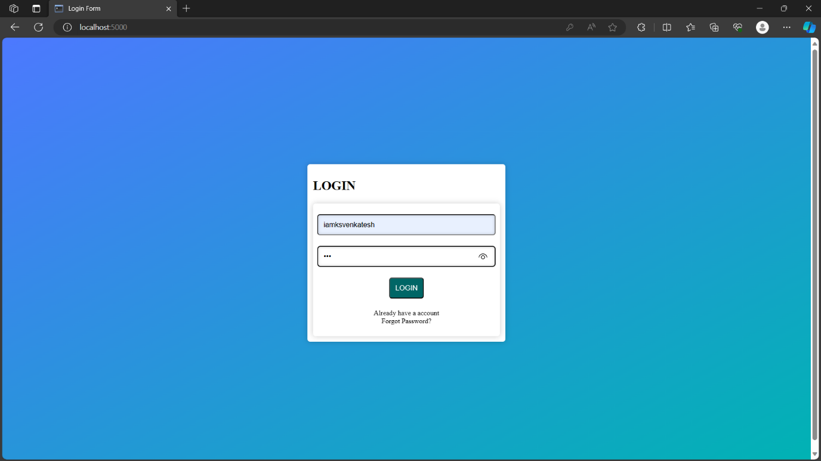

**Home Page:** The central hub of the application featuring video thumbnails stored in IBM Cloud Object Storage. The home page includes two drawers on the left and right side. The left-side drawer allows users to filter videos by language and genre. The right-side drawer provides access to account management, platform information, support, and contact options.

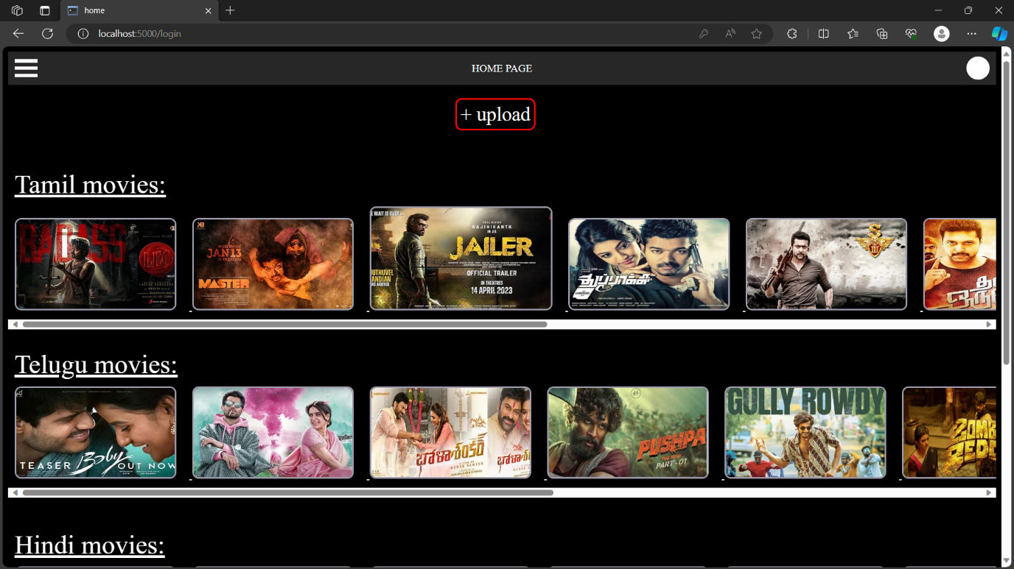

**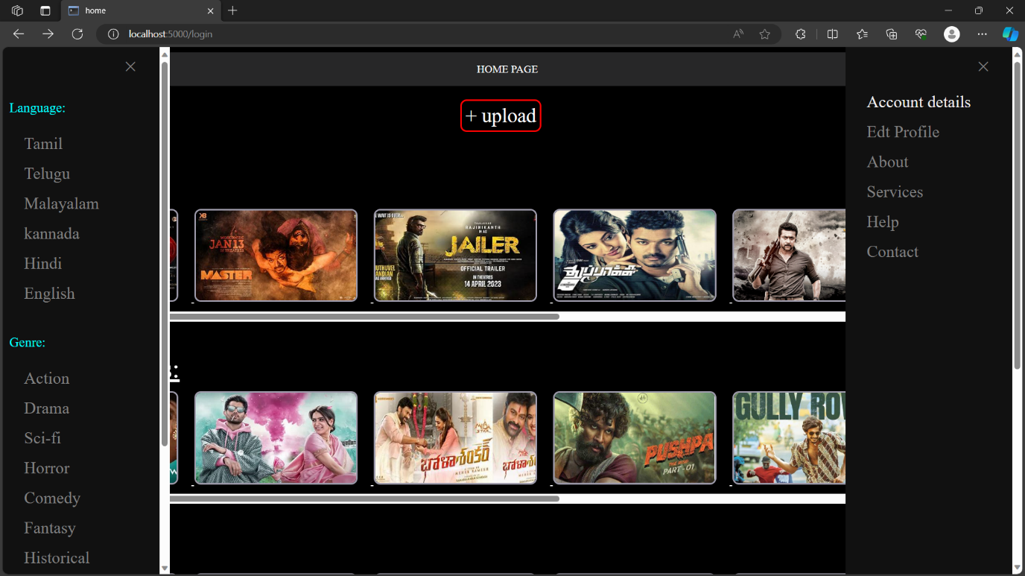  
Video Upload Page:**

* The video upload process involves the following steps:
* Users click the "Upload" button from the video player page.
* Users are prompted to select a video file from their local storage.
* After selecting the video, they provide a name for the video.
* Users specify the video format or other relevant details.
* Finally, they click the "Upload" button to initiate the upload process.

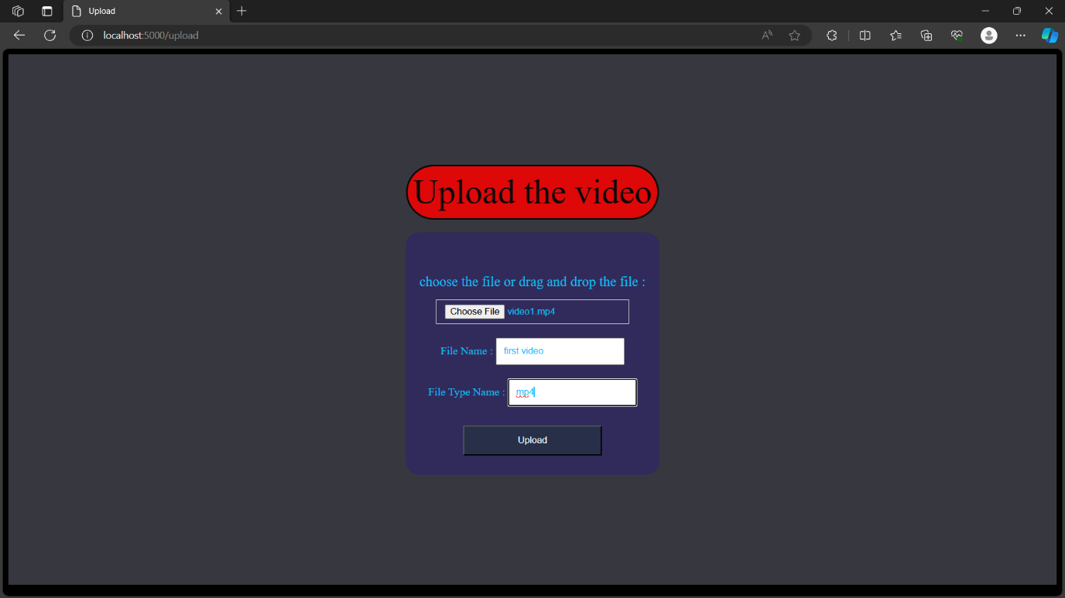

**Video player page and its below contains the chat box:** the video player page is open when the user click on the thumbnails that showing in home page then user redirected to the video player page then the corresponding video will be play an automatically

Below the video the chat box is available: the multiple users are may be watching at the same time then that user can chat to another user

