EX.NO:1a WINDOWS FOUNDATIONS DATE:05/02/2025

NAME: M.A.MADHESH

ROLL.NO:231901029

AIM:

Windows Foundations module ,Learning about the windows desktop,NTFs file system ,UAC,the control pannel and many in tryhackme plateform.

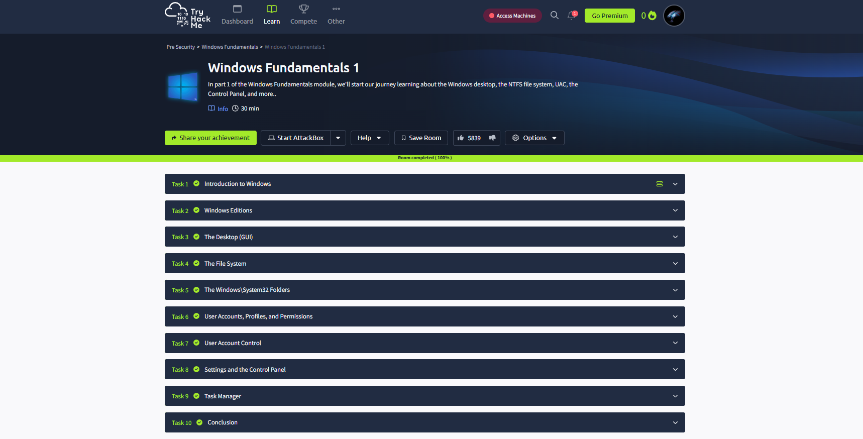

Task 02: Windows Edition.

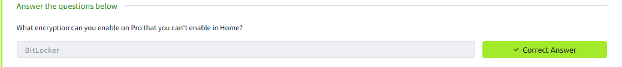

Task 03: The Desktop (GUI)

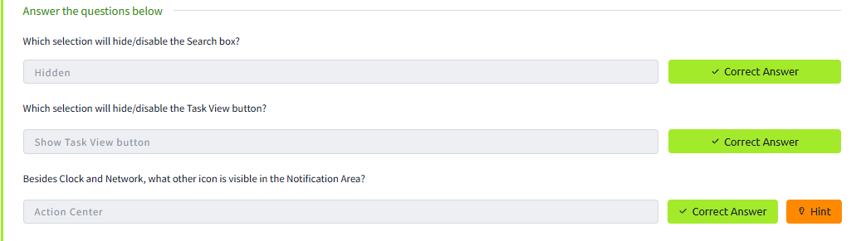

Task 04: The File System

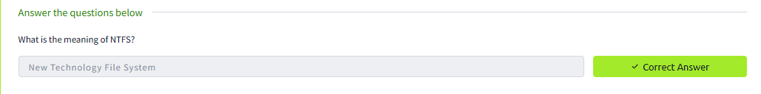

Task 05: The Windows/System32 Folders

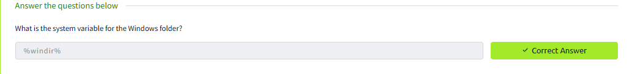

Task 06: User Account, Profiles, and Permissions

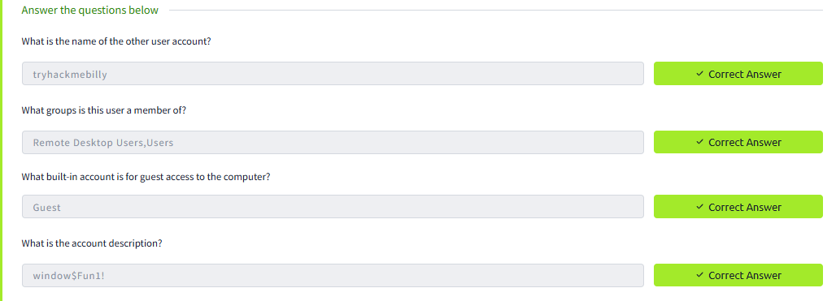

Task 07: User account Control

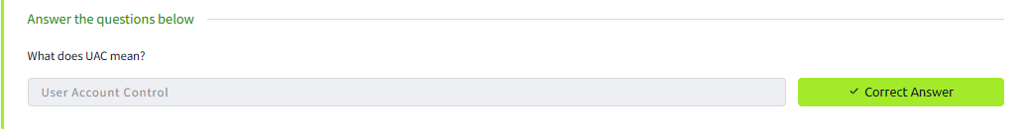

Task 08: Setting and the control Panel

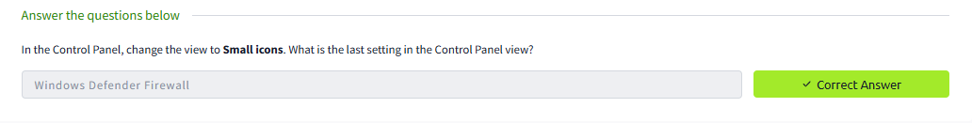

Task 09: Task Manager

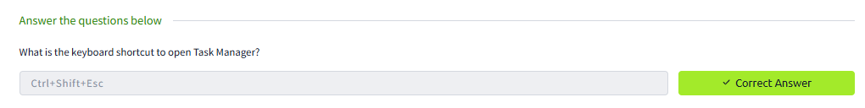

Conclusion:

Hence the Windows Foundations 1 in tryhackme platform is been completed successfully..