EX.NO:1b WINDOWS FOUNDATIONS DATE:05/02/2025

NAME: M.A.MADHESH

ROLL.NO:231901029

AIM:

Windows foundations, Discover more about the GAC settings ,Resource monitoring, Registry Editor.

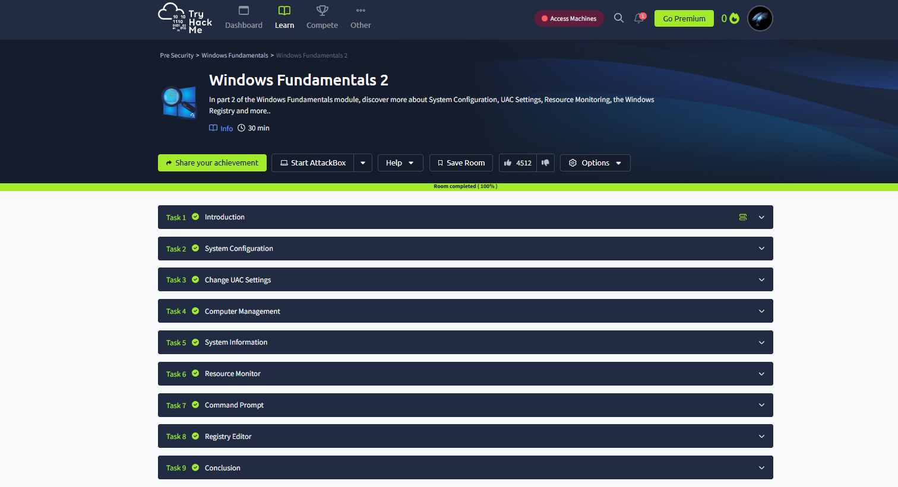

Task 02: System Configuration.

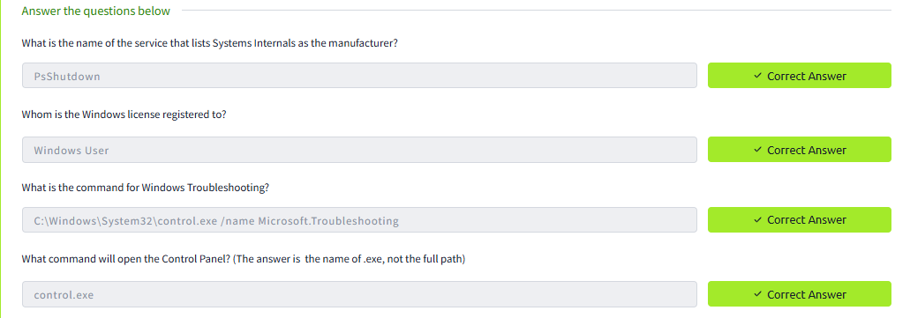

Task 03: Change UAC Settings.

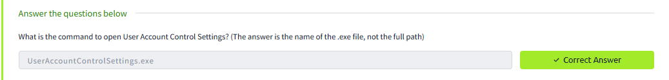

Task 04: Computer Management.

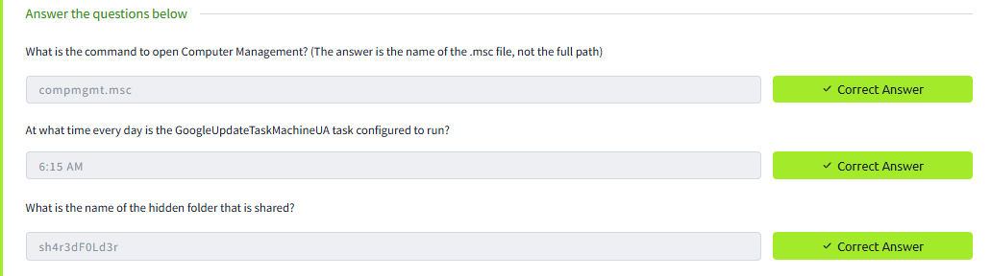

Task 05: System Information

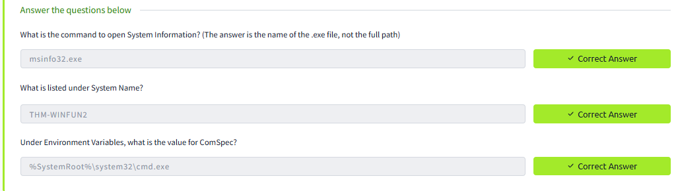

Task 06: Resource Monitor

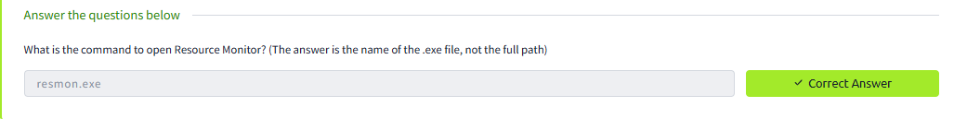

Task 07: Command Prompt

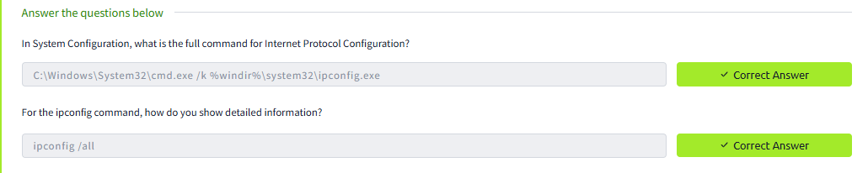

Task 08: Registry Editor

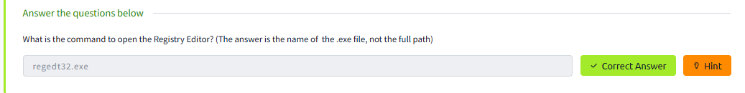

Conclusion:

Hence the Windows Foundations 2 in tryhackme platform is been completed successfully..