EX.NO:1c WINDOWS FOUNDATIONS DATE:05/02/2025

NAME: M.A.MADHESH

ROLL.NO:231901029

AIM:  
 Windows Fundamentals module ,learn about the Microsoft tools that help keep the device secure, such as windows update, Security, BitLocker ,and more 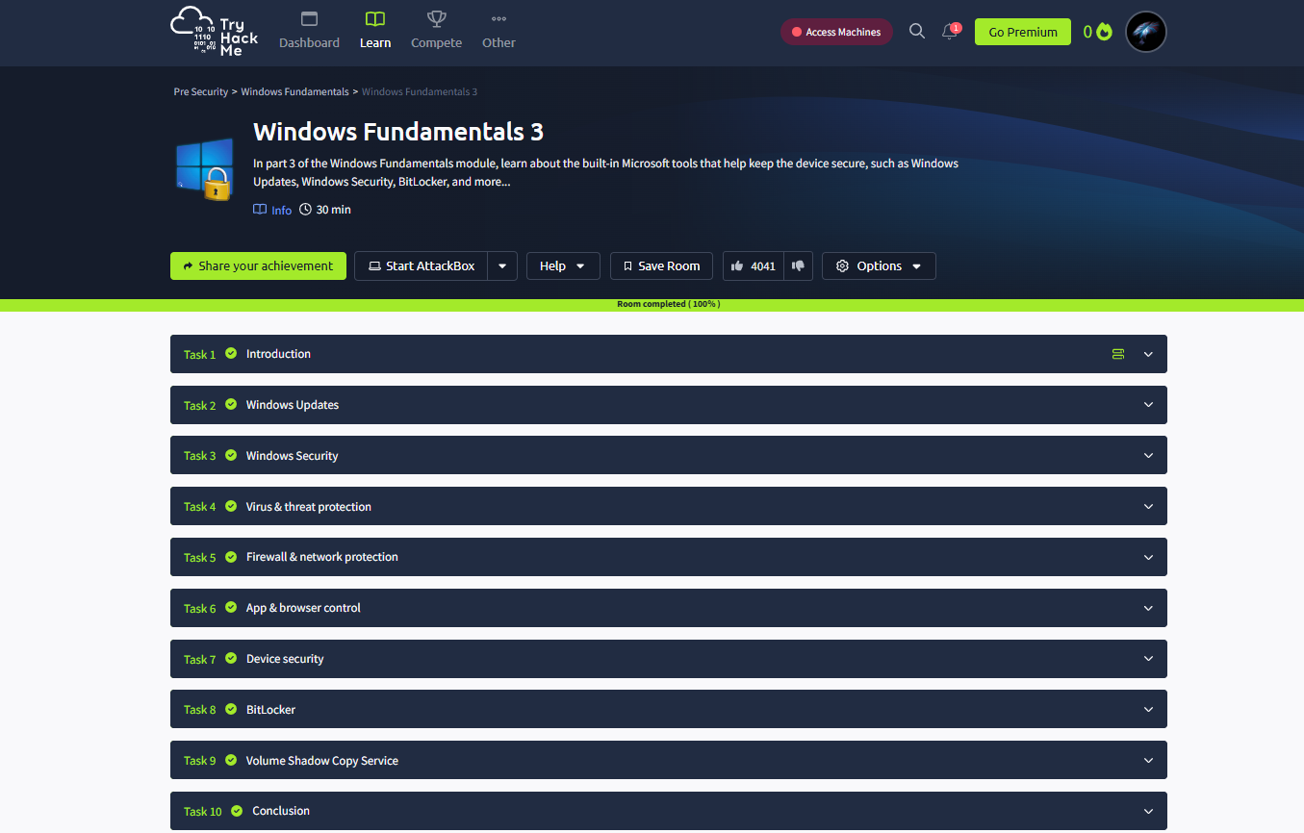

Task 02: Windows Update.

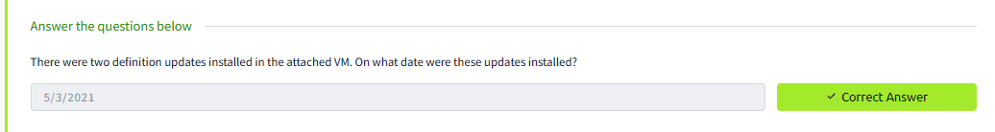

Task 03: Windows Security.

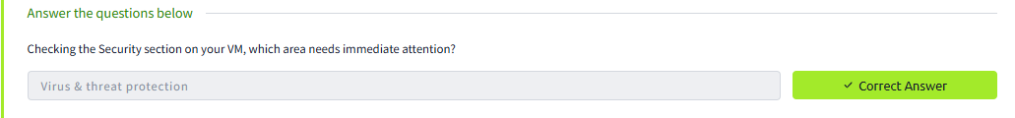

Task 04: Virus & Threat protection.

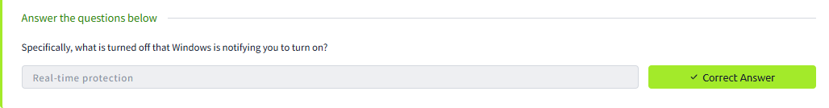

Task 05: Firewall & network protection.

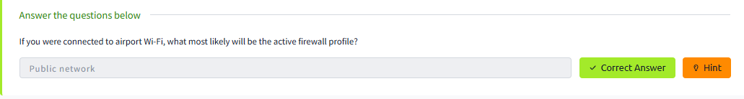

Task 06: App & browser control.

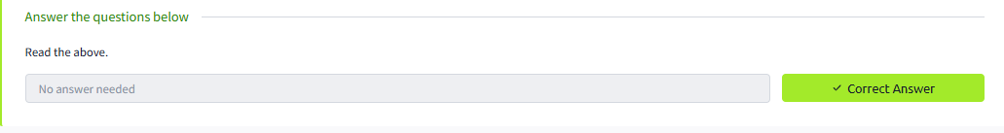

Task 07: Device security.

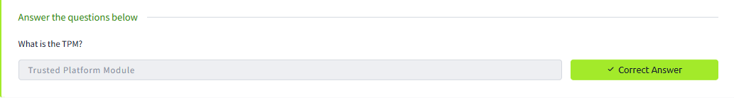

Task 08: BitLocker.

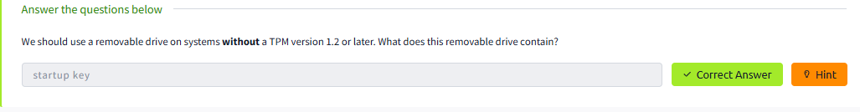

Task 09: Volume Shadow Copy Service.

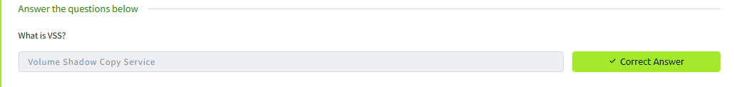

Conclusion:

Hence the Windows Foundations 3 in tryhackme platform is been completed successfully ..