EX.NO:2 SECURITY MODELS AND PRINCIPLES DATE:12/02/2025

NAME: M.A.MADHESH

ROLL.NO:231901029

AIM:

To Study about the security triad and common security models and principles

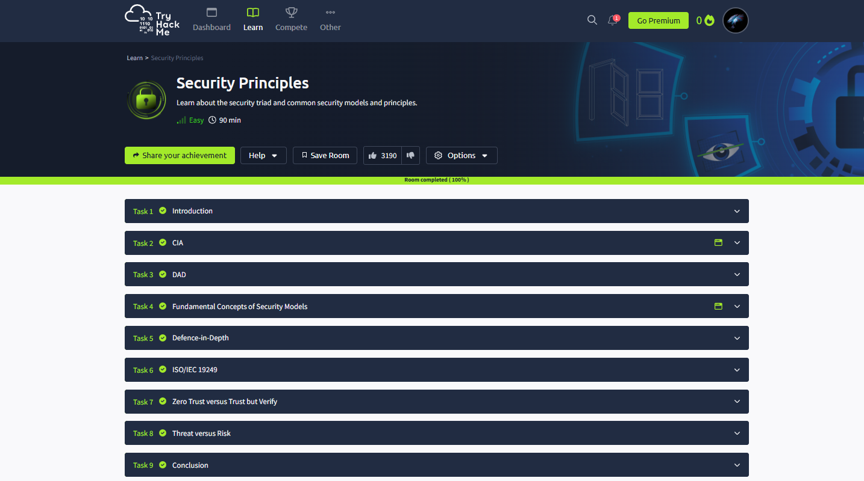

Task 02: CIA



Task 03: DAD

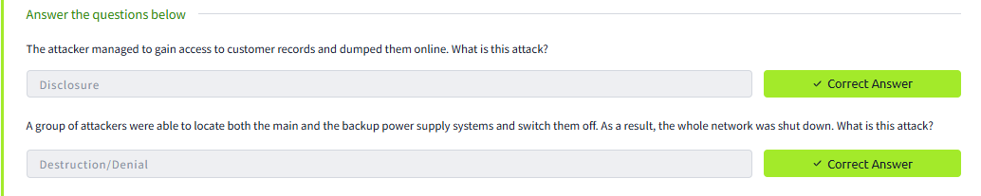

Task 04: Fundamental Concept oof Security Models



Task 05: Defence-in Depth

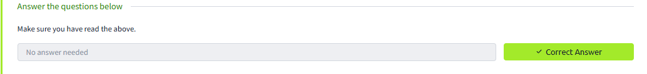

Task 06: ISO/IEC 19249

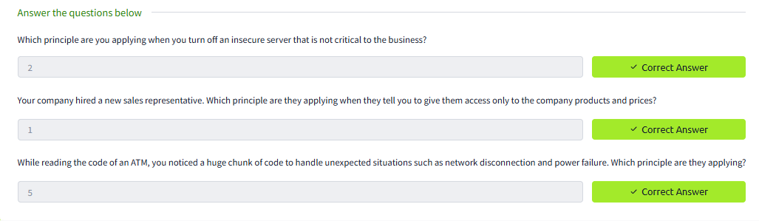

Task 07: Zero Trust versus but Verify

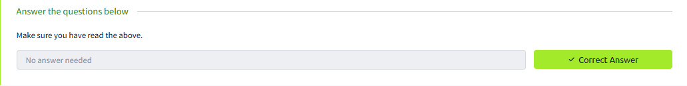

Task 08: Threat Versus Risk

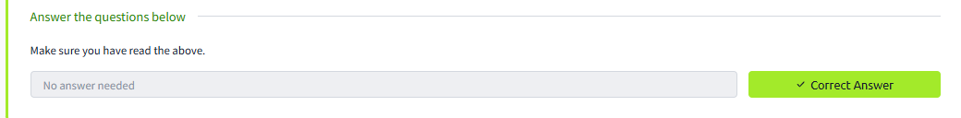

Conclusion:

The security principles in the tryhackme platform is completed successfully