EX.NO:3 Explore Identity and Access Management DATE:19/02/2025

NAME: M.A.MADHESH

ROLL.NO:231901029

AIM:

To Study about identification authentication, authorisation, accounting, and identity management

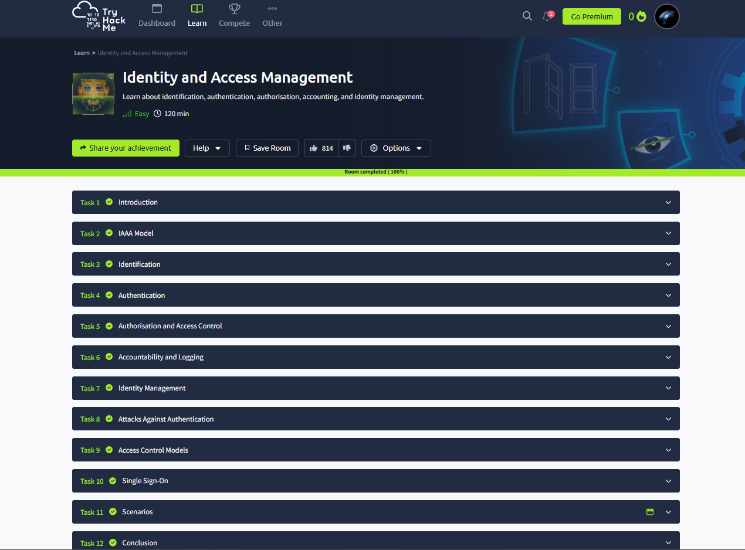

Task 02: IAA Mode.

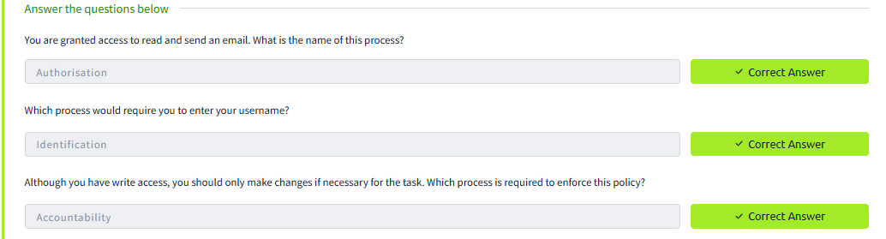

Task 03: Identification.

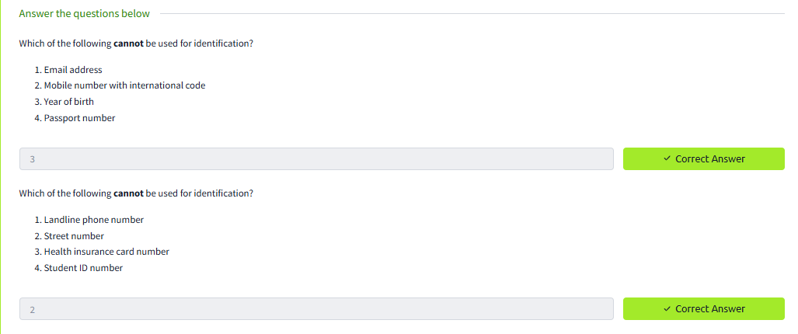

Task 04: Authentication.

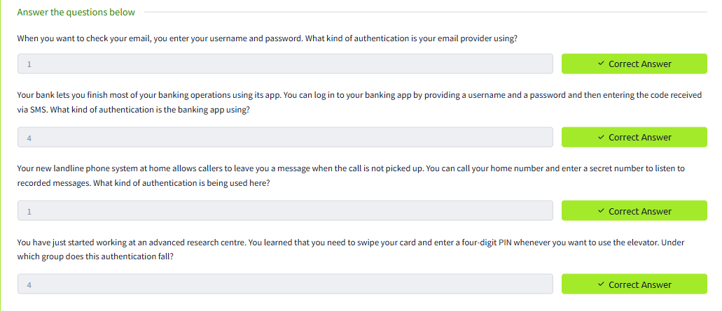

Task 05: Authorisation and Access Control.

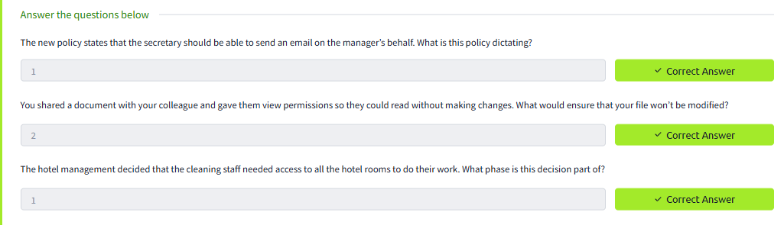

Task 06: Accountability and logging.

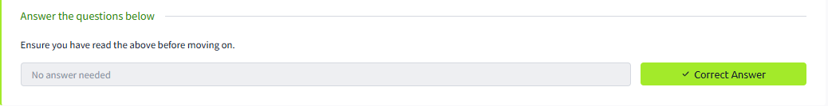

Task 07: Identity Management.

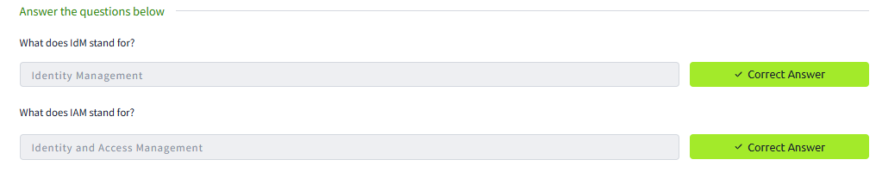

Task 08: Attack Against Authentication.

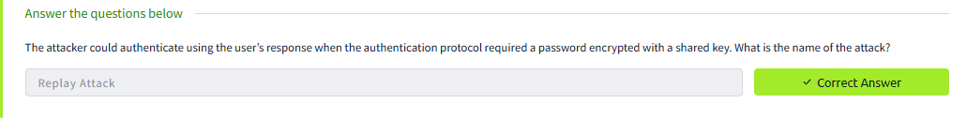

Task 09: Access Control Models.

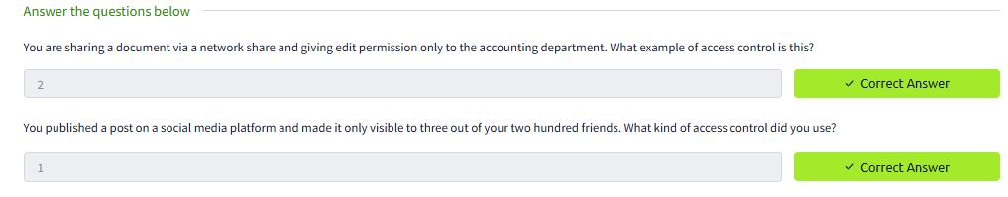

Task 10: Single sign-on.

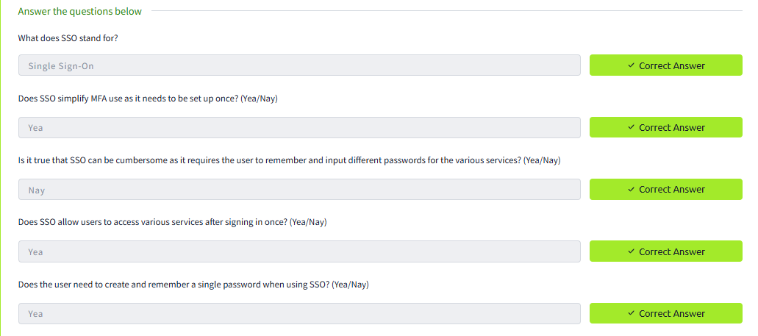

Task 11: Scenarios.

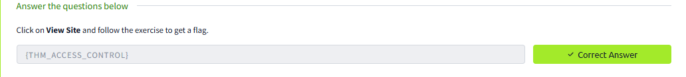

Conclusion:

The Identity and Access Management in tryhackme platform is completed successfully.._