EX.NO:4 Analyze the Malicious Network Traffic using Wireshark DATE:05/03/2025

NAME: M.A.MADHESH

ROLL.NO:231901029

AIM:

To apply your analytical skill to analyze the malicious network traffic using Wireshark.

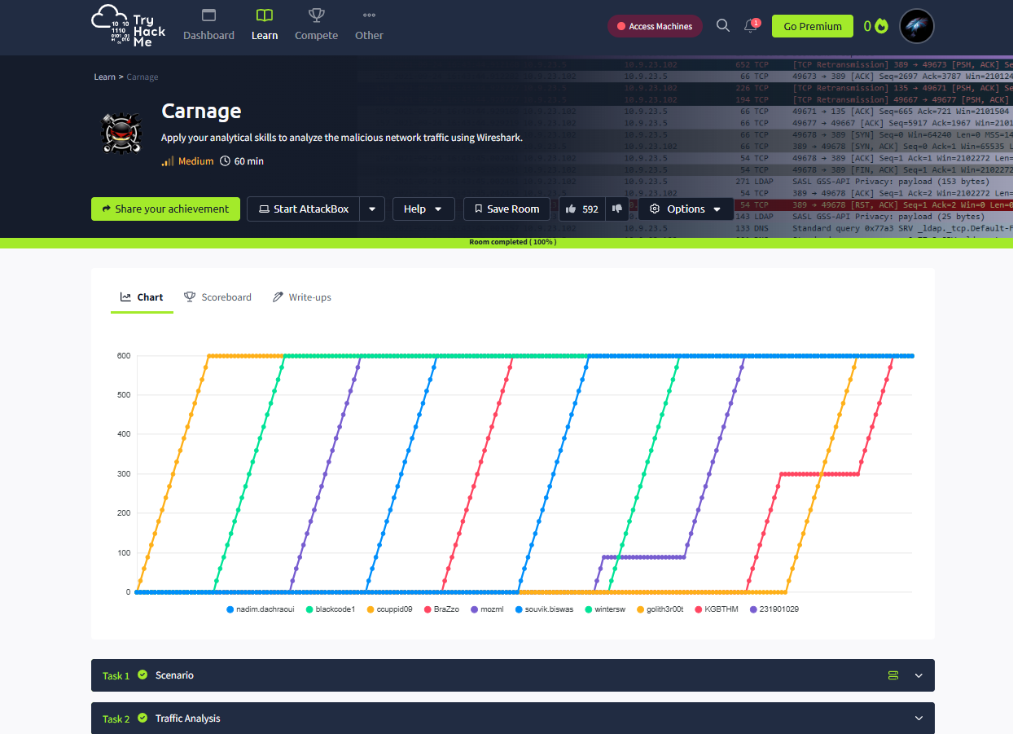

Task 02:

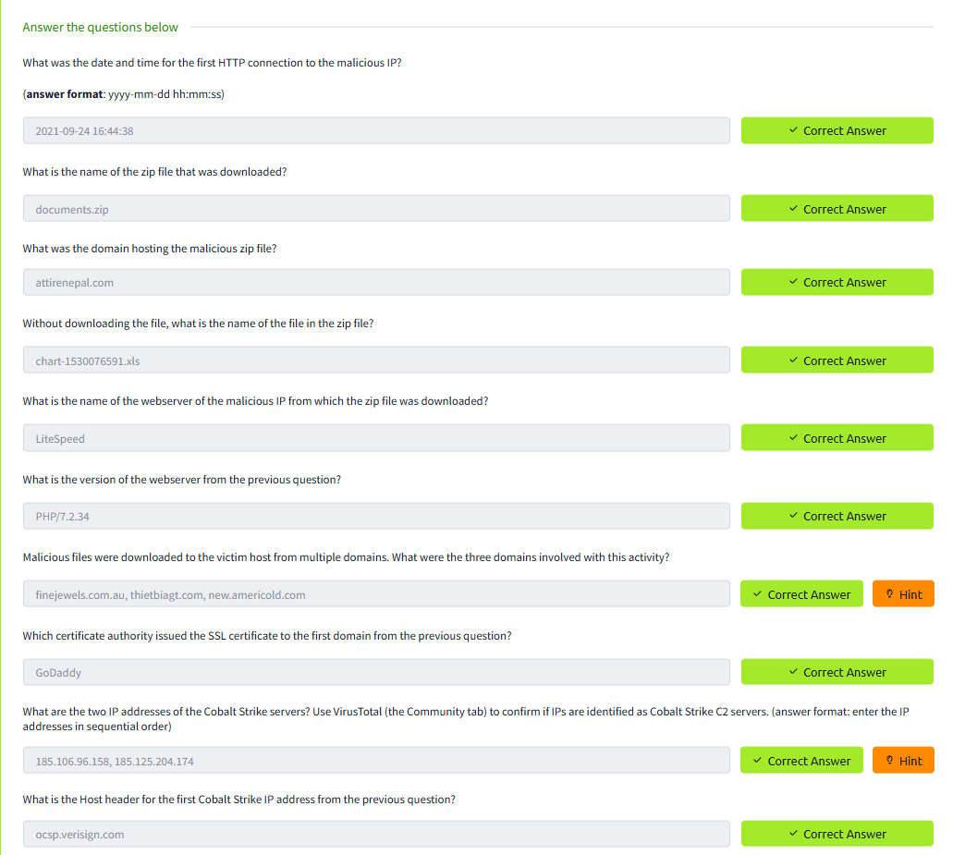

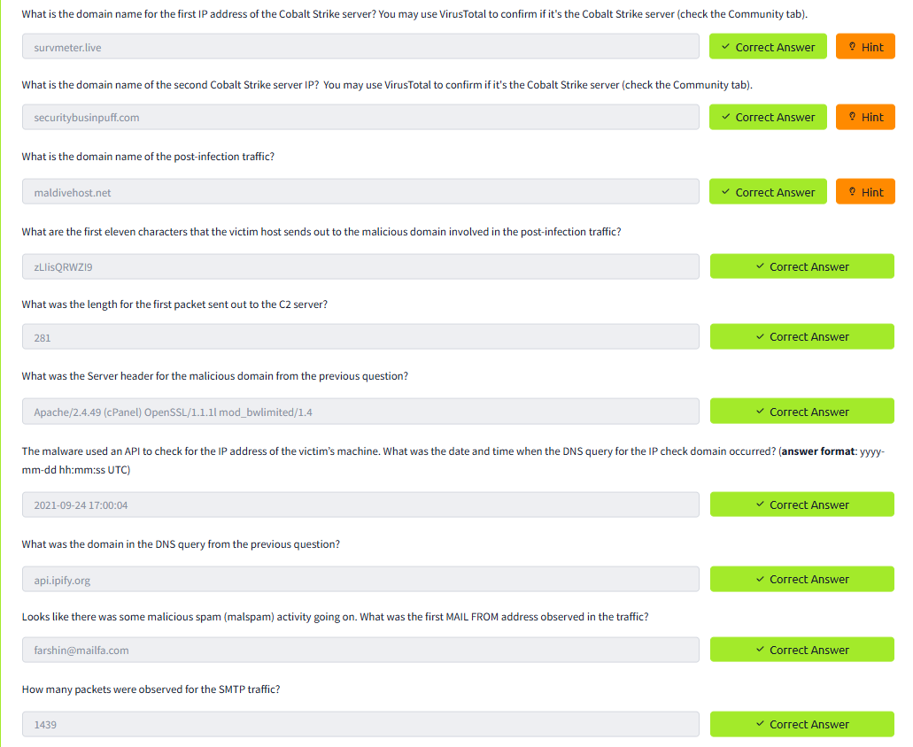

Conclusion:

The analyze the Malicious Network Traffic using Wireshark in tryhackme platform is completed successfully ..