EX.No:O5 Stack based buffer overflow attacks DATE:19/03/2025

NAME: M.A.MADHESH

ROLL.NO:231901029

AIM:

To explore the CVE-2019-18634 in the Unix Sudo Program. Room two in the sudovulns series

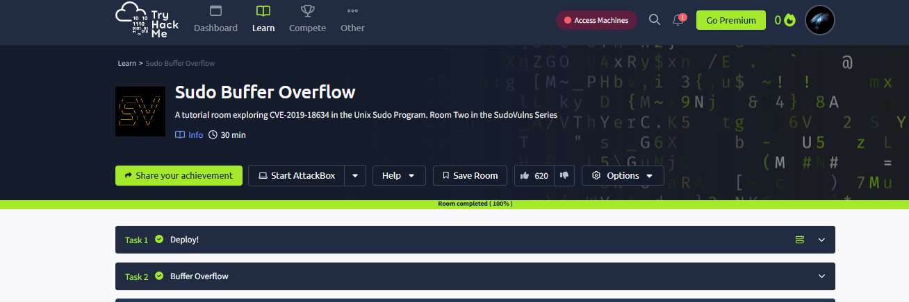

Task 02:Buffer Overflow

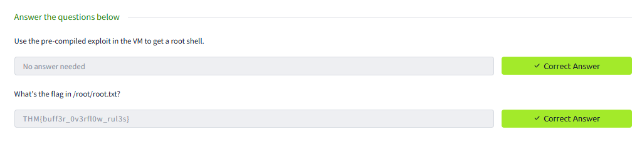

Conclusion:

The Sudo buffer overflow in tryhackme platform is completed successfully ..