EX.No:O5b Stack based buffer overflow attacks DATE:19/03/2025

NAME: M.A.MADHESH

ROLL.NO:231901029

AIM:

To practice stack based buffer overflow

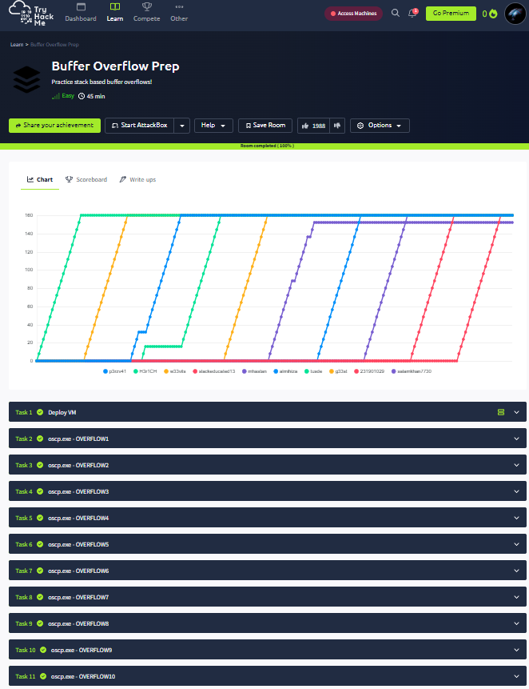

Task 02: oscp.exe-OVERFLOW1

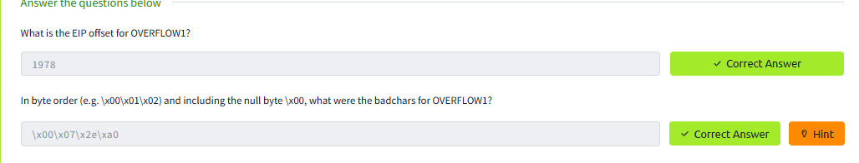

Task 03: oscp.exe-OVERFLOW2

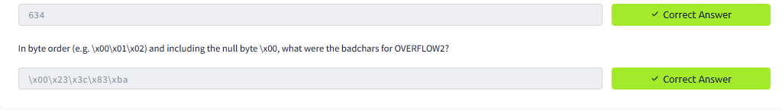

Task 04: oscp.exe-OVERFLOW3

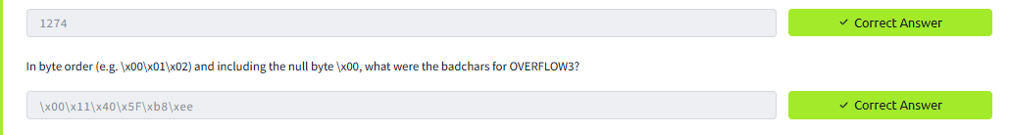

Task 05: oscp.exe-OVERFLOW4

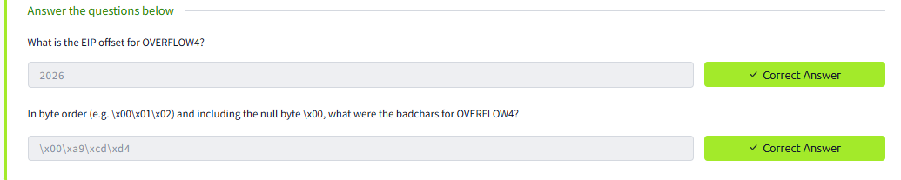

Task 06: oscp.exe-OVERFLOW5

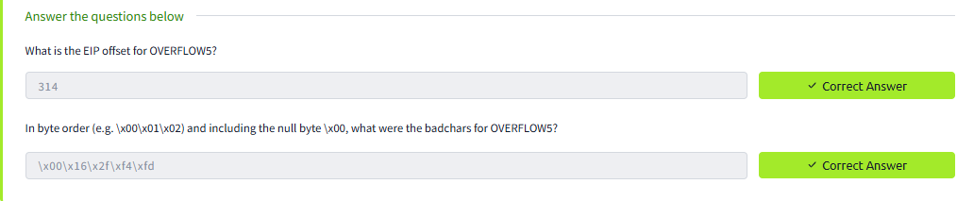

Task 07: oscp.exe-OVERFLOW6

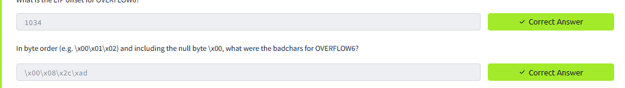

Task 08: oscp.exe-OVERFLOW7

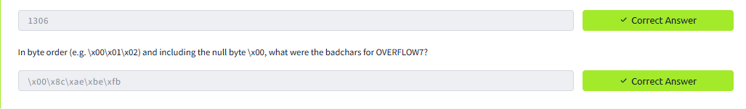

Task 09: oscp.exe-OVERFLOW8

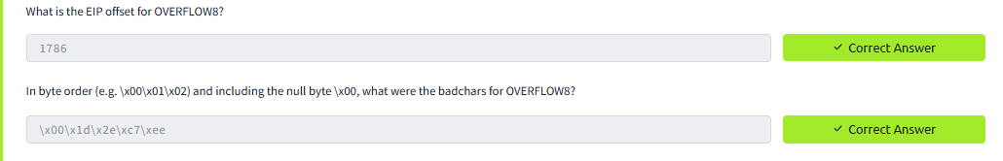

Task 10: oscp.exe-OVERFLOW9

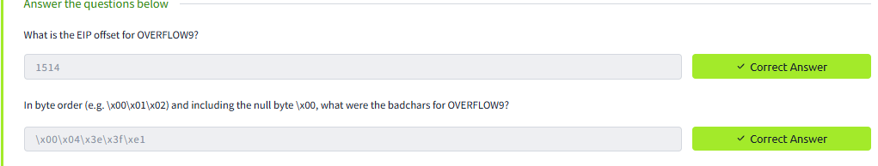

Task 11: oscp.exe-OVERFLOW10

