EX.No:O6 Demonstrate Linux Privilege Escalation DATE:02/04/2025

NAME: M.A.MADHESH

ROLL.NO:231901029

AIM:

To learn the fundamentals of privilege escalation. From enumeration to exploitation, get hands-on with over 8 different privilege escalation techniques

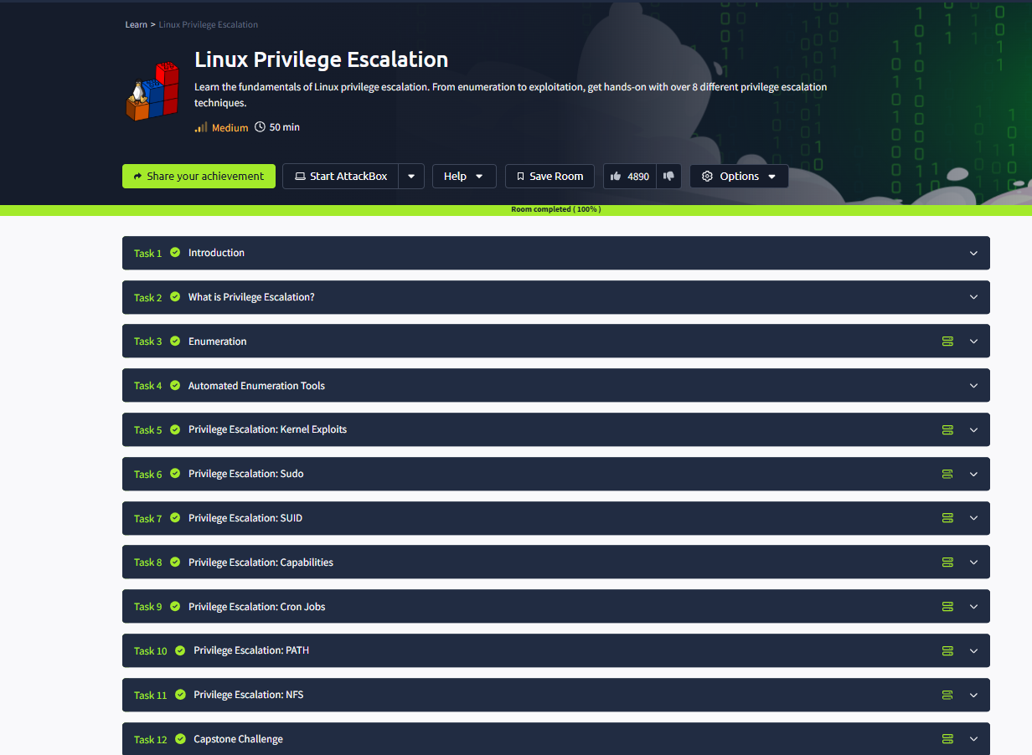

Task 02: What is Privilege Escalation?



Task 03: Enumeration

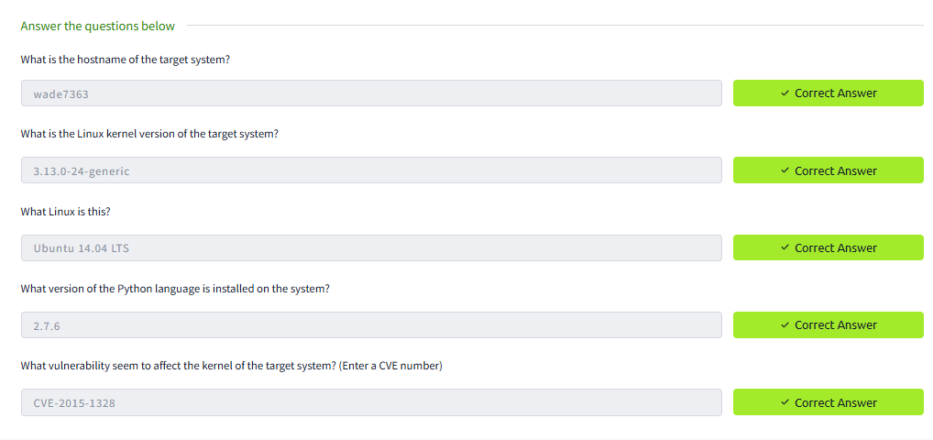

Task 04: Automated Enumeration Tools

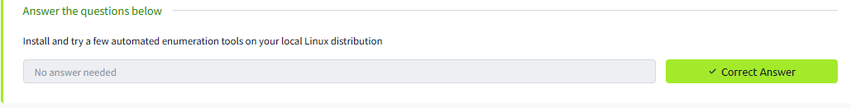

Task 05: Privilege Escalation: Kernel Exploits

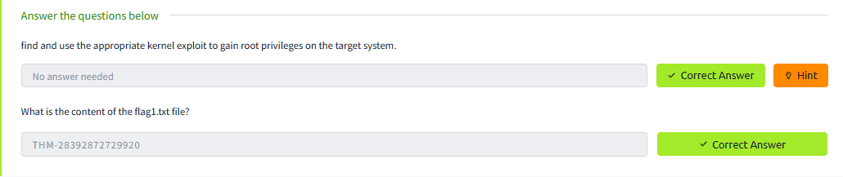

Task 06: Privilege Escalation: Sudo

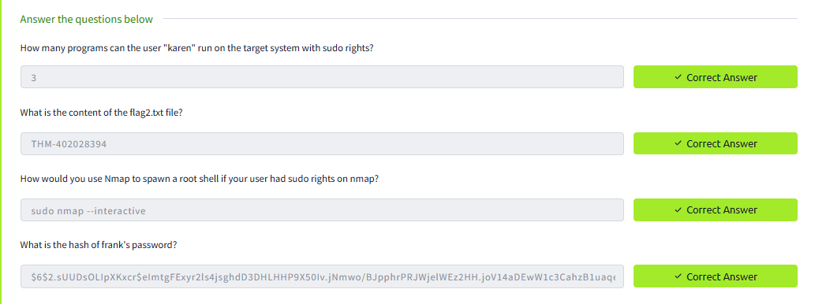

Task 07: Privilege Escalation: SUID

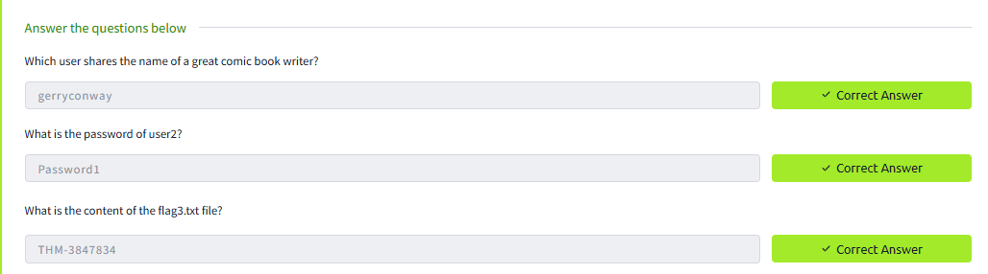

Task 08: Privilege Escalation: Capabilities

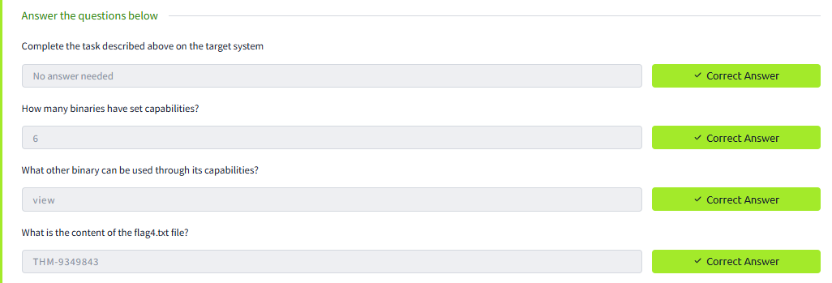

Task 09: Privilege Escalation: Corn Jobs

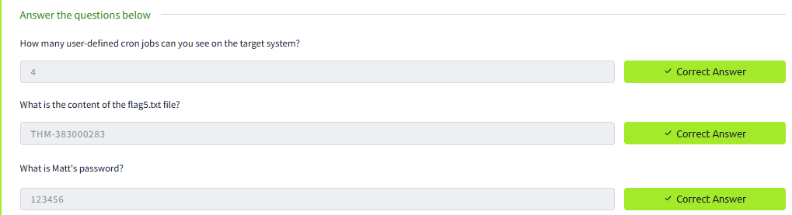

Task 10: Privilege Escalation: PATH

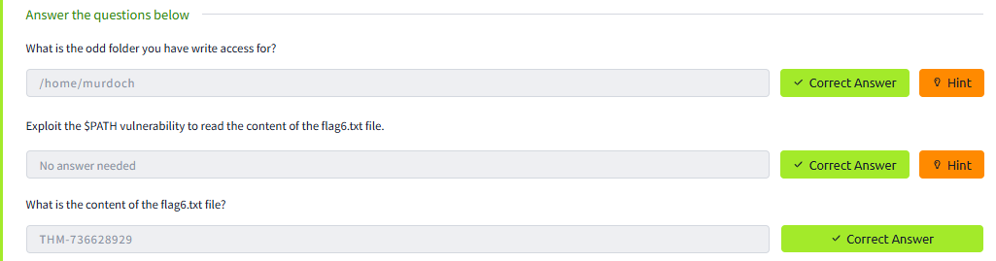

Task 11: Privilege Escalation: NFS

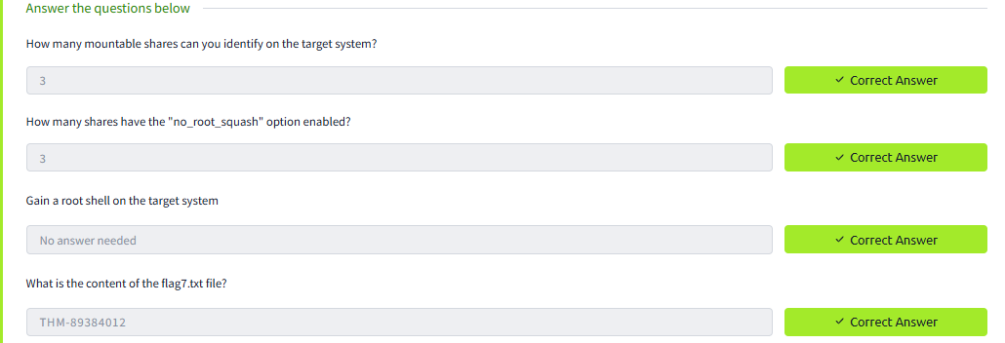

Task 12: Capstone challenge

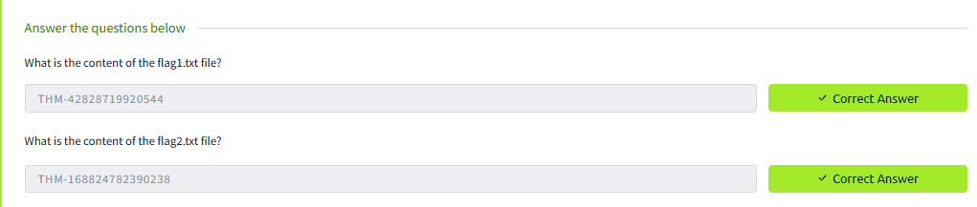

Conclusion:

the Linux privilege escalation in tryhackme platform is completed successfully ..