DATA SCIENCE TOOLS AND TECHNIQUES
BDA400

ASSIGNMENT 2
Technical Analysis using R – Preliminary Stage

STUDENT INFORMATION
Student Name: Ahmed Almadhoun
Student Number: 664428467
Submission Date: October 24, 2026

GitHub Repository
https://github.com/madhounahmed86-debug/TechnicalAnalysis

1. Introduction
The objective of this preliminary stage is to set up a GitHub repository, install and configure R tools, install the required packages, create a portfolio file containing stock symbols, import stock market data, calculate basic statistics, display the results, and document the process with screenshots.
This report documents the work completed so far. Screenshots included below are captures from the working session. Any item marked as pending must be completed or verified before final submission.

2. GitHub Account and Repository
A public GitHub repository named TechnicalAnalysis was created for the BDA400 assignment.
Repository URL: https://github.com/madhounahmed86-debug/TechnicalAnalysis
The repository currently shows the files portfolio.txt and stock_analysis.R. The assignment instructions request that files be organized in an Assignment2 subfolder; this folder organization should be completed before final submission.
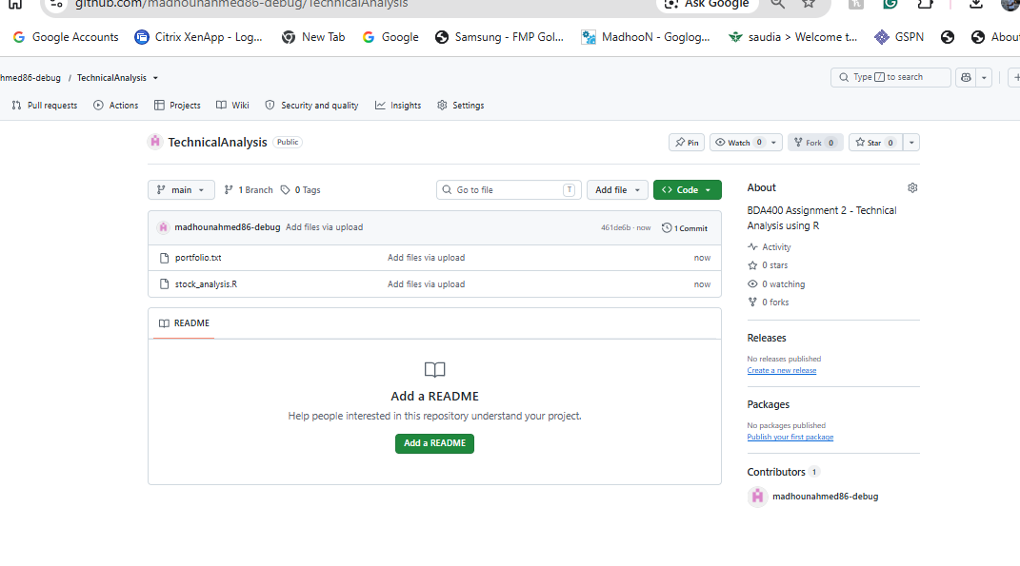
Figure 1. GitHub repository showing portfolio.txt and stock_analysis.R.

3. R Installation and Package Setup
R version 4.6.1 was opened on the Windows computer. The packages quantmod, TTR, and ggplot2 were installed and loaded in the R console. quantmod was used to retrieve stock data, TTR to calculate the moving average, and ggplot2 was included for charting.
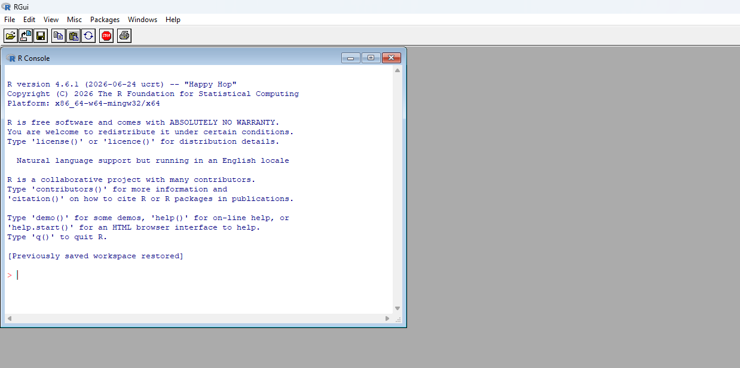
Figure 2. R 4.6.1 console opened on Windows.
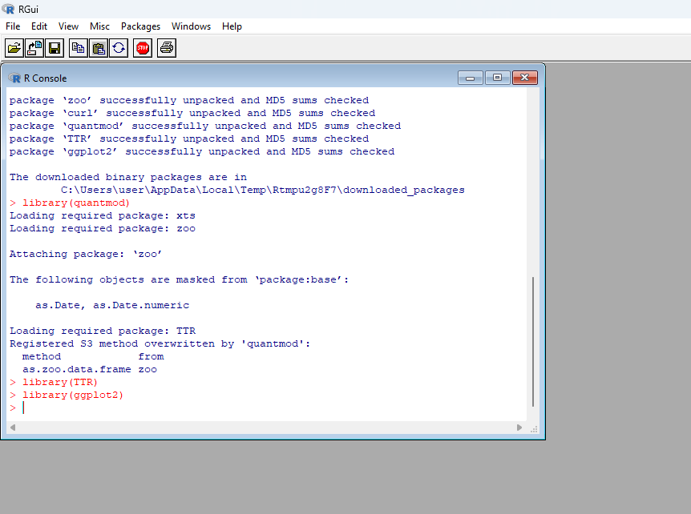
Figure 3. Package installation messages and successful loading of quantmod, TTR, and ggplot2.
Pending verification: the screenshots show the R GUI console. If the instructor specifically expects RStudio, install RStudio Desktop and add a screenshot showing it open. Do not describe RStudio as installed unless verified.

4. Project Configuration and Portfolio
A text file named portfolio.txt was created in the Assignment2 working folder. It contains one ticker symbol per line: AAPL, MSFT, and NVDA. The file was read successfully by R, and file.exists("portfolio.txt") returned TRUE.
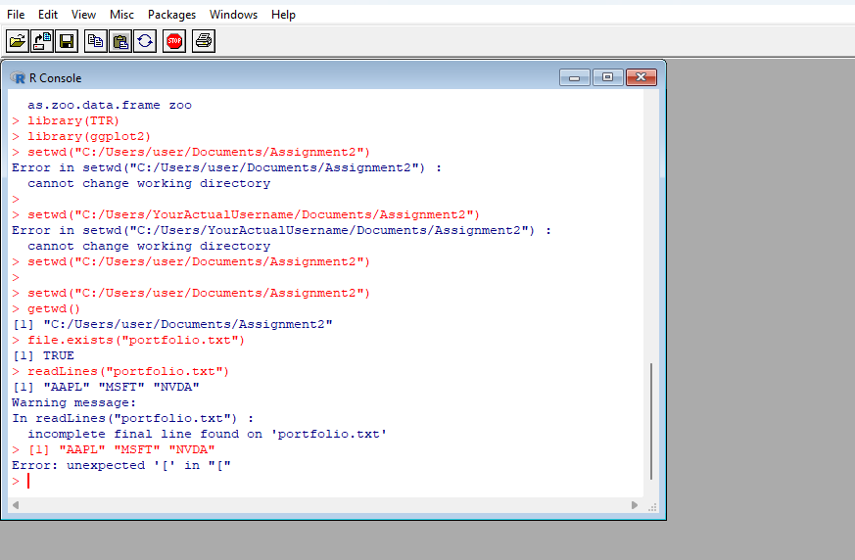
Figure 4. R confirms that portfolio.txt exists and reads the three stock symbols.
A warning noted that the file did not end with a final newline. This is a minor formatting warning and can be resolved by rewriting the file with writeLines(c("AAPL", "MSFT", "NVDA"), "portfolio.txt").

5. Importing Stock Data
The quantmod package was used to retrieve historical stock data from Yahoo Finance. A test download for AAPL returned stock columns including Open, High, Low, Close, Volume, and Adjusted. The assignment script then downloaded data for the portfolio symbols.
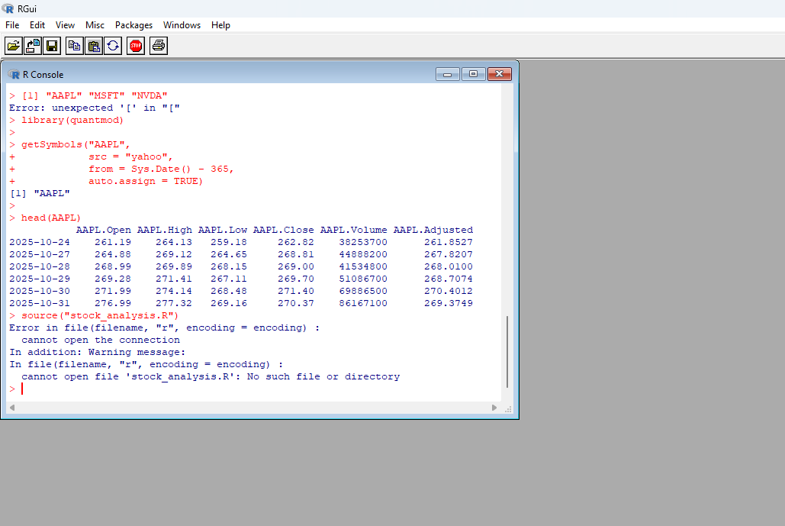
Figure 5. Successful AAPL historical stock-data download and displayed sample rows.
The stock download requires an internet connection and availability of the selected ticker data from the data provider.

6. Functions and Statistical Calculations
The R script contains a load_stock_data() function to read portfolio.txt and download stock data for each symbol. The calculate_statistics() function uses adjusted closing prices to calculate the latest adjusted close, 20-observation simple moving average, mean, mode, median, and standard deviation.
The mode is calculated as the most frequently occurring exact adjusted-price value. For continuous stock prices, there may be multiple values tied for the most frequent occurrence, so the script reports all tied modes.
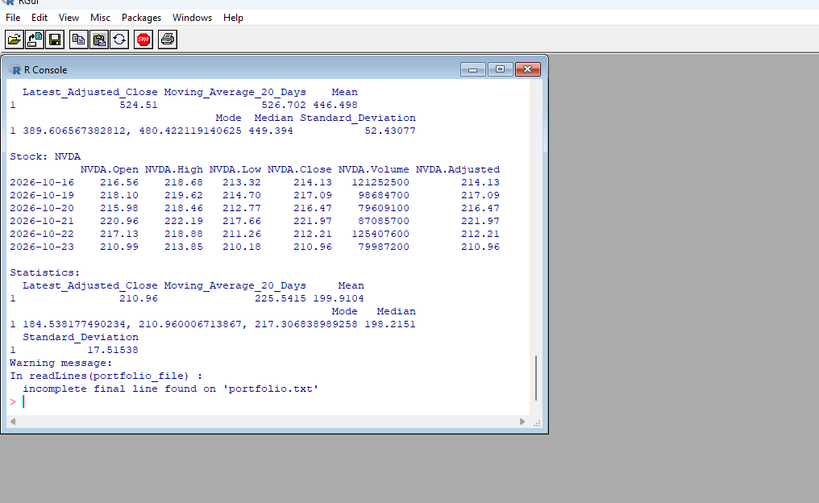
Figure 6. R console showing stock data and computed statistics, including results for NVDA.
The console output confirms that the script ran and produced statistics. The displayed values are from the data retrieved during this session and may change when the script is run again.

7. Data Display and Visualizations
The script prints recent rows of stock data and statistics for each ticker and creates an output folder for chart images. The chart files should be checked in the local output folder after running the script.
Pending evidence: insert screenshots of the generated AAPL, MSFT, and NVDA charts and confirm that all expected chart files exist. The screenshots currently available show console output but do not clearly show the saved charts.

8. Repository Contents and Submission Checklist
- GitHub repository named TechnicalAnalysis created and public.
- portfolio.txt created with AAPL, MSFT, and NVDA.
- stock_analysis.R uploaded to GitHub.
- Word report saved with student name and repository URL.
- Create an Assignment2 subfolder in GitHub and organize the assignment files inside it.
- Verify the R script runs from the Assignment2 folder without errors.
- Confirm the output folder contains the generated charts and statistics CSV, if created by the current script.
- Add screenshots proving RStudio installation if required by the instructor.
- Upload the completed report and all required R files to the appropriate GitHub folder.
- Add the final repository link to the report cover page.

9. Conclusion
The initial setup and analysis steps have been started successfully. R 4.6.1 is available, the required packages loaded successfully, the portfolio symbols were read, historical stock data was retrieved, and the script displayed basic statistics. Before submission, the remaining items are to verify the chart outputs, capture any missing evidence required by the rubric, and organize all files in the Assignment2 subfolder of the public GitHub repository.

10. References
- GitHub Git guide: https://github.com/git-guides/install-git
- GitHub setup guide: https://docs.github.com/en/get-started/quickstart/set-up-git
- R Project: https://www.r-project.org/
- Posit RStudio Desktop: https://posit.co/download/rstudio-desktop/
- quantmod package: https://cran.r-project.org/package=quantmod
- TTR package: https://cran.r-project.org/package=TTR
- ggplot2 package: https://cran.r-project.org/package=ggplot2
- Yahoo Finance: https://finance.yahoo.com/

Appendix A: Stock Price and Trading Volume Charts
The following charts were generated from the stock data downloaded during the analysis run. Each chart displays stock price history and trading volume for the selected ticker.

AAPL
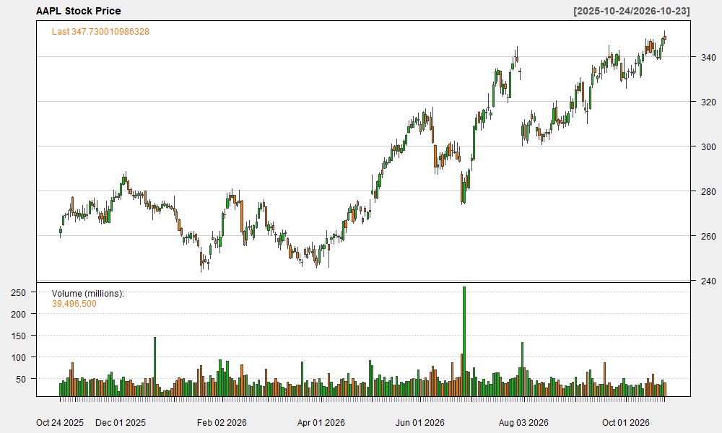
Figure A1. AAPL stock price and trading volume.

MSFT
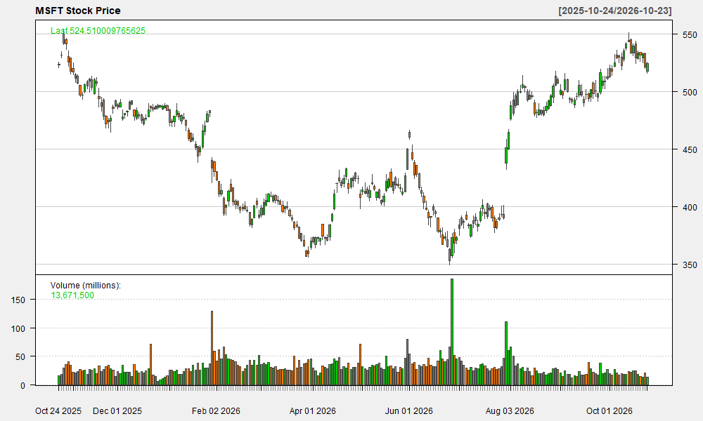
Figure A2. MSFT stock price and trading volume.

NVDA
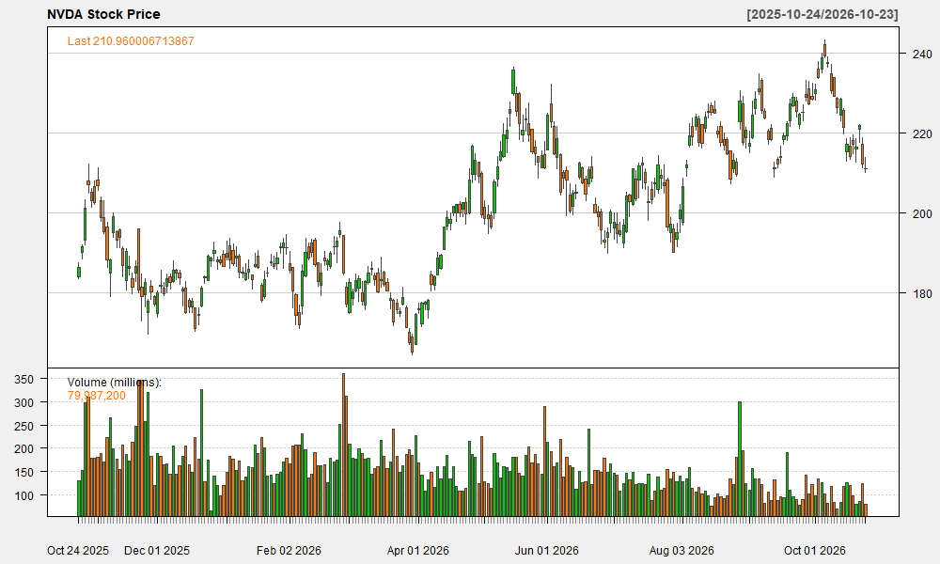
Figure A3. NVDA stock price and trading volume.

