2. Requirement Analysis Phase
Requirements and Technology Stack
Team ID | SWTID-2026-4404
Team Leader | Sakthi Devi B
Team Members | A Kannammal; Shanmuga Rani S
Project Name | Import Data using Transform Maps
Phase Description
The project requires a ServiceNow Developer instance, source employee data, an Import Set, a target employee table, a Transform Map and field mappings.
Step-by-Step Activities
- ServiceNow Developer instance
- Source employee spreadsheet
- Import Set / Import Set Table
- Employee Test target table
- Transform Map and field mappings
- Browser and internet connection
Project Screenshot
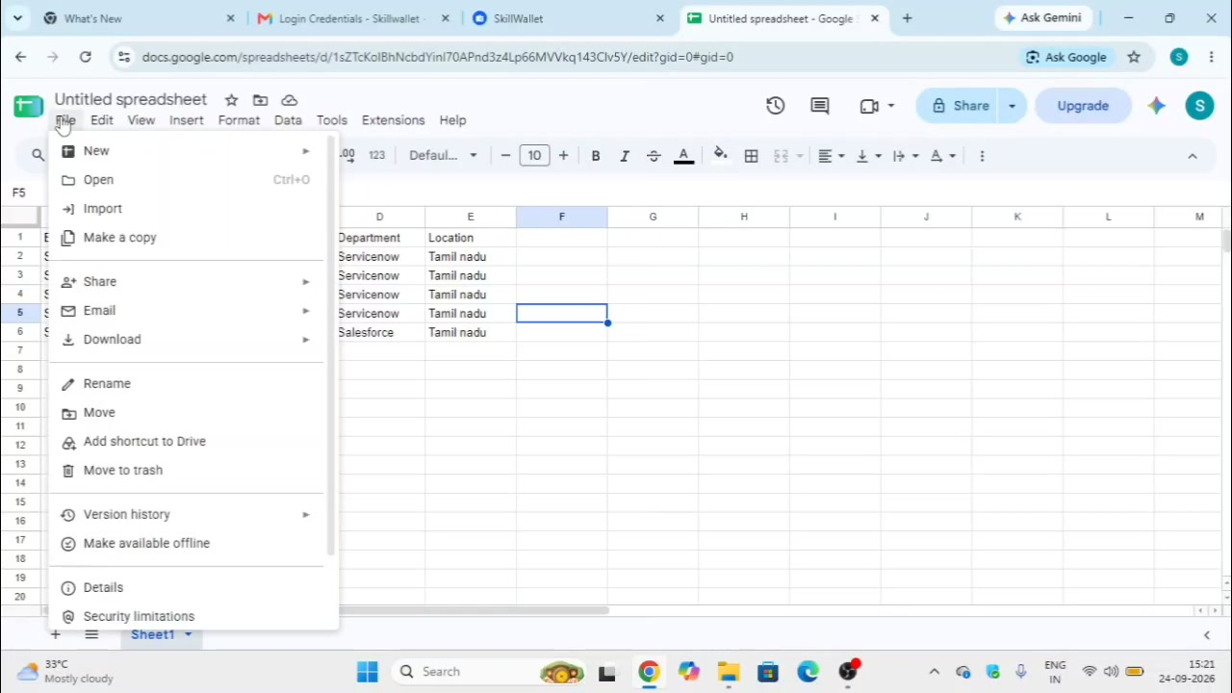
Figure 2: Source data and import preparation.

