3. Project Design Phase
Problem – Solution and Data Flow Design
Team ID | SWTID-2026-4404
Team Leader | Sakthi Devi B
Team Members | A Kannammal; Shanmuga Rani S
Project Name | Import Data using Transform Maps
Phase Description
The design explains how data moves from the source spreadsheet to the ServiceNow target table. The source data is loaded into an import table and the Transform Map connects source fields with target fields.
Step-by-Step Activities
- Source: Employee spreadsheet
- Import layer: Employee Import table
- Transformation layer: Table Transform Map
- Target: Employee Test table
- Map the required employee fields.
Project Screenshot
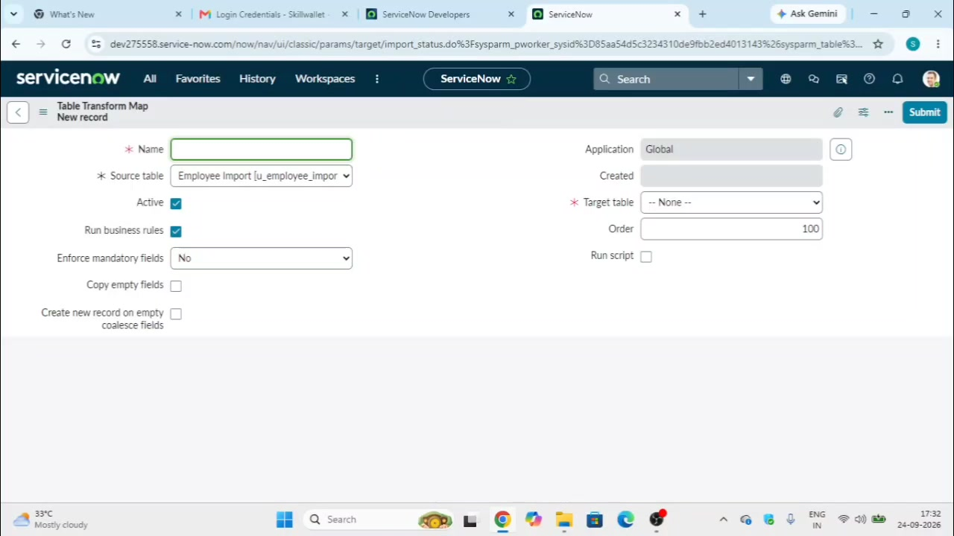
Figure 3: Transform Map creation and source/target setup.

