4. Project Planning Phase
Project Activity Plan
Team ID | SWTID-2026-4404
Team Leader | Sakthi Devi B
Team Members | A Kannammal; Shanmuga Rani S
Project Name | Import Data using Transform Maps
Phase Description
The project was planned as a sequence of activities so the employee data could be imported, transformed and verified systematically.
Step-by-Step Activities
- Prepare the employee spreadsheet.
- Create/select the Import Set table.
- Create the Employee Test target table.
- Create the Table Transform Map.
- Map source fields to target fields.
- Run the transformation.
- Verify imported records.
- Prepare the final report/dashboard.
Project Screenshot
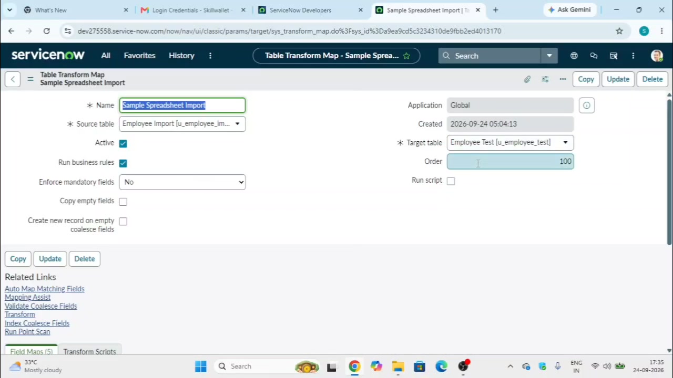
Figure 4: Configured Transform Map used in the planned workflow.

