5. Project Development Phase
Import Set and Transform Map Development
Team ID | SWTID-2026-4404
Team Leader | Sakthi Devi B
Team Members | A Kannammal; Shanmuga Rani S
Project Name | Import Data using Transform Maps
Phase Description
The project was implemented in ServiceNow. The source employee data was imported and a Table Transform Map was configured to transfer the data from the import table to the Employee Test table.
Step-by-Step Activities
- Load employee data into the import table.
- Create the Table Transform Map.
- Select Employee Import as source.
- Select Employee Test as target.
- Configure field mappings.
- Run the Transform operation.
Project Screenshot
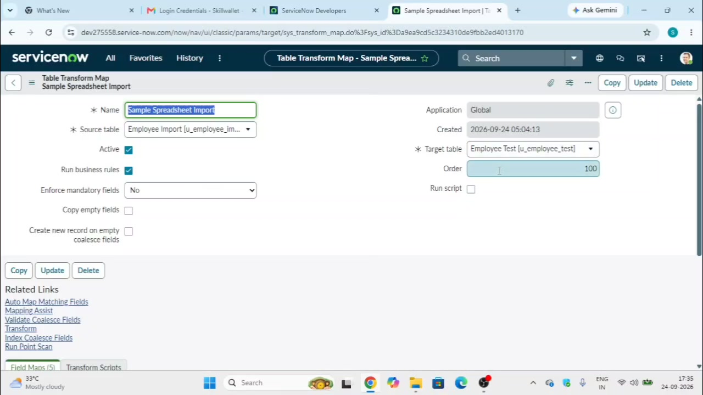
Figure 5: Transform Map configuration used during development.

