6. Project Testing Phase
Data and Transformation Testing
Team ID | SWTID-2026-4404
Team Leader | Sakthi Devi B
Team Members | A Kannammal; Shanmuga Rani S
Project Name | Import Data using Transform Maps
Phase Description
After transformation, the Employee Test table was checked to confirm that records were created correctly. Employee values were reviewed against the source data.
Step-by-Step Activities
- Check whether records are created in the target table.
- Verify Employee ID.
- Verify Employee Name and Email.
- Verify Department and Location.
- Confirm the imported values match the source data.
Project Screenshot
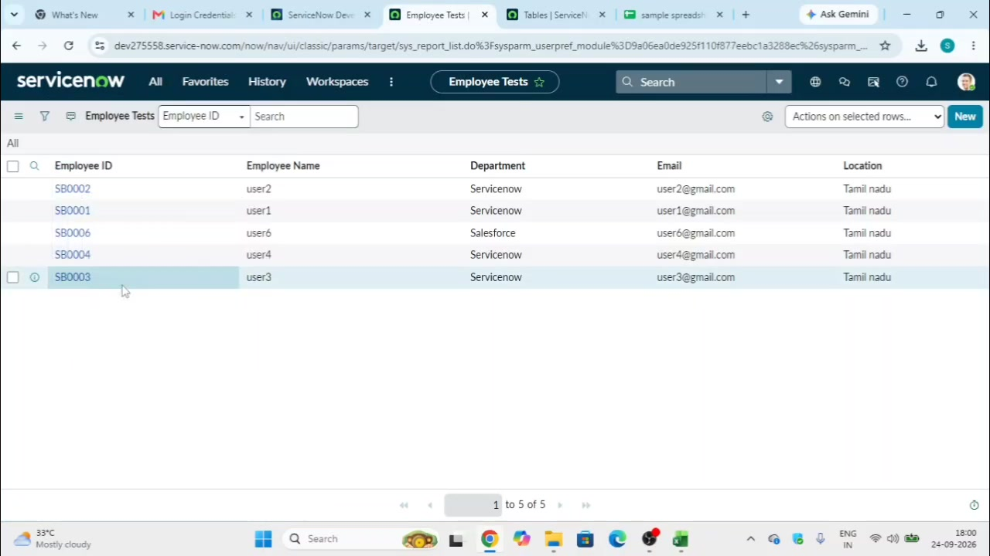
Figure 6: Imported employee records shown in the target table.

