7. Project Documentation Phase
Project Documentation and Evidence
Team ID | SWTID-2026-4404
Team Leader | Sakthi Devi B
Team Members | A Kannammal; Shanmuga Rani S
Project Name | Import Data using Transform Maps
Phase Description
The project process is documented using the source data, Transform Map configuration, field mapping information and final imported records. Screenshots provide evidence of the completed steps.
Step-by-Step Activities
- Document the project objective and requirements.
- Document source and target tables.
- Document Transform Map configuration.
- Record field mappings and transformation steps.
- Include screenshots of imported records and output.
Project Screenshot
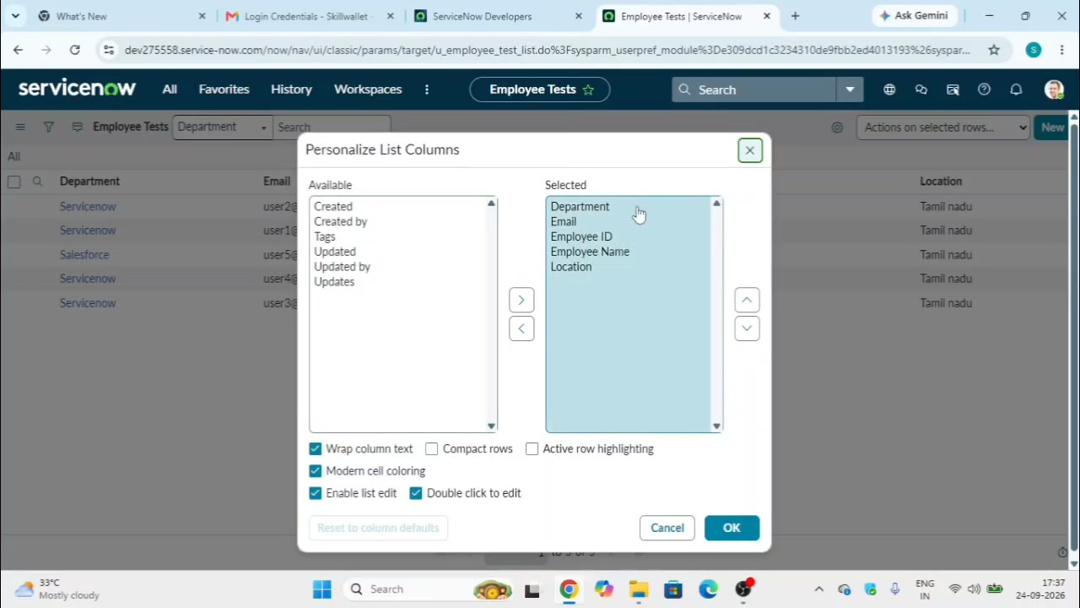
Figure 7: Project evidence from the ServiceNow records and configuration.

