8. Project Demonstration Phase
Final Demonstration and Output
Team ID | SWTID-2026-4404
Team Leader | Sakthi Devi B
Team Members | A Kannammal; Shanmuga Rani S
Project Name | Import Data using Transform Maps
Phase Description
The final demonstration shows the complete flow from source employee data to the ServiceNow target table and the final report/dashboard output.
Step-by-Step Activities
- Show the source employee data.
- Show the Import Set and Transform Map.
- Show the Employee Test records.
- Show the report created from imported data.
- Show the final dashboard/visual output.
Project Screenshot
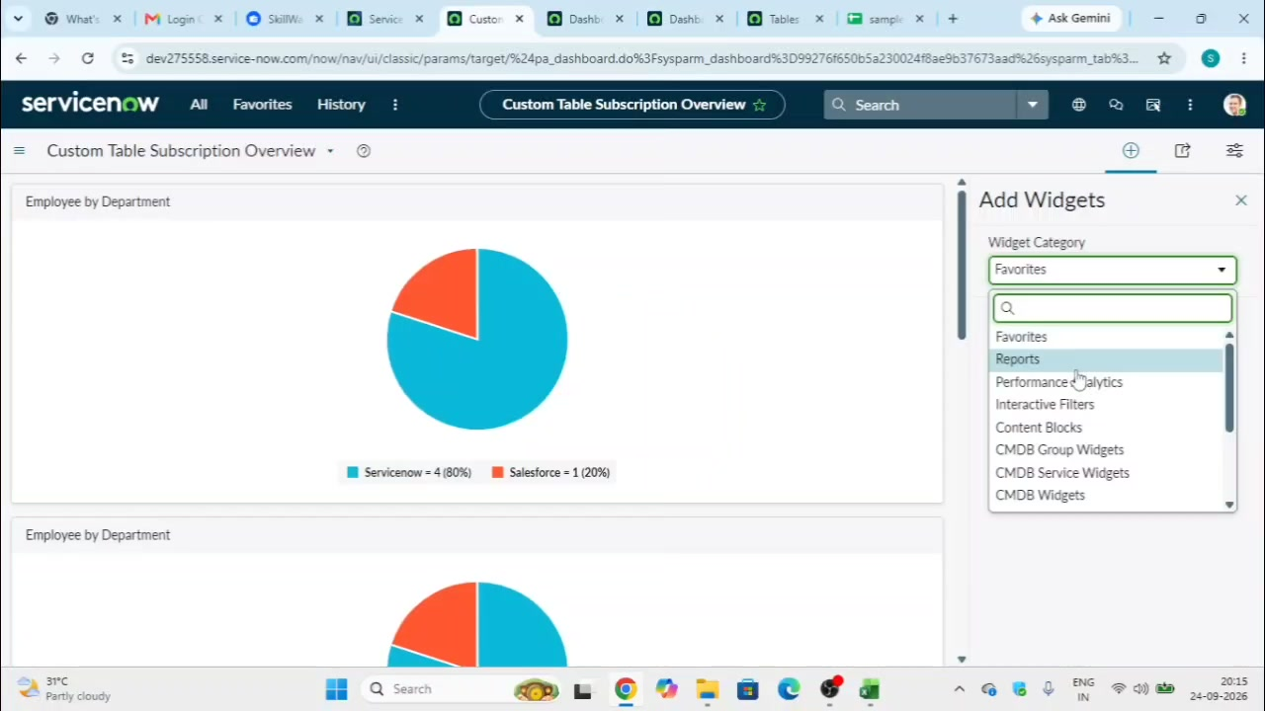
Figure 8: Final report/dashboard output.

