Homework Assignment 1

1. Work *Example 3-3* on Amazon Elastic MapReduce. **Type out all the commands in each step of the process** and print out a screenshot of the final results in Amazon EMR.

Command for make Directory:

hdfs dfs -mkdir /user/Hadoop/input3

Command for compiling Java file:

javac -cp src/:hadoop-common-2.6.1.jar:hadoop-mapreduce-client-core-2.6.1.jar:commons-cli-2.0.jar -d . FileSystemDoubleCat.java

Command for copying a file from local disk to HDFS:

hdfs dfs -copyFromLocal quangle.txt /user/hadoop/input3/quangle3.txt

Command for running Java in Hadoop:

hadoop FileSystemDoubleCat hdfs:///user/hadoop/input3/quangle3.txt



Screenshot of final results in EMR:

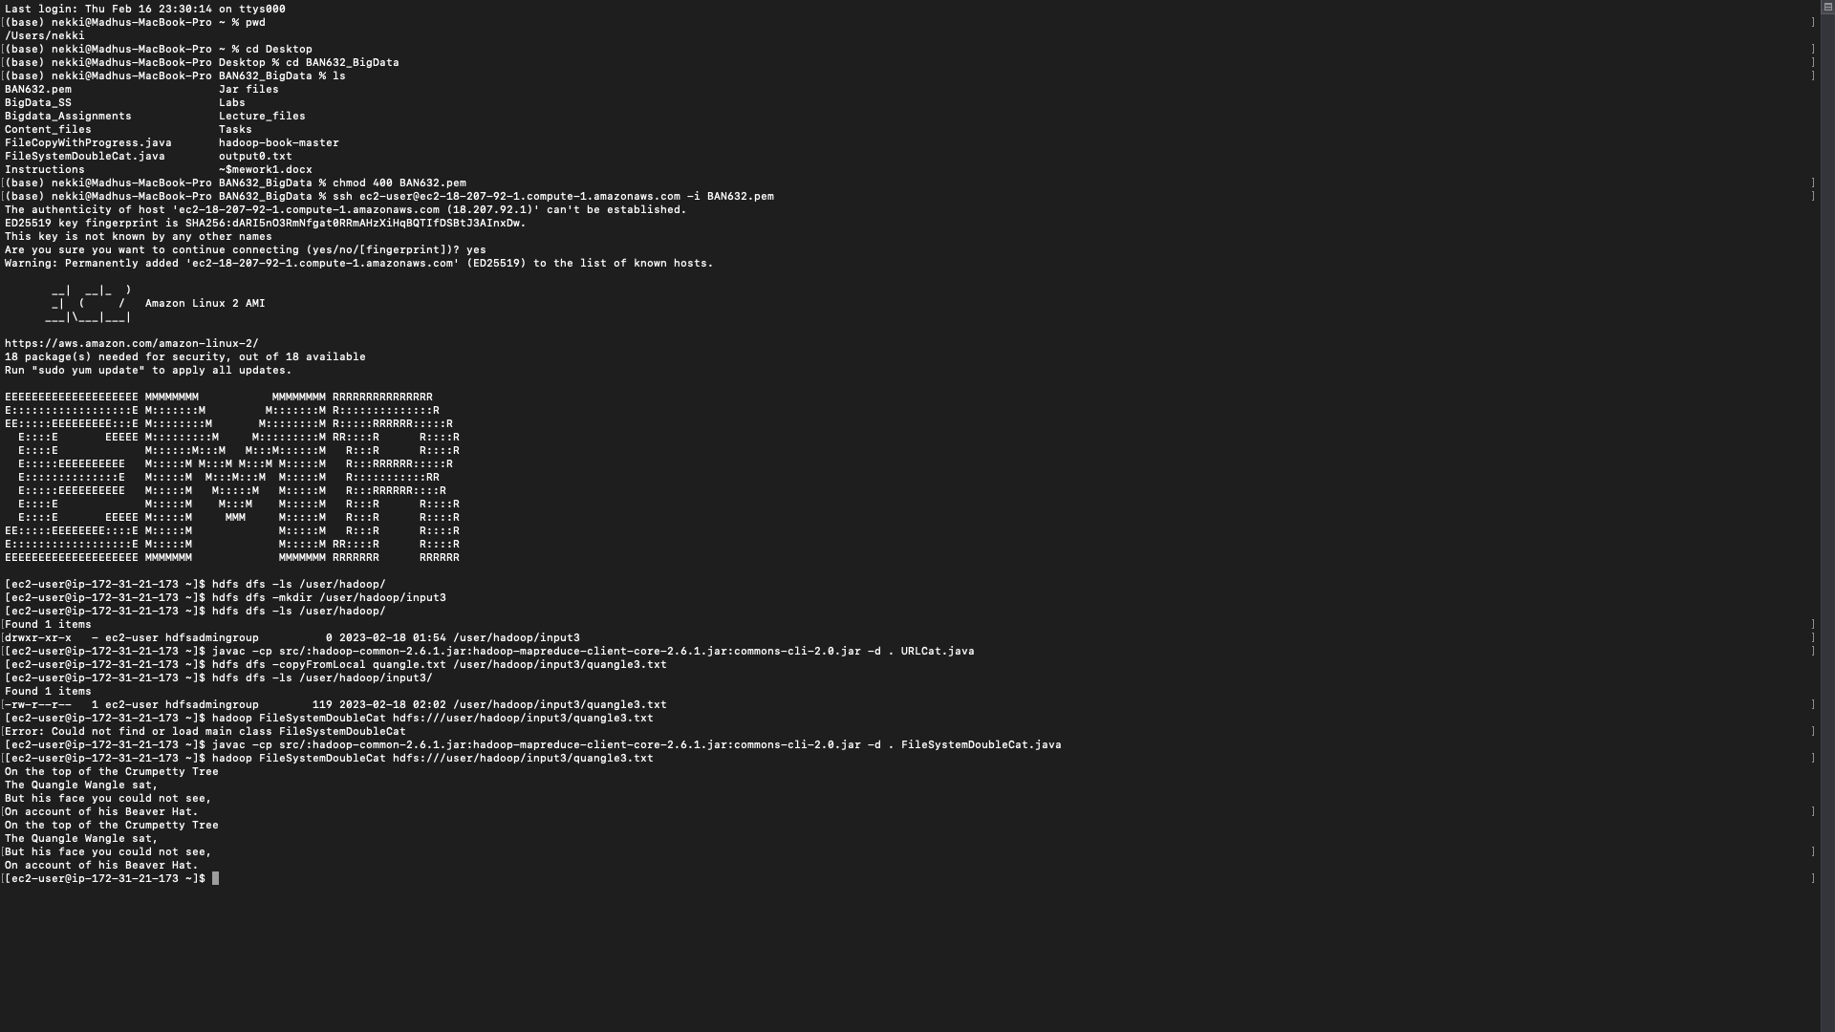



1. Work *Example 3-4* on Amazon Elastic MapReduce. Type out all the commands in each step of the process and print out a screenshot of the final results (showing the file directory) in Amazon EMR.

Command for make Directory:



hdfs dfs -mkdir /user/Hadoop/input4/

Command for copying a file from local disk to HDFS:

hdfs dfs -copyFromLocal 1400-8.txt /user/hadoop/input4/1400-8.txt

Showing the file directory:

hdfs dfs -ls /user/Hadoop/input4/

Screenshot of final results in EMR:



­

#I have tried a few extra commands to check.